# Australian fisheries economic indicators report 2017

Financial and economic performance of the Northern Prawn Fishery

David Mobsby, Robert Curtotti & Andrea Bath

Research by the Australian Bureau of Agricultural and Resource Economics and Sciences

February 2019

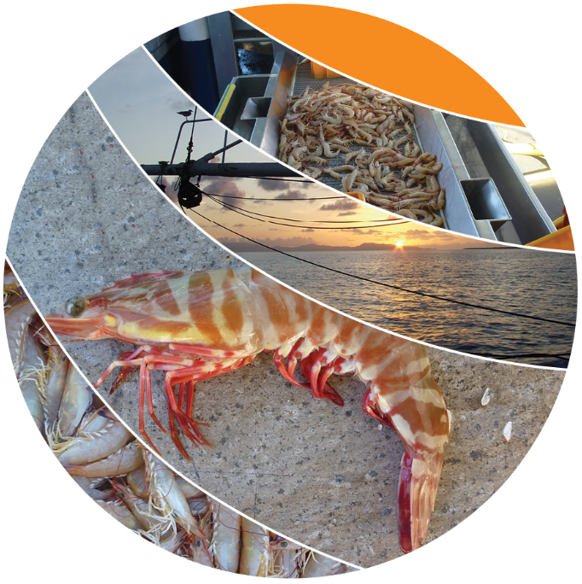

© Commonwealth of Australia 2019

**Ownership of intellectual property rights**

Unless otherwise noted, copyright (and any other intellectual property rights, if any) in this publication is owned by the Commonwealth of Australia (referred to as the Commonwealth).

**Creative Commons licence**

All material in this publication is licensed under a Creative Commons Attribution 4.0 International Licence except content supplied by third parties, logos and the Commonwealth Coat of Arms.

Inquiries about the licence and any use of this document should be emailed to copyright@agriculture.gov.au.

C:\Documents and Settings\west merryn\Local Settings\Temporary Internet Files\Content.Word\by.png

**Cataloguing data**

This publication (and any material sourced from it) should be attributed as: Mobsby, D, Curtotti, R & Bath, A 2019, *Australian fisheries economic indicators report 2017: financial and economic performance of the Northern Prawn Fishery*, ABARES, Canberra, February. CC BY 4.0. https://doi.org/10.25814/5c60cb388f85f

ISSN 2204-9444

ISBN 978-1-74323-421-1

This publication is available at agriculture.gov.au/publications.

Department of Agriculture and Water Resources

GPO Box 858 Canberra ACT 2601

Telephone 1800 900 090

Web agriculture.gov.au

The Australian Government acting through the Department of Agriculture and Water Resources, represented by the Australian Bureau of Agricultural and Resource Economics and Sciences, has exercised due care and skill in preparing and compiling the information and data in this publication. Notwithstanding, the Department of Agriculture and Water Resources, ABARES, its employees and advisers disclaim all liability, including liability for negligence and for any loss, damage, injury, expense or cost incurred by any person as a result of accessing, using or relying on any of the information or data in this publication to the maximum extent permitted by law.

**Acknowledgements**

The ABARES fisheries survey program involves the cooperative effort of industry, fisheries management, agencies and ABARES staff. ABARES surveys are voluntary, so the cooperation of Northern Prawn Fishery fishing operators and their accountants in providing data is essential for the success of the fisheries surveys. Without this assistance the surveys would not be possible.

The Australian Fisheries Management Authority (AFMA) provided logbook and address data, fishery management costs and general information about the surveyed fisheries. In ABARES, Patricia Hobsbawn and Rupert Summerson provided the necessary data and maps.

The Department of Agriculture and Water Resources funded this report through the Fisheries Resources Research Fund and ABARES.

Contents

Summary vi

Key findings vi

Introduction 9

1 Background 12

Fishery description 12

Key economic trends 12

Management arrangements 14

2 Financial and economic performance 17

Financial performance 17

Economic performance 20

3 Other key performance indicators 23

Total factor productivity 23

Terms of trade 24

Management costs 25

Entitlement values 26

Maximum economic yield targets 27

4 Performance against management objectives 29

Appendix A: Survey definitions 30

Financial performance 30

Net economic returns 31

Survey-based estimation of net economic returns 32

Net economic returns and economic performance 34

Appendix B: Survey methods 35

Appendix C: Non–survey based estimation of net economic returns 38

Appendix D: Productivity and terms of trade methodology 41

Productivity measurement 41

Terms of trade measurement 41

Data 41

References 44

Tables

Table 1 Key financial performance results, boat-level average, 2014–15 and 2015–16 vi

Table 2 Key economic performance results, Northern Prawn Fishery, 2014–15 to 2016–17 vii

Table 3 Financial performance of boats operating, Northern Prawn Fishery, 2014–15 and 2015–16 17

Table 4 Cash profit and net economic returns, Northern Prawn Fishery, 2014–15 to 2016–17 20

Table 5 Average entitlement values, Northern Prawn Fishery, 2011–12 to 2015–16 27

Table C1 Regression model for average cash receipts, Northern Prawn Fishery, 2016–17 39

Table C2 Regression model for average operating costs, Northern Prawn Fishery, 2016–17 39

Figures

Figure 1 Landed catch of key species, Northern Prawn Fishery, 1996–97 to 2016–17 13

Figure 2 Gross value of production, Northern Prawn Fishery, 1996–97 to 2016–17 13

Figure 3 Net economic returns, Northern Prawn Fishery, 1996–97 to 2016–17 14

Figure 4 Exchange rate and average real unit price, Northern Prawn Fishery, 1996–97 to 2016–17 14

Figure 5 Management changes time line, Northern Prawn Fishery, 1996–97 to 2016–17 15

Figure 6 Number of boats operating, Northern Prawn Fishery, 1996–97 to 2016–17 16

Figure 7 Financial performance, Northern Prawn Fishery, 2002–03 to 2015–16 19

Figure 8 Economic performance, Northern Prawn Fishery 2002–03 to 2016–17 21

Figure 9 Off-road fuel price index, 2002–03 to 2016–17 22

Figure 10 Productivity indexes, Northern Prawn Fishery, 2003–04 to 2015–16 24

Figure 11 Terms of trade, Northern Prawn Fishery, 2003–04 to 2015–16 25

Figure 12 Total management costs, Northern Prawn Fishery, 1996–97 to 2016–17 26

Figure 13 Average management cost per active boat and as a share of gross value of production, Northern Prawn Fishery, 1996–97 to 2016–17 26

Figure 14 Spawner stock size as a proportion of SMEY for grooved and brown tiger prawns, Northern Prawn Fishery, 1997 to 2015 28

Maps

Map 1 Relative fishing intensity, Northern Prawn Fishery, 2016 12

Boxes

Box 1 Economic indicators in fisheries management 10

Box A1 Fuel excise and net economic return 33

Box D1 Fisher index 42

## Summary

This report provides financial and economic performance indicators for the Northern Prawn Fishery (NPF), one of the key Commonwealth fisheries that ABARES has surveyed for financial and economic performance since the early 1990s. Survey-based results are presented for the 2014–15 and 2015–16 financial years and preliminary non–survey based results are presented for the 2016–17 financial year. The indicators presented are financial performance estimates for the average boat operating in the fishery, the net economic returns (NER) and total factor productivity (TFP) of the fleet, the terms of trade and management costs faced by fishers operating in the NPF and trends in entitlement values (a key asset held by fishers in the NPF). Progress against maximum economic yield (MEY) targeting in the fishery to date is also included. Fishery managers can use these indicators to inform management decisions and monitor performance of the fishery.

### Key findings

#### Financial performance

* Profit at full equity for the average NPF boat has continued to rise in 2014–15 and 2015–16. This increased reflected lower fuel prices, an increased catch, increased prices for banana prawns in 2014–15 and 2015–16 and a shift in catch composition toward higher unit value tiger prawns in 2014–15 (Table 1).
* Fuel and crew costs make up the largest proportions of cash costs in the fishery. Fuel costs made up 31 per cent of total cash costs in 2014–15 and 29 per cent in 2015–16. Crew costs 28 per cent and 35 per cent of total cash costs.

Table 1 Key financial performance results, boat-level average, 2014–15 and 2015–16

|  |  |  |  |
| --- | --- | --- | --- |
| Category | Unit | 2014–15 | 2015–16 |
| Total cash receipts | $ | 2,106,322 | 2,474,842 |
| Total cash costs | $ | 1,564,347 | 1,723,437 |
| Boat cash income | $ | 541,975 | 751,406 |
| – less depreciation | $ | 37,905 | 39,588 |
| Boat business profit | $ | 504,070 | 711,818 |
| – plus interest, leasing, rent | $ | 27,485 | 25,342 |
| Profit full equity | $ | 531,556 | 737,160 |
| Rate of return to full equity | % | 12 | 17 |

#### Economic performance

* Net economic return of the fishery is estimated to have increased to $20.7 million in 2014–15 and $30.9 million in 2015–16 (Table 2). Growth in fishing income was driven by increased landings of tiger prawns in 2015–16 and higher than average catch and price for banana prawns in both survey years. A significant reduction in unit fuel prices has contributed to boosting NER. In 2016–17 net return is estimated to have declined by 2 per cent to $30.3 million.

Table 2 Key economic performance results, Northern Prawn Fishery, 2014–15 to 2016–17

|  |  |  |  |  |
| --- | --- | --- | --- | --- |
| **Category** | **Unit** | **2014–15** | **2015–16** | **2016–17p** |
| Fishing income | $m | 108.4 | 123.8 | 121.5 |
| Operating costs | $m | 85.7 | 90.8 | 88.4 |
| Fishery cash profit | $m | 22.7 | 33.0 | 33.1 |
| – less owner and family labour, opportunity cost of capital and depreciation | | | | |
| – plus interest, leasing and management fees | | | | |
| Net return (excluding management costs) | $m | 23.2 | 32.8 | 32.3 |
| Net return (including management costs) | $m | 20.7 | 30.9 | 30.3 |

p Preliminary estimate.

#### Other indicators

* TFP in the NPF is strongly related to changes in landed catch. The TFP index fell significantly between 2010–11 and 2012–13, when banana prawn catch fell from 5,755 tonnes to 2,990 tonnes. The index rose for most of the decade up to 2013–14 but fell in 2014–15 and 2015–16. Most of this gain occurred after the implementation of the structural adjustment package in 2006–07.
* Changes in the terms of trade in the NPF are driven mainly by fuel prices and the price of banana prawns, which are exposed to competition from imported prawns. For most of the 10-year period to 2013–14, the terms of trade index followed a declining trend. This decline is largely attributable to increased fuel prices (especially to 2009) and to a lesser extent low prices for banana prawns caused by a high Australian dollar. A recovery in the terms of trade in 2012–13 was caused largely by decreases in labour and repair costs and a recovery in banana prawn prices, which allowed NER to recover despite declines in productivity in that year. The terms of trade index has continued to rise in 2014–15 and 2015–16.
* Management costs per active boat remained high between 2007–08 and 2014–15 relative to earlier years in the 2000s because total management cost levels did not decline along with the number of boats post the structural adjustment package in 2006–07. However, management costs as a share of gross value of production of the fishery continued to decline over the period 2014–15 to 2015–16.

#### Implications for management

* Several management arrangements implemented in the past are expected to have contributed to the improvements in productivity and NER over the period of declining terms of trade from 2004–05 to 2010–11. Targeting of MEY in the tiger prawn component of the fishery began in 2004–05. In addition, the structural adjustment package (completed in 2006–07) removed excess capital by removing boat and gear statutory fishing rights (SFRs) from the industry. The introduction of the fishery harvest strategy in 2007–08 has also enabled clear management responses to changes affecting the fishery. The resilience of the fleet in the operating environment of rising inputs and steady output prices is due in large part to an increase in productivity resulting from these management changes. The management changes are expected to have brought the fishery closer towards meeting the management objective of maximising returns to the Australian community.
* Two primary species are caught in the NPF—tiger prawns and banana prawns. The tiger prawn component of the fishery has a biomass target explicitly related to MEY but the banana prawn resource is environmentally driven, making it difficult to develop a stock–recruitment relationship. This means that implementing an explicit MEY biomass target for banana prawns is currently not possible. Instead, a banana prawn catch-rate trigger is in place, which targets catch rates associated with profitable levels of fishing rather than stock levels. If in the future it is possible to reliably estimate a stock–recruitment relationship for banana prawns then management should consider a move to a more explicit MEY biomass target.
* The fishery is currently managed according to input (effort) controls. The merits of moving to output controls (in the form of individual transferable quota) in the fishery have been intensively evaluated for several years. However, setting catch quotas for the highly variable white banana prawn fishery is difficult. Output controls avoid the issues associated with effort creep—that is, the increased use over time of unregulated inputs by fishers. The result of effort creep is catch beyond the intended level and fishers using a suboptimal combination of inputs. Given the NPF is managed with input controls it is important that managers monitor fishing power over time as an indicator of whether or not effort creep is becoming a problem in the fishery, so that it may be addressed.

## Introduction

The Commonwealth Northern Prawn Fishery (NPF) is one of Australia’s most valuable fisheries. In 2016–17 the fishery was the highest earning Commonwealth fishery, achieving a gross value of production of $118 million and accounting for 29 per cent of Commonwealth fishery gross value of production. The fishery rapidly developed to a large commercial scale in the 1970s, following scientific surveys that took place in the 1960s that identified viable prawn grounds. From the early 1990s ABARES has regularly assessed the economic performance of the Northern Prawn Fishery. This report marks the 14th edition covering the NPF since regular reporting began.

The fishery extends across Australia’s northern coastal areas, from Cape York in Queensland to Cape Londonderry in Western Australia. The majority of the catch taken in the Gulf of Carpentaria. The NPF fleet uses otter trawl gear to target a range of tropical prawn species across two main fishing seasons—the banana prawn season that runs from early April to mid June and the tiger prawn season that runs from early August to the end of November. The main target species are banana prawns (Fenneropenaeus merguinsis and Fenneropenaeus indicus) in the banana prawn season, and tiger prawns (Penaeus esculentus and Penaeus semisulcatus) and endeavour prawns (Metapenaeus endeavouri and Metapenaeus ensis) in the tiger prawn season.

Data gathered from ABARES fisheries surveys are used to assess the financial performance of operators in the fishery and the economic performance of the fishery as a whole. Other economic indicators, based on data collected from the ABARES survey and data provided by the Australian Fisheries Management Authority, are also reported. These indicators include productivity, terms of trade indexes, management costs and fisher entitlement values. In this report, survey-based results are presented for 2014–15 and 2015–16 and preliminary non–survey based results are presented for 2016–17. These performance measures act as important indicators for fishery managers (Box 1).

In the report a distinction is made between the two primary indicators—financial performance and economic performance. Financial performance estimates are calculated for the average boat in a fishery and include all cash receipts and cash costs that have been earned and incurred within the survey period. These estimates reflect the average boat’s profit and loss statement for all business activities, including cases where boats have operated in several fisheries. A key indicator derived from the financial performance estimates is rate of return on capital invested. The key indicator of economic performance presented is net economic return (NER), which is reported at the fishery level. The NER estimates differ from financial performance estimates because they relate only to the surveyed fishery; results exclude revenues and costs attributable to operating in other fisheries and non-fishing receipts, and include other economic costs such as the opportunity cost of capital and the opportunity cost of labour. For definitions of the cost elements used in the calculations see Appendix A.

Each indicator provides different information. Boat-level financial performance information provides a context for determining trends in the surveyed fishery. For example, positive financial profits at the boat level may be a feature of a fishery that has had negative economic returns, and favourable fisher terms of trade movements may reveal why a fishery has a positive trend in NER despite a trend deterioration in productivity. Financial performance estimates are relevant to all industry operators, enabling them to compare their individual performance with that of the average boat. Economic performance indicators are mainly relevant to fishery managers and policymakers, allowing them to assess the economic performance of the managed fishery against pursued economic performance targets.

The estimate of NER indicates the economic return to society associated with harvesting the fishery resource. For this reason, NER is the key economic performance indicator referred to in the Fisheries Management Act 1991. According to the Act, the Australian Fisheries Management Authority (AFMA) is required to maximise NER—within the context of ecological sustainable development—to the Australian community through managing Commonwealth fisheries (Patterson et al. 2017). Estimates of NER do not reveal how a fishery has performed relative to maximum potential NER in a given period. However, interpretation of NER trends, together with other economic indicators such as terms of trade and productivity indexes, can assist in assessing AFMA’s performance against this objective.

Box 1 Economic indicators in fisheries management

In September 2007 the Australian Government released the Commonwealth Fisheries Harvest Strategy Policy and Guidelines. It aims to maintain key commercial stocks at ecologically sustainable levels and maximise economic returns to the Australian community by targeting maximum economic yield (MEY) (DAFF 2007). To assess the performance of Commonwealth fisheries against their MEY targets, fishery policymakers frequently rely on economic indicators that provide them with information to inform management decisions and monitor performance.

Indicators informing management decisions against the economic objective

This type of economic indicator is forward-looking and can advise fishery managers on policy settings necessary to achieve MEY. Bioeconomic models provide indicators for this purpose; models have been developed for the Northern Prawn Fishery (Kompas & Che 2004), the Great Australian Bight Trawl Fishery (Kompas et al. 2012) and the Southern and Eastern Scalefish and Shark Fishery (Kompas & Che 2008). Approaches based on management strategy evaluation that include an economic component can also serve this purpose.

Indicators monitoring management performance against the economic objective

This type of economic indicator is retrospective and assesses previous economic performance. It can provide insight into the impact of previous management decisions on economic performance. Several indicators examined in this report fall under this category. This includes the survey-based estimation of NER, productivity indexes, entitlement values, management costs, latency and terms of trade analysis.

AFMA has the management objective of maximising net economic returns to the Australian community in its role of managing and monitoring commercial Commonwealth fishing. For commercial fishing, NER is intended to show the returns to the community—incorporating all costs of the fishery, including recovered and unrecovered management costs, the value of fuel rebates and the opportunity costs of labour and capital. Positive NER generated after accounting for these costs reflects the resource rent accruing to fishers from accessing the fishery (Gooday & Galeano 2003; Wessel 1967). A positive trend in NER is an indicator that the fishery is moving towards a position of MEY.

Many factors influence the level of NER in a fishery. Many of these are outside the control of fishery managers, such as fuel prices. However, fishery managers have some control over stock level—an important indicator is whether managers have implemented MEY targets and whether stocks are at (or moving towards) that desired level.

Total factor productivity analysis is an economic tool used to assess how well fishers use inputs to produce outputs and how their ability to convert inputs into outputs over time has changed with changes in the fishery’s operating environment. Productivity indexes can inform fishery managers about the effect of management arrangements on average productivity levels in the fishery. Results from both NER and total factor productivity analysis trends should be interpreted in light of information on stock status.

Analysis of fishers’ terms of trade indicates the possible drivers of changes in profitability or NER. It uses an index approach to examine changes in the price of inputs and outputs for a fishery over time and reveals information about the productivity improvements required to offset long-term declines in the terms of trade.

In contrast, entitlement values (or quota values) signal the expected value of future profits to be obtained from the fishery. When compared over time, entitlement values can serve as a general indicator of how well the resources in a fishery have been sustained or managed. If entitlement values are increasing over time, this suggests improvements are being made in the way resources are being managed because operating in the fishery is deemed to have become more profitable.

Measures of management costs, in absolute terms, as a proportion of gross value of fishery production (GVP) and per active boat also provide information about the cost-effectiveness of fishery management. This is another key objective of the Fisheries Management Act 1991.

Latency in allowable effort of quota can indicate the level of economic incentive for fishers to participate in the fishery. A fishery where operators are not using their right to fish is unlikely to be near its MEY target.

## Background

### Fishery description

The Northern Prawn Fishery is located off the northern coast of Australia, from Cape Londonderry in Western Australia to Cape York Peninsula in Queensland. Most catch is taken from the southern and western Gulf of Carpentaria, but significant catch is also taken along the Arnhem Land and Darwin coast and Joseph Bonaparte Gulf (Map 1). The NPF fleet uses otter trawl gear to target a range of tropical prawn species across two main fishing seasons—the banana prawn season that runs from early April to mid June and the tiger prawn season that runs from early August to the end of November. The main target species are banana prawns (Fenneropenaeus merguinsis and Fenneropenaeus indicus) in the banana prawn season, and tiger prawns (Penaeus esculentus and Penaeus semisulcatus) and endeavour prawns (Metapenaeus endeavouri, Metapenaeus ensis) in the tiger prawn season.

Map 1 Relative fishing intensity, Northern Prawn Fishery, 2016

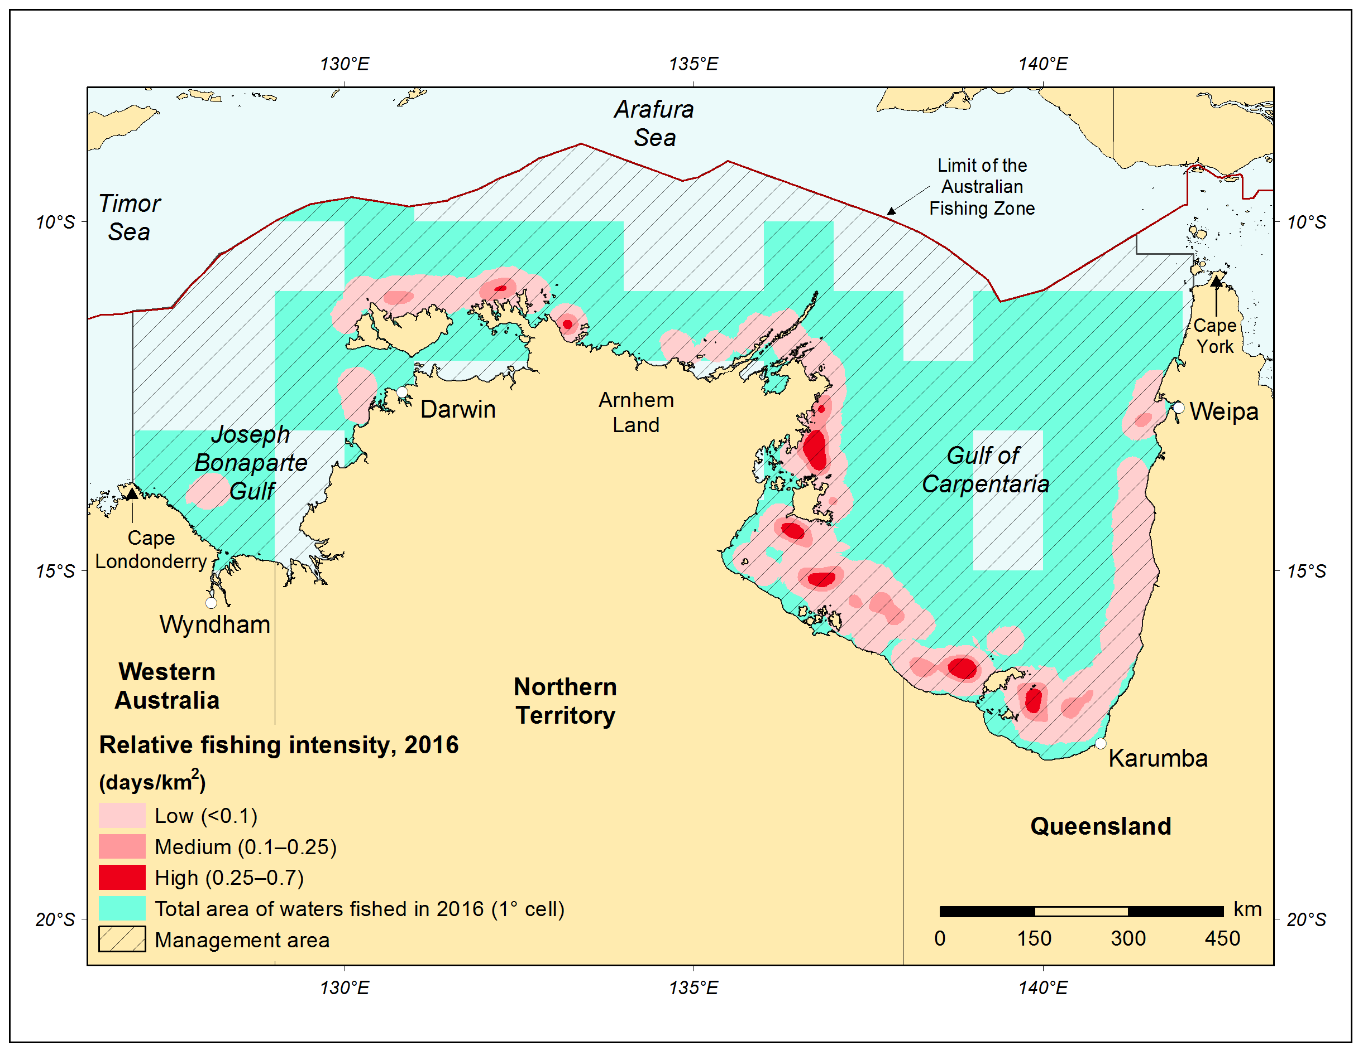

Source: ABARES

### Key economic trends

Banana prawns usually contribute most of the catch in the fishery (Figure 1) and, despite the unit value being lower than for tiger prawns, represent the largest component of gross value of production (GVP). Banana prawn catch levels are volatile because of the species’ short life cycle and sensitivity to seasonal conditions, particularly rainfall in Northern Australia. Volatility in the real gross value of production (Figure 2) and net economic returns (Figure 3) has largely reflected volatility in the banana prawn catch.

The Commonwealth Northern Prawn Fishery (NPF) is one of Australia’s most valuable fisheries. The NPF had a GVP of $119 million in 2016–17 (Figure 2) and accounted for 29 per cent of Commonwealth fishery GVP in 2016–17. It was the highest earning Commonwealth fishery in that year. In 2015–16 GVP in the fishery was the highest in 14 years at $124 million, due to a high catch of tiger prawns. Trends in NER of the fishery have tended to follow the trend in GVP (Figure 3). This is discussed further in chapter 3. The lower levels of GVP since 2000–01 reflect several factors—including a higher Australian dollar exchange rate (Figure 4), which has dampened unit export prices; structural adjustment in the fishery in the late 2000s, which led to boats exiting the fishery; and declines in catch during the early 2000s.

Figure 1 Landed catch of key species, Northern Prawn Fishery, 1996–97 to 2016–17

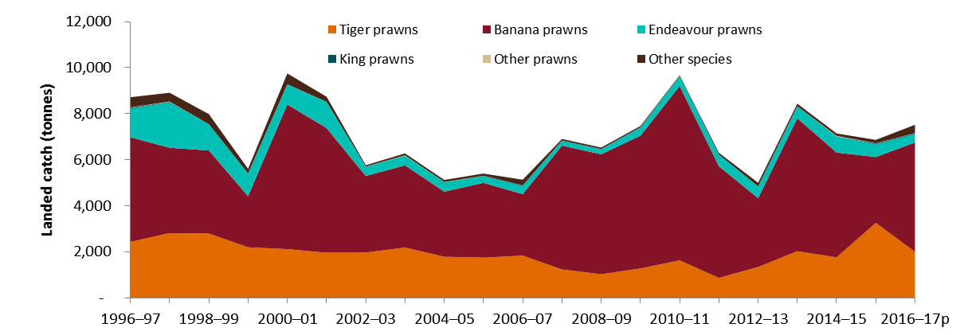

**p** Preliminary estimate.

Figure 2 Gross value of production, Northern Prawn Fishery, 1996–97 to 2016–17

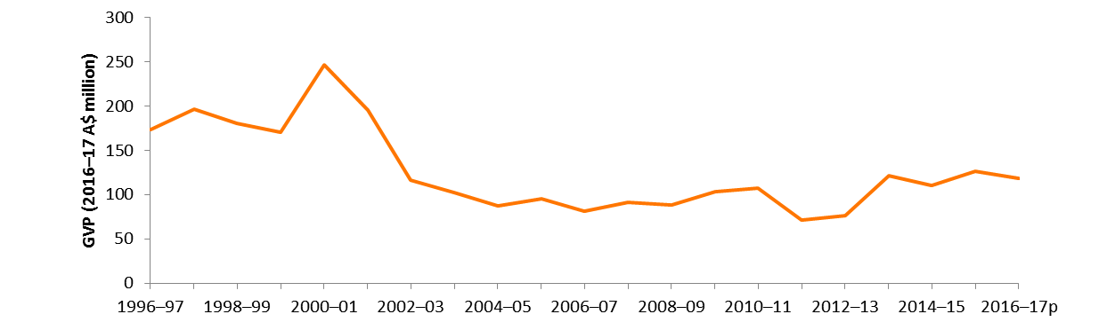

**p** Preliminary estimate.

Figure 3 Net economic returns, Northern Prawn Fishery, 1996–97 to 2016–17

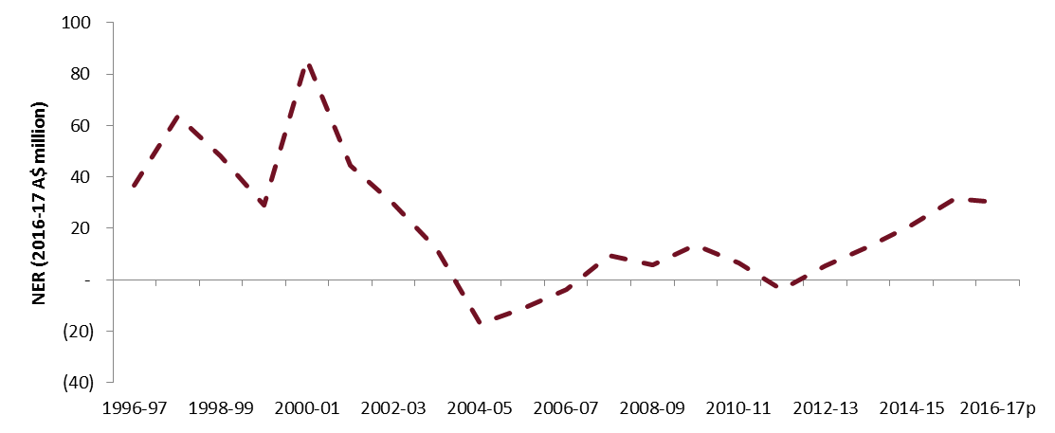

**p** Preliminary estimate.

Note: Time series tables of financial and economic performance data are available at the ABARES website.

Figure 4 Exchange rate and average real unit price, Northern Prawn Fishery, 1996–97 to 2016–17

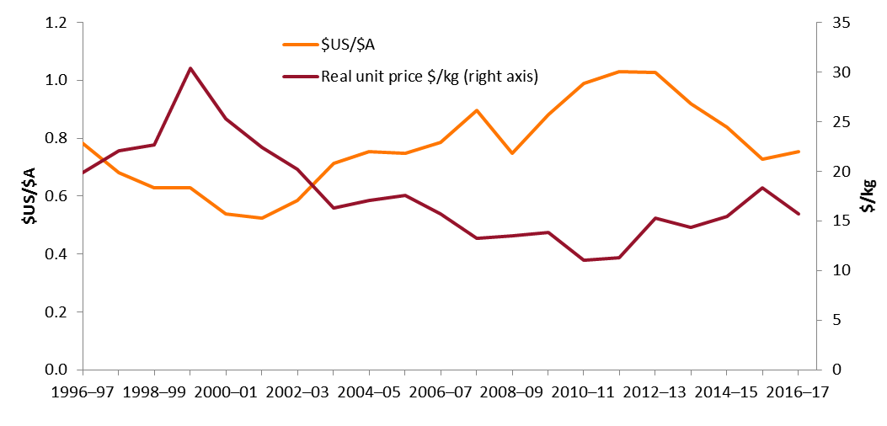

### Management arrangements

The NPF is managed through a series of input controls—including limited entry to the fishery, individual transferable effort units, gear restrictions and bycatch restrictions—and a system of seasonal and spatial closures. The fishery has two seasons—a six to 12 week banana prawn season, which starts in April; and a longer tiger prawn season, which runs from August to November. Two distinct components of the NPF harvest strategy are used to manage the two seasons of the fishery. Both components use input controls (Dichmont et al. 2012) and season length controls that are informed by real-time monitoring of catch and catch rates. The harvest strategies have been subjected to management strategy evaluation testing (Buckworth et al. 2013; Dichmont et al. 2006) to assess their performance against the objectives of the Commonwealth Fisheries Harvest Strategy Policy and Guidelines (DAFF 2007).

Major changes in NPF management arrangements in the 20-year period to 2016–17 include the managed reduction in effort in the early 2000s, introduction of an MEY target for tiger prawns to operate from 2004–05 and the structural adjustment package buyback of 2006–07 (Figure 5). The structural adjustment package buyback resulted in the removal of 43 boat statutory fishing rights and 18,365 gear statutory fishing rights from the industry and a reduction in the number of boats operating in the fishery (Figure 6).

The tiger prawn component of the fishery (tiger and endeavour prawns) has an explicit biomass target of MEY, and a bio-economic model is used to estimate annual fishing effort required to move towards spawning stock sizes at MEY (SMEY) across the stocks. Stock assessments are undertaken every two years. In 2014 an annually updated catch-rate trigger for banana prawns was introduced to the fishery (AFMA 2015). The trigger level is variable and calculated in-season on the basis of prawn prices, catch and costs provided by the Northern Prawn Fishery Industry (NPFI). Restrictions on the trigger prevent large changes in allowable effort from existing levels. Since the 2014 fishing season the banana prawn catch trigger has been set at between 425 and 575 kilograms per boat per day. Throughout stages of the banana prawn season, catch data are used to determine whether closures should occur according to the trigger.

Catch data are used throughout the banana prawn season to determine whether the fishery will close. The banana prawn resource is variable due to environmental factors, so a strong stock–recruitment relationship cannot be determined (Larcombe & Green 2015). A stock assessment model has not been developed because annual recruitment has varied widely to date. The catch trigger system is designed to allow fishing to continue only while catch rates are at profitable levels (Buckworth et al. 2015).

Figure 5 Management changes time line, Northern Prawn Fishery, 1996–97 to 2016–17

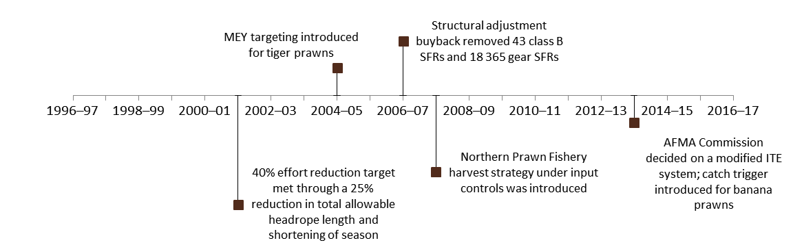

**AFMA** Australian Fisheries Management Authority. **ITE** Individual transferable effort. **MEY** Maximum economic yield. **SFRs** Statutory fishing rights.

Figure 6 Number of boats operating, Northern Prawn Fishery, 1996–97 to 2016–17

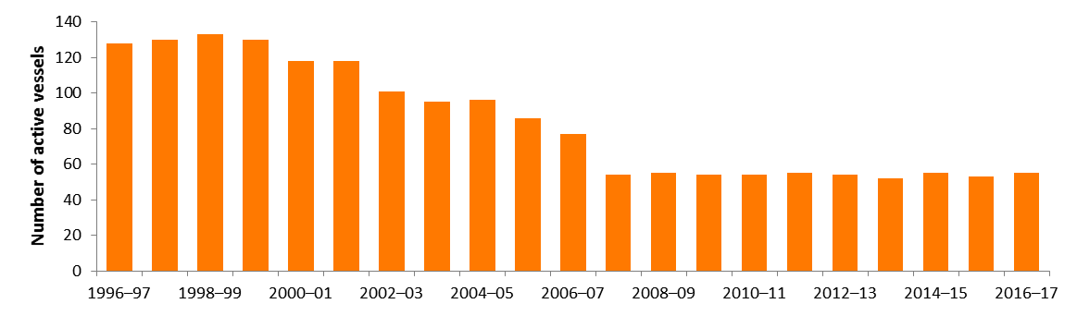

## Financial and economic performance

### Financial performance

The survey population for a given year is the boats that recorded more than one tonne of catch in the Northern Prawn Fishery (NPF). The survey sample represented 51 per cent of the population in 2014–15 and 53 per cent in 2015–16 (Table 3). The survey method is provided in Appendix B.

All boats surveyed only operated in the NPF fishery during the survey period. This means that, unlike some other fisheries in the ABARES Australian fisheries economic indicators series, all receipts and costs in the financial performance results reflect operations in the NPF only.

Between 2014–15 and 2015–16 financial performance of boats in the NPF improved (Table 3 and Figure 7). Total cash receipts increased by 17 per cent to $2.3 million per boat. Total cash costs also increased between 2014–15 and 2015–16, but by a comparatively smaller amount (10 per cent). As a result, average boat cash income was 39 per cent higher in 2015–16 than in 2014–15, averaging $751,406 per vessel, the highest level since 2000–01.

Fuel, labour and repairs and maintenance costs made up the largest cost components of operations in the NPF in 2014–15 and 2015–16, accounting for 75 per cent of total cash costs in 2014–15 and 77 per cent in 2015–16. Fuel costs accounted for the largest share of cash costs in 2014–15 (31 per cent). Labour costs are typically the second largest expense but accounted for the highest share of cash costs in 2015–16 at 32 per cent. Repairs and maintenance made up 16 per cent of total cash costs in 2014–15 and 19 per cent in 2015–16.

Profit at full equity continued to improve in 2014–15 and 2015–16, reaching $737,160 for the average NPF boat, its highest level since 2000–01. A shift in catch composition to a higher volume of the high unit value tiger prawn species, coupled with lower fuel prices, increased profit at full equity during 2015–16. Improved prices for banana prawns in 2014–15 and 2015–16 compared with 2012–13 has seen profits increase, further supported by generally improved catch volumes of other prawn species from 2012–13.

Table 3 Financial performance of boats operating, Northern Prawn Fishery, 2014–15 and 2015–16

| Revenue | Unit | 2014–15 | | 2015–16 | |
| --- | --- | --- | --- | --- | --- |
| Value | RSE | Value | RSE |
| Fishing receipts | $ | 1,970,797 | (4) | 2,336,280 | (3) |
| Non-fishing receipts **a** | $ | 135,525 | (5) | 138,562 | (2) |
| Total cash receipts | $ | 2,106,322 | (4) | 2,474,842 | (3) |
| Costs | | | | | |
| Administration | $ | 6,066 | (25) | 7,848 | (22) |
| Crew costs | $ | 444,545 | (4) | 548,917 | (3) |
| Freight and marketing expenses | $ | 84,837 | (5) | 87,536 | (5) |
| Fuel | $ | 485,349 | (4) | 453,991 | (3) |
| Insurance | $ | 39,077 | (7) | 40,234 | (6) |
| Interest paid | $ | 18,899 | (17) | 15,771 | (18) |
| Licence fees and levies | $ | 59,895 | (3) | 57,679 | (2) |
| Packaging | $ | 42,680 | (5) | 44,582 | (4) |
| Repairs and maintenance | $ | 250,052 | (7) | 319,428 | (7) |
| Other costs **b** | $ | 132,947 | (5) | 147,451 | (5) |
| Total cash costs | $ | 1,564,347 | (4) | 1,723,437 | (2) |
| Boat cash income | $ | 541,975 | (7) | 751,406 | (10) |
| – less depreciation **c** | $ | 37,905 | (8) | 39,588 | (8) |
| Boat business profit | $ | 504,070 | (7) | 711,818 | (10) |
| – plus interest leasing rent | $ | 27,485 | (10) | 25,342 | (9) |
| Profit at full equity | $ | 531,556 | (7) | 737,160 | (10) |
| Capital (excluding quota and licences) | $ | 1,314,598 | (4) | 1,272,554 | (4) |
| Capital (including quota and licences) | $ | 4,359,906 | (2) | 4,441,371 | (2) |
| Rate of return to boat capital **d** | % | 40 | na | 58 | na |
| Rate of return to full equity **e** | % | 12 | na | 17 | na |
| Population | no. | 55 | na | 53 | na |
| Sample | no. | 28 | na | 28 | na |

**a** Includes fuel rebates, charter hire, quota leasing revenue and other non-fishing receipts. **b** Includes quota lease payments. **c** Depreciation adjusted for profit or loss on capital items sold. **d** Excludes value of quota and licences. **e**Includes value of quota and licences. **na** Not available. **RSE** Relative standard error.

Note: An RSE will be higher for estimates closer to zero. A guide to interpreting RSEs is included in Appendix B.

Figure 7 Financial performance, Northern Prawn Fishery, 2002–03 to 2015–16

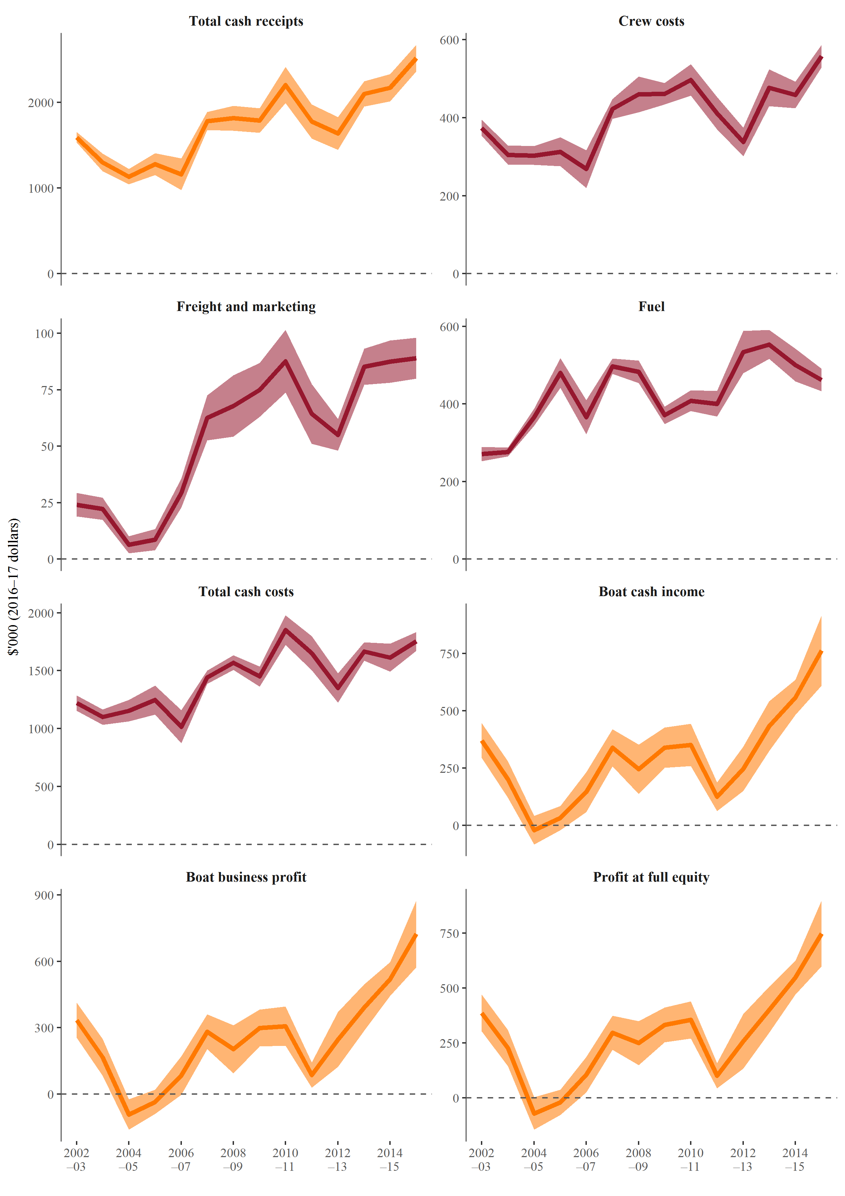

Note: Error bands are equal to two standard errors, approximating the 95 per cent confidence interval.

### Economic performance

Net economic return (NER) of the fishery is estimated to have increased from $20.7 million in 2014–15 to $30.9 million in 2015–16 (Table 4 and Figure 8). The preliminary estimate for 2016–17 shows that NER will decline by 2 per cent to $30.3 million due to lower fishing income. The increase in NER from 2014–15 to 2015–16 was primarily driven by faster growth in fishing income (14 per cent) than in fishing costs (6 per cent). The growth in fishing income was driven by increased landings of tiger prawns (up 85 per cent). The landed catch of tiger prawns during 2015–16 was the highest in the fishery since 1994–95. Fuel prices during 2015–16 were low relative to levels experienced since 2004–05 (Figure 9) contributing to the high NER during the year. Catch data for 2016–17 show total species catch levels increasing by 10 per cent from 2015–16, but the composition of catch had a smaller volume of higher unit value tiger prawns. This is estimated to drive the decline in fishing income in 2016–17.

The level of NER in the NPF varied considerably over the period 2002–03 to 2016–17. In 2002–03 real NER was estimated at $29.5 million (in 2016–17 dollars) but fell sharply in following years to reach a low of –$17.2 million when real unit prices, effort and catch declined. Negative NER continued in the fishery until 2007–08. Targeting of MEY in the tiger prawn component of the fishery began in 2004–05. The Securing our Fishing Future structural adjustment package adjustment programme removed 43 class B statutory fishing rights from the fishery, further reducing active boat numbers from 86 in 2005–06 to 55 in 2007–08. The programme concluded in 2006–07. NER in the fishery remained positive from 2007–08 onwards, except in 2011–12 (when both catch and prices fell).

Table 4 Cash profit and net economic returns, Northern Prawn Fishery, 2014–15 to 2016–17

| **Category** | **2014‒15** | | **2015‒16** | | **2016‒17p** |
| --- | --- | --- | --- | --- | --- |
| **Value** | **RSE** | **Value** | **RSE** | **Value** |
| Receipts | | | | | |
| Fishing income | 108.4 | (4) | 123.8 | (3) | 121.5 |
| **Cash costs** | | | | | |
| Operating costs | 85.7 | (4) | 90.8 | (2) | 88.4 |
| Fishery cash profit | 22.7 | (8) | 33.0 | (11) | 33.1 |
| Less | | | | | |
| – owner and family labour | 0.3 | (47) | 0.6 | (35) | 0.6 |
| – opportunity cost of capital | 1.5 | (11) | 1.4 | (9) | 1.4 |
| – depreciation | 2.1 | (8) | 2.1 | (8) | 2.1 |
| plus interest, leasing and management fees | 4.4 | (5) | 3.9 | (4) | 3.3 |
| Net return (excluding management costs) | 23.2 | (9) | 32.8 | (12) | 32.3 |
| Management costs | 2.5 | na | 1.9 | na | 2.0 |
| Net return (including management costs) | 20.7 | na | 30.9 | na | 30.3 |

**p** Preliminary non–survey based estimates. For estimation method see Appendix C. **na** Not applicable. **RSE** Relative standard error.

Note: RSEs are not available for 2016–17 results because of estimation method used (Appendix C).

Figure 8 Economic performance, Northern Prawn Fishery 2002–03 to 2016–17

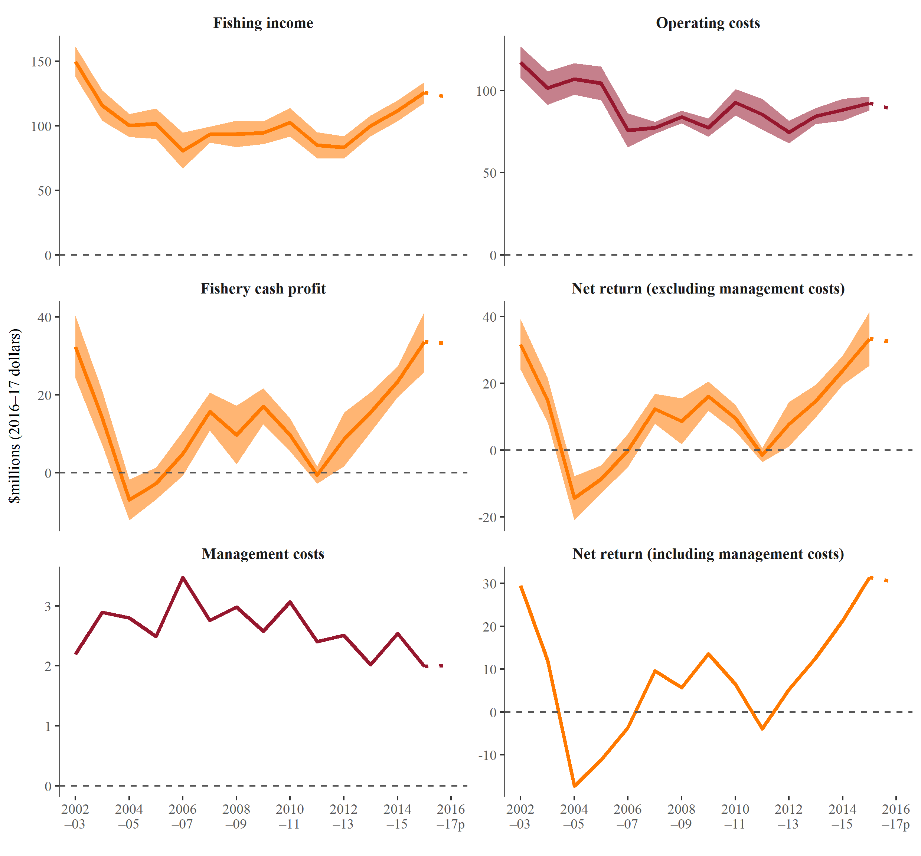

**p** Preliminary non–survey based estimates. For estimation method see Appendix C.

Note: Error bands are equal to two standard errors, approximating the 95 per cent confidence interval.

Figure 9 Off-road fuel price index, 2002–03 to 2016–17

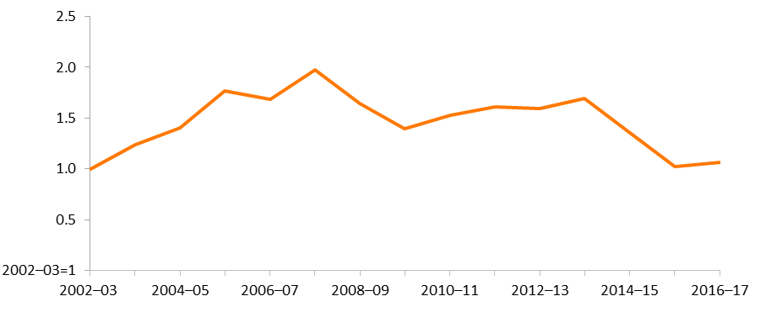

## Other key performance indicators

### Total factor productivity

Total factor productivity (TFP) analysis shows trends in fishers’ economic productivity. TFP analysis is used to examine the ability of fishers to convert inputs into outputs over time (for index calculation method see Appendix D). TFP analysis can indicate the factors in a fishers’ operating environment that affect productivity and assist in evaluating changes in NER over time. These factors may include changes in management settings that regulate fishers’ technology choices, changes in market conditions and changes in the mix of outputs produced. Market conditions include variations in input costs, import competition and the value of the Australian dollar. With other factors held constant, an increase in the ratio of outputs to inputs (productivity) will increase NER and a decrease in the ratio will reduce NER. Managers have some influence over productivity through management settings.

Changes to the fishers’ operating environment can be an incentive for them to pursue boat-level productivity improvements. For example, fishers may keep the business financially viable in response to adverse market conditions (such as increasing input costs or competition) by investing in improvements to enhance productivity. Adverse market conditions can also help drive autonomous structural adjustment in the industry. This can include the movement of fishing rights to the most profitable fishers and the exit from the industry of the least efficient or least profitable boats, resulting in a more productive fleet.

TFP in the NPF is driven almost entirely by changes in landed catch. The total factor productivity index rose from 2003–04 to reach a peak in 2010–11 (Figure 10). The peak in the TFP was driven by the output index reaching a peak in 2010–11, when catch volumes were at a relatively high level at 9,673 tonnes. The TFP index fell significantly between 2010–11 and 2012–13, driven by falls in banana prawn catch over the same period (a decline from 7,577 tonnes to 2,990 tonnes). The input index remained flat relative to the output index from 2003–04 to 2015–16, but it declined significantly (46 per cent) between 2004–05 and 2007–08 when vessels exited the fishery as part of the structural adjustment buyback. The input index has been increasing steadily since 2011–12.

Figure 10 Productivity indexes, Northern Prawn Fishery, 2003–04 to 2015–16

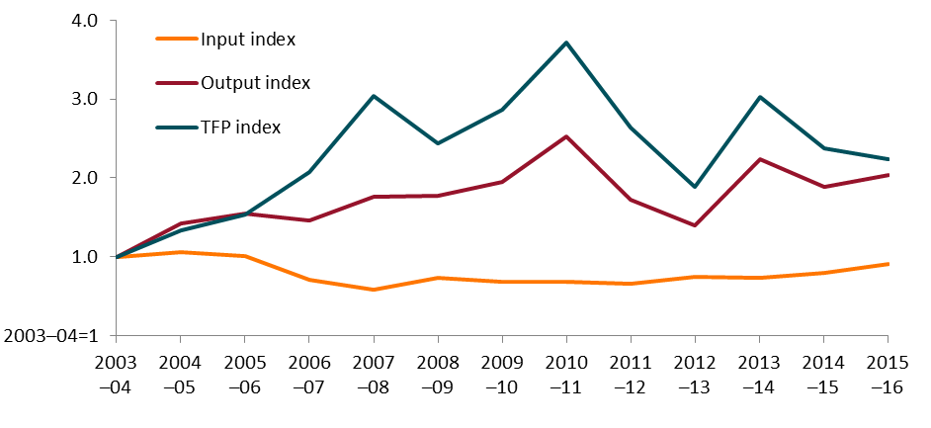

Note: **TFP** total factor productivity.

### Terms of trade

The terms of trade trends show the change in input prices relative to output prices and can indicate whether improvements in NER are driven by productivity increases or favourable terms of trade conditions (for index calculation method see Appendix D). With other factors held constant, an increase in prices received relative to prices paid will increase NER and a decrease will reduce NER. Managers have little or no control over the terms of trade. However, significant changes in the terms of trade can have implications for estimation of maximum economic yield (MEY). For example, the banana prawn trigger is based on costs of fuel, capital depreciation, gear, variable repairs and maintenance, marketing, crew share of catch revenue and beach price data (Dichmont et al. 2014).

Changes in the terms of trade in the NPF are driven mainly by prices for fuel and banana prawns. From 2003–04 to 2011–12 the terms of trade index largely followed a declining trend, falling 37 per cent over the period (Figure 11). The decline in the terms of trade index in this period is largely attributable to increased fuel prices (especially to 2009) and to a lesser extent low prices for banana prawns caused by a high Australian dollar. The input price index increased by 60 per cent from 2003–04 to 2013–14 but declined through to 2015–16 as fuel prices declined. The output price index increased in 2014–15 and 2015–16. The more favourable unit prices for species caught and declining fuel prices led to a 48 per cent increase in the terms of trade index between 2013–14 and 2015–16.

Figure 11 Terms of trade, Northern Prawn Fishery, 2003–04 to 2015–16

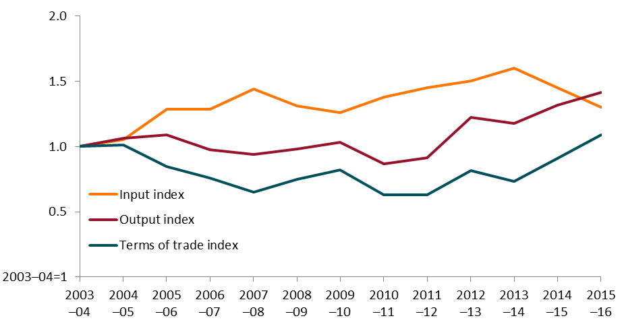

### Management costs

Management costs are incurred so the fishery can operate. Managers directly control the level of management costs. Fishery management costs remained between $1.6 million and $3.5 million (in 2016–17 dollars) from 1996–97 to 2016–17 (Figure 12). Decreases and increases in management costs contributed slightly to NER but this was outweighed by stronger effects of productivity growth and terms of trade.

Management costs per active boat (Figure 13) increased most significantly between 2005–06 and 2007–08, from $28,939 to $51,099, as the number of boats in the fishery declined as a result of structural adjustment. The number of boats in the industry remained steady from 2007–08 and management costs per boat were high relative to the late 1990s and early 2000s.

Management costs as a proportion of GVP declined steadily from 2006–07, when they accounted for just over 4 per cent of GVP. The proportion was as low as 1 per cent in the 1990s up to 2001–02. However, this increased as a result of lower GVP and increased total management costs. From 2006–07 the proportion settled in a range of around 2 per cent to 3 per cent as total management costs declined and stabilised, and higher levels of GVP were recorded. The NPF has a lower ratio of management costs to GVP than most Commonwealth fisheries. This can be partly attributed to the lower costs of input based controls (Department of Agriculture and Water Resources 2016).

Management costs can vary year to year depending on the management cycle of the fishery, such as whether new assessments or research have been undertaken. Management costs may also be increased through implementation of mechanisms to improve productivity and therefore NER (such as estimating MEY biomass targets or introducing new methods of forecasting seasonal conditions). With other factors held constant, an increase in management costs reduces NER and a decrease increases NER, at least in the short term. In the longer term extra expenditure on management could increase NER if that expenditure results in better management of the fishery.

Figure 12 Total management costs, Northern Prawn Fishery, 1996–97 to 2016–17

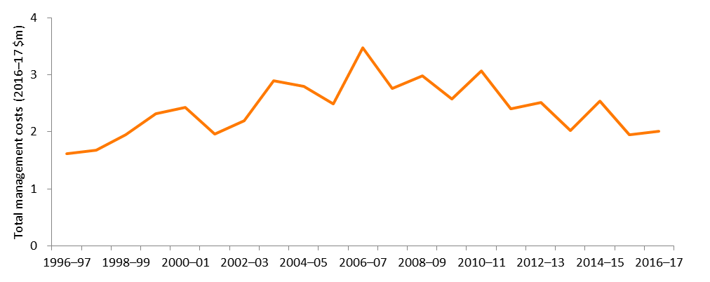

Figure 13 Average management cost per active boat and as a share of gross value of production, Northern Prawn Fishery, 1996–97 to 2016–17

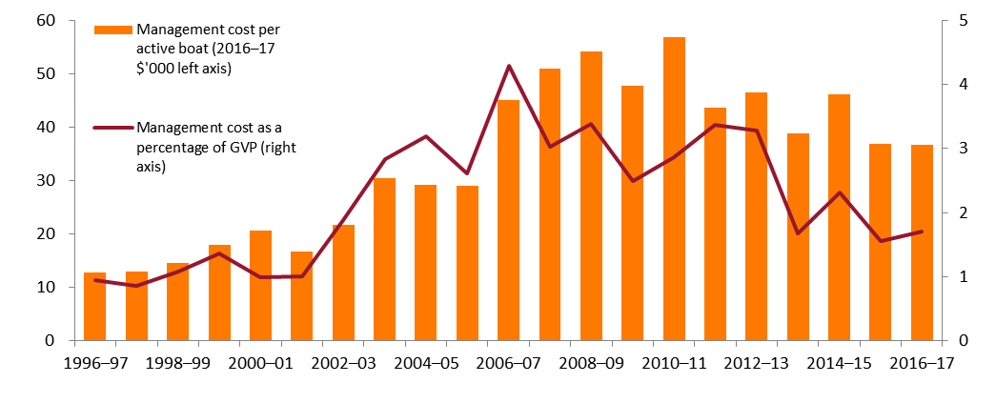

### Entitlement values

Under the Northern Prawn Fishery Management Plan 1995, fishers must have two types of statutory fishing rights (SFRs) to operate in the NPF—class B SFR (or boat SFR) and gear SFR. A class B SFR permits commercial use of a trawl boat in the fishery, and the gear SFR entitles fishers to use a prawn trawl net with a certain head rope and footrope length. Entitlement values are estimated from valuations that fishers operating in the NPF place on the two types of SFR. These valuations cannot be measured directly because of confidentiality in trading prices. Therefore, values estimated by fishers are usually subjective and may differ from operator to operator. ABARES started collecting estimated individual gear and boat SFR entitlement values in the 2011–12 NPF survey (Table 5). Values of gear SFRs slightly increased from 2011–12 to 2015–16, but the value of B SFRs increased significantly after 2011–12. These increases tentatively indicate an increase in profitability between 2011–12 and 2015–16, but a longer time series of entitlement values will provide more information about fishers’ expected profitability or confidence in the fishery.

Table 5 Average entitlement values, Northern Prawn Fishery, 2011–12 to 2015–16

| Average value | Unit | 2011–12 | 2012–13 | **2013–14** | **2014–15** | **2015–16** |
| --- | --- | --- | --- | --- | --- | --- |
| Sale price of individual gear units | $ | 3,758 | 3,773 | 3,742 | 3,931 | 3,981 |
| Gear units held per boat | no. | 714 | 685 | 685 | 716 | 716 |
| Sale price of class B SFR units | $ | 185,185 | 264,545 | 264,545 | 322,414 | 322,414 |

**SFR** Statutory fishing right.

### Maximum economic yield targets

Many factors influence the level of NER in a fishery. Many of these are outside the control of fishery managers, such as fuel prices. However, fishery managers do have some control over the stock level. Therefore, two important indicators are whether managers have implemented MEY targets consistent with the Commonwealth Fisheries Harvest Strategy Policy and whether stocks are at (or moving towards) the desired level. Given the dynamic nature of fisheries stocks are extremely unlikely to always be exactly at their desired level—some variation around targets should be deemed acceptable.

The tiger prawn fishery has explicit MEY targets (three species-level biomass MEY (BMEY) targets for brown and grooved tiger prawns, and blue endeavour prawns). A bio-economic model is used to estimate annual fishing effort required to move towards spawning stock sizes at MEY (SMEY) across the stocks. Endeavour prawns are included in the model as an economic bycatch—that is, effort is not directed at the species but catches provide revenue and attract costs depending on the amount caught. An MEY target is also set for the red-legged banana prawn catch taken in the Joseph Bonaparte Gulf, which makes up a relatively small component of the total banana prawn catch in the NPF. A bio-economic model has not been developed for the Joseph Bonaparte Gulf fishery, so the MEY target for red-legged banana prawns is the Commonwealth Harvest Strategy Policy and Guidelines proxy for BMEY (1.2 of the estimated maximum sustainable yield, BMSY) (Buckworth et al. 2015).

Targeting of SMEY in the tiger prawn fishery began in 2004. The most recent assessment (Buckworth 2016) shows both brown tiger and grooved tiger are now significantly above SMEY in the base-case modelling scenario. From 2005, and particularly from 2011, spawner stock size for both species of tiger prawn fluctuated above and below the target SMEY reference point (Figure 14).

Figure 14 Spawner stock size as a proportion of SMEY for grooved and brown tiger prawns, Northern Prawn Fishery, 1997 to 2015

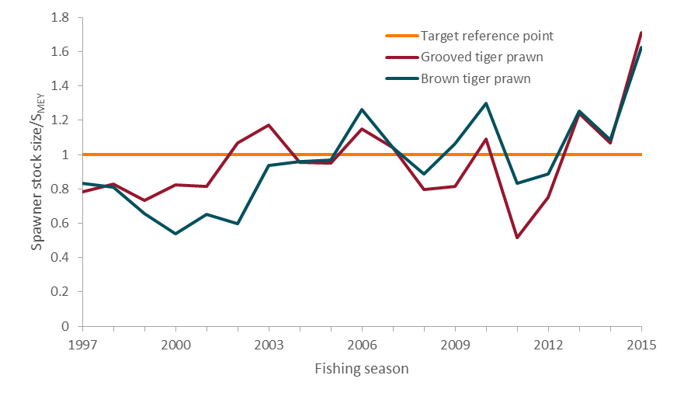

**MEY** Maximum economic yield.

Source: Buckworth 2016

## Performance against management objectives

Since 2004–05 both productivity and NER have improved. Many other factors influence these indicators, but many changes to the management arrangements for the fishery are expected to have brought the fishery closer towards meeting the management objective of maximising returns to the Australian community.

One significant change was the adoption of an explicit MEY target biomass in 2005 for the tiger prawn component of the fishery. A bio-economic model is used to estimate annual fishing effort required to move towards spawning stock sizes at MEY (SMEY) across the stocks. Since around 2005 tiger prawn stocks have fluctuated around this target level. The white banana prawn resource is highly variable and developing a robust stock–recruitment relationship, and in turn estimating the biomass associated with MEY, has not been possible. Instead, an annually updated catch-rate trigger, based on profitable in-season effort levels was introduced in 2014. It is too early to determine whether this change has affected fishery-level NER.

Prior to the adoption of MEY for the tiger prawn component of the fishery, management adopted an effort reduction target of 40 per cent in 2001–02 by reducing allowable head rope length and shortening the fishing season. The structural adjustment package (completed in 2006–07) further removed excess capital by removing boat and gear statutory fishing rights (SFRs) from the industry. The fishery harvest strategy introduced in 2007–08 has enabled clear management responses to changes affecting the fishery.

The fishery appears to be moving towards meeting the management objective of maximising returns to the Australian community. However, in the absence of output controls for the fishery, continued monitoring of fishing power will be important to determine whether or not effort creep—that is, the increased use over time of unregulated inputs by fishers—is occurring. If effort creep is detected it may be possible to adjust the level of effort to effectively limit the catch to desirable levels by adjusting allowable inputs. However, this approach risks forcing fishers to use suboptimal combinations of inputs, leading to lower productivity and profitability. Management would need to carefully consider the issue if it arises.

The adoption of a more explicit MEY biomass target for white banana prawns, or methods of forecasting seasonal conditions (if possible), would potentially increase productivity. However, such gains would need to be balanced against increased management costs resulting from the additional research required to establish an explicit target.

Management should continue to monitor the economic performance of the fishery and identify reasons for change in NER trends, especially during implementation of key management changes. Fishery managers can use the estimation of NER for the fishery together with the other economic indicators presented in this report to better apply management controls to achieve economic objectives.

## Appendix A: Survey definitions

This appendix provides definitions of key financial performance variables, net economic return (NER) and the ABARES method of calculating NER. Use of NER as an indicator of economic performance is briefly discussed.

### Financial performance

ABARES used these definitions of key variables in the analysis of boat-level financial performance.

**Total cash receipts** represent returns from sale of fish, from non-fishing activities (including charter operations and rebated fuel excise) and from other sources (insurance claims and compensation, quota and/or endorsements leased out, government assistance and any other revenue) in the financial year.

For most operators, this information is readily available from their own records. However, different operators record their fishing income in different ways. Where fish are sold through a cooperative, some operators may only record payments received from the cooperative. These payments may be net of commissions, freight and other purchases made through the cooperative.

In other cases, the cooperative or agency pays the crew directly for the catch; the owner’s financial records might include only the revenues received after the crew’s share has been deducted. For consistency, marketing charges may need to be added back into fishing receipts for some boats to give a gross value. Where this is necessary, these selling costs are also added into the cost estimates to offset the new revenue figure. Receipts also include amounts received in the survey year for fish sold in previous years.

**Total cash costs** include payments made for both permanent and casual hired labour and for materials and services—including payments on capital items subject to leasing, rent, interest, licence fees, fuel (inclusive of excise) and repairs and maintenance. Capital and household expenditures are excluded.

Labour costs are often the highest cash cost in the fishing operation. Labour costs include wages and an estimated value for owner/partner, family and unpaid labour. Labour costs cover the cost of labour involved in boat-related aspects of the fishing business, such as crew or onshore administration costs, but do not cover the cost of onshore labour to process fisheries products.

On many boats, the costs of labour are reflected in wages paid by boat owners and/or in the share of the catch they earn. However, in some cases, such as where owner–skippers are involved or where family members work in the fishing operation, payments made can be low or even nil. This will not always reflect the market value of the labour provided. To allow for this possible underestimation, all owner/partner and family labour costs are based on estimates collected at the interview of what it would cost to employ someone else to do the work.

**Boat cash income** is the difference between total cash receipts and total cash costs.

**Depreciation** costs are estimated using the diminishing value method, based on the current replacement cost and age of each item. The rates applied are the standard rates allowed by the Commissioner of Taxation. For items purchased or sold during the survey year, depreciation is assessed as if the transaction had taken place at the midpoint of the year. ABARES uses this method of calculating depreciation in other industry surveys.

**Boat business profit** is boat cash income less depreciation and accounting for any profit or loss on the sale of capital.

**Profit at full equity** is boat profit plus rent, interest and lease payments.

**Capital** is the value placed on the assets employed by the business that owns the surveyed boat. It includes the value of the boat, hull, engine and other onboard equipment (including gear). Estimates are also reported for the value of quotas and endorsements held by the surveyed boat. Estimates of the value of capital are based on the market value of capital and are usually obtained at interview. However, in some cases quota and endorsement values are obtained from industry sources.

**Depreciated replacement value** is the depreciated capital value based on the current age and replacement values of the boat and gear. The value of quota and endorsements held is not included in the estimate.

**Rate of return to boat capital** is calculated as if the proprietors owned all fishing assets. This enables financial performance of sample boats to be compared regardless of proprietors’ equity in the business. Rate of return to boat capital is calculated by expressing profit at full equity as a percentage of total capital (excluding quota and licence value).

**Rate of return to full equity** is calculated by expressing profit at full equity as a percentage of total capital (including quota and licence value).

### Net economic returns

Net economic returns are the long-run profits from a fishery after all costs have been met. Costs include fuel, crew costs, repairs, the opportunity cost of family and owner labour, fishery management costs, depreciation and the opportunity cost of capital. More specifically, a fishery’s net economic returns for a given period can be defined as:

An equation showing how net economic return is derived from cash receipts less operating costs, capital costs and management costs.

Where:

NER = net economic returns

R = total cash receipts attributable to sale of fish from the fishery

CC = total cash costs attributable to the fishery, including recovered management costs

OWNFL = imputed cost of owner and family labour

ILR = interest and quota/permit leasing costs

OppK = opportunity cost of capital

DEP = depreciation

recMC = recovered management costs

totMC = total management costs.

Recovered management costs are those management costs paid by industry through management fees and are included in total cash costs (CC). These costs are removed (as indicated by ‘+ recMC’) to prevent double counting because these costs are a component of total management costs. Similarly, interest and quota/permit leasing costs are removed (indicated by ‘+ ILR’) because these costs at the fishery level represent revenues that have been redistributed to external investors in the fishery.

### Survey-based estimation of net economic returns

#### Fish sale receipts

Fish sale receipts are usually taken from fishers’ financial accounts. Where a fisher operates in more than one fishery, they are asked to indicate the proportion of total fish sales attributable to the fishery being surveyed. Any freight or marketing costs must also be deducted. This provides an estimate of net fishing receipts that incorporates only the price received for fish at its first landing point (beach price).

Income received from leasing out quota and licences is not included as income in calculating net economic returns. This item represents a redistribution of profits among investors in the fishery. Also, the amount a fisher earns from leasing out quota and licences relates to the amount of profits the fishery generates. Therefore, including leasing revenue would result in double counting. Rebated fuel excise, along with any other non-fishing income, is also excluded (Box A1).

#### Operating costs

Operating costs include day-to-day operational expenses incurred to harvest fish in the fishery. Cash costs (CC) are a component of operating costs that includes those cost items that are easily identified in fishers’ accounts—such as fuel (inclusive of excise), repairs and gear replacement.

Labour costs are often specified in fishers’ accounts as wages. However, in calculating net returns, an estimate of the opportunity cost of labour is needed. The opportunity cost of labour is the wage that could have been earned performing a similar role elsewhere. Where a market wage is paid, it is assumed to represent the opportunity cost of labour and is included in the cash costs component of operating costs.

The opportunity cost of owner and family labour is not easily identifiable in fishers’ accounts. Owners and their families are often involved in operating a boat, either as skippers and crew or onshore as accountants and shore managers. Some will be paid market value for their labour, some will not be paid at all and others will be paid very high amounts (for example, as director fees or manager fees). In these cases, ABARES survey officers ask survey respondents to estimate the market value of owner and family labour—that is, the amount that would need to be paid to employ a non-family member to fulfil the same position. This amount is entered as a component of operating costs (OWNFL).

Quota and licence leasing costs and interest expenses are included in cash costs. However, these costs must be removed from calculation of net returns for the same reason they are excluded from income. See ‘Fish sale receipts’ for explanation.

Box A1 Fuel excise and net economic return

Fuel in Australia attracts an excise of approximately 38 cents a litre. However, fishers are entitled to a rebate for the full amount of excise they have paid. This is because the stated purpose of such excise is to pay for the construction and maintenance of roads, which fishers do not use.

When ABARES surveys fishers, it records fuel expenditure and excise rebates as separate items. Fuel costs are the wholesale price of fuel, including excise. Rebates of excise are recorded under non-fishing income. If a fisher’s account includes only fuel expenditure net of excise that has been rebated, then it is altered to account for excise and a balancing item is added to other income.

For financial performance both these items appear. The total expenditure on fuel, including excise, is incorporated into total cash costs. The excise that is rebated is incorporated into non-fishing income.

For net economic return (NER), only the total expenditure of fuel (including excise) is included. NER does not incorporate non-fishing income, whether in the form of rebated excise, charter revenue or anything else.

NER is intended to show the economic returns to the community, incorporating all costs of the fishery. Rebated excise is a cost borne by the government as forgone revenue—revenue it would have received if the rebate policy was not in place.

The effect of excluding rebated excise on NER varies by fishery. Trawl fisheries are more dependent on fuel. Their NER is lowered by the inclusion of excise in costs (but not in income) to a larger extent than line or gillnet fisheries, which use less fuel.

#### Capital costs

To calculate capital costs, an estimate of the value of capital is needed. ABARES survey officers ask fishers to provide information for all capital items associated with the fishing business (including hull, engine, onboard equipment, vehicles and sheds). Information collected for each item includes the year the capital item was manufactured and an estimate of what it would cost to replace that item with a new equivalent item. By accounting for previous depreciation and inflation, these data are used to estimate the total value of capital invested in the fishery for the survey year.

Capital costs include the opportunity cost of capital (OppK) and depreciation (DEP). The opportunity cost of capital is the return that could have been earned if capital had been invested elsewhere. This cost is not identifiable in fishers’ accounts. A real interest rate that represents the long-term average rate of return that could be earned on an investment elsewhere is applied to the value of capital in the fishery. For fisheries surveys, ABARES uses a rate of 7 per cent per year.

Depreciation expense is the cost of capital becoming less valuable over time as a result of wear and tear and obsolescence. Depreciation expense is not consistently identifiable in fishers’ accounts, so ABARES calculates annual depreciation of boats based on the capital inventory list collected during the surveys and predetermined depreciation rates for each capital item type.

#### Management costs

Management costs are those costs associated with harvesting fish in the fishery. They are incurred to ensure the fishery continues operating. Management costs comprise two components: recovered management costs and non-recovered management costs. Recovered management costs (recMC) are recovered from fishers and appear in the accounts of fishers as payments of management fees or levies. Non-recovered management costs are not charged to fishers but instead are covered by the managing body or government. Calculation of net economic returns requires deduction of total management costs, which is the sum of these two components.

Total cash costs (CC) includes an estimate of recovered management costs based on management levy expenses contained in fishers’ accounts. This estimate of recovered management costs is based only on a sample of the fishery, so it may not be consistent with the actual value of management costs recovered from the entire fishery. The Australian Fisheries Management Authority (AFMA) provides an estimate of total management costs for each fishery—that is, the sum of both recovered and non-recovered management costs. For these reasons, recovered management costs from fishers’ accounts are ignored (as indicated by +recMC in the net returns equation). Total management costs (totM) supplied by AFMA are then used to estimate net economic returns.

### Net economic returns and economic performance

Fishery managers, policymakers and decision-makers use information on fisheries’ performance to achieve the objective of maximising NER from fish stocks—an objective commonly referred to as MEY. Effort, catch and stock levels in a fishery operating at MEY are optimised so that the difference between ‘discounted’ revenues and costs, and therefore profits, is maximised. Revenues and costs are discounted when the value of a dollar earned today relative to the value of a dollar earned in the future is accounted for. Estimates of NER do not reveal how a fishery is performing relative to its maximum potential, but positive trends in NER together with other indicators can suggest that the MEY objective is closer to being met.

## Appendix B: Survey methods

#### Collecting economic survey data

ABARES has undertaken economic surveys of selected Commonwealth fisheries since the early 1980s. These have been done on a regular basis for particular fisheries since 1992. The current fisheries survey program involves surveying major Commonwealth fisheries every few years or more frequently where the fishery is undergoing major changes and monitoring is particularly important. The aim is to develop a consistent time series of economic information for each fishery. Such information, in conjunction with scientific assessments of each fishery, is vital for assessing fisheries’ economic performance.

Survey information is made publicly available so the performance of fisheries and the effect of management policies can be independently assessed.

#### Sample design

ABARES surveys are designed and samples selected on the basis of information provided by AFMA. This information includes data on the volume of catch, fishing effort and boat characteristics.

Because surveying all boats in a fishery is not possible, a representative sample of boats is selected. Where possible, boats are classified into subgroups based on the fishing method used (longline, purse seine and trawl) or on the size of operations (small, medium and large producers). A minimum number of representative boats from each subgroup are targeted for the survey.

In practice, this sample is seldom fully realised. Non-response is relatively high across fishery surveys, reflecting the difficulty in contacting some operators and a reluctance of others to participate. This may bias the results; for example, if a significant difference exists between the profitability of respondents and non-respondents. Sample design and weighting systems have been developed to reduce the non-response effect but care should be taken when interpreting survey information.

Between February and August every two years, an ABARES officer visits the owner of each boat selected in the sample. The officer interviews the boat owner to obtain physical and financial details of the fishing business for the survey years. When necessary the skipper of the boat is also interviewed. Further information is subsequently obtained from accountants, selling agents and marketing organisations on the signed authority of survey respondents.

Information obtained from various sources is reconciled to produce the most accurate description possible of the financial characteristics of each sample boat in the survey.

#### Sample weighting

All population estimates presented in this report are calculated from the weighted survey data of sample boats. A weight is calculated for each boat in the sample based on how representative that boat is in the population. Sample weights are calculated such that the weights sum to the population of boats that the sample is representing, and the weighted sum of catch reported by the sample boats approximates as closely as possible the total catch for the fishery according to AFMA logbook data.

That is,

An equation showing that the weighted sum of the sample catch approximate total catch of the fleet.An equation showing that the sum of the weight of the boats equals the number of boats in the population.and

where:

wi is the weight for the ith boat

P is the number of boats in the population

xi is the catch for the ith boat

X is the total catch for the target population.

Sample weights are estimated based on a regression model of GVP on catch for each vessel in the fleet population. The individual estimated weights for sampled vessels in the fleet population are then standardised such that the two conditions in the former method are still met; the sum of sample weights equal the population and the weighted sum of the sample catch approximate total catch of the fleet.

#### Reliability of estimates

A relatively small number of boats out of the total number in a particular fishery are surveyed. Estimates derived from these boats are likely to be different from those that would have been obtained if information had been collected from a census of all boats. How closely the survey results represent the population is influenced by the number of boats in the sample, the variability of boats in the population and, most importantly, the design of the survey and the estimation procedures used.

To give a guide to the reliability of the survey estimates, measures of sampling variation have been calculated. These measures, expressed as percentages of the survey estimates and termed relative standard errors, are given next to each estimate in parentheses. In general, the smaller the relative standard error, the more reliable the estimate.

#### Use of relative standard errors

Relative standard errors can be used to calculate ‘confidence intervals’ for the survey estimate. First, calculate the standard error by multiplying the relative standard error by the survey estimate and dividing by 100. For example, if average total cash receipts are estimated to be $100,000, with a relative standard error of 6 per cent, the standard error for this estimate is $6,000.

There is roughly a two-in-three chance that the ‘census value’ (the value that would have been obtained if all boats in the target population had been surveyed) is within one standard error of the survey estimate. There is roughly a 19-in-20 chance that the census value is within two standard errors of the survey estimates. Thus, in this example, there is approximately a two-in-three chance that the census value is between $94,000 and $106,000, and approximately a 19in-20 chance that the census value is between $88,000 and $112,000.

#### Comparing estimates

When comparing estimates across groups or years, it is important to recognise that the differences are also subject to sampling error. As a basic principle, a conservative estimate of the standard error of the difference can be constructed by adding the squares of the estimated standard errors of the component estimates and then taking the square root of the result.

For example, suppose the estimates of total cash receipts were $100,000 in one year and $125,000 in the previous year—a difference of $25,000—and the relative standard error is given as 6 per cent for each estimate. The standard error of the difference can be estimated as:

Shows the calculation of the standard error of the difference, which is equal to $9,605.

The relative standard error of the difference is:

Shows the calculation for the relative standard error of the difference, which is equal to 38 per cent.

The population of a fishery may change from one year to the next. If these population changes are substantial, differences in estimates may be caused more by the changes in population than by changes in the variables themselves.

#### Non-sampling errors

The values obtained in a survey may be affected by errors other than those directly related to the sampling procedure. For example, obtaining information from certain respondents may not be possible, respondents may provide inaccurate information or respondents may differ from non-respondents for a particular variable being surveyed.

In conducting surveys, ABARES draws on a depth of experience. Survey staff are generally experienced and undergo rigorous pre-survey training, aimed at minimising non-sampling errors. However, when drawing inferences from estimates derived from sample surveys, users should remember that both sampling and non-sampling errors occur.

## Appendix C: Non–survey based estimation of net economic returns

ABARES has developed a non–survey based method of estimating net economic returns for financial years where survey data are not yet available. It allows more timely reporting of net economic return estimates to better inform industry and government decision-making. This method is intended to complement data collection and publication of results normally undertaken through the fisheries surveys.

#### Method

The method used to calculate non–survey based estimates of net economic returns for a non-survey year (a year for which no survey data are available) uses regression estimates for key components of net economic returns. Regression approaches use the most relevant variables for each fishery, given unique fishing methods and other characteristics. In all cases, each component is estimated based on an assumed sample of the population and a set of corresponding assumed weights. This assumed sample represents those boats that are expected to be sampled in the next survey. Key variables correlating with cash receipts and operating costs were used in the estimates. Results show that the same variables were used to estimate both cash receipts and operating costs. See Table C1 and Table C2 for full regression results.

#### Reliability of estimates

Estimates from the regression analysis are subject to uncertainties. First, relationships estimated between surveyed values of receipts and costs and other more readily available data rely on the historical sample of boats surveyed. Boats that are consistently not included in a sample may be under-represented in the estimates.

Historical relationships will not necessarily hold each new survey year. Fishery operating conditions may change, resulting in changes in receipts and costs not foreseeable using this method.

Estimates should be used as an indication of the likely direction and magnitude of changes in net economic returns. For each receipt and cost category, the coefficient of determination (R2) indicates the extent to which the explanatory variables can explain variation in the dependent variable. Lower coefficients of determination suggest a greater level of uncertainty surrounding the estimates.

#### Cash receipts

Cash receipts are the primary component of net economic return calculations because all other costs are deducted from cash receipts. Cash receipts represent income from fishing operations in the surveyed fishery. For non-survey years, real gross value of production (GVP) is a good indicator for cash receipts because it is closely related to fishing income. Real GVP was estimated using average price data and catch data. Variables included are real GVP and a boat factor (Table C1).

Table C1 Regression model for average cash receipts, Northern Prawn Fishery, 2016–17

| Variable | Estimate | Standard error | t value | Pr(>|t|) |
| --- | --- | --- | --- | --- |
| Intercept | 1.33E+05 | 7.31E+04 | 1.808 | 0.07 |
| GVP | 9.32E-01 | 3.19E-02 | -4.03 | < 2e-16 |
| Year dummy (2010) | -2.4E+05 | 1.60E+04 | -4.034 | 7.67E-05 |
| Year dummy (2014) | -3.96E+05 | 6.36E+04 | -6.23 | 2.53E-09 |
| R2 | 0.81 | – | – | – |
| Prob (F Stat) | 291.3 | – | – | – |

**GVP** Gross value of production. **E** exponential.

#### Operating costs

Key drivers of operating costs in any fishery are fuel and labour. Therefore, accurately calculating operating costs for a non-survey year requires selecting variables that influence these two components. For labour, share payment systems imply a close relationship between fishery GVP and labour costs. Hours trawled is an indicator of fuel costs in the NPF. Preliminary estimates of operating cost were based on real GVP, hours trawled and year factors (Table C2).

Table C2 Regression model for average operating costs, Northern Prawn Fishery, 2016–17

| Variable | Estimate | Standard error | t value | Pr(>|t|) |
| --- | --- | --- | --- | --- |
| Intercept | 9.36E+04 | 1.97E+05 | 0.476 | 0.63426 |
| GVP | 5.36E-01 | 3.00E-02 | 17.85 | 2.00E-16 |
| Fuel price | 4.76E+05 | 1.77E+01 | 2.69 | 0.00773 |
| Boat dummy | 2.78E+05 | 1.01E+05 | 2.758 | 0.00633 |
| Year dummy (2014) | -1.66E+05 | 6.39E+04 | -2.591 | 0.01025 |
| R2 | 0.66 | – | – | – |
| Prob (F Stat) | 101.8 | – | – | – |

**GVP** Gross value of production. **E** exponential.

Cash receipts and operating cost regressions were tested for model fit including residual normality, heteroskedasticity, multicollinearity and autocorrelation. Initially a larger set of variables was considered for all regressions but only variables that were statistically significant or improved model fit were kept in the final regression.

#### Interest, leasing and management fees

Interest and leasing fees represent a redistribution of profits to investors in the fishery. As such, they are not costs at the fishery level. They are estimated based on historical ratios and values.

Management fees for the purpose of the estimation are taken from the Australian Fisheries Management Authority (AFMA) (recovered and non-recovered) and include all costs for managing the fishery, not just those recovered from industry. Management fees are also estimated based on historical ratios and values.

#### Opportunity cost of capital and depreciation

Capital values, the opportunity cost of capital and depreciation expenses were estimated based on an implied capital rate of 7 per cent, assuming a depreciation rate equal to that in the most recent survey year and a capital upgrade rate (an assumed capital investment amount).

#### Management costs

Total management costs (recovered and non-recovered) for 2014–15 were based on AFMA’s budgeted estimates.

## Appendix D: Productivity and terms of trade methodology

### Productivity measurement

Productivity is defined as the quantity of output produced with a given quantity of inputs. For example, a partial measure of productivity for a fishing vessel would be kilograms of a particular species of fish produced per hook used. A more complete measure of productivity is the total catch per unit of all inputs used. This latter approach is preferred as a measure of productivity and is usually referred to as total factor productivity.

Various methods have been developed to quantitatively assess total factor productivity trends for industries, and individual enterprises within industries (see Coelli et al. 2005 for discussion). A popular approach to measuring productivity trends uses index number theory. In this report a Fisher quantity index is used to measure total factor productivity trends for key Commonwealth fisheries. Fishery-level input, output and total factor productivity indexes were estimated for each of the Commonwealth fisheries analysed and for each year where data were available. The Fisher quantity index is well suited to handling the range of inputs and outputs recorded in ABARES fisheries economic survey data. For example, ABARES fisheries economic survey data contain many zero entries, which are well handled by the Fisher quantity index approach.

As with other index number approaches that measure productivity, the Fisher quantity index enables measurement of productivity trends with multiple inputs and outputs. The prices paid for inputs and received for outputs are used as weights to derive aggregations of outputs and inputs, which are expressed in index form. Output and input indexes are estimated using both Laspeyres and Paasche index approaches. A geometric mean of these indexes is derived to determine the Fisher output and input indexes. Total factor productivity is measured as the ratio of the Fisher output and Fisher input indexes.

### Terms of trade measurement

ABARES constructs a terms of trade analysis using the same process as is used for TFP, except constructing Fisher price indexes rather than Fisher quantity indexes. The price index accounts for the prices of labour and fuel—the major cost components—and the costs of repairing and maintaining capital.

### Data

The data used for this total factor productivity analysis are sourced from the ABARES Australian Fisheries Surveys dataset. The surveys dataset comprises physical and financial survey data for a sample of vessels operating in key Commonwealth fisheries. The inputs incorporated in the input indexes for each fishery are labour, fuel, repairs and capital. The output indexes for each fishery are described in the results section for each individual fishery. Population estimates are derived using sample vessel data from this database, and are calculated for each of the fisheries analysed in this report. A weight is calculated for each boat in the sample, to represent its importance in the total unobserved population. The weight is generally based on the vessel’s catch representation. Weighted vessel level information is used to derive fishery level input and output indexes.

Box D1 Fisher index

Using price (p) and quantity (q) data for a set of outputs (and separately for inputs), the Laspeyres quantity index $Q_{0t}^{L}$ can be defined as:



where



is the share of $ith$ item in the total value of outputs or inputs in the base period (denoted by 0). The Laspeyres index compares a total quantity in time period $(t)$ to a base period.

The Paasche index () is defined as:



where



is the share of $ith$ item in the total value of outputs or inputs in the current period (denoted by $t$). Like the Laspeyres index, the Paasche index compares a total quantity in time $(t)$ to a base period $(0)$.

The Fisher index () is the geometric mean of Laspeyres and Paasche indexes, defined as:



The TFP index can be calculated as the ratio of the Fisher output ($Q_{0t}^{FO})$ and input ${(Q}_{0t}^{FI}$) indexes:

An equation showing the calculation of the Total Factor Productivity index which is the Fisher index for outputs divided by the Fisher index for inputs.

The terms of trade index is constructed by the same means as a Fisher quantity index, except with every instance of Q replaced by P, and every instance of P replaced by Q.

#### Inputs and outputs

Total inputs consist of items that can be split into four major groups:

**Capital**—account for all capital items associated with the fishing business. These include the boat, hull, engine, onboard equipment, vehicles and sheds. The estimate of capital is based on the depreciated replacement value. For the total factor productivity and terms of trade analysis the quantity of capital inputs are the number of days fished, while price is user cost of using boat capital.

**Repairs and maintenance**—account for costs associated with the repairing and maintaining boat capital during the financial year. The value of repairs and maintenance is obtained through fishery surveys. A producer price index for shipbuilding and repair Services is used to estimate the price of repairs and maintenance.

**Fuel costs**—include the costs of all fuel, oil and grease. The quantity variable used for all fuel is the average of fuel use deflated by the fuel price paid.

**Labour**—includes the number of crew employed in boat-related aspects of the fishing business, such as crew or onshore administration costs, but does not cover the cost of onshore labour involved in processing fisheries products. It covers owner/partner, family and unpaid labour. For the total factor productivity and terms of trade analysis the quantity of labour input is the number of days fished multiplied by the average number of crew, while price is the opportunity cost of labour measured by average daily wage.

**Outputs** are the species caught by vessels in each fishery. For the Northern Prawn Fishery this includes tiger prawns.

## References

AFMA 2015, *Northern Prawn Fishery: directions and closures 2015*, Australian Fisheries Management Authority, Canberra.

Buckworth, RC 2016, *Northern Prawn Fishery assessment 2015–18*, milestone report to the Australian Fisheries Management Authority, AFMA research project 20135/0811, CSIRO, Brisbane.

Buckworth, RC, Deng, RA, Plagányi, EE, Punt, A, Upston, J, Pascoe, S, Miller, M, Hutton, T, Lawrence, E, & Venables W 2015, Northern Prawn Fishery RAG assessments 2013–15, final report to the Australian Fisheries Management Authority, research project 2013/0005, CSIRO, Brisbane, June.

Buckworth, RC, Ellis, N, Zhou, S, Pascoe, S, Deng, RA, Hill, FG & O’Brien, M 2013, Comparison of TAC and current management for the White Banana Prawn Fishery of the Northern Prawn Fishery, final report for project RR2012/0812 to the Australian Fisheries Management Authority, CSIRO, Canberra.

Coelli, TJ, Rao, DSP, O’Donnell, CJ & Battese, GE 2005, *An introduction to efficiency and productivity analysis*, 2nd edn, Springer, Berlin.

DAFF 2007, Commonwealth Fisheries Harvest Strategy Policy and Guidelines (pdf 526kb), Australian Government Department of Agriculture, Fisheries and Forestry, Canberra.

Department of Agriculture and Water Resources 2016, ABARES input to the Department of Agriculture and Water Resources submission (pdf 2.04mb), Productivity Commission—inquiry into regulation of the Australian marine fisheries and aquaculture sectors: submission from the Australian Government Department of Agriculture and Water Resources, Canberra, April.

Dichmont, CM, Deng, A, Punt, A, Venables, W & Haddon, M 2006, ‘*Management strategies for short lived species: the case of Australia’s Northern Prawn Fishery: 2—choosing appropriate management strategies using input controls*’, Fisheries Research, vol. 82, pp. 221–34.

Dichmont, CM, Jarrett, A, Hill, F & Brown, M 2012, *Harvest strategy for the Northern Prawn Fishery under input controls*, Australian Fisheries Management Authority and CSIRO, Canberra.

—— 2014, *Harvest strategy for the Northern Prawn Fishery under input controls*, Australian Fisheries Management Authority and CSIRO, Canberra.

Gooday, P & Galeano, D 2003, Fisheries management: a framework for assessing economic performance (pdf 161kb), ABARE eReport 03.7, prepared for the Fisheries Resources Research Fund, Canberra, April.

Kompas, T & Che, TN 2004, *A bioeconomic model of the Australian Northern Prawn Fishery: management options under uncertaint*y, Australian Bureau of Agricultural and Resource Economics, Canberra.

—— 2008, *Maximum economic yield in the Southern and Eastern Scalefish and Shark Fishery*, Australian Bureau of Agricultural and Resource Economics, Canberra, February.

Kompas, T, Che, N, Chu, L & Klaer, N 2012, *Transition to MEY goals for the Great Australian Bight Trawl Fisher*y, Australian Fisheries Management Authority, Canberra.

Larcombe, J & Green, R 2015 Northern Prawn Fishery (pdf 430kb), in H Patterson, L Georgeson, I Stobutzki & R Curtotti (eds), Fishery status reports 2015, Australian Bureau of Agricultural and Resource Economics and Sciences, Canberra, October.

Patterson, H, Noriega R, Georgeson, L, Larcombe, J and Curtotti, R 2017, Fishery status reports 2017, Australian Bureau of Agricultural and Resource Economics and Sciences, Canberra.

Wessel, WH 1967, ‘A note on economic rent’, American Economic Review, vol. 57, no. 4, pp. 873–85.