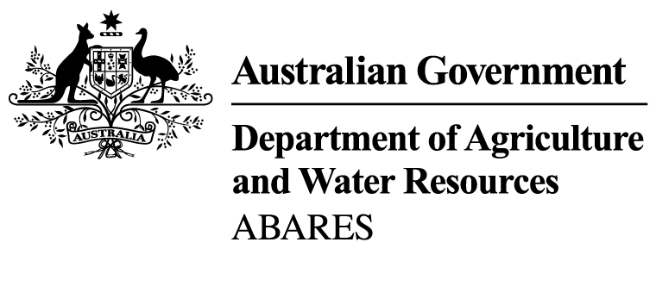

Australian crop report

Prepared by the Australian Bureau of Agricultural
and Resource Economics and Sciences
No. 181
February 2017

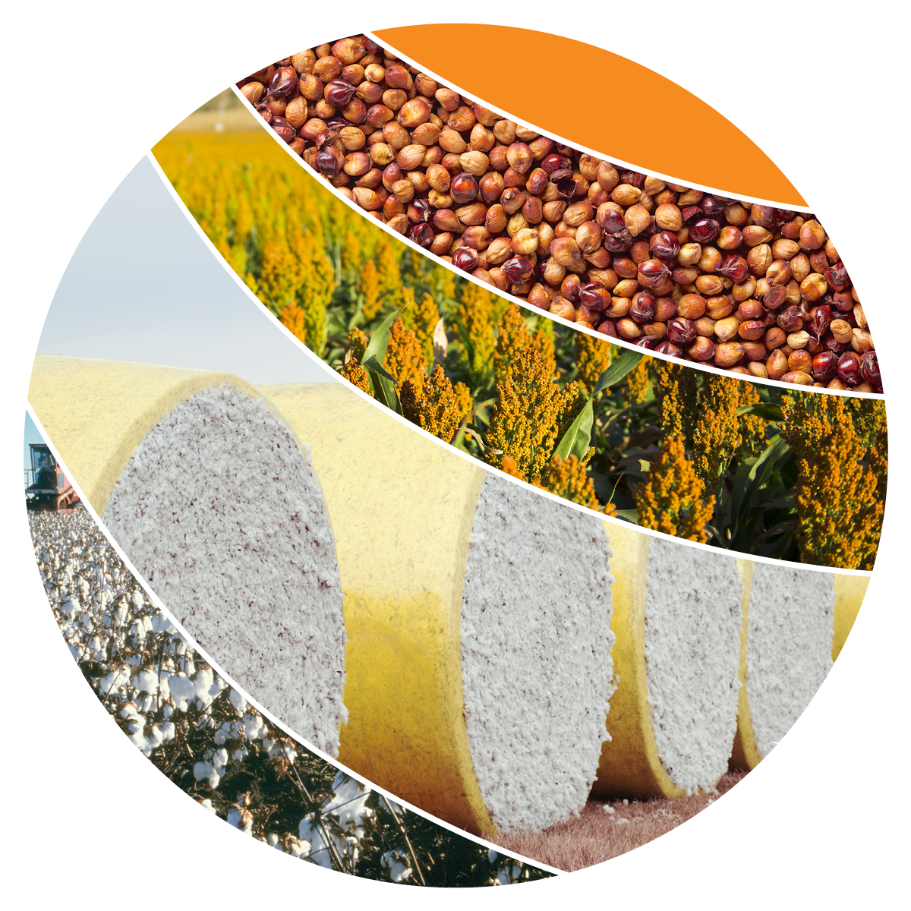
© Commonwealth of Australia 2017
Ownership of intellectual property rights
Unless otherwise noted, copyright (and any other intellectual property rights, if any) in this publication is owned by the Commonwealth of Australia (referred to as the Commonwealth).
Creative Commons licence
All material in this publication is licensed under a Creative Commons Attribution 3.0 Australia Licence, save for content supplied by third parties, logos and the Commonwealth Coat of Arms.
Creative Commons Attribution 3.0 Australia Licence is a standard form licence agreement that allows you to copy, distribute, transmit and adapt this publication provided you attribute the work. See the summary of the licence terms or the full licence terms.
Cataloguing data
ABARES 2017, Australian crop report, Australian Bureau of Agricultural and Resource Economics and Sciences, Canberra, February.
ISSN 1447-8358
ISBN 978-1-74323-329-0
ABARES project 43506
Internet
Australian crop report is available online at agriculture.gov.au/abares/publications
Australian Bureau of Agricultural and Resource Economics and Sciences (ABARES)
Postal address GPO Box 858 Canberra ACT 2601
Switchboard +61 2 6272 2010
Email info.abares@agriculture.gov.au
Web agriculture.gov.au/abares
Inquiries about the licence and any use of this document should be emailed to copyright@agriculture.gov.au.
The Australian Government acting through the Department of Agriculture and Water Resources, represented by the Australian Bureau of Agricultural and Resource Economics and Sciences, has exercised due care and skill in preparing and compiling the information and data in this publication. Notwithstanding, the Department of Agriculture and Water Resources, ABARES, its employees and advisers disclaim all liability, including for negligence and for any loss, damage, injury, expense or cost incurred by any person as a result of accessing, using or relying on information or data in this publication to the maximum extent permitted by law.
The next issue of Australian crop report is scheduled to be released on 14 June 2017.
In the next issue:
2016–17 summer crop area and production estimates updated
2017–18 winter crop area and production forecasts
Acknowledgements
This report was prepared by Benjamin Agbenyegah, Amelia Brown, James Fell, Dean Mansfield, Nathan Pitts, Christopher Price and Sarah Smith.

Contents
National overview 1
Climatic and agronomic conditions 4
Crop conditions and production forecasts, by state 11
New South Wales 11
Queensland 12
Victoria 14
South Australia 14
Western Australia 15
Statistical tables 17

Tables
Table 1 Summer crop area and production, Australia, 2006–07 to 2016–17 2
Table 2 Winter crop production, Australia, 2006–07 to 2016–17 2
Table 3 Winter crop area, Australia, 2006–07 to 2016–17 3
Table 4 Rainfall in major cropping districts, median and actual, November 2016 to January 2017 8
Table 5 Summer crop forecasts, New South Wales, 2016−17 12
Table 6 Winter crop estimates, New South Wales, 2016−17 12
Table 7 Summer crop forecasts, Queensland, 2016−17 13
Table 8 Winter crop estimates, Queensland, 2016−17 14
Table 9 Winter crop estimates, Victoria, 2016–17 14
Table 10 Winter crop estimates, South Australia, 2016–17 15
Table 11 Winter crop estimates, Western Australia, 2016–17 16
Table 12 Winter crop production and area, Australia, 2014–15 to 2016–17 17
Table 13 Summer crop production and area, Australia, 2014–15 to 2016–17 17
Table 14 Production, major crops, Australian states, 2014–15 to 2016–17 18
Table 15 Production, other crops, Australian states, 2014–15 to 2016–17 20
Table 16 Supply and disposal of wheat, canola and pulses, Australia, 2010–11 to 2015–16 22
Table 17 Supply and disposal of coarse grains, Australia, 2010–11 to 2015–16 23
Table 18 Grain and oilseed prices, second quarter 2015 to fourth quarter 2016 24

Maps
Map 1 Australian rainfall percentiles, 1 November 2016 to 31 January 2017 4
Map 2 Upper layer soil moisture, 6 February 2017 5
Map 3 Lower layer soil moisture, 6 February 2017 6
Map 4 Rainfall outlook, February to April 2017 7
Map 5 Rainfall districts, Australia 10

National overview
Drier and warmer than average seasonal conditions in the cropping regions of Queensland and northern New South Wales over the past three months have reduced prospects for summer crop production in 2016–17. The recent unfavourable seasonal conditions have lowered soil moisture levels, curtailed the planting of summer crops in the latter part of the planting window and adversely affected yield prospects for dryland crops. The timing and quantity of rainfall over the remainder of the season will be critical to the ongoing development of dryland summer crops. However, favourable supplies of irrigation water mean the recent unfavourable seasonal conditions have not adversely affected prospects for irrigated cotton and rice.
Rainfall is likely to be below average and temperatures above average for the remainder of the summer crop season, according to the Bureau of Meteorology climate outlook for February to April 2017 (issued 25 January 2017).
Planting of summer crops is now largely complete and total area planted to summer crops is estimated to have increased by 15 per cent in 2016–17 to around 1.4 million hectares. The increase in planted area was driven by plentiful supplies of irrigation water and favourable planting conditions early in the planting window. Total summer crop production is forecast to rise by 12 per cent to 4.2 million tonnes.
Area planted to cotton is estimated to have more than doubled in 2016–17 to 557,400 hectares, reflecting favourable supplies of irrigation water, high levels of soil moisture early in the planting window and expected favourable returns from growing cotton relative to production alternatives. Area planted to irrigated cotton is estimated to have increased by 66 per cent to 348,000 hectares and area planted to dryland cotton is estimated to have increased by 248 per cent to 209,400 hectares. The increase in the share of area planted to dryland cotton is forecast to result in a 21 per cent fall in the average yield, and cotton production is forecast to rise by 64 per cent to 1.0 million tonnes of lint and around 1.5 million tonnes of cottonseed.
Area planted to grain sorghum is forecast to fall by 35 per cent in 2016–17 to 441,000 hectares, largely because of higher expected returns from growing cotton. Additionally, late season planting is expected to be minimal because of unfavourable seasonal conditions over the past three months. These conditions are also expected to constrain the average yield, with production forecast to fall by 41 per cent to 1.2 million tonnes.
Area planted to rice is estimated to be almost four times higher in 2016–17 than the previous year because of an increase in the supply of irrigation water available to rice growers. Rice production is forecast to increase to 870,000 tonnes from 250,000 tonnes in 2015–16.
Table 1 Summer crop area and production, Australia, 2006–07 to 2016–17
Year | New South Wales |  | Queensland |  | Australia
 | ’000 ha | kt | ’000 ha | kt | ’000 ha | kt
2006–07 | 338 | 1,037 | 545 | 1,099 | 918 | 2,166
2007–08 | 398 | 1,668 | 791 | 2,877 | 1,199 | 4,567
2008–09 | 402 | 1,430 | 746 | 2,350 | 1,156 | 3,794
2009–10 | 381 | 1,405 | 514 | 1,342 | 903 | 2,764
2010–11 | 713 | 2,514 | 790 | 1,901 | 1,514 | 4,446
2011–12 | 757 | 3,064 | 783 | 2,379 | 1,558 | 5,494
2012–13 | 712 | 3,205 | 687 | 2,250 | 1,412 | 5,505
2013–14 | 568 | 2,317 | 559 | 1,469 | 1,139 | 3,847
2014–15 | 435 | 2,044 | 696 | 2,134 | 1,149 | 4,262
2015–16 s | 436 | 1,639 | 725 | 2,067 | 1,177 | 3,779
2016–17 f | 655 | 2,453 | 682 | 1,691 | 1,353 | 4,218
% change 2015–16 to 2016–17 | 50 | 50 | –6 | –18 | 15 | 12
f ABARES forecast. s ABARES estimate.
Note: State production includes cottonseed, grain sorghum, corn (maize), mung beans, rice, peanuts, soybeans and sunflowers. Total for Australia also includes navy beans and small areas and volumes of summer crops in other states.
Table 2 Winter crop production, Australia, 2006–07 to 2016–17
Year | Unit | New South Wales | Victoria | Queensland | South Australia | Western Australia | Australia
2006–07 | kt | 3,794 | 1,748 | 924 | 2,793 | 8,278 | 17,580
2007–08 | kt | 3,999 | 4,692 | 1,194 | 4,706 | 10,761 | 25,415
2008–09 | kt | 9,438 | 3,887 | 2,326 | 4,863 | 13,785 | 34,378
2009–10 | kt | 7,787 | 5,889 | 1,617 | 7,035 | 12,943 | 35,344
2010–11 | kt | 14,784 | 7,625 | 1,821 | 9,316 | 8,044 | 41,672
2011–12 | kt | 11,952 | 7,352 | 2,329 | 7,371 | 16,600 | 45,670
2012–13 | kt | 11,123 | 6,886 | 2,156 | 6,470 | 11,243 | 37,934
2013–14 | kt | 9,773 | 6,773 | 1,516 | 7,221 | 16,510 | 41,878
2014–15 | kt | 10,445 | 5,117 | 1,464 | 7,439 | 14,662 | 39,197
2015–16 s | kt | 11,408 | 4,156 | 2,149 | 7,174 | 14,666 | 39,608
2016–17 s | kt | 16,263 | 10,180 | 3,111 | 11,217 | 18,041 | 58,874
% change 2015–16 to 2016–17 | – | 43 | 145 | 45 | 56 | 23 | 49
s ABARES estimate.
Note: Includes barley, canola, chickpeas, faba beans, field peas, lentils, linseed, lupins, oats, safflower, triticale and wheat.
Table 3 Winter crop area, Australia, 2006–07 to 2016–17
Year | Unit | New South Wales | Victoria | Queensland | South Australia | Western Australia | Australia
2006–07 | ’000 ha | 5,671 | 3,082 | 808 | 4,141 | 6,477 | 20,207
2007–08 | ’000 ha | 6,312 | 3,375 | 873 | 4,131 | 7,265 | 21,978
2008–09 | ’000 ha | 6,295 | 3,492 | 1,208 | 3,979 | 7,899 | 22,901
2009–10 | ’000 ha | 6,106 | 3,488 | 1,173 | 3,783 | 8,271 | 22,844
2010–11 | ’000 ha | 6,158 | 3,457 | 1,217 | 3,821 | 7,715 | 22,392
2011–12 | ’000 ha | 5,969 | 3,411 | 1,205 | 3,838 | 8,252 | 22,693
2012–13 | ’000 ha | 5,852 | 3,457 | 1,222 | 3,776 | 8,097 | 22,421
2013–14 | ’000 ha | 5,314 | 3,283 | 1,105 | 3,448 | 8,249 | 21,420
2014–15 | ’000 ha | 5,491 | 3,304 | 995 | 3,639 | 8,313 | 21,760
2015–16 s | ’000 ha | 5,674 | 3,242 | 1,235 | 3,568 | 8,378 | 22,116
2016–17 s | ’000 ha | 5,685 | 3,340 | 1,333 | 3,543 | 8,442 | 22,361
% change 2015–16 to 2016–17 | – | 0 | 3 | 8 | –1 | 1 | 1
s ABARES estimate.
Note: Includes barley, canola, chickpeas, faba beans, field peas, lentils, linseed, lupins, oats, safflower, triticale and wheat.
Harvesting of winter crops is almost finished, with only small areas yet to be harvested in Victoria. Generally favourable seasonal conditions pushed national winter crop production to a new record high. All mainland states are estimated to have achieved record highs.
Total Australian winter crop production is estimated to have increased by 49 per cent in 2016–17 to 58.9 million tonnes. This estimate represents a 12 per cent upward revision to the December 2016 Australian crop report forecast. The revision was the result of yields being higher than anticipated and reaching unprecedented levels in most regions.
For the major winter crops, wheat production is estimated to have risen by 45 per cent to a record high of 35.1 million tonnes, barley production by 56 per cent to a record high of 13.4 million tonnes, canola production by 41 per cent to equal the record high of 4.1 million tonnes achieved in 2012–13 and chickpea production by 40 per cent to a record high of 1.4 million tonnes.

Climatic and agronomic conditions
During the period November 2016 to January 2017, rainfall was well below average to extremely low in the cropping regions in northern New South Wales and Queensland. Rainfall was mostly average in cropping areas in southern New South Wales, Victoria and south-east Western Australia. In cropping regions elsewhere in Western Australia and in South Australia, rainfall was average to extremely high (Map 1).
Map 1 Australian rainfall percentiles, 1 November 2016 to 31 January 2017
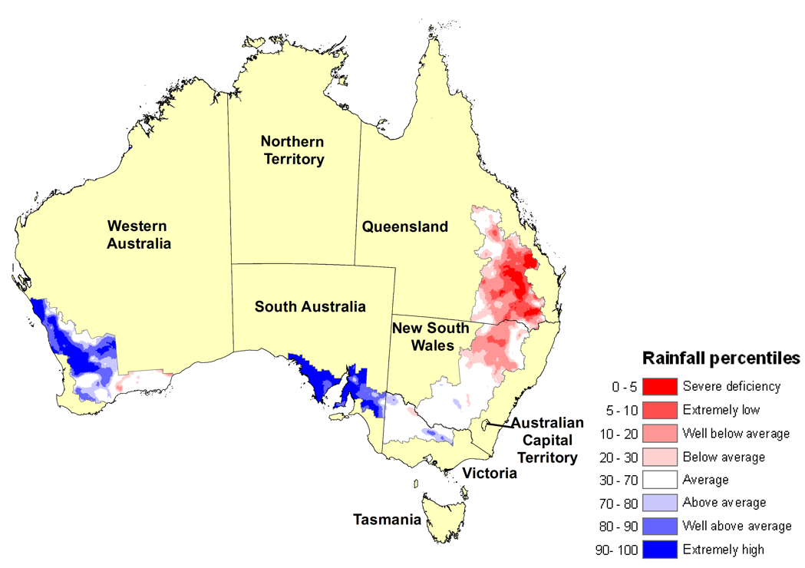
Note: Rainfall percentiles are displayed for cropping regions only.
Source: Bureau of Meteorology
Map 2 and Map 3 show the relative levels of modelled upper layer (~0.1 metres) and lower layer (~0.1 to ~1 metres) soil moisture for cropping zones across Australia as at 6 February 2017. Soil moisture estimates are relative to the historical long-term average (1911 to 2015) and presented in percentiles.
Upper layer soil moisture responds quickly to seasonal conditions and often shows a pattern that reflects rainfall and temperature events in the days leading up to the analysis date. Lower layer soil moisture is a larger, deeper store that is slower to respond to seasonal conditions and tends to reflect the accumulated effects of events that have occurred over longer periods.

Relative upper layer soil moisture on 6 February 2017 (Map 2) in Queensland was generally extremely low to well below average for central and southern summer cropping regions, with average to above average upper layer soil moisture in northern cropping regions. In New South Wales, relative upper layer soil moisture was generally average to above average in the southern cropping regions and generally well below average to extremely low in the northern cropping regions.
Map 2 Upper layer soil moisture, 6 February 2017
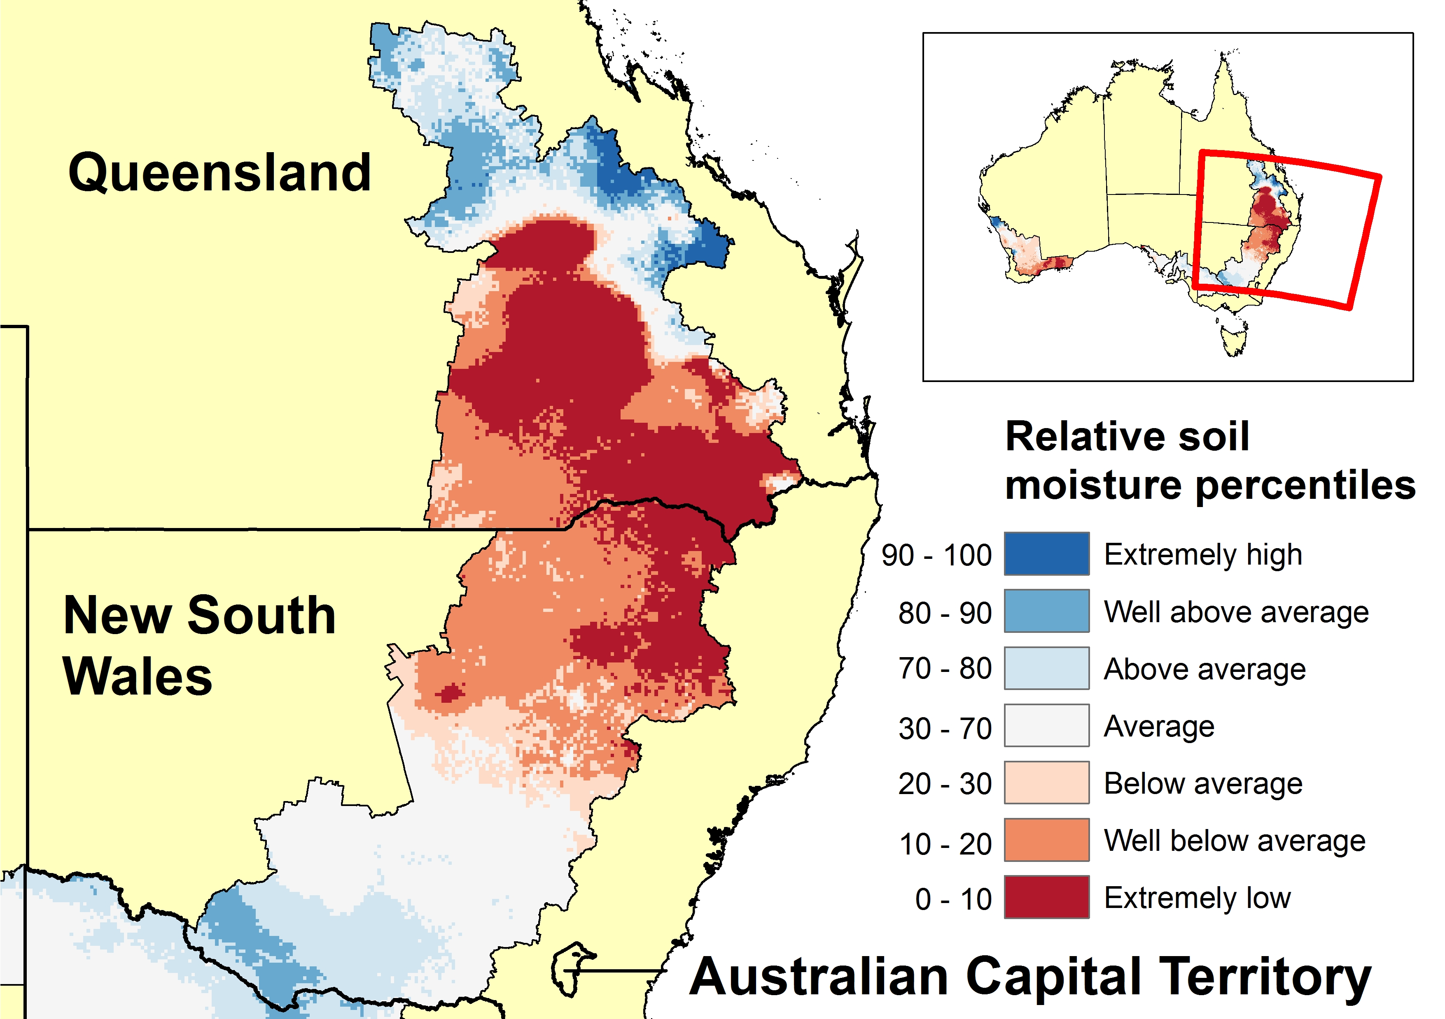
Note: Relative upper layer soil moisture is displayed for cropping regions only. The extremely high band indicates where the estimated soil moisture level on 6 February 2017 fell into the wettest 10 per cent of estimated soil moisture levels on that day each year between 1910 and 2015. The extremely low band indicates where the estimated soil moisture levels on 6 February 2017 fell into the driest 10 per cent of estimated soil moisture levels on that day between 1910 and 2015.
Source: Bureau of Meteorology.

Relative soil moisture in the lower layer on 6 February 2017 for summer cropping regions in New South Wales was generally average but was below average in some areas in the south and the north-west. In Queensland summer cropping regions, relative lower layer soil moisture was generally below average to average and extremely low in some areas in the east (Map 3).
Map 3 Lower layer soil moisture, 6 February 2017
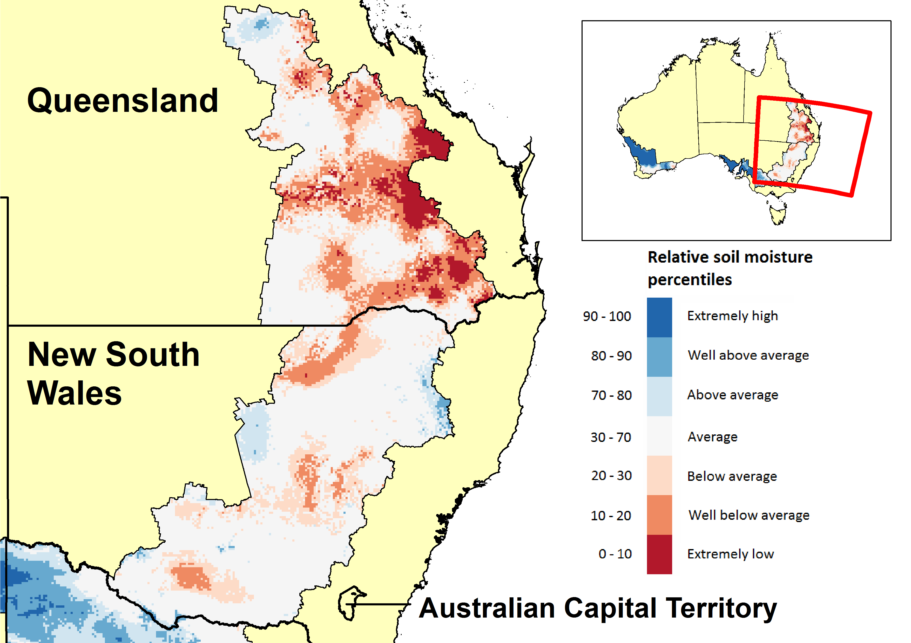
Note: Relative lower layer soil moisture is displayed for summer cropping regions only. The extremely high band indicates where the estimated soil moisture level on 6 February 2017 fell into the wettest 10 per cent of estimated soil moisture levels on that day each year between 1910 and 2015. The extremely low band indicates where the estimated soil moisture levels on 6 February 2017 fell into the driest 10 per cent of estimated soil moisture levels on that day between 1910 and 2015.
Source: Bureau of Meteorology.

Rainfall is likely to be below average and temperatures above average for the remainder of the summer crop season, according to the Bureau of Meteorology climate outlook for February to April 2017 (issued 25 January 2017).
Rainfall is likely to be below average across all cropping areas in New South Wales, Queensland, Victoria and South Australia (Map 4), according to the Bureau of Meteorology rainfall outlook for February to April 2017. For cropping areas in Western Australia, the chance of the three-month period being drier or wetter than average is roughly equal.
Map 4 Rainfall outlook, February to April 2017
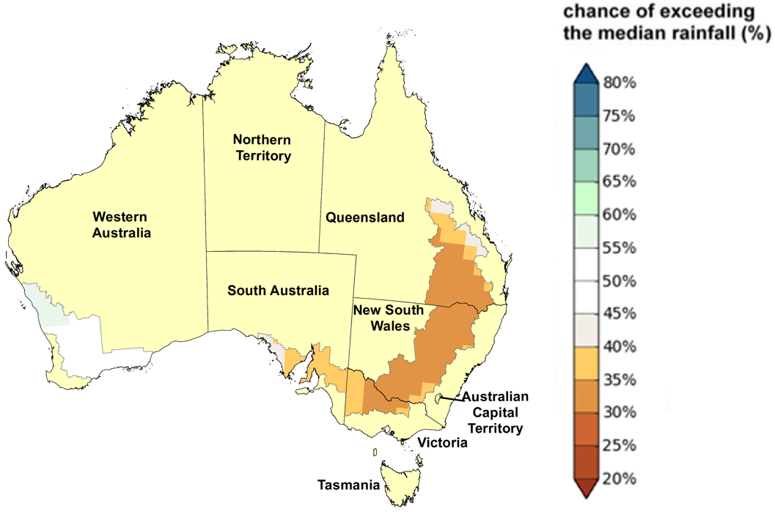
Note: Rainfall outlook is displayed for cropping regions only.
Source: Bureau of Meteorology
Maximum and minimum temperatures from February to April 2017 are likely to be above average in cropping regions in New South Wales, Queensland, Victoria and South Australia. Hotter conditions are likely to draw down soil moisture levels in these areas ahead of winter crop planting. For cropping regions in Western Australia, the forecast indicates no strong tendency towards either hotter or cooler than average conditions.
Table 4 Rainfall in major cropping districts, median and actual, November 2016 to January 2017
District | District no. | November median  mm | November 2016  mm | December median  mm | December 2016  mm | January median  mm | January 2017  mm
New South Wales
NW Plains (W) | 52 | 37 | 13 | 47 | 34 | 50 | 26
NW Plains (E) | 53 | 51 | 16 | 62 | 40 | 62 | 58
NW Slopes (N) | 54 | 64 | 28 | 79 | 73 | 78 | 101
NW Slopes (S) | 55 | 66 | 27 | 76 | 61 | 72 | 85
N Tablelands (N) | 56 | 83 | 42 | 97 | 69 | 97 | 125
CW Plains (S) | 50 | 30 | 35 | 35 | 51 | 33 | 24
CW Plains (N) | 51 | 33 | 12 | 42 | 45 | 42 | 31
CW Slopes (N) | 64 | 50 | 33 | 46 | 44 | 61 | 44
CW Slopes (S) | 65 | 42 | 49 | 45 | 59 | 46 | 21
C Tablelands (N) | 62 | 60 | 50 | 57 | 60 | 59 | 37
C Tablelands (S) | 63 | 61 | 49 | 66 | 66 | 74 | 40
Riverina (W) | 75 | 22 | 27 | 24 | 27 | 17 | 13
Riverina (E) | 74 | 33 | 35 | 31 | 37 | 22 | 19
SW Slopes (N) | 73 | 47 | 41 | 45 | 60 | 36 | 21
SW Slopes (S) | 72 | 73 | 65 | 68 | 83 | 55 | 59
Victoria
N Mallee | 76 | 20 | 26 | 15 | 11 | 13 | 26
S Mallee | 77 | 23 | 20 | 18 | 14 | 13 | 25
N Wimmera | 78 | 25 | 19 | 20 | 22 | 15 | 28
S Wimmera | 79 | 32 | 28 | 26 | 38 | 20 | 36
Lower North | 80 | 28 | 34 | 21 | 26 | 22 | 31
Upper North | 81 | 34 | 39 | 26 | 35 | 26 | 35
Lower North East | 82 | 67 | 66 | 62 | 75 | 45 | 65
North Central | 88 | 55 | 52 | 49 | 45 | 37 | 31
Western Plains | 89 | 47 | 30 | 36 | 30 | 28 | 44
West Coast | 90 | 53 | 42 | 44 | 39 | 31 | 48
Queensland
Central Highlands | 35 | 54 | 23 | 77 | 52 | 91 | 92
Maranoa | 43 | 54 | 18 | 62 | 46 | 62 | 54
W Darling Downs | 42 | 50 | 20 | 70 | 42 | 65 | 44
E Darling Downs | 41 | 59 | 29 | 81 | 43 | 67 | 66
Moreton S Coast | 40 | 79 | 42 | 108 | 72 | 118 | 101
continued …
Table 4 Rainfall in major cropping districts, median and actual, November 2016 to January 2017 (continued)
District | District no. |  | November median  mm | November 2016  mm | December median  mm | December 2016  mm | January median  mm | January 2017  mm
South Australia
Upper South East |  | 25B | 27 | 21 | 22 | 51 | 16 | 37
Murray Mallee |  | 25A | 21 | 21 | 17 | 40 | 13 | 35
Murray River |  | 24 | 21 | 18 | 16 | 51 | 13 | 30
East Central |  | 23 | 30 | 25 | 24 | 70 | 16 | 47
Yorke Peninsula |  | 22A | 20 | 15 | 16 | 44 | 9 | 42
Lower North |  | 21 | 24 | 16 | 20 | 59 | 14 | 44
Upper North |  | 19 | 17 | 7 | 18 | 66 | 13 | 56
Western Agricultural |  | 18 | 18 | 5 | 13 | 48 | 9 | 50
Western Australia
North Coast | 8 |  | 6 | 4 | 5 | 2 | 6 | 50
Central Coast | 9 |  | 16 | 11 | 8 | 9 | 4 | 44
Northern Central | 10 |  | 9 | 2 | 7 | 15 | 8 | 51
South Central | 10A |  | 16 | 9 | 10 | 33 | 8 | 17
South East | 12 |  | 13 | 3 | 17 | 28 | 13 | 49
Note: Median rainfall is calculated over the period 1900 to January 2017. Australian rainfall districts are shown in Map 5.
Source: Bureau of Meteorology
Map 5 Rainfall districts, Australia
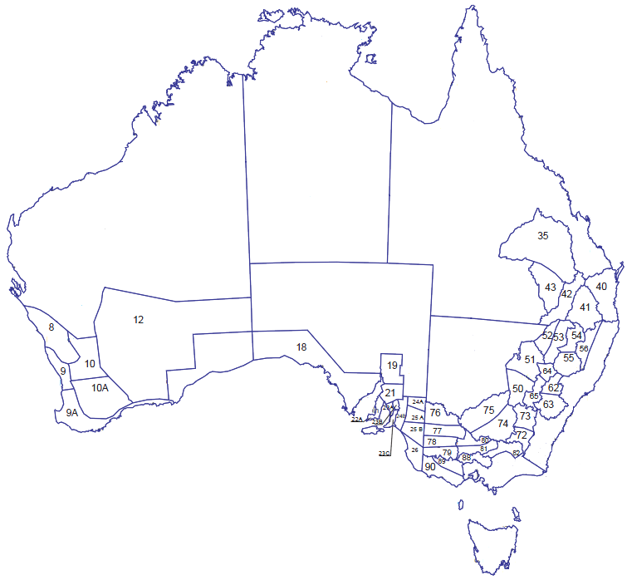
Note: Displayed for major cropping districts only. See Table 4 for district names and observed district rainfall.
Source: Bureau of Meteorology

Crop conditions and production forecasts, by state

New South Wales
Seasonal conditions during November and December were not favourable for dryland summer crop planting. Below average rainfall combined with above average temperatures depleted upper layer soil moisture. Unfavourable seasonal conditions continued into January and are expected to adversely affect prospects for dryland crop yields. The timing and quantity of rainfall over the remainder of the season will be critical to the ongoing development of dryland summer crops.
Summer cropping regions in New South Wales are likely to be drier than average, with only a 35 per cent chance of rainfall exceeding the average, according to the Bureau of Meteorology rainfall outlook for February to April 2017 (issued on 25 January 2017). The chance of the temperature being hotter than average is 70 per cent.
Area planted to summer crops in New South Wales is forecast to increase by 50 per cent in 2016–17 to 655,000 hectares. An increase in the supply of irrigation water and favourable planting conditions early in the planting window for cotton have resulted in a significant increase in area planted to cotton and rice. Total summer crop production in New South Wales is forecast to increase by 50 per cent to around 2.5 million tonnes. Forecast increases in cottonseed and rice production are expected to more than offset a forecast fall in grain sorghum production.
Area planted to grain sorghum in 2016–17 is forecast to fall by 22 per cent to 140,000 hectares, reflecting higher expected returns from growing cotton and unfavourable planting conditions for much of the grain sorghum planting window. Yields are forecast to be below average at around 2.9 tonnes a hectare, reflecting below average November to January rainfall and above average temperatures. Grain sorghum production is forecast to fall by 31 per cent to 406,000 tonnes.
Area planted to cotton is estimated to have doubled in 2016–17 to 328,000 hectares—driven by favourable supplies of irrigation water, high levels of soil moisture early in the planting window and expected favourable returns from growing cotton relative to production alternatives. Area planted to irrigated cotton is estimated to have increased by 66 per cent to 219,000 hectares and dryland cotton by 252 per cent to 109,000 hectares. The average yield is forecast to fall by 20 per cent because of an increase in the share of dryland cotton in the total area planted to cotton. Cotton production is forecast to increase by 61 per cent to around 637,000 tonnes of cotton lint and 900,000 tonnes of cottonseed.
Rice production is forecast to be 865,000 tonnes in 2016–17, compared with 245,000 tonnes in 2015–16. Area planted to rice in 2016–17 is estimated to be 85,000 hectares, which is almost four times higher than in the previous season. This reflects a large increase in the supply of irrigation water available to rice producers. Seasonal conditions have been generally favourable for crop development but the average yield is expected to be lower than the near-record in 2015–16.
Table 5 Summer crop forecasts, New South Wales, 2016−17
Crop | Area  ’000 ha | Yield  t/ha | Production  kt | Area change  % | Prod. change  %
Grain sorghum | 140 | 2.90 | 406 | –22 | –31
Cotton lint | 328 | 1.94 | 637 | 101 | 61
Cottonseed | 328 | 2.74 | 900 | 101 | 61
Rice | 85 | 10.18 | 865 | 282 | 253
Note: Cotton yields are based on area harvested. All other yields are based on area planted.
Total winter crop production in New South Wales is estimated to have increased by 43 per cent in 2016–17 to a record high of 16.3 million tonnes, driven by significant increases in the production of wheat and barley. Waterlogging adversely affected crops in some regions but yields were still high in most affected regions.
Wheat production is estimated to have increased by 52 per cent in 2016–17 to around 11.4 million tonnes, reflecting an estimated increase in the average yield to a record high of 3.3 tonnes a hectare. Area planted to wheat increased by 3 per cent to 3.5 million hectares.
Barley production is estimated to have increased by 43 per cent in 2016–17 to a record high of 2.7 million tonnes. The average barley yield is estimated at a record high of 3.1 tonnes a hectare. Area planted to barley fell by 3 per cent to 870,000 hectares.
Canola production is estimated to have increased marginally in 2016–17 to around 842,000 tonnes, despite a 9 per cent fall in planted area. The average yield is estimated to have increased by 11 per cent to 1.7 tonnes a hectare.
Table 6 Winter crop estimates, New South Wales, 2016−17
Crop | Area  ’000 ha | Yield  t/ha | Production  kt | Area change  % | Prod. Change  %
Wheat | 3,500 | 3.25 | 11,375 | 3 | 52
Barley | 870 | 3.10 | 2,697 | –3 | 43
Canola | 510 | 1.65 | 842 | –9 | 1
Note: Yields are based on area planted.

Queensland
Rainfall in most summer cropping regions in Queensland was below to very much below average and temperatures were above average from November 2016 to January 2017. These unfavourable seasonal conditions reduced soil moisture levels and are expected to adversely affect yield prospects for dryland summer crops. The timing and quantity of rainfall over the remainder of the summer crop season will be critical to the ongoing development of dryland crops.
Summer cropping regions in Queensland are likely to be drier than average, with the chance of rainfall exceeding the median only 30 per cent to 40 per cent, according to the Bureau of Meteorology rainfall outlook for February to April 2017 (issued 25 January 2017). The chance of temperatures being higher than average in the major cropping regions is 65 per cent to 75 per cent.
Area planted to summer crops in Queensland is forecast to fall by 6 per cent in 2016–17 to around 682,000 hectares, driven by a significant fall in area planted to grain sorghum. This fall was partially offset by an increase in area planted to cotton. Total summer crop production is forecast to decrease by 18 per cent to around 1.7 million tonnes.
Area planted to grain sorghum is forecast to fall by 40 per cent in 2016–17 to 300,000 hectares. Higher expected returns from growing cotton resulted in a significant shift in planted area from grain sorghum to cotton. The recent reduction in soil moisture levels and an unfavourable seasonal outlook also constrained planting of grain sorghum. The planting window remains open in central Queensland but further planting of grain sorghum is expected to be limited. Production is forecast to fall by 45 per cent in 2016–17 to 800,000 tonnes.
Area planted to cotton is estimated to have more than doubled to 229,400 hectares. Area planted to irrigated cotton is estimated to have increased by 65 per cent to 129,000 hectares and area planted to dryland cotton by 246 per cent to 100,400 hectares. However, the average yield is forecast to decline by 22 per cent as a result of an increase in the share of dryland cotton in area planted to cotton. Cotton production is forecast to increase by 68 per cent to 393,000 tonnes of cotton lint and around 555,000 tonnes of cottonseed.
Table 7 Summer crop forecasts, Queensland, 2016−17
Crop | Area  ’000 ha | Yield  t/ha | Production  kt | Area change  % | Prod. change  %
Grain sorghum | 300 | 2.67 | 800 | –40 | –45
Cotton lint | 229 | 1.71 | 393 | 114 | 68
Cottonseed | 229 | 2.42 | 555 | 114 | 68
Note: Cotton yields are based on area harvested. All other yields are based on area planted.
Total winter crop production in Queensland is estimated to have risen by 45 per cent in 2016–17 to a record high of around 3.1 million tonnes. Production for all major winter crops increased.
Wheat production is estimated to have increased by 40 per cent in 2016–17 to around 1.9 million tonnes, despite a 5 per cent fall in planted area. Crop quality was variable but generally better than had been expected. Protein levels were slightly below average.
Barley production is estimated to have risen by 45 per cent in 2016–17 to 300,000 tonnes. The average yield is estimated to have increased by more than 50 per cent to a record 3.2 tonnes a hectare.
Chickpea production is estimated to have increased by 55 per cent in 2016–17 to 850,000 tonnes. Area planted to chickpeas is estimated to have risen by 40 per cent to a record 475,000 hectares in response to expected higher returns compared with other winter crops. Despite difficulties with excess moisture in some regions, overall yields and quality were better than expected.
Table 8 Winter crop estimates, Queensland, 2016−17
Crop | Area  ’000 ha | Yield  t/ha | Production  kt | Area change  % | Prod. change  %
Wheat | 735 | 2.62 | 1,925 | –5 | 40
Barley | 95 | 3.16 | 300 | –5 | 45
Chickpeas | 475 | 1.79 | 850 | 40 | 55
Note: Yields are based on area planted.

Victoria
Seasonal conditions through spring and into harvest were very favourable for winter crops in Victoria. Waterlogging, lodging (fallen crops) and frost events adversely affected crops in some regions but impacts were not widespread.
The estimated high yields and long growing season resulted in lower than average protein levels in some wheat and barley crops. State-wide average screenings and falling numbers (a measure of starch content) have been favourable.
Total winter crop production in Victoria is estimated to have more than doubled in 2016−17 to 10.2 million tonnes. Average yields are expected to be much larger than the well below average yields of 2015–16. Planted area is estimated to have increased by 3 per cent to 3.3 million hectares.
Wheat production is estimated to have more than doubled in 2016−17 to 5.2 million tonnes, largely driven by a 133 per cent increase in the average yield to a record high of 3.4 tonnes a hectare. Planted area is estimated to have increased by 7 per cent to 1.6 million hectares.
Barley production is estimated to have increased by 137 per cent in 2016−17 to 3.2 million tonnes, driven by a record average yield of 3.4 tonnes a hectare. Lodging and black tipping was most significant for early planted barley. However, the share of the crop that met malt specifications was around average. Planted area is estimated to have been unchanged from the previous year.
Canola production is estimated to have doubled in 2016−17 to 700,000 tonnes, driven by an estimated record average yield. Yields and crop quality were not adversely affected by disease. Planted area is estimated to have fallen by 4 per cent to 355,000 hectares.
Table 9 Winter crop estimates, Victoria, 2016–17
Crop | Area  ’000 ha | Yield  t/ha | Production  kt | Area change  % | Prod. change  %
Wheat | 1,550 | 3.35 | 5,200 | 7 | 149
Barley | 940 | 3.40 | 3,200 | 0 | 137
Canola | 355 | 1.97 | 700 | –4 | 100
Note: Yields are based on area planted.

South Australia
Exceptional seasonal conditions during crop development supported high-volume winter crop production in South Australia, and yields in most regions were better than anticipated.
Total winter crop production in South Australia is estimated to have increased by 56 per cent in 2016−17 to 11.2 million tonnes, driven by large increases in average yields. Planted area is estimated to have been unchanged from 2015–16 at 3.5 million hectares.
Wheat production is estimated to have increased by 51 per cent in 2016−17 to 6.6 million tonnes, driven by an increase in the average yield to a record 3.3 tonnes a hectare. Planted area is estimated to have been unchanged from 2015–16.
Barley production is estimated to have risen by 59 per cent in 2016−17 to 3.0 million tonnes as a result of an estimated 61 per cent increase in the average yield. Planted area is estimated to have fallen by 1 per cent.
Canola production is estimated to have increased by 35 per cent in 2016−17 to 400,000 tonnes, driven by a record high average yield of 1.8 tonnes a hectare. Oil content benefited from mild conditions and the extended maturing process. Planted area is estimated to have fallen by 2 per cent.
Lentil production is estimated to have doubled in 2016−17 to 420,000 tonnes as a result of record yields. Planted area is estimated to have increased by 10 per cent because of favourable expected returns at the time of sowing.
Table 10 Winter crop estimates, South Australia, 2016–17
Crop | Area  ’000 ha | Yield  t/ha | Production  kt | Area change  % | Prod. Change  %
Wheat | 2,000 | 3.30 | 6,600 | 0 | 51
Barley | 800 | 3.75 | 3,000 | –1 | 59
Canola | 220 | 1.82 | 400 | –2 | 35
Note: Yields are based on area planted.

Western Australia
Winter crop production in Western Australia reached a new record high of 18.0 million tonnes, as a result of timely rainfall and low rates of evaporation across the state’s cropping areas, coupled with above average rainfall in the far south. Despite frost-related losses across the state, yields in unaffected areas were very high and more than offset losses.
Publicly reported winter crop receivals were at over 16.6 million tonnes after harvesting had concluded. In recent years, total production has averaged around 1 million tonnes above publicly reported harvest receivals in Western Australia. The differential is expected to be larger in 2016–17 as a result of an increase in the production of feed oats, lupins and barley. These crops are more likely than wheat and canola to be placed in on-farm storage for use or later sale outside of the main bulk-handling system.
Wheat production is estimated to have risen by 14 per cent in 2016–17 to 10.0 million tonnes, driven by an increase in yields. Area planted was similar to 2015–16 at 5.1 million hectares. Protein content was below average, which is consistent with high yields.
Barley production is estimated to have increased by 29 per cent to a record high 4.2 million tonnes. The average yield was boosted by favourable seasonal conditions in the far south of the state’s cropping region.
Canola production is estimated to have risen by 50 per cent to a record high 2.2 million tonnes. Yields were exceptionally high in each region, with heavy rainfall in April particularly beneficial. Oil content was above average.
Table 11 Winter crop estimates, Western Australia, 2016–17
Crop | Area  ’000 ha | Yield  t/ha | Production  kt | Area change  % | Prod. change  %
Wheat | 5,125 | 1.95 | 10,000 | 0 | 14
Barley | 1,325 | 3.17 | 4,200 | –2 | 29
Canola | 1,240 | 1.77 | 2,200 | 3 | 50
Lupins | 361 | 2.23 | 805 | 11 | 81
Note: Yields are based on area planted.

Statistical tables
Table 12 Winter crop production and area, Australia, 2014–15 to 2016–17
Crop | Area |  |  | Production
 | 2014–15  ’000 ha | 2015–16 s  ’000 ha | 2016–17 s  ’000 ha | 2014–15  kt | 2015–16 s  kt | 2016–17 s  kt
Wheat | 12,384 | 12,793 | 12,917 | 23,743 | 24,168 | 35,134
Barley | 4,078 | 4,105 | 4,035 | 8,646 | 8,593 | 13,414
Canola | 2,897 | 2,357 | 2,327 | 3,540 | 2,944 | 4,144
Chickpeas | 425 | 663 | 814 | 555 | 1,006 | 1,407
Faba beans | 164 | 282 | 256 | 284 | 319 | 571
Field peas | 237 | 238 | 230 | 290 | 205 | 415
Lentils | 189 | 232 | 253 | 242 | 258 | 620
Lupins | 443 | 490 | 515 | 549 | 607 | 1,031
Oats | 854 | 832 | 909 | 1,198 | 1,308 | 1,879
Triticale | 82 | 117 | 96 | 143 | 195 | 247
s ABARES estimate.
Note: Slight discrepancies may appear between tables as a result of including the Northern Territory and Australian Capital Territory in Australian totals.
Sources: ABARES; Australian Bureau of Statistics; Pulse Australia
Table 13 Summer crop production and area, Australia, 2014–15 to 2016–17
Crop | Area |  |  | Production
 | 2014–15  ’000 ha | 2015–16 s  ’000 ha | 2016–17 s  ’000 ha | 2014–15  kt | 2015–16 s  kt | 2016–17 f  kt
Grain sorghum | 732 | 681 | 441 | 2,209 | 2,037 | 1,208
Cottonseed a | 197 | 270 | 557 | 746 | 890 | 1,455
Cotton lint a | 197 | 270 | 557 | 528 | 629 | 1,029
Rice | 70 | 23 | 86 | 690 | 250 | 870
Corn (maize) | 60 | 67 | 70 | 495 | 439 | 467
Soybeans | 20 | 21 | 28 | 37 | 40 | 48
Sunflower | 25 | 23 | 29 | 30 | 25 | 33
a Cotton area is estimated harvested area. f ABARES forecast. s ABARES estimate.
Note: Crop year refers to crops planted during the 12 months to 31 March. Slight discrepancies may appear between tables as a result of including the Northern Territory and the Australian Capital Territory in Australian totals.
Sources: ABARES; Australian Bureau of Statistics

Table 14 Production, major crops, Australian states, 2014–15 to 2016–17
Winter crops | New South Wales |  | Victoria |  | Queensland |  | South Australia |  | Western Australia |  | Tasmania
 | area  ’000 ha | prod.  kt | area  ’000 ha | prod.  kt | area  ’000 ha | prod.  kt | area  ’000 ha | prod.  kt | area  ’000 ha | prod.  kt | area  ’000 ha | prod.  kt
Wheat
2016–17 s | 3,500 | 11,375 | 1,550 | 5,200 | 735 | 1,925 | 2,000 | 6,600 | 5,125 | 10,000 | 7 | 34
2015–16 s | 3,410 | 7,500 | 1,450 | 2,085 | 775 | 1,375 | 2,000 | 4,376 | 5,150 | 8,800 | 8 | 32
2014–15 | 3,166 | 6,654 | 1,493 | 2,631 | 634 | 987 | 2,045 | 4,602 | 5,038 | 8,824 | 8 | 44
Five-year average to 2015–16 | 3,440 | 7,317 | 1,548 | 3,096 | 797 | 1,380 | 2,068 | 4,287 | 5,074 | 9,078 | 7 | 37
Barley
2016–17 s | 870 | 2,697 | 940 | 3,200 | 95 | 300 | 800 | 3,000 | 1,325 | 4,200 | 5 | 17
2015–16 s | 900 | 1,890 | 940 | 1,350 | 100 | 207 | 810 | 1,881 | 1,350 | 3,250 | 5 | 15
2014–15 | 882 | 1,869 | 916 | 1,374 | 125 | 253 | 840 | 1,941 | 1,308 | 3,192 | 5 | 17
Five-year average to 2015–16 | 758 | 1,591 | 892 | 1,743 | 100 | 200 | 841 | 1,865 | 1,276 | 3,002 | 6 | 19
Canola
2016–17 s | 510 | 842 | 355 | 700 | 1 | 1 | 220 | 400 | 1,240 | 2,200 | 1 | 1
2015–16 s | 560 | 833 | 370 | 350 | 1 | 1 | 225 | 296 | 1,200 | 1,463 | 1 | 1
2014–15 | 699 | 1,014 | 483 | 559 | 1 | 0 | 316 | 324 | 1,397 | 1,641 | 1 | 2
Five-year average to 2015–16 | 737 | 1,071 | 472 | 635 | 1 | 1 | 291 | 374 | 1,239 | 1,495 | 1 | 1
Oats
2016–17 s | 322 | 477 | 154 | 440 | 25 | 31 | 63 | 175 | 341 | 750 | 4 | 7
2015–16 s | 300 | 360 | 140 | 175 | 18 | 15 | 60 | 101 | 310 | 651 | 4 | 6
2014–15 | 362 | 350 | 133 | 179 | 65 | 15 | 57 | 89 | 233 | 558 | 4 | 6
Five-year average to 2015–16 | 280 | 305 | 125 | 207 | 34 | 14 | 59 | 88 | 270 | 607 | 4 | 8
continued …
Table 14 Production, major crops, Australian states, 2014–15 to 2016–17 (continued)
Summer crops | New South Wales |  | Victoria |  |  | Queensland |  | South Australia |  | Western Australia |  | Tasmania
 | area  ’000 ha | prod.  kt | area  ’000 ha | prod.  kt |  | area  ’000 ha | prod.  kt | area  ’000 ha | prod.  kt | area  ’000 ha | prod.  kt | area  ’000 ha | prod.  kt
Grain sorghum
2016–17 f | 140 | 406 | 0 | 0 | 300 |  | 800 | 0 | 0 | 1 | 2 | 0 | 0
2015–16 s | 180 | 585 | 0 | 0 | 500 |  | 1,450 | 0 | 0 | 1 | 2 | 0 | 0
2014–15 | 184 | 586 | 0 | 1 | 547 |  | 1,618 | 0 | 1 | 1 | 4 | 0 | 0
Five-year average to 2015–16 | 195 | 630 | 1 | 2 | 454 |  | 1,364 | 0 | 0 | 1 | 2 | 0 | 0
Cottonseed a
2016–17 f | 328 | 900 | 0 | 0 | 229 |  | 555 | 0 | 0 | 0 | 0 | 0 | 0
2015–16 s | 163 | 559 | 0 | 0 | 107 |  | 331 | 0 | 0 | 0 | 0 | 0 | 0
2014–15 | 124 | 472 | 0 | 0 | 73 |  | 274 | 0 | 0 | 0 | 0 | 0 | 0
Five-year average to 2015–16 | 237 | 775 | 0 | 0 | 143 |  | 436 | 0 | 0 | 0 | 0 | 0 | 0
Rice
2016–17 f | 85 | 865 | 0 | 2 | 1 |  | 4 | 0 | 0 | 0 | 0 | 0 | 0
2015–16 s | 22 | 245 | 0 | 2 | 1 |  | 4 | 0 | 0 | 0 | 0 | 0 | 0
2014–15 | 69 | 688 | 0 | 2 | 0 |  | 0 | 0 | 0 | 0 | 0 | 0 | 0
Five-year average to 2015–16 | 76 | 763 | 0 | 4 | 0 |  | 1 | 0 | 0 | 0 | 0 | 0 | 0
a Cotton area is estimated harvested area. f ABARES forecast. s ABARES estimate.
Note: Zero is used to denote nil or less than 500 tonnes or 500 hectares.
Sources: ABARES; Australian Bureau of Statistics
Table 15 Production, other crops, Australian states, 2014–15 to 2016–17
Winter crops | New South Wales |  | Victoria |  | Queensland |  | South Australia |  | Western Australia |  | Tasmania
 | area  ’000 ha | prod.  kt | area  ’000 ha | prod.  kt | area  ’000 ha | prod.  kt | area  ’000 ha | prod.  kt | area  ’000 ha | prod.  kt | area  ’000 ha | prod.  kt
Chickpeas
2016–17 s | 300 | 495 | 16 | 28 | 475 | 850 | 19 | 27 | 4 | 7 | 0 | 0
2015–16 s | 291 | 439 | 13 | 5 | 339 | 548 | 17 | 11 | 3 | 3 | 0 | 0
2014–15 | 209 | 282 | 26 | 52 | 165 | 201 | 21 | 16 | 3 | 4 | 0 | 0
Five-year average to 2015–16 | 249 | 342 | 37 | 46 | 217 | 325 | 18 | 18 | 4 | 5 | 0 | 0
Field peas
2016–17 s | 50 | 85 | 49 | 100 | 0 | 0 | 100 | 175 | 31 | 55 | 0 | 0
2015–16 s | 48 | 73 | 54 | 21 | 0 | 0 | 114 | 82 | 22 | 29 | 0 | 0
2014–15 | 51 | 66 | 51 | 65 | 0 | 0 | 110 | 127 | 25 | 32 | 0 | 0
Five-year average to 2015–16 | 49 | 64 | 49 | 56 | 0 | 0 | 112 | 135 | 40 | 46 | 0 | 0
Lentils
2016–17 s | 1 | 0 | 111 | 200 | 0 | 0 | 142 | 420 | 0 | 0 | 0 | 0
2015–16 s | 3 | 2 | 100 | 50 | 0 | 0 | 130 | 206 | 0 | 0 | 0 | 0
2014–15 | 1 | 1 | 86 | 80 | 0 | 0 | 102 | 162 | 0 | 0 | 0 | 0
Five-year average to 2015–16 | 1 | 1 | 84 | 89 | 0 | 0 | 100 | 155 | 0 | 0 | 0 | 0
Lupins
2016–17 s | 51 | 66 | 33 | 60 | 0 | 0 | 70 | 100 | 361 | 805 | 0 | 0
2015–16 s | 62 | 76 | 33 | 24 | 0 | 0 | 70 | 61 | 326 | 445 | 0 | 0
2014–15 | 56 | 66 | 32 | 26 | 0 | 0 | 68 | 75 | 287 | 382 | 0 | 0
Five-year average to 2015–16 | 62 | 69 | 34 | 30 | 0 | 0 | 64 | 72 | 332 | 473 | 0 | 0
continued …
Table 15 Production, other crops, Australian states, 2014–15 to 2016–17 (continued)
Summer crops | New South Wales |  | Victoria |  | Queensland |  | South Australia |  | Western Australia |  | Tasmania
 | area  ’000 ha | prod.  kt | area  ’000 ha | prod.  kt | area  ’000 ha | prod.  kt | area  ’000 ha | prod.  kt | area  ’000 ha | prod.  kt | area  ’000 ha | prod.  kt
Corn (maize)
2016–17 f | 21 | 189 | 5 | 55 | 43 | 217 | 0 | 0 | 1 | 6 | 0 | 0
2015–16 s | 22 | 188 | 5 | 52 | 39 | 193 | 0 | 0 | 1 | 6 | 0 | 0
2014–15 | 23 | 246 | 5 | 59 | 31 | 183 | 0 | 0 | 1 | 7 | 0 | 0
Five-year average to 2015–16 | 25 | 222 | 4 | 40 | 36 | 189 | 0 | 1 | 1 | 5 | 0 | 0
Soybeans
2016–17 f | 16 | 29 | 1 | 1 | 11 | 18 | 0 | 0 | 0 | 0 | 0 | 0
2015–16 s | 13 | 26 | 1 | 1 | 7 | 12 | 0 | 0 | 0 | 0 | 0 | 0
2014–15 | 13 | 26 | 0 | 0 | 7 | 11 | 0 | 0 | 0 | 0 | 0 | 0
Five-year average to 2015–16 | 21 | 31 | 0 | 1 | 8 | 14 | 0 | 0 | 0 | 0 | 0 | 0
Sunflower
2016–17 f | 15 | 20 | 0 | 0 | 11 | 10 | 0 | 0 | 3 | 3 | 0 | 0
2015–16 s | 11 | 13 | 0 | 0 | 9 | 9 | 0 | 0 | 3 | 3 | 0 | 0
2014–15 | 11 | 17 | 1 | 0 | 9 | 9 | 0 | 0 | 4 | 4 | 0 | 0
Five-year average to 2015–16 | 13 | 17 | 1 | 0 | 9 | 8 | 0 | 0 | 2 | 2 | 0 | 0
f ABARES forecast. s ABARES estimate.
Note: Zero is used to denote nil or less than 500 tonnes or 500 hectares.
Sources: ABARES; Australian Bureau of Statistics; Pulse Australia
Table 16 Supply and disposal of wheat, canola and pulses, Australia, 2010–11 to 2015–16
Crop | 2010–11  kt |  | 2011–12  kt | 2012–13  kt | 2013–14  kt | 2014–15  kt | 2015–16 s  kt
Wheat
Production | 27,410 |  | 29,905 | 22,855 | 25,303 | 23,743 | 24,168
Apparent domestic use | 5,663 |  | 6,334 | 6,451 | 6,785 | 7,154 | 6,848
– seed | 695 |  | 649 | 631 | 619 | 640 | 648
– other a | 4,968 |  | 5,685 | 5,820 | 6,165 | 6,514 | 6,200
Exports b | 18,584 |  | 24,656 | 18,644 | 18,612 | 16,587 | 16,116
Imports b | 12 |  | 14 | 17 | 20 | 22 | 25
Canola
Production |  | 2,359 | 3,427 | 4,142 | 3,832 | 3,540 | 2,944
Apparent domestic use a |  | 811 | 871 | 631 | 969 | 915 | 1,088
Exports |  | 1,549 | 2,557 | 3,512 | 2,863 | 2,626 | 1,857
Pulses
Production
– lupins | 808 |  | 982 | 459 | 626 | 549 | 607
– field peas | 395 |  | 342 | 320 | 342 | 290 | 205
– chickpeas | 513 |  | 673 | 813 | 629 | 555 | 1,006
Apparent domestic use a
– lupins | 621 |  | 416 | 290 | 310 | 306 | 244
– field peas | 95 |  | 130 | 145 | 175 | 124 | 72
– chickpeas | 39 |  | 93 | 1 | 0 | 1 | 1
Exports
– lupins | 186 |  | 565 | 169 | 316 | 243 | 362
– field peas | 302 |  | 215 | 177 | 169 | 168 | 134
– chickpeas | 474 |  | 581 | 853 | 629 | 663 | 1,145
a Calculated as a residual: production plus imports less exports less any observed or assumed change in stocks and, for wheat only, less seed use. b Includes grain and grain equivalent of wheat flour. s ABARES estimate.
Note: Production, use, trade and stock data are on a marketing-year basis: October–September for wheat; November–October for canola, peas and lupins. Export data on a marketing-year basis are not comparable with financial year export figures published elsewhere. Zero is used to denote nil or less than 500 tonnes.
Sources: ABARES; Australian Bureau of Statistics; Pulse Australia
Table 17 Supply and disposal of coarse grains, Australia, 2010–11 to 2015–16
Crop | 2010–11  kt | 2011–12  kt | 2012–13  kt | 2013–14  kt | 2014–15  kt | 2015–16 s  kt
Barley
Production | 7,995 | 8,221 | 7,472 | 9,174 | 8,646 | 8,593
Apparent domestic use | 2,631 | 2,075 | 2,182 | 2,218 | 2,714 | 2,251
– seed | 167 | 164 | 172 | 184 | 185 | 180
– other a | 2,464 | 1,911 | 2,011 | 2,035 | 2,529 | 2,071
Export | 5,364 | 6,146 | 5,289 | 6,957 | 5,932 | 6,342
– feed barley | 3,601 | 3,758 | 2,972 | 3,944 | 3,070 | 4,351
– malting barley | 1,062 | 1,619 | 1,512 | 2,273 | 2,149 | 1,394
– malt (grain equivalent) | 700 | 770 | 805 | 740 | 713 | 596
Oats
Production | 1,128 | 1,262 | 1,121 | 1,255 | 1,198 | 1,308
Apparent domestic use | 1,009 | 1,049 | 884 | 1,001 | 960 | 1,035
– seed | 35 | 35 | 34 | 41 | 40 | 44
– other a | 974 | 1,014 | 850 | 960 | 920 | 991
Export | 118 | 213 | 237 | 253 | 238 | 274
Triticale
Production | 355 | 285 | 171 | 126 | 143 | 195
Apparent domestic use | 355 | 285 | 171 | 126 | 143 | 195
– seed | 7 | 5 | 4 | 4 | 6 | 5
– other a | 348 | 280 | 167 | 122 | 137 | 190
Export | 0 | 0 | 0 | 0 | 0 | 1
Grain sorghum
Production | 1,935 | 2,239 | 2,229 | 1,282 | 2,209 | 2,037
Apparent domestic use b | 1,167 | 984 | 1,060 | 1,083 | 885 | 571
– seed | 3 | 3 | 3 | 3 | 4 | 3
– other a | 1,164 | 981 | 1,056 | 1,080 | 881 | 568
Export b | 341 | 950 | 1,179 | 1,146 | 397 | 1,638
Corn (maize)
Production | 357 | 451 | 506 | 390 | 495 | 439
Apparent domestic use b | 320 | 312 | 347 | 401 | 331 | 432
– seed | 1 | 1 | 1 | 1 | 1 | 1
– other a | 319 | 311 | 346 | 400 | 330 | 431
Export b | 9 | 46 | 106 | 106 | 60 | 64
a Calculated as a residual: production plus imports less exports less any observed or assumed change in stocks and less seed use. b For summer crops, export and apparent domestic use volumes are shown in year of actual export and consumption, which is typically in the year following production. Export data are on a marketing-year basis and are not comparable with financial year export figures published elsewhere. s ABARES estimate.
Note: Production, use and export data are on a marketing year basis: November–October for barley, oats and triticale; March–February for grain sorghum and corn (maize). Zero is used to denote nil or less than 500 tonnes.
Sources: ABARES; Australian Bureau of Statistics; UN Commodity Trade Statistics Database (UN Comtrade)
Table 18 Grain, oilseed and pulse prices, second quarter 2015 to fourth quarter 2016
Crop | 2015  Q2  A$/t | 2015  Q3  A$/t | 2015  Q4  A$/t | 2016  Q1  A$/t | 2016  Q2  A$/t | 2016  Q3  A$/t | 2016  Q4  A$/t
Wheat
Domestic: feed, del. Sydney | 297 | 295 | 289 | 271 | 264 | 240 | 239
International: US no. 2 hard red winter, fob Gulf a | 304 | 309 | 298 | 288 | 265 | 249 | 253
Barley
Domestic: 2 row feed, del. Sydney | 285 | 275 | 252 | 237 | 227 | 191 | 183
Export: feed b | 327 | 374 | 273 | 278 | 248 | 248 | 234
Export: malting b | 373 | 387 | 329 | 318 | 292 | 275 | 267
International: feed, fob Rouen a | 251 | 255 | 251 | 228 | 218 | 204 | 204
Grain sorghum
Domestic: feed, del. Sydney | 328 | 318 | 286 | 259 | 244 | 219 | 232
Export b | 352 | 367 | 500 | 290 | 261 | 272 | 284
Oats
Domestic: feed, del. Sydney | 310 | 295 | 214 | 218 | 231 | 239 | 194
International: CME oats nearby contract | 221 | 221 | 223 | 184 | 181 | 168 | 200
Corn (maize)
Domestic: feed, del. Sydney | 387 | 391 | 377 | 351 | 366 | 367 | 346
International: US no. 2 yellow corn, fob Gulf a | 217 | 234 | 233 | 222 | 231 | 204 | 204
Oilseeds
Domestic: canola, del. Melbourne | 501 | 541 | 552 | 536 | 537 | 508 | 548
International: Europe rapeseed, cif Hamburg | 549 | 571 | 576 | 548 | 557 | 544 | 578
International: US no. 2 soybeans, fob Gulf a | 497 | 524 | 492 | 482 | 547 | 544 | 521
Pulses
Domestic: lupins, del. Kwinana | 320 | 322 | 320 | 298 | 270 | 278 | 272
Domestic: chickpeas, del. Melbourne | 768 | 841 | 794 | 993 | 1,139 | 1,108 | 776
Domestic: field peas, del. Melbourne | 530 | 534 | 519 | 555 | 602 | 413 | 355
Export: chickpeas b | 699 | 874 | 865 | 904 | 1,055 | 1,272 | 953
Export: field peas b | 575 | 544 | 568 | 590 | 646 | 634 | 508
a Average of daily offer prices made in US dollars and converted to Australian dollars using quarterly average of daily exchange rates. b Export unit values reflect average price received for grain exported over the quarter, not current market prices. These prices are the average unit value (free on board) of Australian exports recorded by the Australian Bureau of Statistics. A long lag time can exist between when exporters negotiate prices and when product is exported.
Note: Q1 refers to January–March; Q2 refers to April–June; Q3 refers to July–September; Q4 refers to October–December. Prices used in these calculations exclude GST.
Sources: ABARES; Australian Bureau of Statistics; CME Group; Farm Weekly; International Grains Council; The Land; US Department of Agriculture; The Weekly Times

