## C:\Users\georgeson lee\AppData\Local\Microsoft\Windows\Temporary Internet Files\Content.Outlook\O00IQ8X5\NEW Header climate change (2).jpg9 February 2012

The full report is available from [**www.daff.gov.au/abares**](http://www.daff.gov.au/abares)

**This week’s report contains information (pages 12–13) on the recent heavy rain and flooding in northern New South Wales and southern Queensland**

# Summary of key issues

* Widespread heavy rainfall has resulted in flooding in parts of northern New South Wales and southern Queensland. See section 4 for more details.
* January 2010 to December 2011 was Australia’s wettest two year period on record (Bureau of Meteorology Special Climate Statement, 7 February 2012).
* Water storage levels in the Murray–Darling Basin increased this week by 72 gigalitres to approximately 83 per cent of total capacity.
* Avocado, banana, bean, cherry, cauliflower, orange and rockmelon wholesale prices were higher in the week ending 4 February 2012, but apple, broccoli, lettuce, pineapple and tomato prices were lower.
* The world sugar indicator price averaged US23.5 cents a pound in the week ending 8 February 2012, US0.2 cents a pound or 1 per cent lower than the previous week.
* The world wheat indicator price (US hard red winter, free on board Gulf ports) averaged US$306 a tonne in the week ending 7 February 2012, compared with US$300 a tonne in the previous week.
* The Australian canola indicator price (Portland, Victoria) averaged $481 a tonne in the week ending 6 February 2012, compared with $493 a tonne in the previous week.
* Saleyard lamb prices declined in all states in the week ending 3 February 2012, except Western Australia where prices remained largely unchanged.
* Australian beef exports in January 2012 totalled 47 000 tonnes, 14 per cent higher than the same time last year.

|  |  |
| --- | --- |
| Registrations are now open for the 2012 Outlook conference | Outlook 2012 conference – registrations openRegistrations are now open for Australia’s premier agriculture economics and commodity forecasting event. Details at [www.daff.gov.au/abares/outlook](http://www.daff.gov.au/abares/outlook) |

## **Climate**

### Notable events

* For the week ending 8 February, a band of heavy rain fell from the top of Cape York through central Queensland to eastern New South Wales. The highest measured total for the week was 332 millimetres near Ingham in North Queensland.
* Natural Disaster Relief and Recovery Arrangements have been made available for 21 local government areas (LGAs) in Queensland and 21 LGAs in New South Wales that have been affected by severe weather and flooding. There are a total of 74 LGAs in Queensland and 152 LGAs in New South Wales.
* January 2012 rainfall was average to well above average throughout most of southern Australia and below average across parts of northern Australia.
* Upper layer soil moisture at the end of January 2012 was generally average or better in the wheat-sheep zone. There are upper layer soil moisture deficiencies along parts of the south-east coast, Tasmania and parts of central and northern Australia. Lower layer soil moisture deficiencies are evident across the Western Australian wheatbealt and parts of south-east Australia.
* January 2010 to December 2011 was Australia’s wettest two year period on record (Bureau of Meteorology Special Climate Statement 38, 7 February 2012). The rain has increased soil moisture reserves and replenished surface water and groundwater storages.

### Rainfall this week

For the week ending 8 February 2012, rainfall was received in all states and territories. For further information, go to [www.bom.gov.au/climate/current/weeklyrain.shtml](http://www.bom.gov.au/climate/current/weeklyrain.shtml).

#### Rainfall for the week ending 8 February 2012

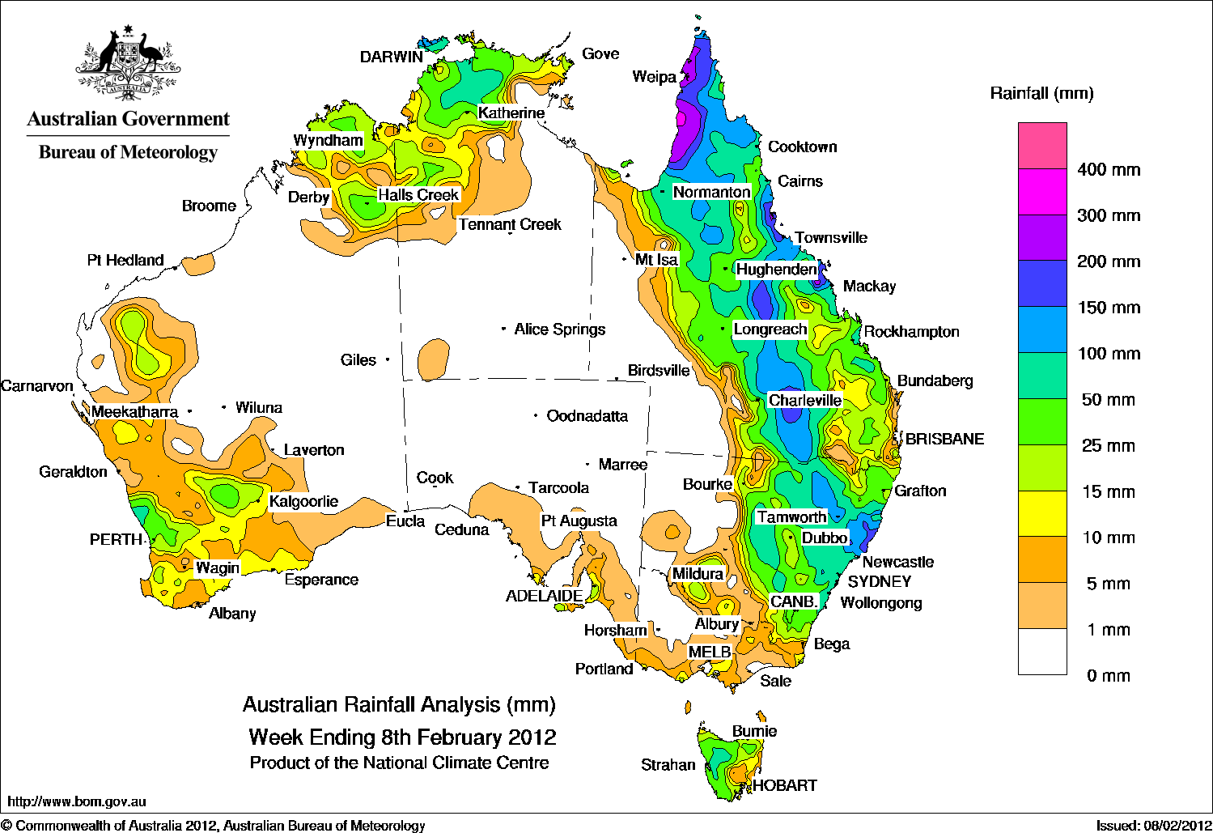

### Temperature anomalies this week

Spatial temperature analyses are based on historical weekly temperature data provided by the Bureau of Meteorology. These temperature anomaly maps show the departure of the maximum and minimum from the long-term average. Temperature anomalies are calculated using high resolution gridded datasets from 1911 onwards. For further information on temperature anomalies, go to [www.bom.gov.au/jsp/awap/](http://www.bom.gov.au/jsp/awap/).

#### Maximum temperature anomalies for the week ending 7 February 2012

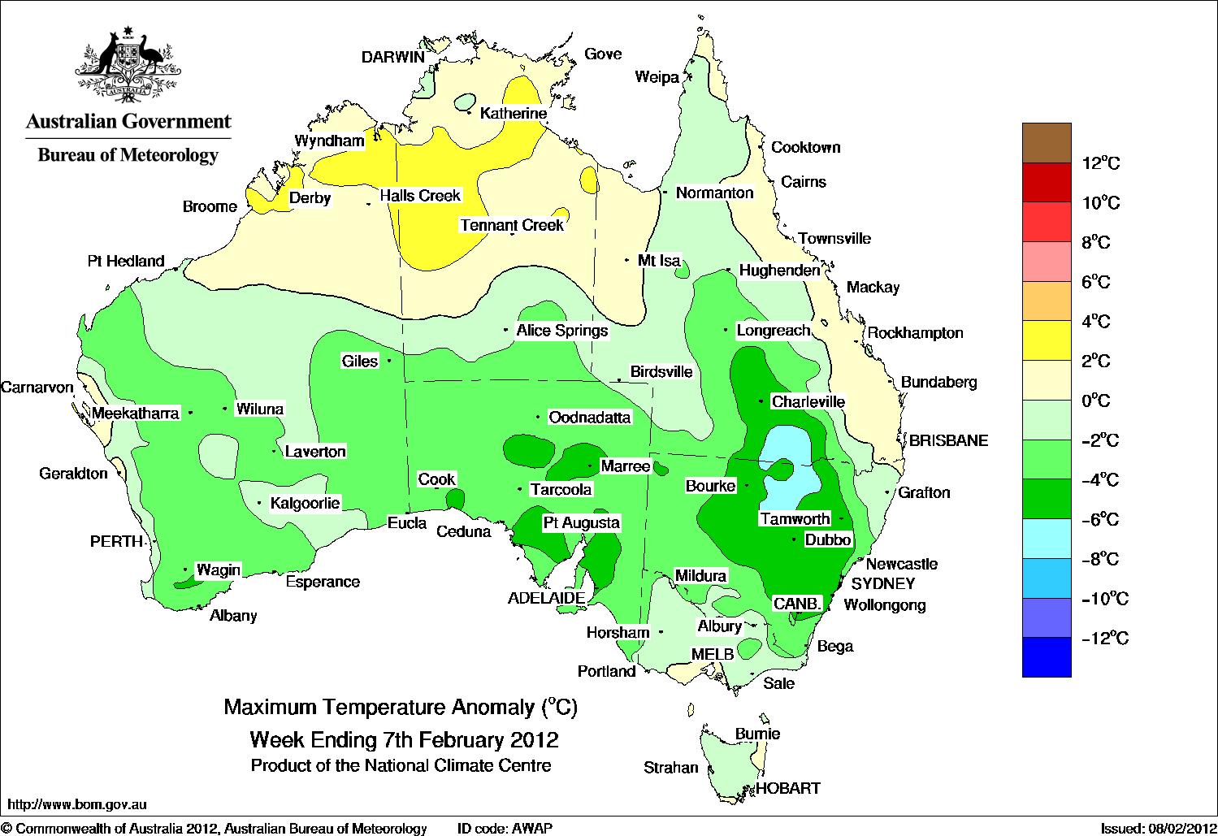

#### Minimum temperature anomalies for the week ending 7 February 2012

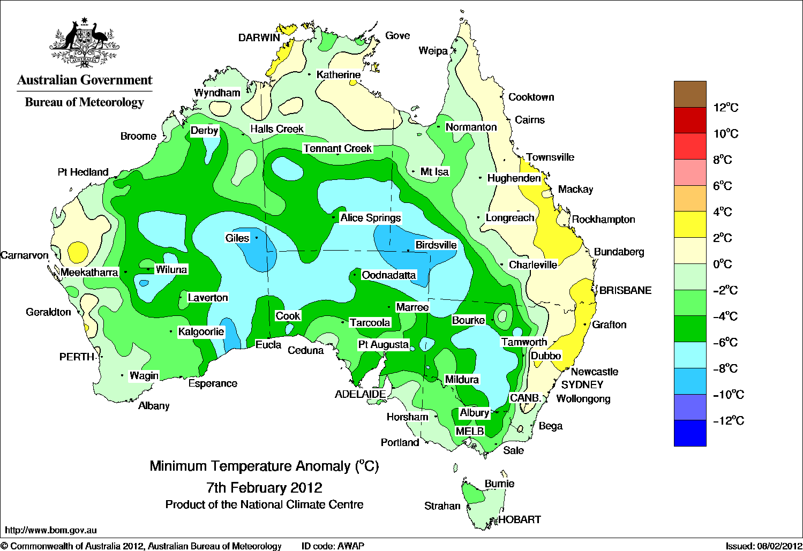

### January 2012 rainfall

#### Rainfall percentiles for January 2012

|  |  |
| --- | --- |
| Map showing rainfall percentiles for January 2012. Data provided by the Bureau of Meteorology. | K:\ec\reference_data\legend_images\rainfall_percentiles_legend_WEEKLY.PNG |
|  |  |

### January 2012 relative soil moisture

The maps show the relative levels of modelled upper (0 to ~0.2 metres) soil moisture and lower (~0.2 to ~1.5 metres) soil moisture at the end of January 2012. These maps show soil moisture estimates relative to the long-term average with respect to the reference period 1961 to 1990.

#### Upper layer soil moisture

|  |  |
| --- | --- |
| Map showing upper layer soil moisture January 2012 | K:\ec\reference_data\legend_images\soil_moisture_legend_WEEKLY.PNG |

The bulk of plant roots occur in the top 0.3 metres of the soil profile and soil moisture in the upper layer of the soil profile (0.2 metres) is the most appropriate indication of the availability of water, particularly for germinating plants. The lower layer soil moisture is a larger, deeper store that is slower to respond to rainfall and tends to reflect accumulated events over seasonal and longer time scales.

#### Lower layer soil moisture

|  |  |
| --- | --- |
| Map showing lower layer soil moisture January 2012 | K:\ec\reference_data\legend_images\soil_moisture_legend_WEEKLY.PNG |

### Rainfall outlook

The rainfall forecast below is produced from computer models. As it contains no input from weather forecasters, it is important to also check local forecasts and warnings by the Bureau of Meteorology.

#### Total forecast rainfall for the period 9 to 16 February 2012

## Map showing total forecast rainfall for the period 9 to 16 February 2012. Most rainfall is expected along the south-east coast. Image provided by the Bureau of Meteorology.

## **Water**

### Water availability

* Water storage levels in the Murray–Darling Basin increased this week by 72 gigalitres (GL) to approximately 83 per cent of total capacity. This is 2 percentage points or 452 GL more than this time last year.

### Water storages

#### Water storages in the Murray–Darling Basin (NSW, Victoria and Queensland)

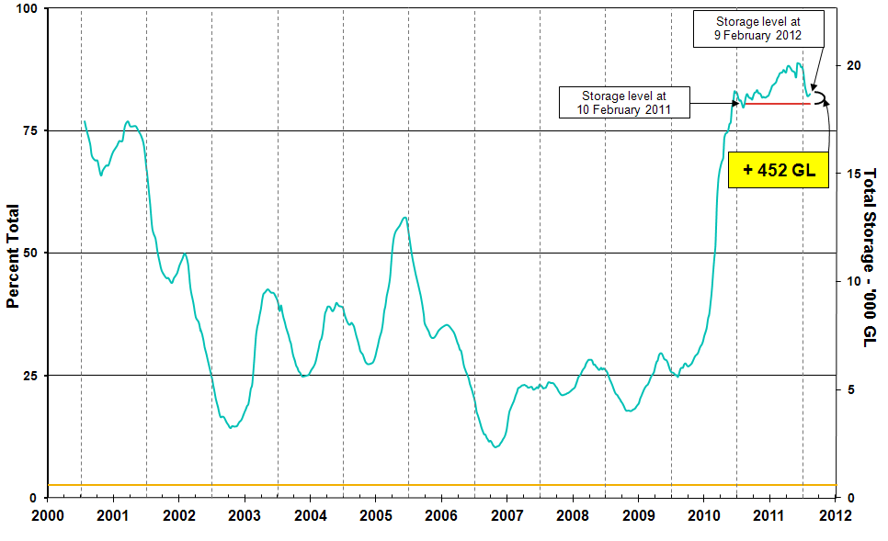

Information on irrigation water available in the Murray–Darling Basin from 1 January 2001 to 9 February 2012 is shown above. The top horizontal (red) line indicates the storage level at the similar time last year. The bottom horizontal (orange) line indicates the amount of ‘dead’ or unusable storage.

### Commodities

### Production and commodities

* The world wheat indicator price (US hard red winter, free on board Gulf ports) averaged US$306 a tonne in the week ending 7 February 2012, compared with US$300 a tonne in the previous week.
* The world coarse grains indicator price (US no. 2 yellow corn, free on board Gulf ports) averaged US$281 a tonne in the week ending 8 February 2012, similar to the previous week.
* The world cotton indicator price (Cotlook ‘A’ index) averaged US102.8 cents a pound in the week ending 8 February 2012, compared with US101.4 cents a pound in the previous week.
* The Australian canola indicator price (Portland, Victoria) averaged $481 a tonne in the week ending 6 February 2012, compared with $493 a tonne in the previous week.
* The world canola indicator price (rapeseed, Europe, cif Hamburg) averaged US$613 a tonne in the week ending 2 February 2012, compared with US$614 a tonne in the previous week.
* The world sugar indicator price (Intercontinental Exchange, nearby futures, no. 11 contract) declined by 1 per cent to average US23.5 cents a pound in the week ending 8 February 2012. The Indian government announced on 8 February that it has approved a further one million tonnes of raw sugar exports in 2011-12, in addition to the one million tonnes approved in November 2011.
* Bean and cauliflower prices at wholesale were higher in the week ending 4 February 2012, but prices of broccoli, lettuce and tomato were lower.
* Avocado, cherry, banana, orange and rockmelon at wholesale were higher in the week ending 4 February 2012, but apple and pineapple prices were lower.
* The Eastern Market Indicator price for wool remained largely unchanged in the week ending 2 February 2012, at 1193 cents a kilogram clean. Bales offered for sale were down 16.5 per cent.
* Saleyard lamb prices declined in all states in the week ending 3 February 2012, except Western Australia where prices remained largely unchanged. As a result of a significant increase in yardings, the Victorian indicator price fell 4 per cent to 493 cents a kilogram, while prices in South Australia declined by 2 per cent to 485 cents a kilogram.
* Australian beef exports in January 2012 totalled 47 000 tonnes, 14 per cent higher than the same month last year. Shipments to the United States were double compared with January 2011, while shipments to Taiwan and the ASEAN nations (excluding Indonesia) were also higher. Exports to the Republic of Korea were lower than the same month last year.

### Recent movements in fruit and vegetable prices

**Weekly wholesale prices for selected fruit, Melbourne market**

Line graph showing weekly wholesale prices for banana (cavendish), cherry (all varieties), pineapple (smoothleaf) and rockmelon, Melbourne marketLine graph showing weekly wholesale prices for orange (navel), apple (royal gala), peach (white) and avacado (hass), Melbourne market

**Weekly wholesale prices for selected vegetables, Melbourne market**

Line graph showing weekly wholesale prices for onion (brown), cauliflower, potato (white, washed) and tomato (field gourmet), Melbourne marketLine graph showing weekly wholesale prices for broccoli, pumpkin (grey), lettuce (iceberg) and bean (round, stringless), Melbourne market

### Selected world indicator prices

**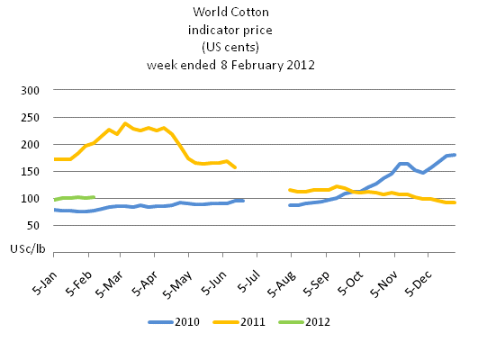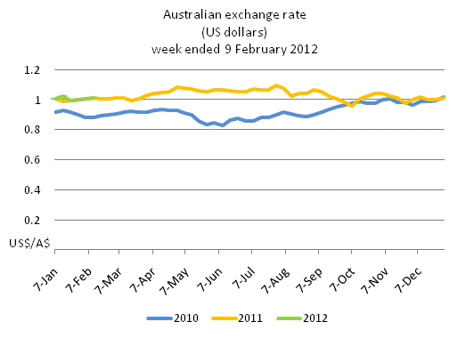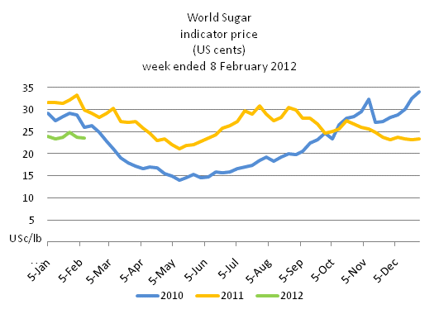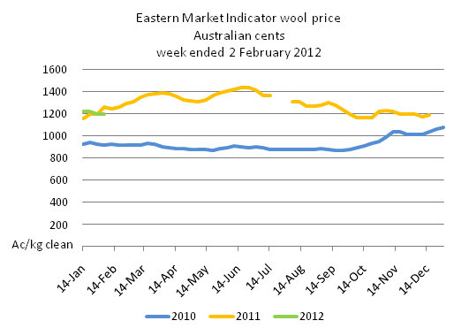**

### Crop indicator prices

Line graph showing the difference in trading prices for canola since 2010. The price at 6 February 2012 was $481 per tonne.
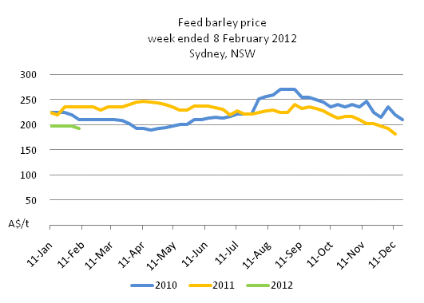

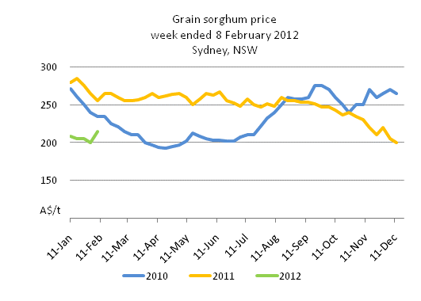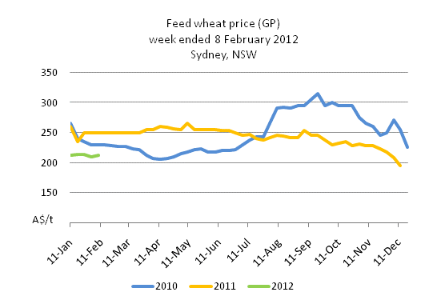

### Livestock indicator prices

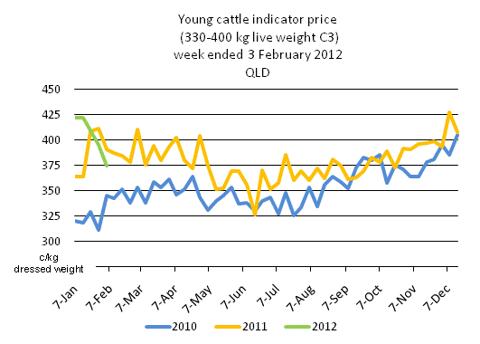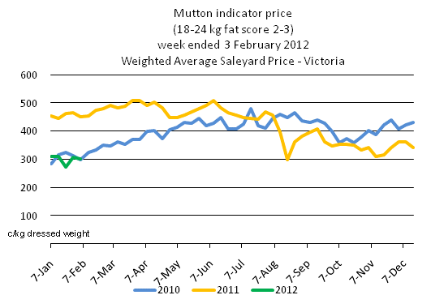

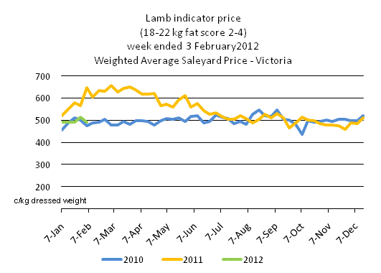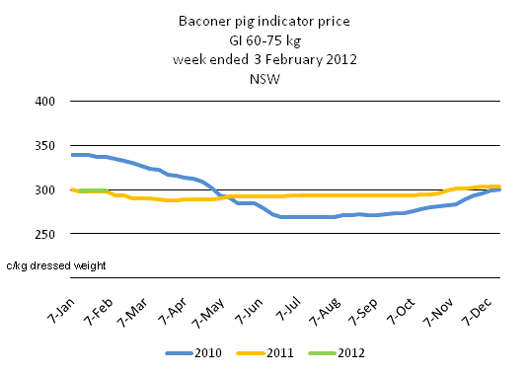

### The floods in northern New South Wales and southern Queensland

### Extent of the floods

* Flooding generally affects low-lying areas and comprises a small proportion of the total land area, which means the effects of flooding on agricultural production tend to be localised.
* Widespread heavy rainfall during early 2012, following heavy rainfall in late 2011, resulted in flooding in parts of northern New South Wales and southern Queensland.
* The Central-North and North-West regions of New South Wales and the South West region in Queensland have experienced the most severe flooding.
* At 9.00pm Tuesday 7 February, the height of the Balonne River at St George was 13.92 metres and rising slowly. The river reached 14 metres by 9pm Wednesday 8 February. By 9.00am Thursday 9 February the river was at 13.74 metres and falling.
* At 2.30pm Tuesday 7 February, the height of the Warrego River at Charleville was 6.16 metres and falling. Flooding is easing upstream of Charleville. By 8.30am Thursday 8 February it had fallen to 4.38 metres, which is classified as minor flooding at this station.
* Areas around Wee Waa, Mungindi, Collarenebri, Lightning Ridge, Walgett and Goodooga are still isolated and some areas may remain so for a number of weeks.
* Some crops are likely to have been affected by floodwater for up to a week, with the extent of damage still being assessed.
* The most damage to crops is likely to be in western areas, where floodwaters from various smaller rivers that flow roughly from north-east to south-west have converged and will likely result in a longer period of inundation.

**MODIS satellite image showing flood extent at 6 February 2012**

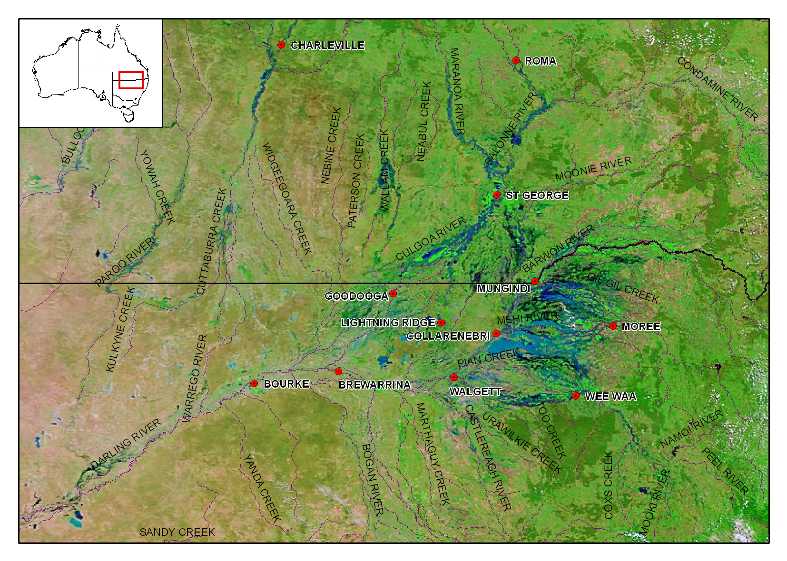Source: NASA/GSFC, MODIS Rapid

### Commodities produced in flood affected areas and possible damage

### Grain sorghum

* The recent flooding events have affected a significant proportion of the total grain sorghum cropping areas in northern New South Wales and south-central Queensland. While it is estimated that around 75 000 ha of grain sorghum has been planted in the Moree region; 15 000 ha around Narrabri; and 60 000 ha around Gunnedah, the area of grain sorghum crops directly affected by flood water will be smaller because the effects of flooding tend to be localised.
* It is still too early to tell what effect the floods will have on grain sorghum crops but the effect on total production is not expected to be substantial.
* In the floods last season, producers were generally surprised by how well grain sorghum recovered once the water receded.
* The damage this year will depend on crop maturity and the length of time it takes for the flood waters to recede. There is a significant variation in crop maturity ranging from just emerged to nearing harvest.

### Cotton

* Some cotton growing regions, particularly the Gwydir, Namoi, Mungindi and Walgett Valleys in Northern New South Wales and the Mungindi, Dirranbandi and St George Valleys in southern Queensland have been affected by flooding. While it is estimated that around 48 per cent of the total area planted to cotton is in regions affected by floods, the area of cotton crops directly affected by flood water will be smaller because the effects of flooding tend to be localised.
* The full extent of any damage to cotton crops in flood affected regions will not be clear until the water recedes, with the actual damage dependent on the level of inundation and the growth stage of the plants. However, the effect on total production is not expected to be substantial.
* The St George region is protected by a large flood levee and the extreme flood peaks at around this time in 2010 and 2011 caused only minor damage to cotton crops in the St George and Dirranbandi regions.

### Sugar

* Flooding in sugar producing regions from recent heavy rain has been confined to the northern New South Wales region that accounts for around 5 per cent of Australian sugar production. The 2011–12 cane harvest in this region was completed in December 2011. At this stage it is expected that the reduction to the 2012–13 New South Wales harvest will probably be less than 5 per cent provided there is no further heavy rainfall over the next week. This would represent a negligible impact on the Australian harvest.

### Livestock

* While there have been some reports of localised stock losses, overall losses are not expected to be significant.
* According to the Queensland Department of Employment, Economic Development and Innovation (DEEDI), some cattle producers in the Mitchell region of southern Queensland called in helicopters to round up stock before the worst of the floods eventuated.

### Summer crops outside flooded areas and winter crops

* In areas not inundated by flood water, summer crop yields are expected to be above average, reflecting full moisture profiles of the subsoil as a result of the average to well above average rainfall across the major summer cropping regions.
* The recent heavy rainfall will also recharge surface and groundwater storages in the upper Murray–Darling Basin.
* Harvesting of winter crops is now virtually complete and there is not expected to be any impact on winter crop production for the current harvest and there will be a positive effect for the forthcoming growing period.

### Data attribution

### Climate

**Bureau of Meteorology**

* Weekly rainfall totals: [www.bom.gov.au/jsp/awap/rain/index.jsp](http://www.bom.gov.au/jsp/awap/rain/index.jsp)
* Monthly and last 3-months rainfall percentiles: [www.bom.gov.au/jsp/awap/](http://www.bom.gov.au/jsp/awap/)
* Temperature anomalies: [www.bom.gov.au/jsp/awap/](http://www.bom.gov.au/jsp/awap/)
* Rainfall forecast: [www.bom.gov.au/jsp/watl/rainfall/pme.jsp](http://www.bom.gov.au/jsp/watl/rainfall/pme.jsp)
* Seasonal outlook: [www.bom.gov.au/climate/ahead](http://www.bom.gov.au/climate/ahead)
* Drought statement: [www.bom.gov.au/climate/drought/drought.shtml](http://www.bom.gov.au/climate/drought/drought.shtml)
* ENSO Wrap-Up: [www.bom.gov.au/climate/enso/](http://www.bom.gov.au/climate/enso/)
* Soil moisture (BoM, CSIRO and the former Bureau of Rural Sciences): [www.eoc.csiro.au/awap/](http://www.eoc.csiro.au/awap/)

### Water

**New South Wales**

* New South Wales Water Information: <http://waterinfo.nsw.gov.au/>
* New South Wales Office of Water, Department of Environment, Climate Change and Water: [www.water.nsw.gov.au/Home/default.aspx](http://www.water.nsw.gov.au/Home/default.aspx)
* Available water determinations register: [www.wix.nsw.gov.au/wma/DeterminationSearch.jsp?selectedRegister=Determination](http://www.wix.nsw.gov.au/wma/DeterminationSearch.jsp?selectedRegister=Determination)
* Snowy Hydro: [www.snowyhydro.com.au/lakeLevels.asp?pageID=47&parentID=61&grandParentID=4](http://www.snowyhydro.com.au/lakeLevels.asp?pageID=47&parentID=61&grandParentID=4)

**Queensland**

* Sunwater: [www.sunwater.com.au](http://www.sunwater.com.au)
* seqwater: <http://seqwater.com.au>

**South Australia**

* SA Water: [www.sawater.com.au/SAWater/Environment/TheRiverMurray/River+Murray+Levels.htm](http://www.sawater.com.au/SAWater/Environment/TheRiverMurray/River+Murray+Levels.htm)
* South Australian Department of Water: [www.waterforgood.sa.gov.au/](http://www.waterforgood.sa.gov.au/)

**Victoria**

* Goulburn–Murray Water: [www.g-mwater.com.au](http://www.g-mwater.com.au)

**Water trading**

* Waterexchange: [www.waterexchange.com.au](http://www.waterexchange.com.au)

### Commodities

**Fruit and vegetables**

* Datafresh: [www.datafresh.com.au](http://www.datafresh.com.au)

**Mutton, lambs, wheat, barley and grain sorghum**

* The Land: hardcopy or online at <http://theland.farmonline.com.au/markets.aspx>

**Cattle, mutton, lambs and pigs**

* Meat and Livestock Australia: [www.mla.com.au/Prices-and-markets](http://www.mla.com.au/Prices-and-markets)

**Canola**

* Weekly Times: hardcopy