25 October 2012
The full report is available from www.daff.gov.au/abares

Summary of key issues
- The Bureau of Meteorology predicts a warmer summer with average to above-average rainfall across most of Australia. An El Niño event this summer is unlikely.
- Lightning strikes have ignited hundreds of fires in central Australia, northern Queensland and far west New South Wales, burning thousands of hectares of grazing land.
- Water storage levels in the Murray–Darling Basin decreased by 144 gigalitres this week and are at 97 per cent of total capacity.
- The world wheat indicator price (US No. 2 hard red winter, free on board Gulf ports) averaged US$377 a tonne in the week ending 23 October 2012, compared with US$373 a tonne in the previous week.
- The world coarse grains indicator price (US No. 2 yellow corn, free on board Gulf ports) averaged US$325 a tonne in the week ending 24 October 2012, compared with US$321 a tonne in the previous week.
- Vegetable wholesale prices were generally lower in the week ending 20 October 2012. Fruit prices were mostly steady or lower, apart from small increases for banana and pineapple.
- The Australian Eastern Market Indicator price for wool rose by 4 per cent in the week ending 18 October 2012 to 1014 cents a kilogram clean.

Climate

Notable events
- El Niño Southern Oscillation (ENSO) indicators are showing neutral values, suggesting the El Niño event that was predicted for this summer may not occur (Bureau of Meteorology ‘ENSO Wrap-Up’ 23 October 2012). In the absence of an El Niño event, the Bureau of Meteorology predicts a warmer summer with average to above-average rainfall across most of Australia.
- Lightning strikes have ignited hundreds of fires in central Australia, northern Queensland and far west New South Wales, burning thousands of hectares of grazing land and causing damage to cattle yards and other infrastructure. Graziers are assessing stock and pastures losses; the full extent is not yet known.
- The record-breaking run of high temperatures in central Australia came to an end yesterday (24 October 2012) with the arrival of a cool change. This is expected to assist fire-fighting efforts in the region.
- GrainCorp reported a positive start to the harvest in Queensland and northern NSW on 23 October 2012, where hot conditions have advanced ripening. Early deliveries of wheat and canola are of good quality.
- Patchy, light rain has fallen in Western Australia’s agricultural regions in the past week, bringing temporary relief from hot spring temperatures and a slight reduction to bushfire risk.

Rainfall this week
For the week ending 24 October 2012, light, patchy rain was scattered across the continent. Medium to heavy falls were recorded in the far north with more than 200 mm falling on the tip of Cape York. Moderate falls were recorded in Tasmania and south-west Western Australia. The highest measured rainfall total for the week was 118.6 millimetres at Horn Island in the Torres Strait. For further information, go to www.bom.gov.au/climate/current/weeklyrain.shtml.

Rainfall for the week ending 24 October 2012
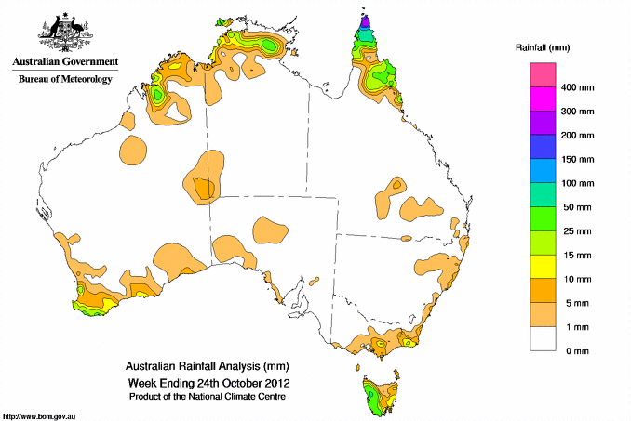
©Commonwealth of Australia 2012, Australia Bureau of Meteorology Issued: 24/10/2012

Temperature anomalies this week
Spatial temperature analyses are based on historical weekly temperature data provided by the Bureau of Meteorology. These temperature anomaly maps show the departure of the maximum and minimum from the long-term average. Temperature anomalies are calculated using high resolution gridded datasets from 1911 onwards. For further information on temperature anomalies, go to www.bom.gov.au/jsp/awap/.

Maximum temperature anomalies for the week ending 23 October 2012
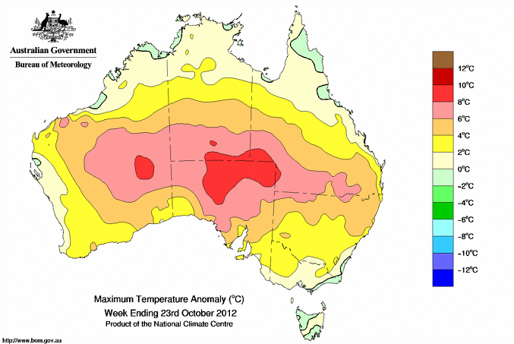
©Commonwealth of Australia 2012, Australia Bureau of Meteorology Issued: 24/10/2012

Minimum temperature anomalies for the week ending 23 October 2012
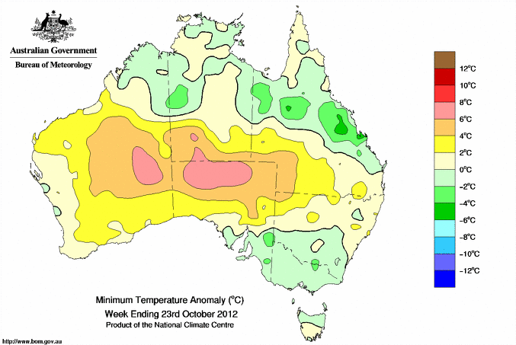
©Commonwealth of Australia 2012, Australia Bureau of Meteorology Issued: 24/10/2012

Rainfall outlook
The rainfall forecast below is produced from computer models. As it contains no input from weather forecasters, it is important to also check local forecasts and warnings by the Bureau of Meteorology.

Total forecast rainfall for the period 25 October to 1 November 2012
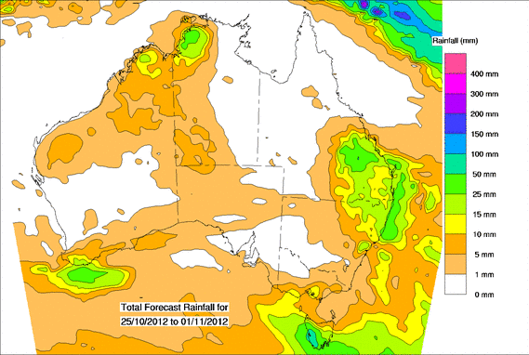
©Commonwealth of Australia 2012, Australia Bureau of Meteorology Issued: 24/10/2012

Seasonal outlook
Chance of exceeding the median rainfall
November 2012 to January 2013
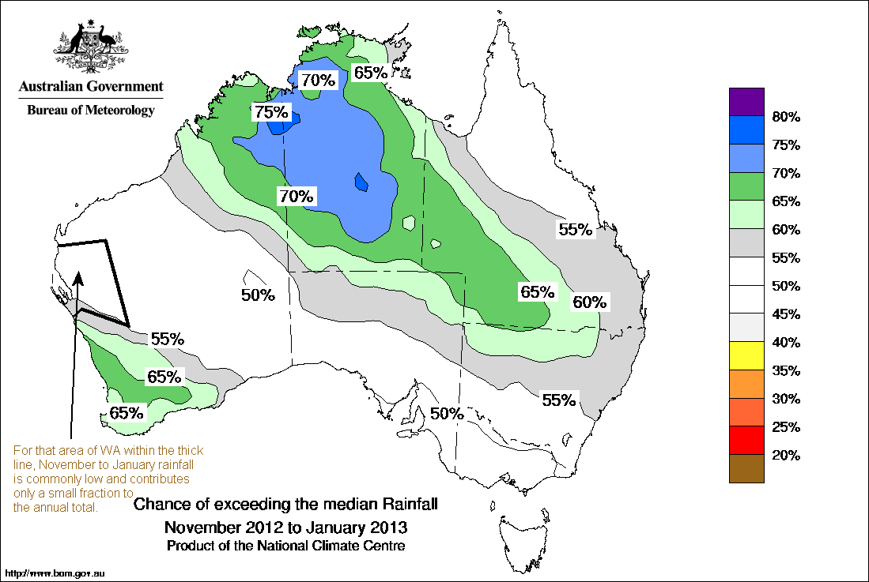©Commonwealth of Australia 2012, Australia Bureau of Meteorology Issued: 24/10/2012
Chance of exceeding the median maximum temperature
November 2012 to January 2013
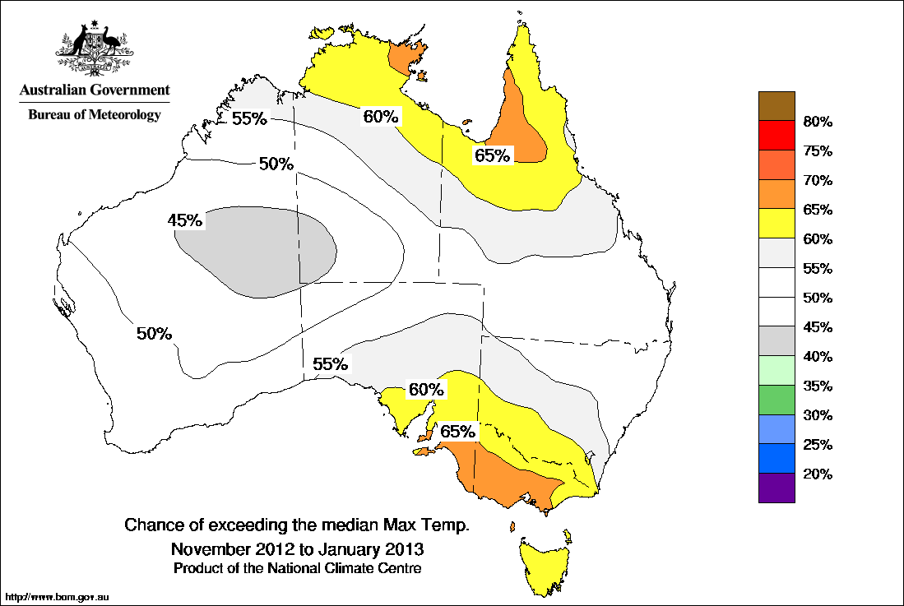©Commonwealth of Australia 2012, Australia Bureau of Meteorology Issued: 24/10/2012

Chance of exceeding the median minimum temperature
November 2012 to January 2013
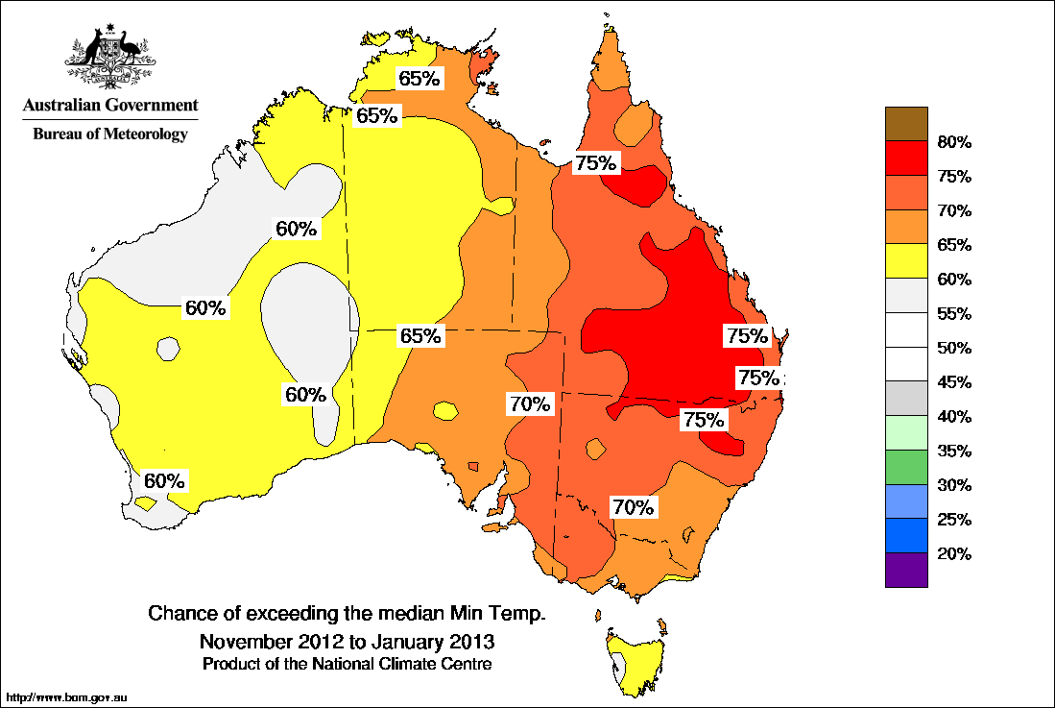©Commonwealth of Australia 2012, Australia Bureau of Meteorology Issued: 24/10/2012

Water

Water availability
Water storage levels in the Murray–Darling Basin (MDB) decreased this week by 144 gigalitres (GL) and are at 97 per cent of total capacity. This is 9 percentage points, or 2047 GL, more than this time last year.

Water storages

Water storages in the Murray–Darling Basin (NSW, Victoria and Queensland)
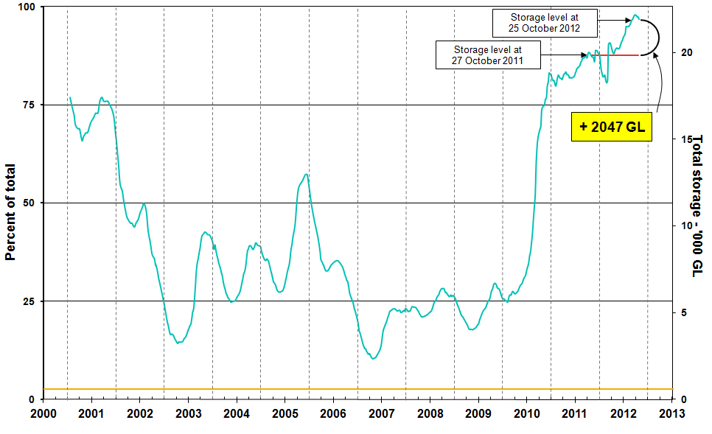
Information on irrigation water available in the Murray–Darling Basin from 1 January 2001 to 25 October 2012 is shown above. The top horizontal (red) line indicates the storage level at the similar time last year. The bottom horizontal (orange) line indicates the amount of ‘dead’, or unusable, storage.

Water allocations
The current water allocations for the 2012–13 water trading season for licence holders in New South Wales, Victoria and South Australia water systems are summarised in the following table.

 | Allocations at 17 October 2012 (%) | Allocations at 24 October 2012 (%)
NSW Murray Valley
High security | 100 | 100
General security | 100* | 100*
NSW Murrumbidgee Valley
High security | 95 | 95
General security | 64* | 64*
NSW Lower Darling
High security | 100 | 100
General security | 100* | 100*
NSW Macquarie Valley
High security | 100 | 100
General security | 58* | 58*
NSW Hunter Valley
High security | 100 | 100
General security | 100 | 100
NSW Lachlan Valley
High security | 100 | 100
General security | 0* | 0*
NSW Lower Namoi
High security | 100 | 100
General security | 32* | 32*
NSW Upper Namoi
High security | 100 | 100
General security | 100* | 100*
NSW Gwydir Valley
High security | 100 | 100
General security | 150* | 150*
NSW Border Rivers
High security | 100 | 100
General security | 100 | 100
NSW Peel Valley
High security | 100 | 100
General security | 78* | 78*
Victoria Murray Valley
High reliability | 95 | 95
Low reliability | 0 | 0
Victoria Goulburn
High reliability | 100 | 100
Low reliability | 0 | 0

 | Allocations at 17 October 2012 (%) | Allocations at 24 October 2012 (%)
Victoria Campaspe
High reliability | 100 | 100
Low reliability | 68 | 68
Victoria Loddon
High reliability | 100 | 100
Low reliability | 0 | 0
Victoria Bullarook
High reliability | 100 | 100
Low reliability | 100 | 100
Victoria Broken
High reliability | 100 | 100
Low Reliability | 0 | 0
South Australia Murray Valley
High security | 100 | 100
*Carryover water may also be available.

Commodities

Production and commodities
- The world wheat indicator price (US No. 2 hard red winter, free on board Gulf ports) averaged US$377 a tonne in the week ending 23 October 2012, compared with US$373 a tonne in the previous week.
- The government of Ukraine announced that, through cooperation with exporters, wheat exports in
2012–13 could increase from 4 million tonnes to 5 million tonnes.
- The world coarse grains indicator price (US No. 2 yellow corn, free on board Gulf ports) averaged US$325 a tonne for the week ending 24 October 2012, compared with US$321 a tonne in the previous week.
- The world canola indicator price (Rapeseed, Europe, free on board Hamburg) averaged US$638 a tonne in the week ending 23 October 2012, compared with US$626 a tonne in the previous week.
- The world cotton indicator price (the Cotlook ‘A’ index) averaged US84.6 cents a pound in the week ending 24 October 2012, compared with US81.1 cents a pound in the previous week.
- The world sugar indicator price (Intercontinental Exchange, nearby futures, No. 11 contract) averaged US19.9 cents a pound in the week ending 24 October 2012, similar to the previous week.
- Wholesale prices of avocado (hass), rockmelon, strawberry and watermelon (seedless) were lower in the week ending 20 October 2012, but there were small price increases for banana (cavendish) and smoothleaf pineapple.
- Vegetable wholesale prices were generally lower in the week ending 20 October 2012, with the exception of cauliflower and green pea. Tomato wholesale prices are returning to more normal levels after a period of high prices due to unusually cool weather in key producing regions.
- The Queensland young cattle indicator price (300-400 kg live weight C3) rose by 1 per cent to 340 cents per kilogram in the week ending 19 October 2012, compared with the previous week. In other states, the young cattle indicator rose 4 per cent in South Australia to 334 cents per kilogram while declining in both New South Wales (down 2 per cent) and Victoria (1 per cent) to 364 cents and 356 cents, respectively.
- Saleyard lamb prices fell in all states in the week ending 19 October 2012. The largest decline was in Western Australian where the lamb indicator price (18-22kg fat score 2-4) fell by 11 per cent to 270 cents per kilogram. The fall largely reflects a 54 per cent increase in the number of lambs offered for sale over the previous week and continued weak buyer demand. In other states, the lamb indicator price declined by 4 per cent in both New South Wales and Victoria and by 1 per cent in South Australia.
- The Australian Eastern Market Indicator price for wool rose by 4 per cent in the week ending 18 October 2012 to 1014 cents a kilogram clean. The total number of bales offered at sale was 50 585 bales, 36 per cent higher than previous week and the second largest offering for the 2012–13 season to date.

Recent movements in fruit and vegetable prices
Weekly wholesale prices for selected fruit, Melbourne market
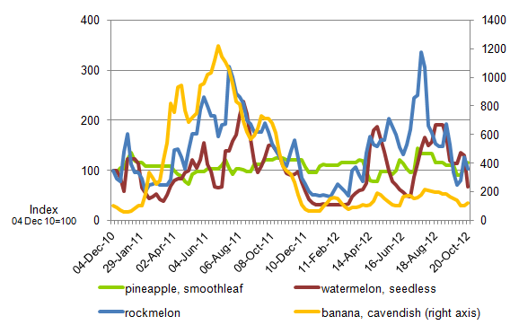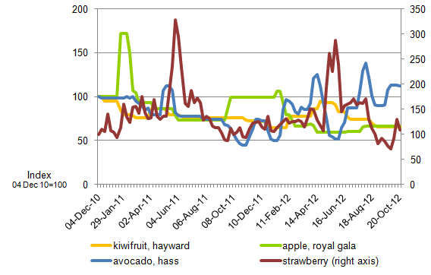
Weekly wholesale prices for selected vegetables, Melbourne market
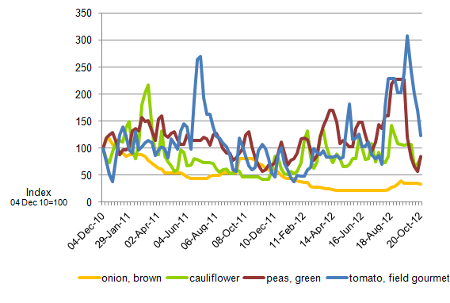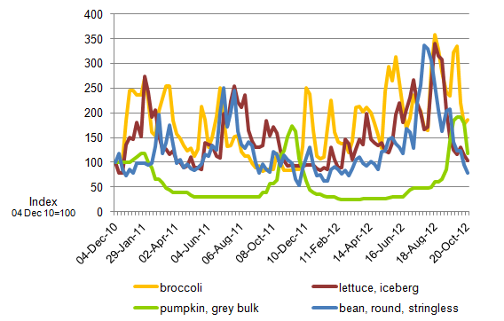

Selected world indicator prices
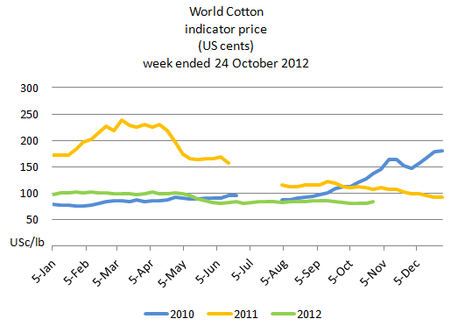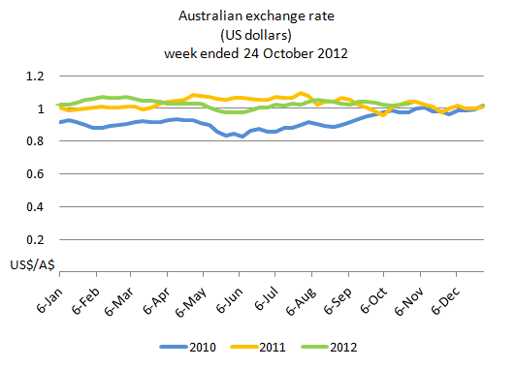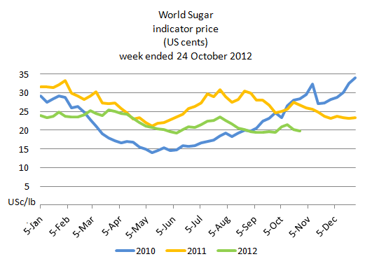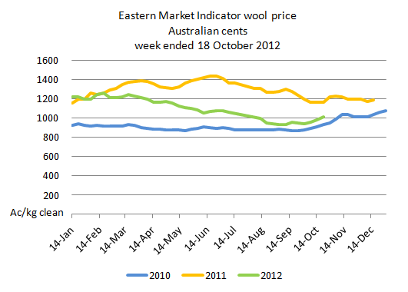

Crop indicator prices
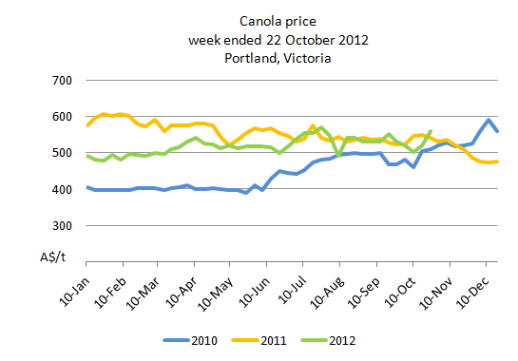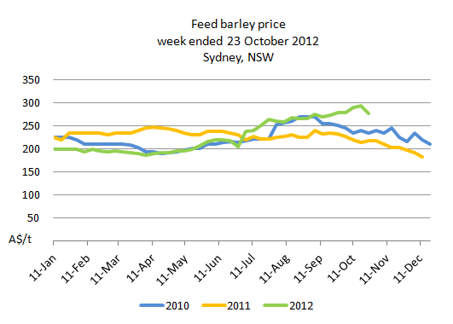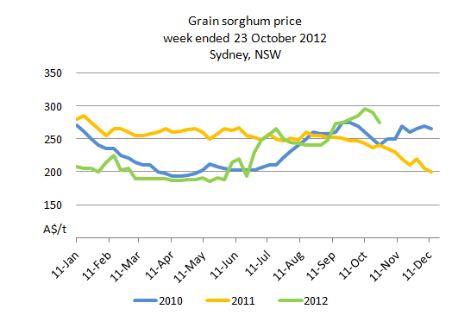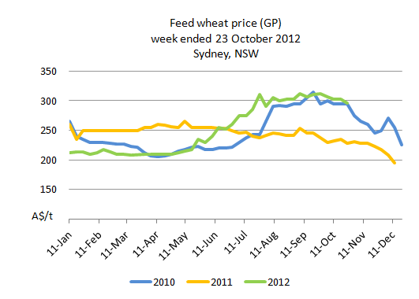

Livestock indicator prices
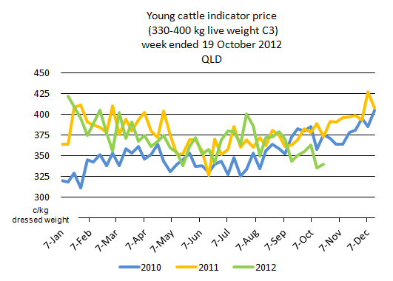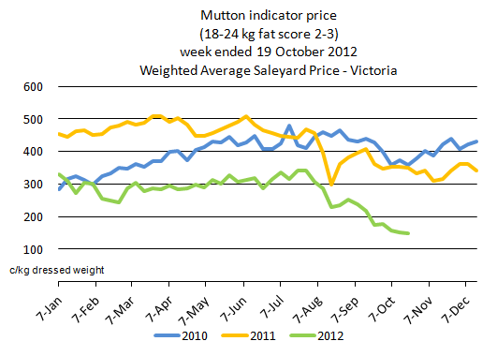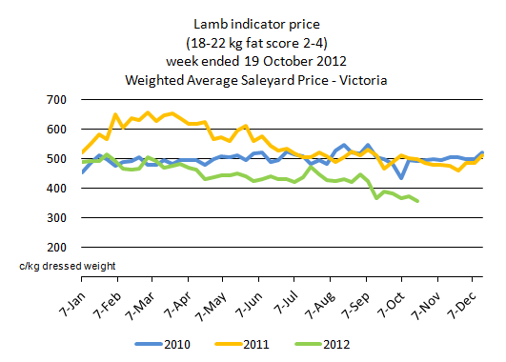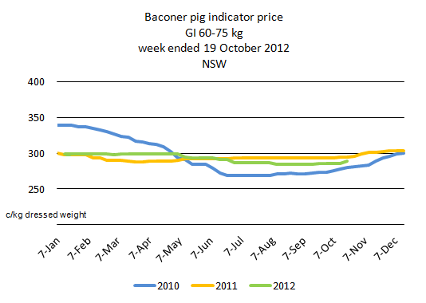

Data attribution

Climate
Bureau of Meteorology
- Weekly rainfall totals: www.bom.gov.au/jsp/awap/rain/index.jsp
- Monthly and last 3-months rainfall percentiles: www.bom.gov.au/jsp/awap/
- Temperature anomalies: www.bom.gov.au/jsp/awap/
- Rainfall forecast: www.bom.gov.au/jsp/watl/rainfall/pme.jsp
- Seasonal outlook: www.bom.gov.au/climate/ahead
- Drought statement: www.bom.gov.au/climate/drought/drought.shtml
- ENSO Wrap-Up: www.bom.gov.au/climate/enso/
- Soil moisture (BoM, CSIRO and the former Bureau of Rural Sciences): www.eoc.csiro.au/awap/

Water
New South Wales
- New South Wales Water Information: http://waterinfo.nsw.gov.au/
- New South Wales Office of Water, Department of Environment, Climate Change and Water: www.water.nsw.gov.au/Home/default.aspx
- Available water determinations register: www.wix.nsw.gov.au/wma/DeterminationSearch.jsp?selectedRegister=Determination
- Snowy Hydro: www.snowyhydro.com.au/lakeLevels.asp?pageID=47&parentID=61&grandParentID=4
Queensland
- Sunwater: www.sunwater.com.au
- seqwater: http://seqwater.com.au
South Australia
- SA Water: www.sawater.com.au/SAWater/Environment/TheRiverMurray/River+Murray+Levels.htm
- South Australian Department of Water: www.waterforgood.sa.gov.au/
Victoria
- Goulburn–Murray Water: www.g-mwater.com.au
Water trading
- Waterexchange: www.waterexchange.com.au

Commodities
Fruit and vegetables
- Datafresh: www.datafresh.com.au
Mutton, lambs, wheat, barley and grain sorghum
- The Land: hardcopy or online at http://theland.farmonline.com.au/markets.aspx
Cattle, mutton, lambs and pigs
- Meat and Livestock Australia: www.mla.com.au/Prices-and-markets
Canola
- Weekly Times: hardcopy

