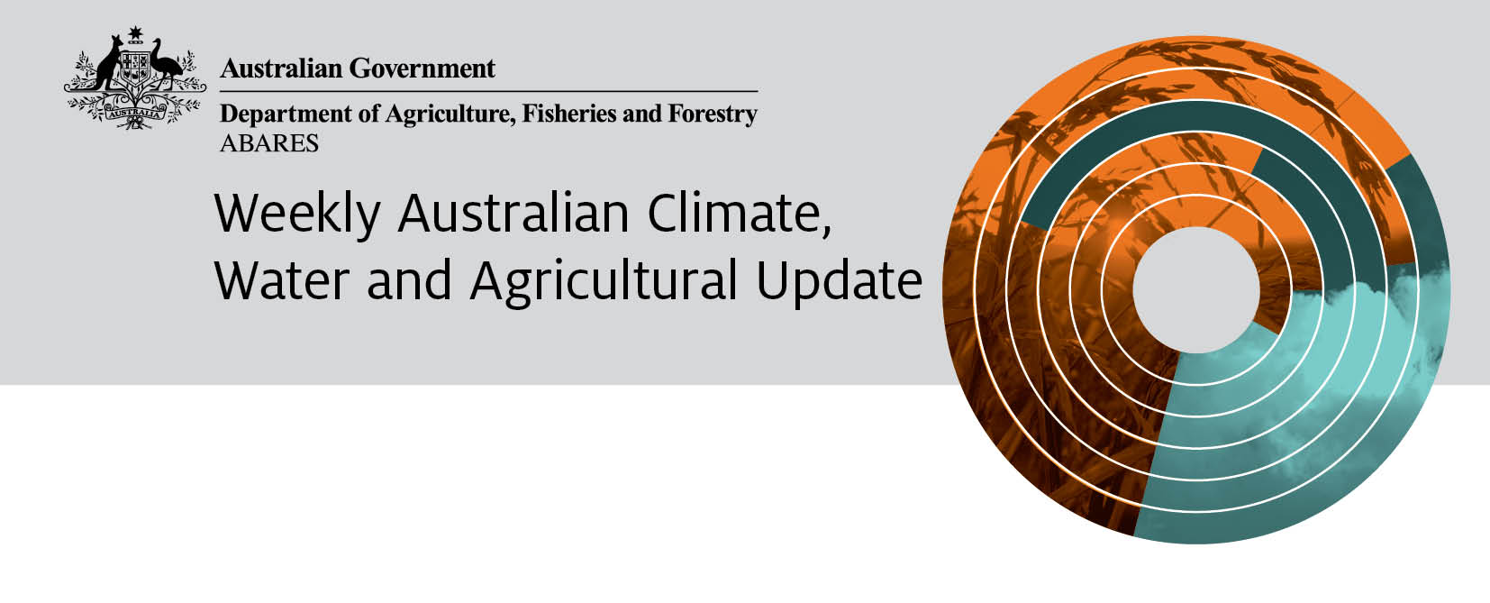
13 December 2012
The full report is available from www.daff.gov.au/abares

Summary of key issues
- A wet winter and hot, dry finish to the cherry growing season has reportedly provided one of the best crops in more than a decade.
- The harvest of winter crops in Western Australia is again experiencing delays with heavy falls recorded over much of the wheatbelt this week. However, harvest activities in eastern Australia have continued largely uninterrupted.
- Rabbit numbers are reportedly on the increase with plentiful feed and a growing resistance to virus controls assisting the population growth.
- Water storage levels in the Murray–Darling Basin have decreased by 382 gigalitres this week and are at 88 per cent of total capacity.
- The world wheat indicator price (US No. 2 hard red winter, free on board Gulf ports) averaged US$367 a tonne in the week ending 11 December 2012, compared with US$373 a tonne in the previous week.
- The world coarse grains indicator price (US No. 2 yellow corn, free on board Gulf ports) averaged US$321 a tonne for the week ending 11 December 2012, compared with US$328 a tonne in the previous week.
- The world canola indicator price (Rapeseed, Europe, free on board Hamburg) averaged US$630 a tonne in the week ending 11 December 2012, compared with US$624 a tonne in the previous week.
- Saleyard lamb prices rose in all states in the week ending 7 December 2012 with the largest increase being in Western Australia where the lamb indicator price (18-22kg fat score 2-4) rose 5 per cent to 272 cents a kilogram.
- The Australian Eastern Market Indicator (EMI) wool price rose by 5 per cent in the week ending 6 December 2012 to 1086 cents a kilogram clean.
- Australian beef and veal production was 756 000 tonnes during the first four months of 2012-13, about 4 per cent higher than the same period last year.
- Australian production of whole milk powder fell by 18 per cent in the first four months of 2012–13, compared with the same period last year.
- In contrast, butter production and skim milk powder production both increased by 8 per cent while cheese production rose by 5 per cent.

Climate

Notable events
- A wet winter and hot, dry finish to the cherry growing season has reportedly provided one of the best crops in more than a decade. Western NSW growers are reporting the best quality cherry crop in more than fifteen years, with recent hot and dry conditions leading to little or no fruit splitting and allowing picking to proceed without delay.
- The harvest of winter crops in Western Australia is again experiencing delays with heavy falls recorded over much of the wheatbelt this week. Drier conditions in Victoria, South Australia and much of New South Wales have seen harvest activities in eastern Australia continue largely uninterrupted.
- Rabbit numbers are on the increase with plentiful feed and a growing resistance to virus controls assisting the population growth. The Invasive Animals Co-operative Research Centre is reporting that rabbits now cover two-thirds of the country, threaten vulnerable plant species and are costing farmers around $200 million a year in terms of loss production and control measures. Producers are being advised to continue to use conventional control measures such as warren ripping until new virus control measures are released.

Rainfall this week
For the week ending 12 December 2012, rainfall was recorded in all states and territories. Moderate to heavy falls were recorded over much of Western Australia, the Top End, the New South Wales north coast, southern Queensland and Tasmania. The highest rainfall total for the week was 111 millimetres at Clarence Town, about 50 km north of Newcastle, New South Wales. For further information, go to www.bom.gov.au/climate/current/weeklyrain.shtml.

Rainfall for the week ending 12 December 2012
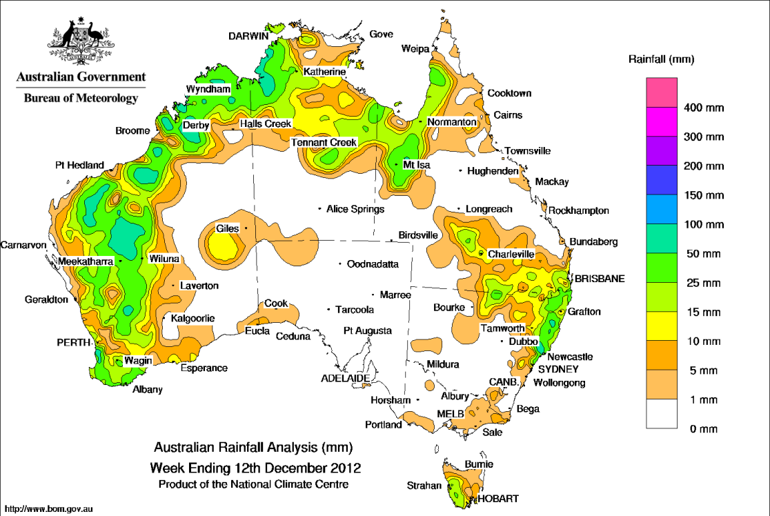
©Commonwealth of Australia 2012, Australia Bureau of Meteorology Issued: 12/12/2012

Temperature anomalies this week
Spatial temperature analyses are based on historical weekly temperature data provided by the Bureau of Meteorology. These temperature anomaly maps show the departure of the maximum and the minimum from their respective long-term average. Temperature anomalies are calculated using high resolution gridded datasets from 1911 onwards. For further information on temperature anomalies, go to www.bom.gov.au/jsp/awap/.

Maximum temperature anomalies for the week ending 11 December 2012
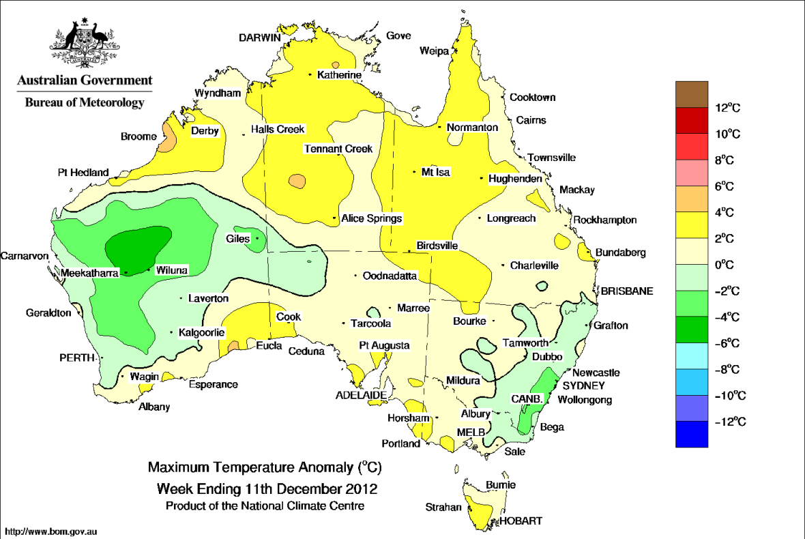
©Commonwealth of Australia 2012, Australia Bureau of Meteorology Issued: 12/12/2012

Minimum temperature anomalies for the week ending 11 December 2012
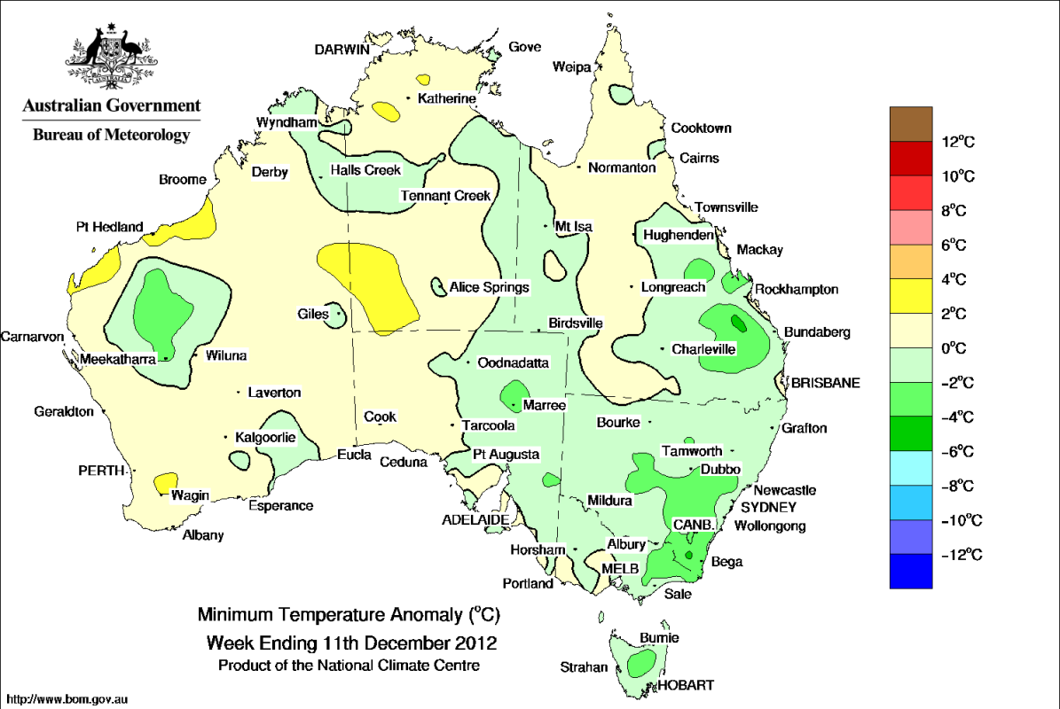
©Commonwealth of Australia 2012, Australia Bureau of Meteorology Issued: 12/12/2012

Rainfall outlook
The rainfall forecast below is produced from computer models. As it contains no input from weather forecasters, it is important to also check local forecasts and warnings by the Bureau of Meteorology.

Total forecast rainfall for the period 13 to 20 December 2012
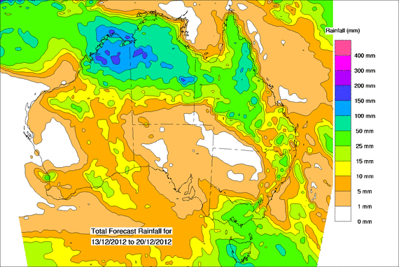©Commonwealth of Australia 2012, Australia Bureau of Meteorology Issued: 12/12/2012

Water

Water availability

Water storage levels in the Murray–Darling Basin (MDB) have decreased this week by 382 gigalitres (GL) and are at 88 per cent of total capacity. This is 1 percentage point or 112 GL less than this time last year.

Water storages

Water storages in the Murray–Darling Basin (NSW, Victoria and Queensland)

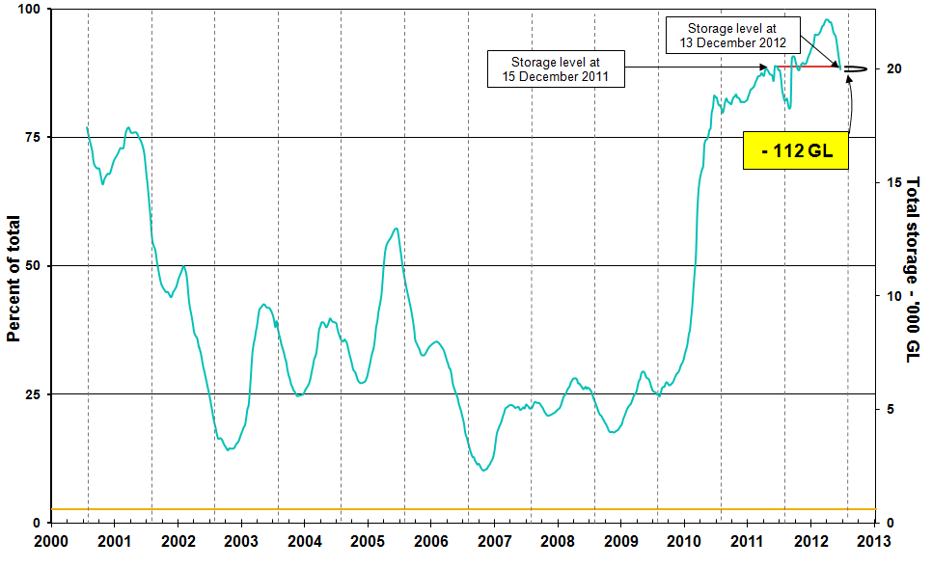
Information on irrigation water available in the Murray–Darling Basin from 1 January 2001 to 13 December 2012 is shown above. The top horizontal (red) line indicates the storage level at the similar time last year. The bottom horizontal (orange) line indicates the amount of ‘dead’ or unusable storage.

Commodities

Production and commodities
- The world wheat indicator price (US No. 2 hard red winter, free on board Gulf ports) averaged US$367 a tonne in the week ending 11 December 2012, compared with US$373 a tonne in the previous week.
- The world coarse grains indicator price (US No. 2 yellow corn, free on board Gulf ports) averaged US$321 a tonne for the week ending 11 December 2012, compared with US$328 a tonne in the previous week.
- The world canola indicator price (Rapeseed, Europe, free on board Hamburg) averaged US$630 a tonne in the week ending 11 December 2012, compared with US$624 a tonne in the previous week.
- The Australian canola indicator price (Portland, Victoria) averaged $546 a tonne in the week ending 10 December 2012, compared with $545 a tonne in the previous week.
- The world cotton indicator price (the Cotlook ‘A’ index) averaged US 82.6 cents a pound in the week ending 12 December 2012, largely unchanged from previous week.
- The world sugar indicator price (Intercontinental Exchange, nearby futures, No. 11 contract) averaged US18.9 cents a pound in the week ending 12 December 2012, the lowest since the week ended 11 August 2010 when it averaged US18.2 cents a pound.
- Data from the Brazil Sugar Industry Association indicates that sugar production in Brazil’s important Centre/South region reached 32.91 million tonnes in 2012-13 (April to October), around 6 per cent higher than the same period in 2011-12.
- The wholesale prices of fruit were generally lower or largely unchanged in the week ending 8 December 2012 with the prices of blueberry, strawberry and banana (cavendish) all falling, compared with the previous week. The prices of pineapple (smoothleaf), watermelon (seedless) kiwifruit (Hayward) and apple (royal gala) were largely unchanged.
- The wholesale prices of vegetables were generally lower in the week ending 8 December 2012 compared with the previous week. Prices of beans (round), cauliflower, tomato (field gourmet), broccoli and peas (green) were all lower while onions (brown) increased.
- The Queensland young cattle indicator price (330 – 400 kg live weight C3) fell by 5 per cent to 321 cents a kilogram in the week ending 7 December 2012.
- Australian beef and veal production was 756 000 tonnes during the first four months of 2012-13, 4 per cent higher than the same period last year.
- Saleyard lamb prices rose in all states in the week ending 7 December 2012. The largest increase was in Western Australia where the lamb indicator price (18-22kg fat score 2-4) rose 5 per cent to 272 cents a kilogram. In other states, the indicator price rose 4 per cent in South Australia to 341 cents a kilogram, 2 per cent in Victoria to 310 cents a kilogram and 1 per cent in New South Wales to 343 cents a kilogram.
- The Australian Eastern Market Indicator (EMI) wool price rose by 5 per cent in the week ending 6 December 2012 to 1086 cents a kilogram clean. The total number of bales offered at auction declined by 13 per cent compared with the previous sale week.
- Australian production of whole milk powder fell by 18 per cent in the first four months of 2012–13, compared with the same period last year.
- In contrast, production of butter and skim milk powder production both increased by 8 per cent while cheese production rose by 5 per cent.

Recent movements in fruit and vegetable prices
Weekly wholesale prices for selected fruit, Melbourne market
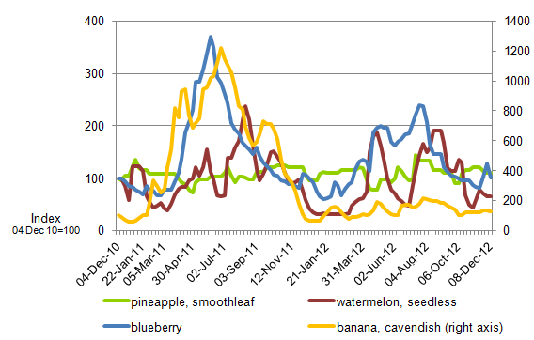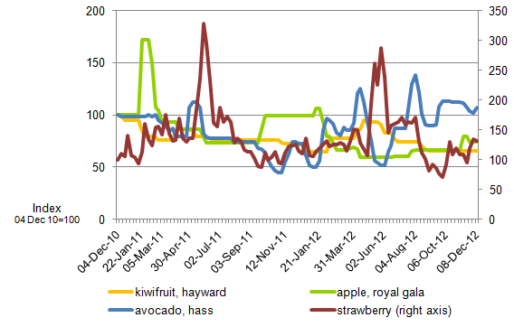
Weekly wholesale prices for selected vegetables, Melbourne market
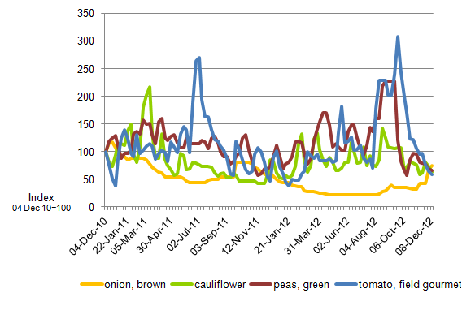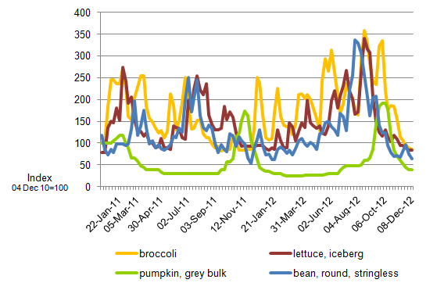

Selected world indicator prices
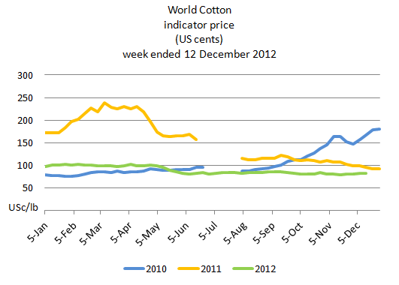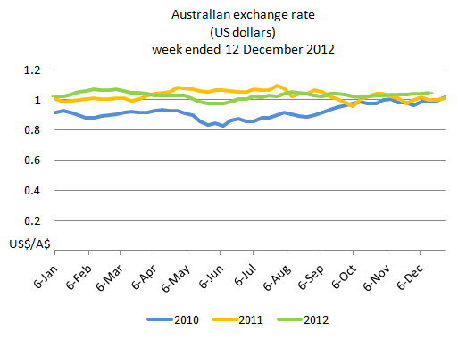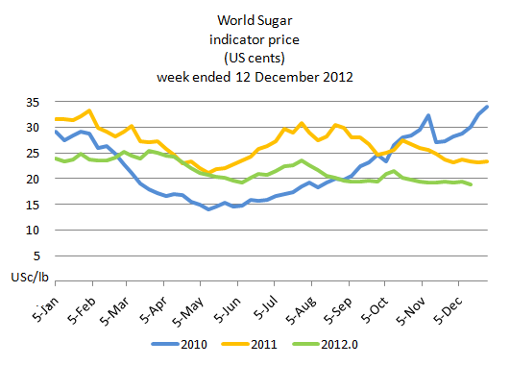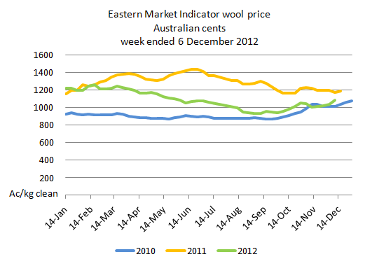

Crop indicator prices
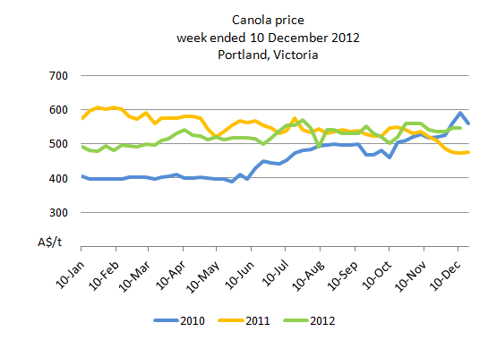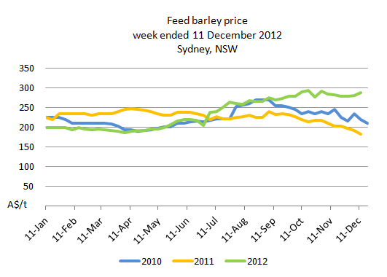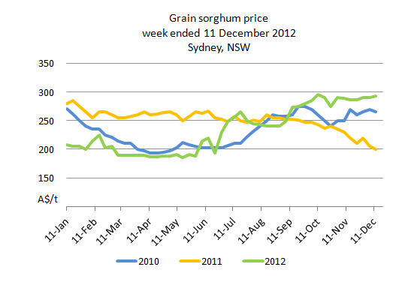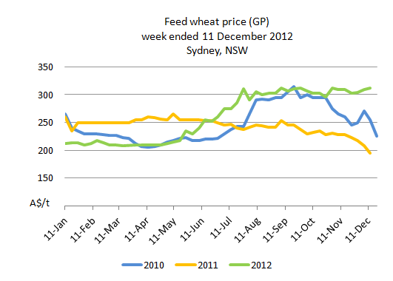

Livestock indicator prices
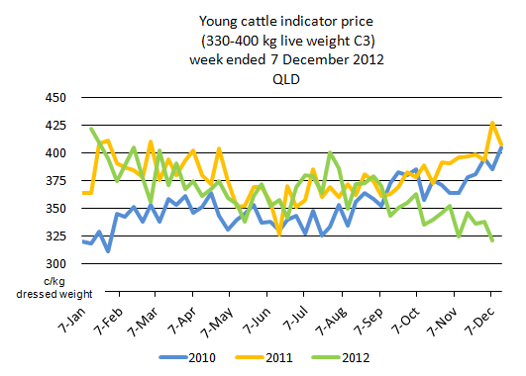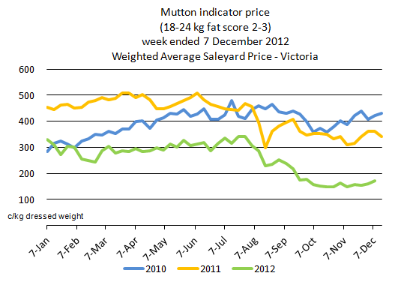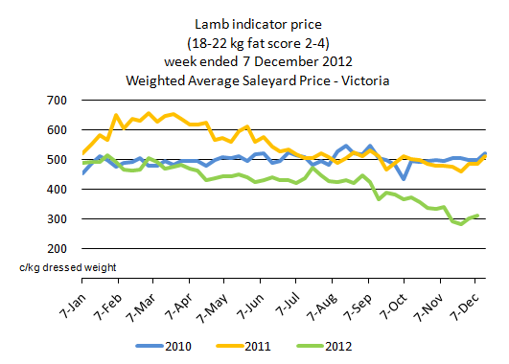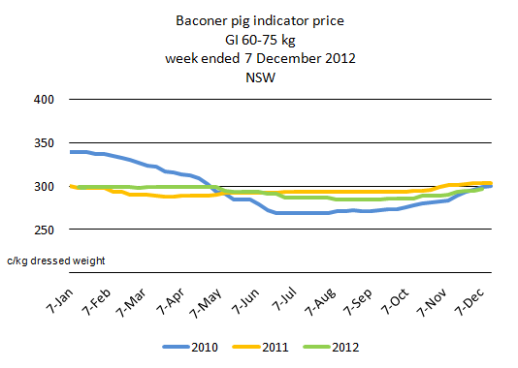

Global Dairy Trade (GDT) weighted average prices
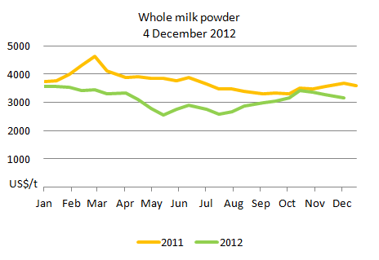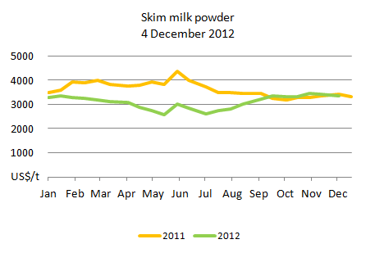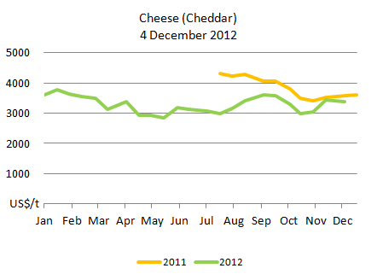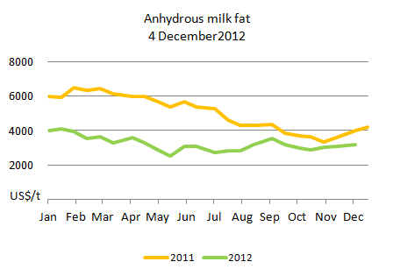

Data attribution

Climate
Bureau of Meteorology
- Weekly rainfall totals: www.bom.gov.au/jsp/awap/rain/index.jsp
- Monthly and last 3-months rainfall percentiles: www.bom.gov.au/jsp/awap/
- Temperature anomalies: www.bom.gov.au/jsp/awap/
- Rainfall forecast: www.bom.gov.au/jsp/watl/rainfall/pme.jsp
- Seasonal outlook: www.bom.gov.au/climate/ahead
- Drought statement: www.bom.gov.au/climate/drought/drought.shtml
- ENSO Wrap-Up: www.bom.gov.au/climate/enso/
- Soil moisture (BoM, CSIRO and the former Bureau of Rural Sciences): www.eoc.csiro.au/awap/

Water
New South Wales
- New South Wales Water Information: http://waterinfo.nsw.gov.au/
- New South Wales Office of Water, Department of Environment, Climate Change and Water: www.water.nsw.gov.au/Home/default.aspx
- Available water determinations register: www.wix.nsw.gov.au/wma/DeterminationSearch.jsp?selectedRegister=Determination
- Snowy Hydro: www.snowyhydro.com.au/lakeLevels.asp?pageID=47&parentID=61&grandParentID=4
Queensland
- Sunwater: www.sunwater.com.au
- seqwater: http://seqwater.com.au
South Australia
- SA Water: www.sawater.com.au/SAWater/Environment/TheRiverMurray/River+Murray+Levels.htm
- South Australian Department of Water: www.waterforgood.sa.gov.au/
Victoria
- Goulburn–Murray Water: www.g-mwater.com.au
Water trading
- Waterexchange: www.waterexchange.com.au

Commodities
Fruit and vegetables
- Datafresh: www.datafresh.com.au
Mutton, lambs, wheat, barley and grain sorghum
- The Land: hardcopy or online at http://theland.farmonline.com.au/markets.aspx
Cattle, mutton, lambs and pigs
- Meat and Livestock Australia: www.mla.com.au/Prices-and-markets
Canola
- Weekly Times: hardcopy
Dairy
- Global Dairy Trade: http://www.globaldairytrade.info/Results/HistoricalData.aspx

