23 August 2012
The full report is available from www.daff.gov.au/abares

Summary of key issues
- The Grains Research and Development Corporation is urging grain growers to check their wheat crops for stripe rust as current temperatures and high humidity can increase the risk of disease.
- South-west Western Australia is likely to receive more than the median rainfall for spring in combination with warmer temperatures. Rainfall throughout spring would help to alleviate soil moisture deficiencies and maintain the growth of crops and pastures in this region.
- Drier and warmer than normal conditions are more likely across most other parts of Australia between September and November 2012.
- The world canola indicator price (Rapeseed, Europe, free on board Hamburg) averaged US$641 a tonne in the week ending 21 August 2012, compared with US$639 a tonne in the previous week.
- Dry and hot conditions in the Black Sea region (Russian Federation, Ukraine and Kazakhstan) have adversely affected winter grain crops in Ukraine, and spring crops in Kazakhstan and the Russian Federation.
- Reports of early harvest results of the winter and spring crops from the agriculture ministries of the Russian Federation, Ukraine and Kazakhstan, indicate average grain yields for these crops are around 28 per cent, 25 per cent and 33 per cent lower, respectively, compared with the previous season. These Black Sea exporting countries typically comprise around one tenth of world coarse grains exports and around one quarter of world wheat exports.
- The world coarse grains indicator price (US no. 2 yellow corn, free on board Gulf ports) averaged US$335 a tonne for the week ending 22 Aug 2012, compared with US$328 a tonne in the previous week.
- The world wheat indicator price (US no. 2 hard red winter, free on board Gulf ports) averaged US$363 a tonne in the week ending 21 August 2012, compared with US$362 a tonne in the previous week.
- The Queensland trade steer indicator price (330-400 kg live weight C3) increased by 7 per cent to 372 cents a kilogram in the week ending 17 August 2012, 3 per cent higher than the same time last year.
- Saleyard lamb prices rose in the eastern states in the week ending 17 August 2012. The lamb indicator price (18-22kg fat score 2-3) rose 3 per cent in South Australia, 2 per cent in New South Wales and 1 per cent in Victoria.

Climate

Notable events
- The Grains Research and Development Corporation are urging grain growers to check their wheat crops for stripe rust following a recent case of disease found in Mace wheat in South Australia. Current temperatures and high humidity in Australia’s southern states can increase the risk of infection and spread among cereal crops.
- In the coming week up to 50 millimetres of rain is forecast for some areas of Australia’s south-east cropping zone. The forecast rainfall will help sustain the growth of winter crops and the establishment of spring pastures in these areas.
- South-west Western Australia is likely to receive more than the median rainfall from September to November 2012 in combination with warmer temperatures (Bureau of Meteorology National Seasonal Rainfall Outlook, 22 August 2012). If the outlook eventuates, rainfall throughout spring should help to alleviate soil moisture deficiencies and maintain the growth of crops and pastures in this region.
- Drier and warmer than normal conditions are more likely across most other parts of Australia between September and November 2012. Some areas of southern Queensland and northern New South Wales are likely to experience cooler overnight temperatures throughout spring (Bureau of Meteorology National Seasonal Rainfall and Temperature Outlooks, 22 August 2012).
- Unusually hot and dry conditions over the last five months have adversely affected crops across 21 administrative divisions of the Russian Federation (Russian Federation Ministry of Agriculture, 21 August 2012). Drought conditions are likely to continue for the Urals and Siberian regions of Russia and southern Kazakhstan (Hydrometeorological Centre of Russia).

Rainfall this week
For the week ending 22 August 2012, moderate to heavy rainfall was recorded across southern Australia and areas on the south-east coast, with particularly heavy rainfall recorded in southern Victoria and Tasmania. The highest measured rainfall total for the week was 108 millimetres at Falls Creek in south-east Victoria. For further information, go to www.bom.gov.au/climate/current/weeklyrain.shtml.

Rainfall for the week ending 22 August 2012
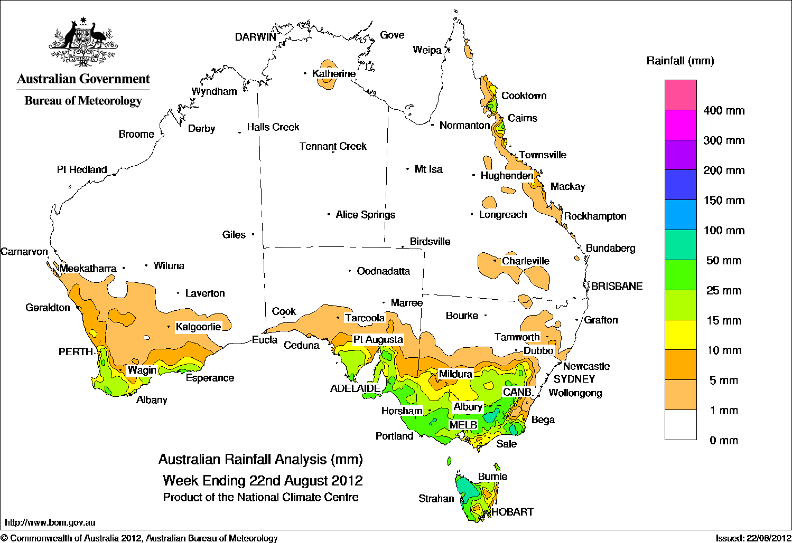

Temperature anomalies this week
Spatial temperature analyses are based on historical weekly temperature data provided by the Bureau of Meteorology. These temperature anomaly maps show the departure of the maximum and minimum from the long-term average. Temperature anomalies are calculated using high resolution gridded datasets from 1911 onwards. For further information on temperature anomalies, go to www.bom.gov.au/jsp/awap/.

Maximum temperature anomalies for the week ending 21 August 2012
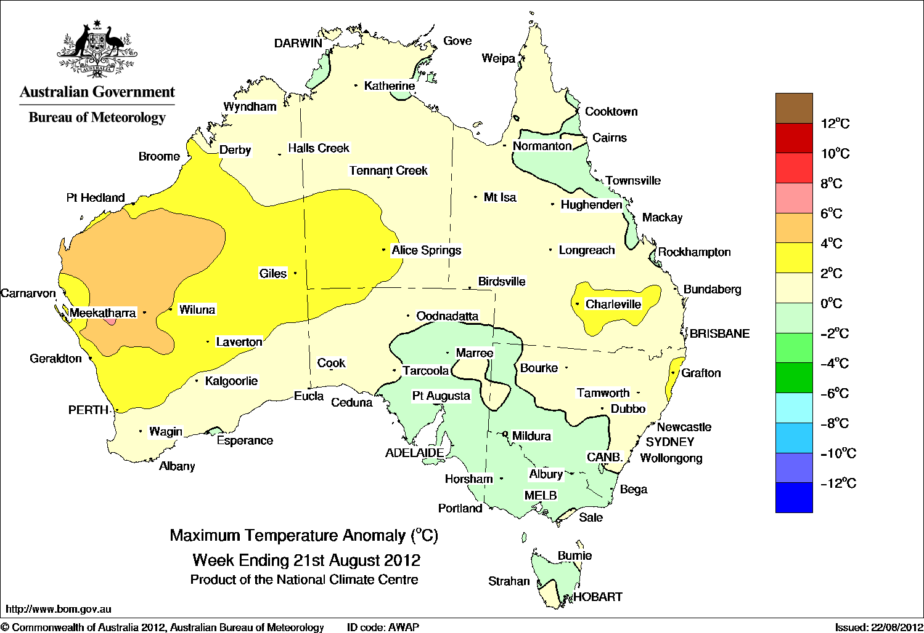

Minimum temperature anomalies for the week ending 21 August 2012
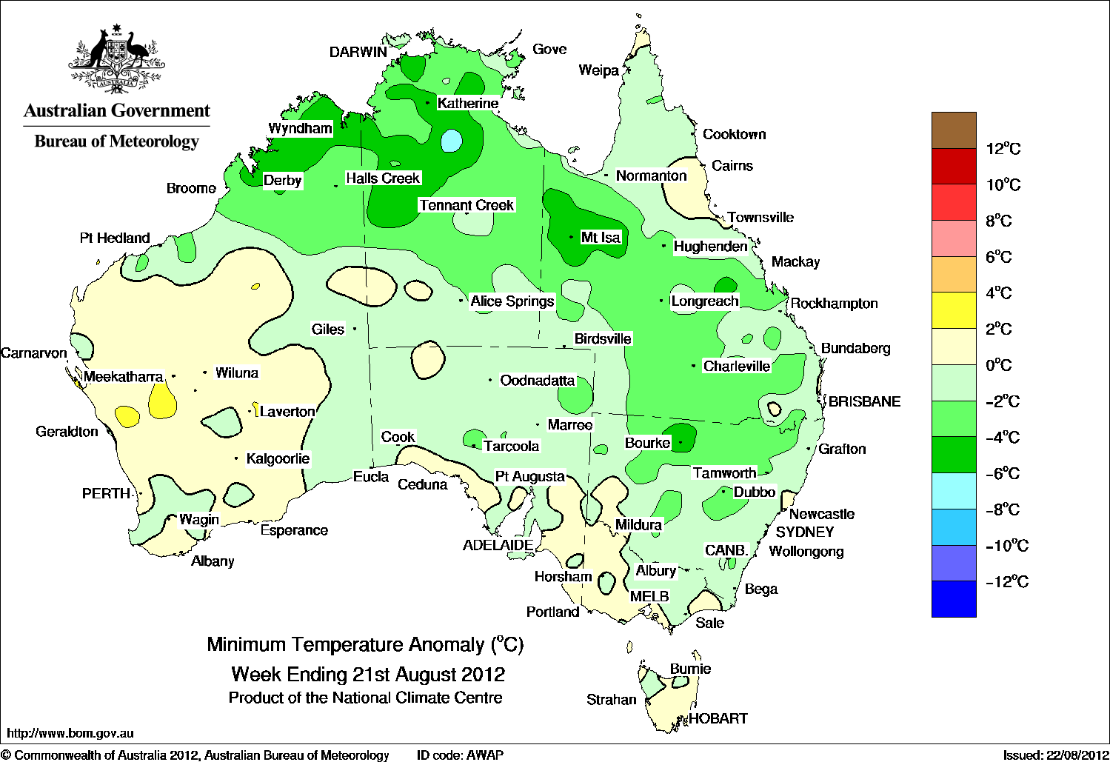

Rainfall outlook
The rainfall forecast below is produced from computer models. As it contains no input from weather forecasters, it is important to also check local forecasts and warnings provided by the Bureau of Meteorology.

Total forecast rainfall for the period 23 to 30 August 2012

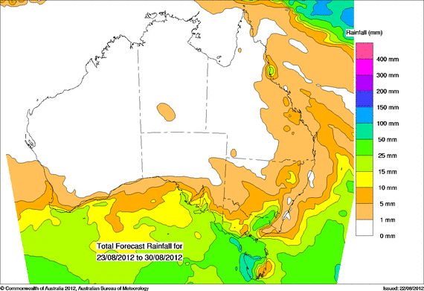

Seasonal outlook
Chance of exceeding the median rainfall – September to November 2012
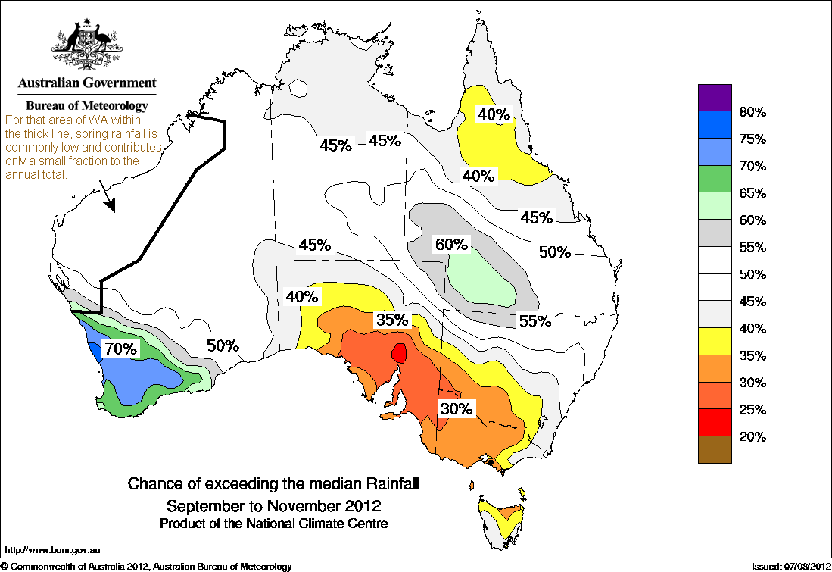
Chance of exceeding the median maximum temperature – September to November 2012

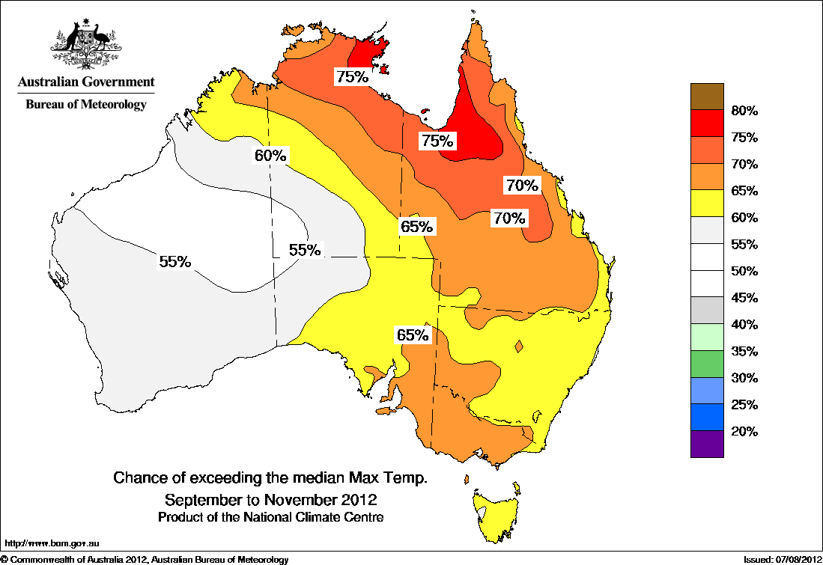
Chance of exceeding the median minimum temperature – September to November 2012
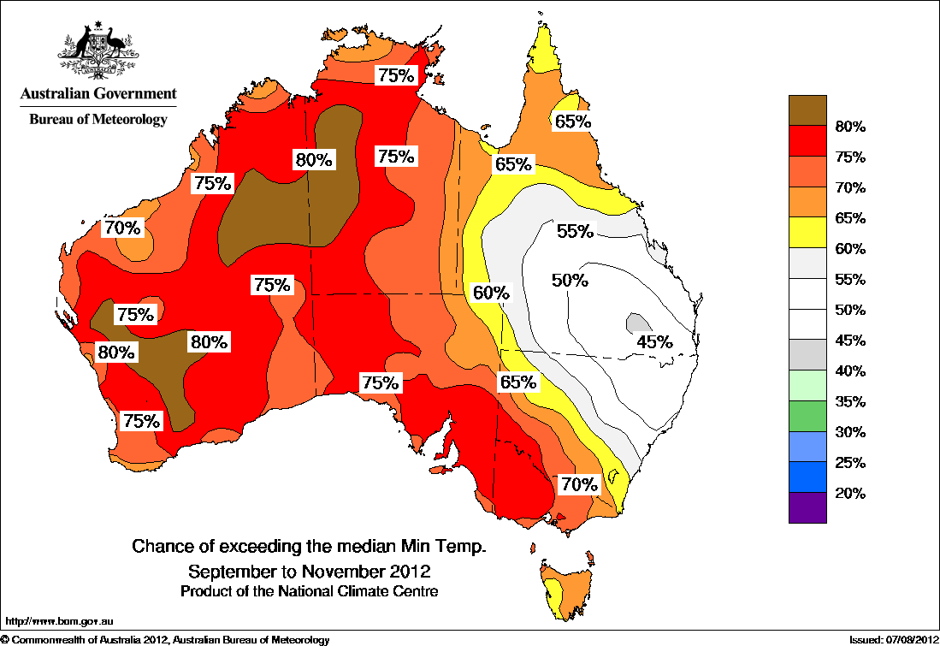

Water

Water availability
Water storage levels in the Murray–Darling Basin increased by 117 gigalitres (GL) this week and are at 95 per cent of total capacity. This is 9 percentage points, or 2041 GL, more than this time last year.

Water storages in the Murray–Darling Basin (NSW, Victoria and Queensland)
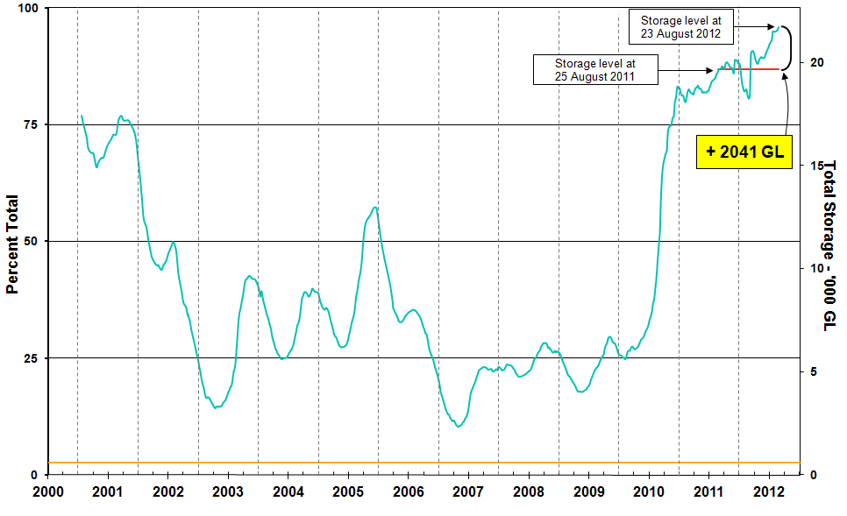
Information on irrigation water available in the Murray–Darling Basin from 1 January 2001 to 3 August 2012 is shown above. The top horizontal (red) line indicates the storage level at the similar time last year. The bottom horizontal (orange) line indicates the amount of ‘dead’ or unusable storage.

Water allocations
The current water allocations for the 2012–13 water trading season for licence holders in New South Wales, Victoria and South Australia water systems are summarised in the following table.
 | Allocations at 2 August 2012 (%) | Allocations at 16 August 2012 (%)
NSW Murray Valley
High security | 100 | 100
General security | 100* | 100*
NSW Murrumbidgee Valley
High security | 95 | 95
General security | 64* | 64*
NSW Lower Darling
High security | 100 | 100
General security | 100* | 100*
NSW Macquarie Valley
High security | 100 | 100
General security | 28* | 28*
NSW Hunter Valley
High security | 100 | 100
General security | 100 | 100
NSW Lachlan Valley
High security | 100 | 100
General security | 0* | 0*
NSW Lower Namoi
High security | 100 | 100
General security | 0* | 0*
NSW Upper Namoi
High security | 100 | 100
General security | 100* | 100*
NSW Gwydir Valley
High security | 100 | 100
General security | 0* | 0*
NSW Border Rivers
High security | 100 | 100
General security | 100 | 100
NSW Peel Valley
High security | 100 | 100
General security | 78* | 78*
Victoria Murray Valley
High reliability | 41 | 52
Low reliability | 0 | 0
Victoria Goulburn
High reliability | 88 | 100
Low reliability | 0 | 0
 | Allocations at 2 August 2012 (%) | Allocations at 16 August 2012 (%)
Victoria Campaspe
High reliability | 100 | 100
Low reliability | 18 | 25
Victoria Loddon
High reliability | 88 | 100
Low reliability | 0 | 0
Victoria Bullarook
High reliability | 100 | 100
Low reliability | 100 | 100
Victoria Broken
High reliability | 26 | 36
Low Reliability | 0 | 0
South Australia Murray Valley
High security | 100 | 100
*Carryover water may also be available.

Other Commodities

Production and commodities
- The wholesale prices of fruit were generally lower or unchanged in the week ending 18 August 2012. The prices of pineapple (smoothleaf), avocado (hass), rockmelon and strawberry all decreased, while watermelon (seedless) prices increased.
- The wholesale prices of vegetables were generally higher in the week ending 18 August 2012. The prices of peas (green), cauliflower, iceberg lettuce, broccoli and pumpkin (grey bulk) were all higher, while beans (round) prices decreased for the third week in a row.
- The world cotton indicator price (the Cotlook ‘A’ index) averaged US84.3 cents a pound in the week ending 22 August 2012, largely unchanged from the previous week.
- The world sugar indicator price (Intercontinental Exchange, nearby futures, no. 11 contract) averaged US20.1 cents a pound in the week ending 22 August 2012, around 2 per cent lower than in the previous week.
- According to the Russian Sugar Union, sugar yields will increase by around 17 per cent in 2012­13 to a record 4.04 tonnes a hectare.
- The Australian Eastern Market Indicator price for wool fell by 5 per cent in the week ending 16 August to 949 cents a kilogram clean. The total volume of bales offered for sale fell 20 per cent compared to the previous week.
- The world canola indicator price (Rapeseed, Europe, free on board Hamburg) averaged US$641 a tonne in the week ending 21 August 2012, compared with US$639 a tonne in the previous week.
- The Australian canola indicator price (Portland, Victoria) averaged $540 a tonne in the week ending 20 August 2012, which was unchanged from the previous week and 1 per cent higher than the same time last year when the price was $535 a tonne.
- Dry and hot conditions first emerged in the Black Sea region in November 2011 and intensified from June to August (Russian Federation, Ukraine and Kazakhstan).
- The Hydrometeorological Centre of Russia’s seasonal outlook for September to November 2012 indicates that hot and dry conditions are likely to continue for the Urals and Siberian regions of Russia, and for southern Kazakhstan. In contrast, Ukraine is likely to experience above average temperatures and rainfall.
- While most of Ukraine’s wheat crop is grown in winter, almost all of Kazakhstan’s grain crops are planted in spring, and around 35 per cent and 90 per cent of the Russian Federation’s wheat and barley crops, respectively, are also planted in spring. Reports of early harvest results of the winter and spring crops from the agriculture ministries of the Russian Federation, Ukraine and Kazakhstan, indicate average grain yields for these crops are around 28 per cent, 25 per cent and 33 per cent lower, respectively, compared with the previous season.
- The Black Sea exporting countries as a whole typically comprise around one tenth of world coarse grains exports and around one quarter of world wheat exports.
- The world coarse grains indicator price (US no. 2 yellow corn, free on board Gulf ports) averaged US$335 a tonne for the week ending 22 Aug 2012, compared with US$328 a tonne in the previous week.
- The world wheat indicator price (US no. 2 hard red winter, free on board Gulf ports) averaged US$363 a tonne in the week ending 21 August 2012, compared with US$362 a tonne in the previous week.
- Australian wheat stocks at the beginning of August 2012 were around 11.5 million tonnes, higher than each of the previous three years. Around 72 per cent of the wheat in stocks was milling wheat.
Australian wheat stocks, month beginning
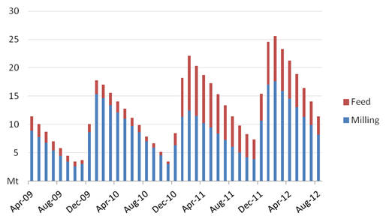
- The Queensland trade steer indicator price (330-400 kg live weight C3) increased by 7 per cent to 372 cents a kilogram in the week ending 17 August 2012, 3 per cent higher than the same time last year.
- Saleyard lamb prices rose in the eastern states in the week ending 17 August 2012. The lamb indicator price (18-22kg fat score 2-3) rose 3 per cent in South Australia, 2 per cent in New South Wales and 1 per cent in Victoria. In contrast, the lamb indicator price fell by 14 per cent in Western Australia. Saleyard throughput increased by 11 per cent in the eastern states and fell by 17 per cent in Western Australia.

Recent movements in fruit and vegetable prices
Weekly wholesale prices for selected fruit, Melbourne market
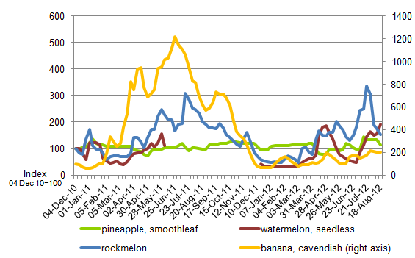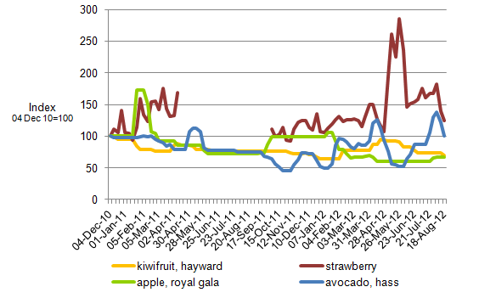
Weekly wholesale prices for selected vegetables, Melbourne market
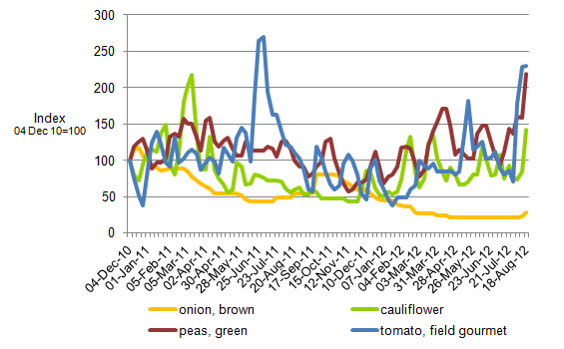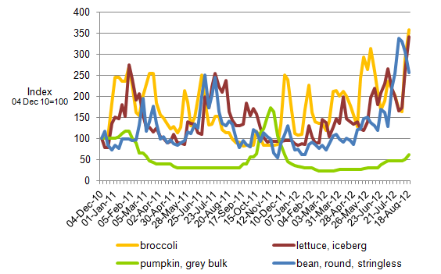

Selected world indicator prices
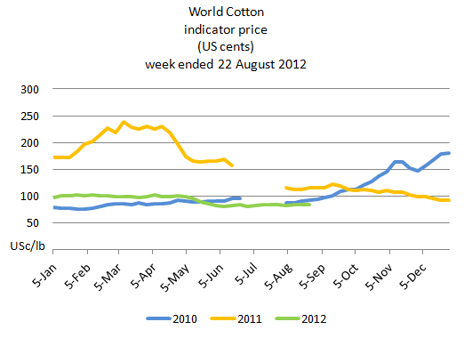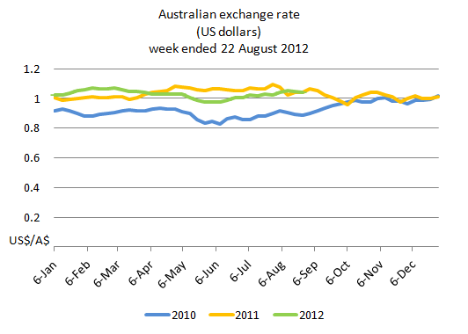
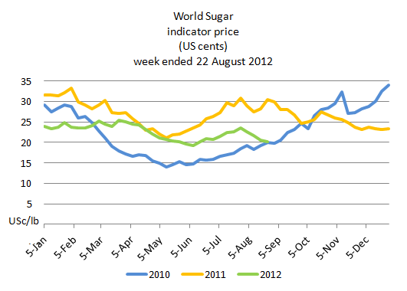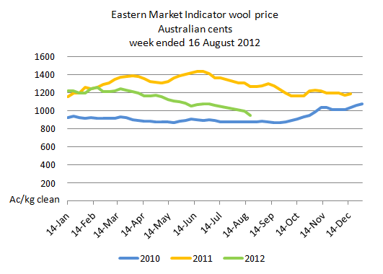

Crop indicator prices
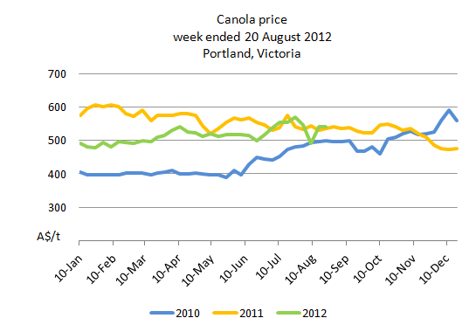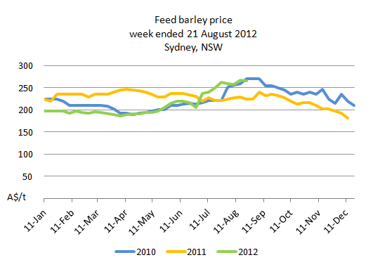
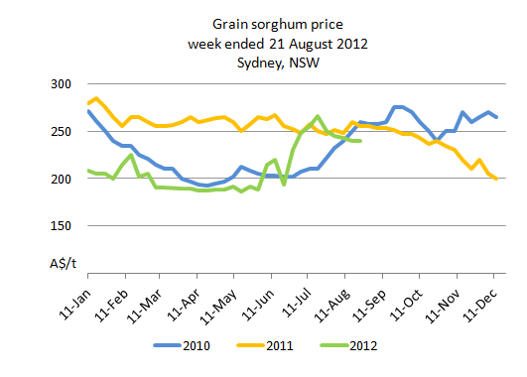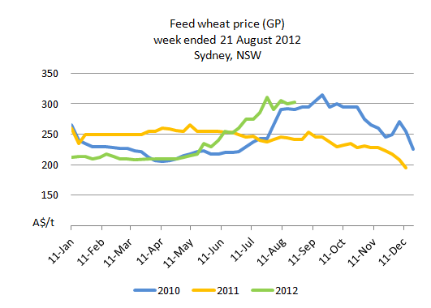

Livestock indicator prices
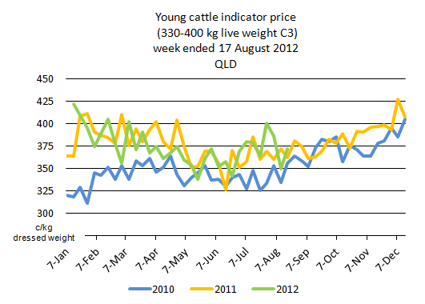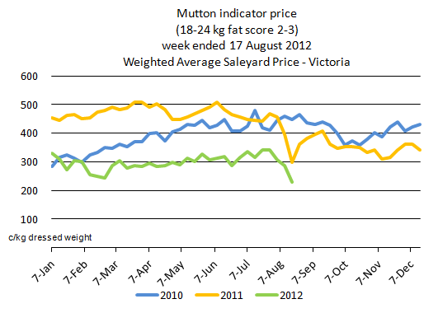
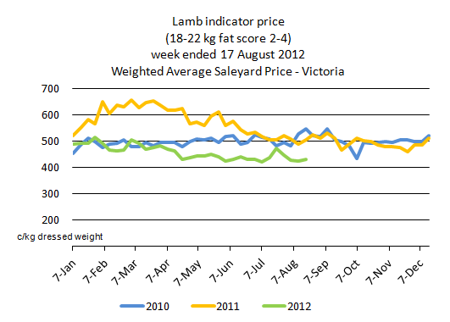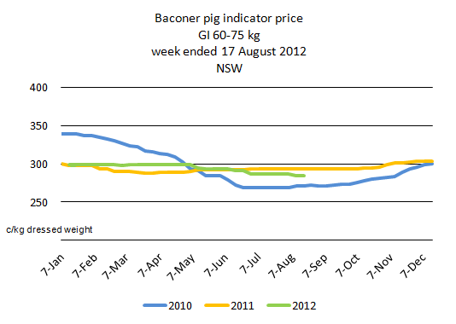

Data attribution

Climate
Bureau of Meteorology
- Weekly rainfall totals: www.bom.gov.au/jsp/awap/rain/index.jsp
- Monthly and last 3-months rainfall percentiles: www.bom.gov.au/jsp/awap/
- Temperature anomalies: www.bom.gov.au/jsp/awap/
- Rainfall forecast: www.bom.gov.au/jsp/watl/rainfall/pme.jsp
- Seasonal outlook: www.bom.gov.au/climate/ahead
- Drought statement: www.bom.gov.au/climate/drought/drought.shtml
- ENSO Wrap-Up: www.bom.gov.au/climate/enso/
- Soil moisture (BoM, CSIRO and the former Bureau of Rural Sciences): www.eoc.csiro.au/awap/
- Hydrometeorological Centre of Russia: http://wmc.meteoinfo.ru/season
- Russian Federation Ministry of Agriculture statement about current drought conditions http://www.mcx.ru/news/news/show/6265.355.htm

Water
New South Wales
- New South Wales Water Information: http://waterinfo.nsw.gov.au/
- New South Wales Office of Water, Department of Environment, Climate Change and Water: www.water.nsw.gov.au/Home/default.aspx
- Available water determinations register: www.wix.nsw.gov.au/wma/DeterminationSearch.jsp?selectedRegister=Determination
- Snowy Hydro: www.snowyhydro.com.au/lakeLevels.asp?pageID=47&parentID=61&grandParentID=4
Queensland
- Sunwater: www.sunwater.com.au
- seqwater: http://seqwater.com.au
South Australia
- SA Water: www.sawater.com.au/SAWater/Environment/TheRiverMurray/River+Murray+Levels.htm
- South Australian Department of Water: www.waterforgood.sa.gov.au/
Victoria
- Goulburn–Murray Water: www.g-mwater.com.au
Water trading
- Waterexchange: www.waterexchange.com.au

Commodities
Fruit and vegetables
- Datafresh: www.datafresh.com.au
Mutton, lambs, wheat, barley and grain sorghum
- The Land: hardcopy or online at http://theland.farmonline.com.au/markets.aspx
Cattle, mutton, lambs and pigs
- Meat and Livestock Australia: www.mla.com.au/Prices-and-markets
Canola
- Weekly Times: hardcopy

