21 June 2012
The full report is available from www.daff.gov.au/abares

Summary of key issues
- Winter crops will benefit from rainfall received this week across most of southern Australia.
- The recent rainfall will particularly benefit grain producers in parts of western Victoria and South Australia who have had a slow start to the season. Further rain is forecast across these areas in the coming week.
- Neutral El Niño/Southern Oscillation (ENSO) conditions persist, with the majority of climate models forecast El Nino conditions forming before the end of winter.
- Warmer and drier conditions are forecast across most of Australia over the next three months.
- Water storage levels in the Murray–Darling Basin increased this week by 108 gigalitres and remain at approximately 91 per cent of total capacity.
- Fruit wholesale prices were generally lower or unchanged in the week ending 16 June 2012, while vegetable wholesale prices were generally lower.
- The world cotton indicator price (the Cotlook ‘A’ index) averaged around US84 cents a pound in the week ending 20 June 2012, compared with US82.4 cents a pound in the previous week.
- The world sugar indicator price (Intercontinental Exchange, nearby futures, no. 11 contract) averaged US21 cents a pound in the week ending 20 June 2012, 4.5 per cent higher than in the previous week.
- The Australian canola indicator price (Portland, Victoria) averaged $500 a tonne in the week ending 18 June 2012, compared with $515 a tonne in the previous week.
- The Queensland young cattle indicator price (330400 kg live weight C3) rose 5 cents to 357 cents a kilogram in the week ending 15 June 2012.
- The Eastern Market Indicator price for wool fell 25 cents in the week ending 14 June 2012 to 1054 cents a kilogram clean.
- Saleyard prices of lamb rose in most states in the week ending 15 June 2012. The largest increase was in Western Australia.
- Australian market milk sales rose 3.3 per cent, year on year, for the first eleven months of 2011-12.

Climate

Notable events
- For the week ending 20 June 2012, most rainfall was recorded across southern Australia. Little to no rainfall was recorded over most of central and northern Australia. The highest measured rainfall total for the week was 156 mm at Mount Read, in west Tasmania.
- The recent rainfall will benefit grain producers in parts of western Victoria and South Australia who have had a slow start to the season. Further rain is forecast across most of these areas in the coming week.
- Neutral El Niño/Southern Oscillation (ENSO) conditions persist across the Tropical Pacific Ocean, with the majority of climate models forecast El Nino conditions forming before the end of winter (Bureau of Meteorology ENSO ‘Wrap-up’, 19 June 2012).
- Drier conditions are favoured over most of Australia, except north Queensland, between July and September 2012 (Bureau of Meteorology National Seasonal Rainfall Outlook, 20 June 2012).
- Warmer than normal daytime temperatures are forecast across the whole of the Australian continent between July and September 2012, with Western Australia likely to record the highest anomalies. Warmer night time temperatures are more likely in Western Australia, South Australia, Victoria, Tasmania, most of the Northern Territory, and the south-west of New South Wales (Bureau of Meteorology National Seasonal Temperature Outlook, 20 June 2012).

Rainfall this week
For the week ending 20 June 2012, most rainfall was recorded across southern Australia. Fronts produced rain in southern Western Australia, coastal South Australia, Victoria, Tasmania and throughout most of New South Wales. For further information, go to www.bom.gov.au/climate/current/weeklyrain.shtml.

Rainfall for the week ending 20 June 2012
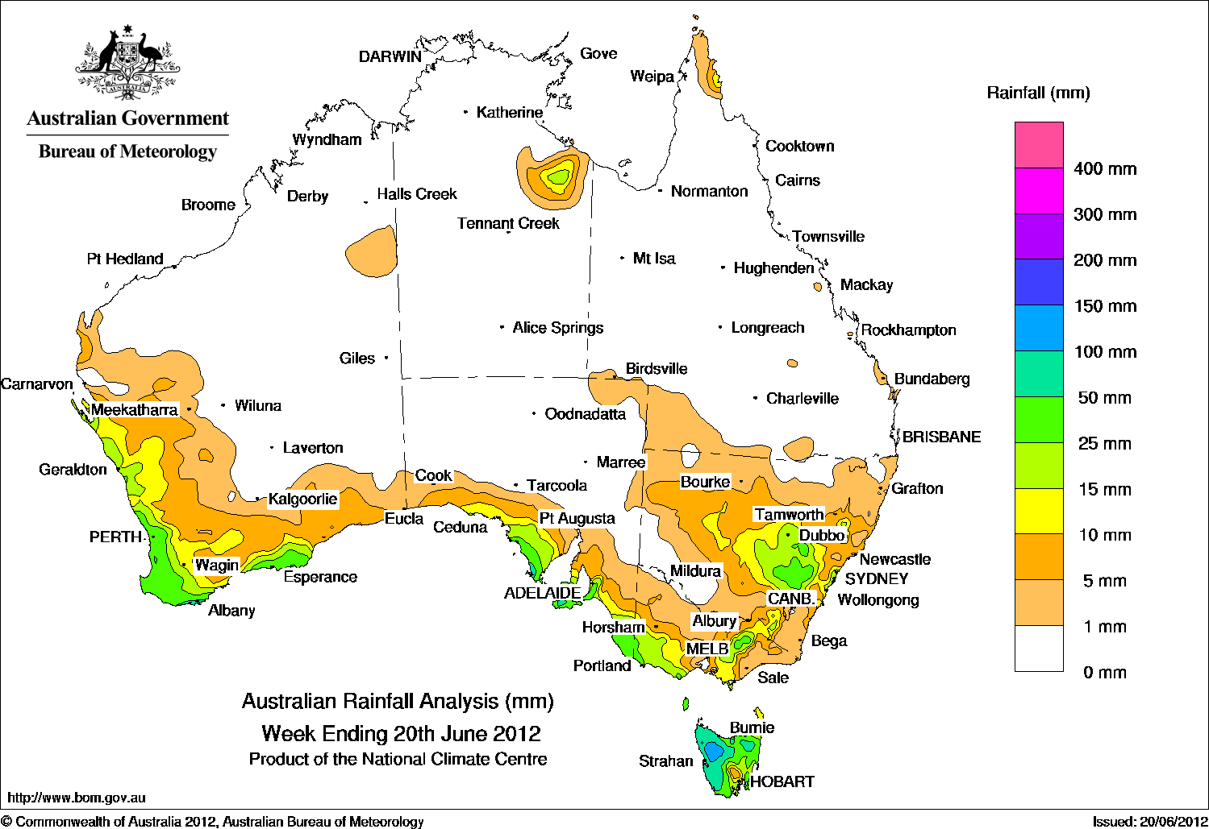

Temperature anomalies this week
Spatial temperature analyses are based on historical weekly temperature data provided by the Bureau of Meteorology. These temperature anomaly maps show the departure of the maximum and minimum from the long-term average. Temperature anomalies are calculated using high resolution gridded datasets from 1911 onwards. For further information on temperature anomalies, go to www.bom.gov.au/jsp/awap/.

Maximum temperature anomalies for the week ending 19 June 2012
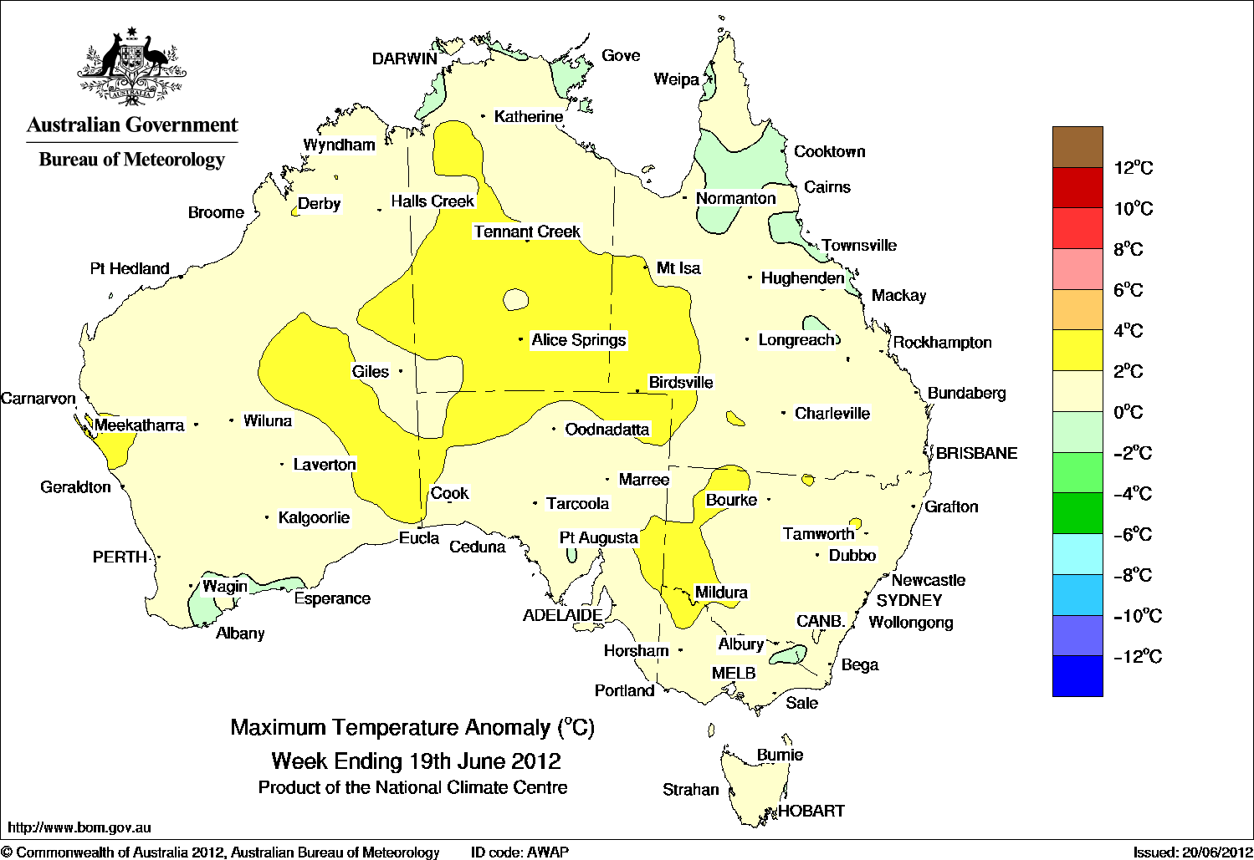

Minimum temperature anomalies for the week ending 19 June 2012
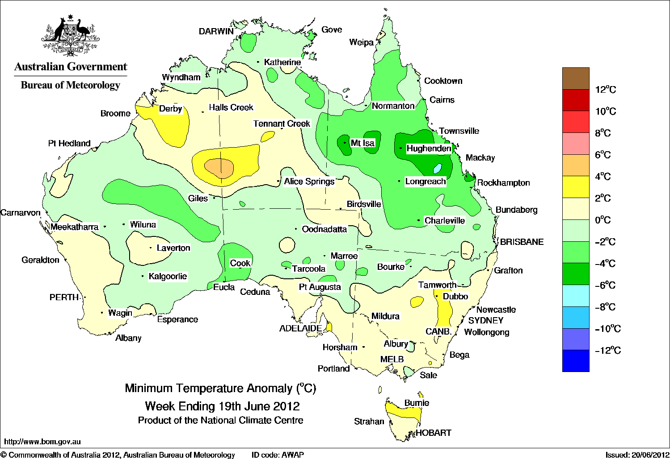

Rainfall outlook
The rainfall forecast below is produced from computer models. As it contains no input from weather forecasters, it is important to also check local forecasts and warnings by the Bureau of Meteorology.

Total forecast rainfall for the period 21 to 28 June 2012

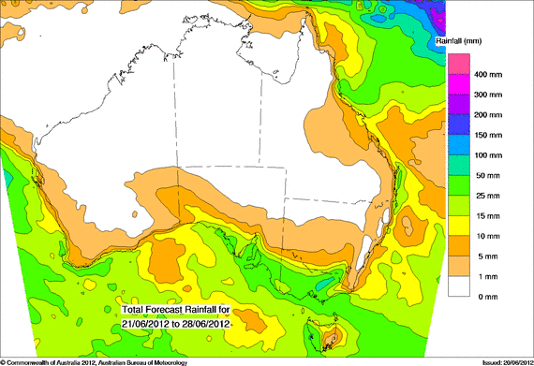

Seasonal outlook
Chance of exceeding the median rainfall – July to September 2012
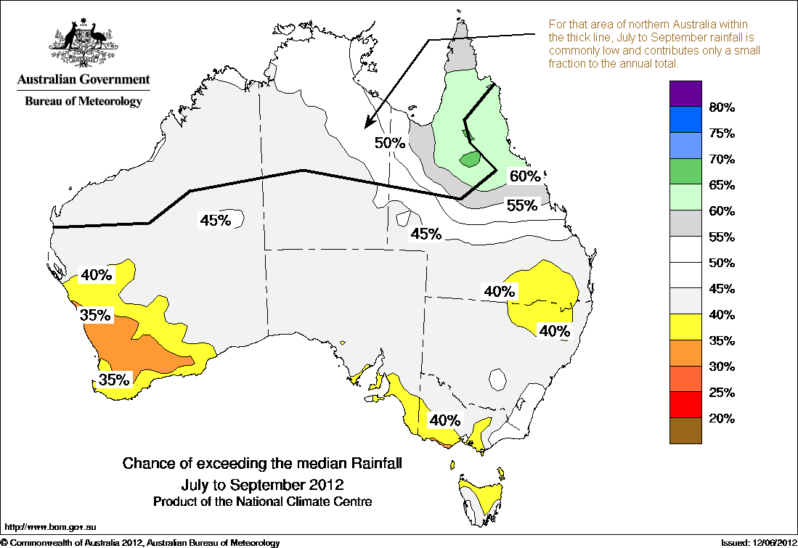
Chance of exceeding the median maximum temperature – July to September 2012

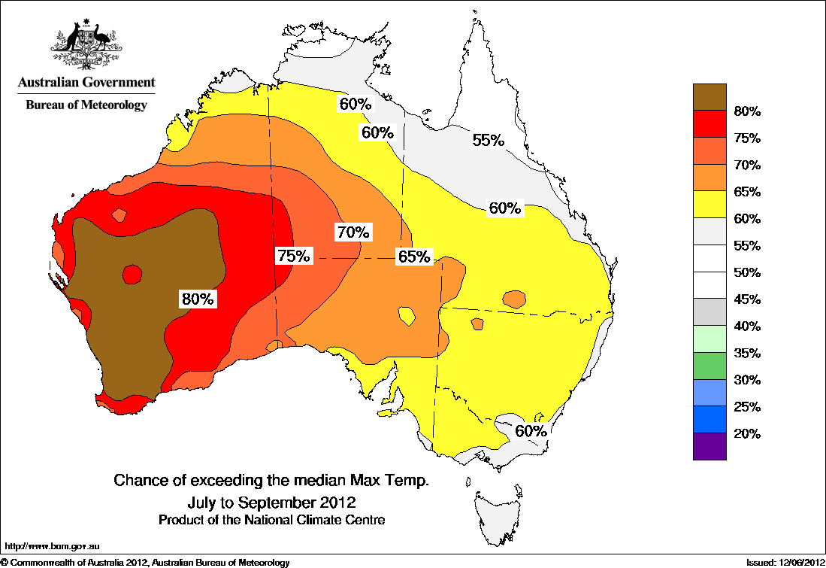
Chance of exceeding the median minimum temperature – July to September 2012
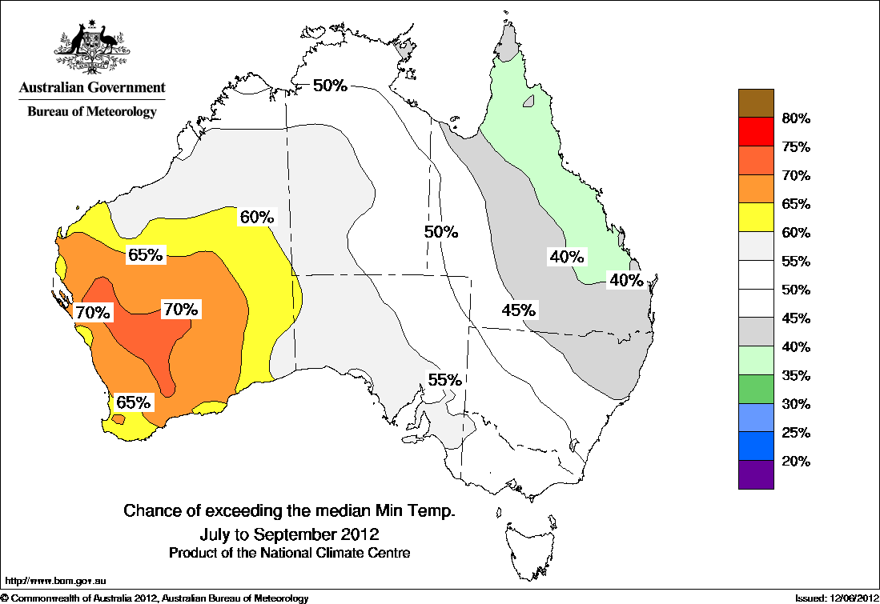

Water

Water availability
- Water storage levels in the Murray–Darling Basin (MDB) increased this week by 108 gigalitres (GL) to remain approximately 91 per cent of total capacity. This is 9 percentage points or 2077 GL more than this time last year.

Water storages in the Murray–Darling Basin (NSW, Victoria and Queensland)
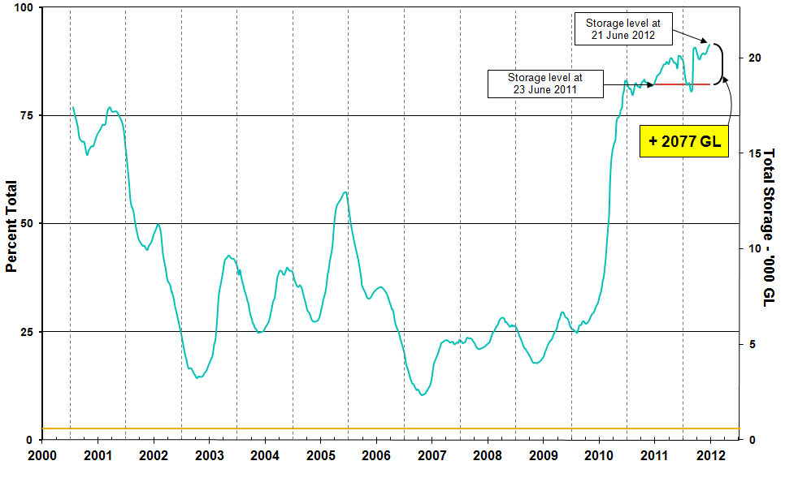
Information on irrigation water available in the Murray–Darling Basin from 1 January 2001 to 21 June 2012 is shown above. The top horizontal (red) line indicates the storage level at the similar time last year. The bottom horizontal (orange) line indicates the amount of ‘dead’ or unusable storage.

Commodities

Production and commodities
- Fruit wholesale prices were generally lower or unchanged in the week ending 16 June 2012. However, banana (cavendish) wholesale prices were significantly higher than the previous week. Most fruit prices are lower than at the same time in 2011, pineapple (smoothleaf), orange (navel) and lemon (eureka) are the main exceptions (Figure A).
- Vegetable wholesale prices were generally lower in the week ending 16 June 2012, with significant decreases in broccoli and tomato (field gourmet) prices. Prices of only a few vegetables are higher than at the same time in 2011, such as iceberg lettuce (figure B).
- The world cotton indicator price (the Cotlook ‘A’ index) averaged around US84 cents a pound in the week ending 20 June 2012, compared with US82.4 cents a pound in the previous week. The annual monsoon rains have started in India, covering almost half of the country, and are showing signs of a pick-up after falling short in the first 15 days of the season. India's June–September monsoon rains are vital for agriculture.
- The world sugar indicator price (Intercontinental Exchange, nearby futures, no. 11 contract) averaged US21 cents a pound in the week ending 20 June 2012, 4.5 per cent higher than in the previous week.
- The Eastern Market Indicator price for wool fell 25 cents in the week ending 14 June 2012 to 1054 cents a kilogram clean. The number of bales offered for sale was 18 per cent higher than in the previous week.
- The world canola indicator price (Rapeseed, Europe, free on board Hamburg) averaged US$593 a tonne in the week ending 19 June 2012, compared with US$595 a tonne in the previous week and 12 per cent lower than the same time last year when the price was US$676 a tonne.
- The Australian canola indicator price (Portland, Victoria) averaged $500 a tonne in the week ending 18 June 2012, compared with $515 a tonne in the previous week.
- The world coarse grains indicator price (US no. 2 yellow corn, free on board Gulf ports) averaged US$269 a tonne for the week ending 20 June 2012, compared with US$266 a tonne in the previous week.
- The world wheat indicator price (US no. 2 hard red winter, free on board Gulf ports) averaged US$280 a tonne in the week ending 19 June 2012, compared with US$279 a tonne in the previous week.
- The Queensland young cattle indicator price (330-400 kg live weight C3) rose 5 cents to 357 cents a kilogram in the week ending 15 June 2012. Young cattle prices also rose in New South Wales and South Australia, but fell in Victoria and Tasmania.
- Saleyard prices of lamb rose in most states in the week ending 15 June 2012. The largest increase was in Western Australia where the indicator price (18-22kg fat score 2-4) rose 11 per cent to 451 cents a kilogram.
- Australian market milk sales rose 3.3 per cent, year on year, for the first eleven months of 2011-12. Sales of full cream milk and reduced fat milk increased by 2.2 per cent and 7.6 per cent, respectively, over this period.
Figure A: Year-on-year changes in selected fruit prices, Melbourne wholesale market, 16 June 2012
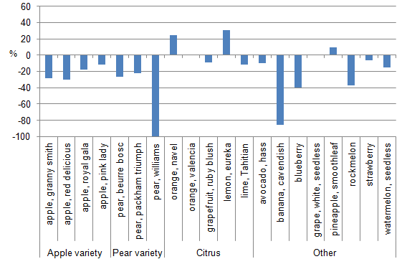
Figure B: Year-on-year changes in selected vegetable prices, Melbourne wholesale market, 16 June 2012
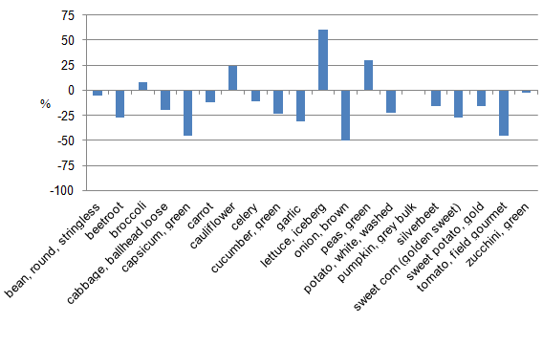

Recent movements in fruit and vegetable prices
Weekly wholesale prices for selected fruit, Melbourne market
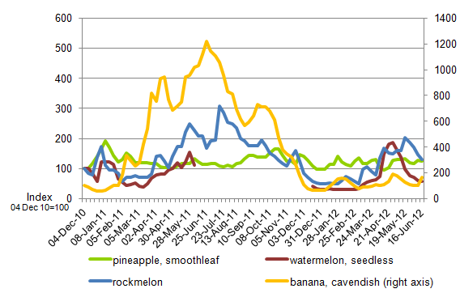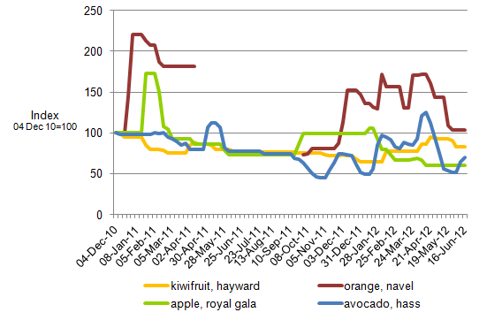
Weekly wholesale prices for selected vegetables, Melbourne market

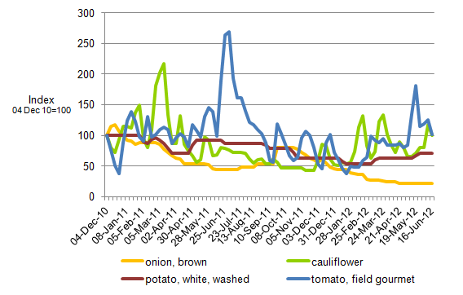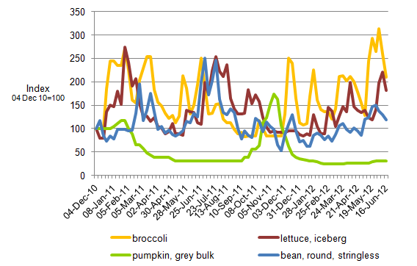

Selected world indicator prices
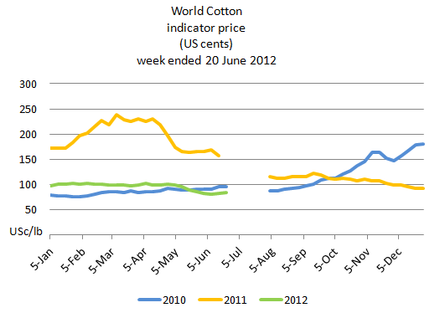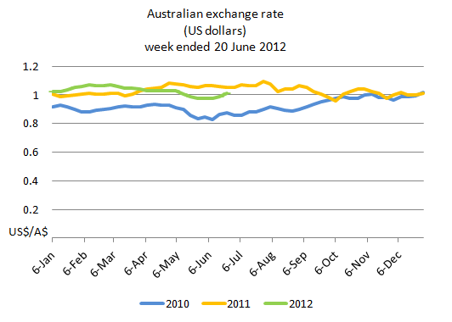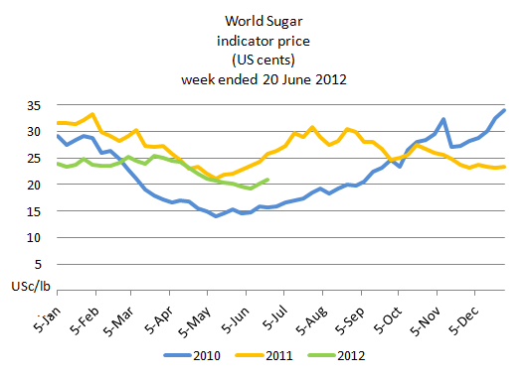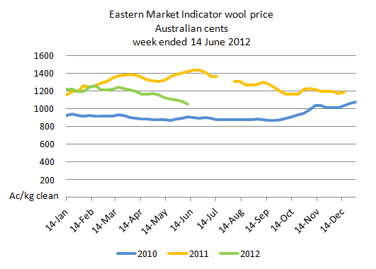

Crop indicator prices
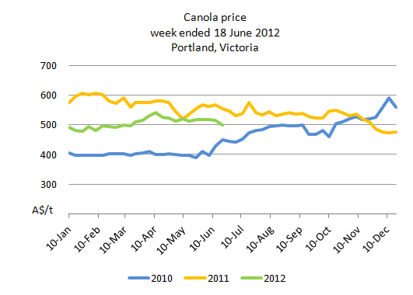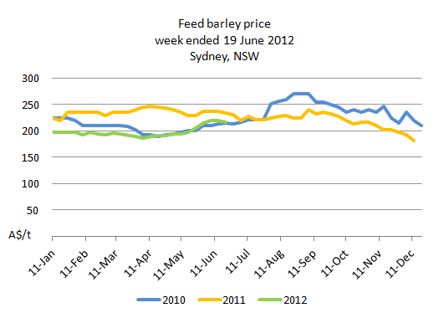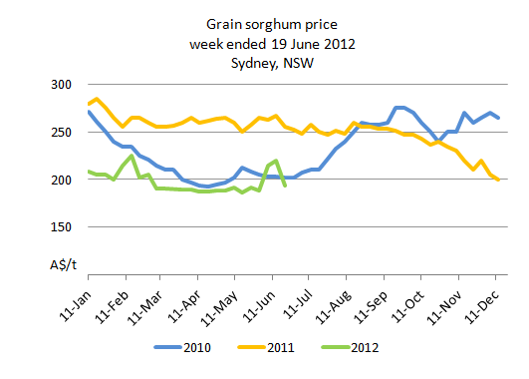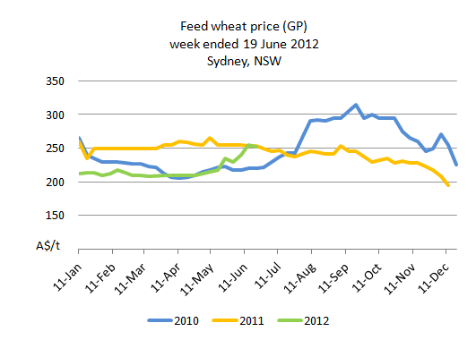

Livestock indicator prices
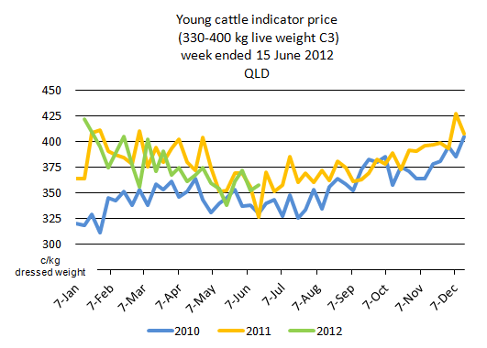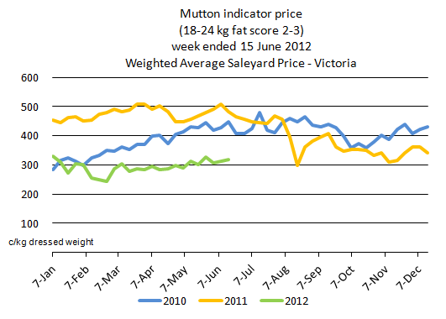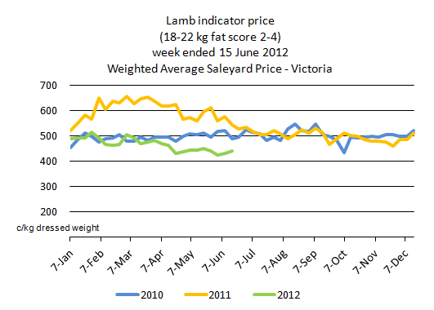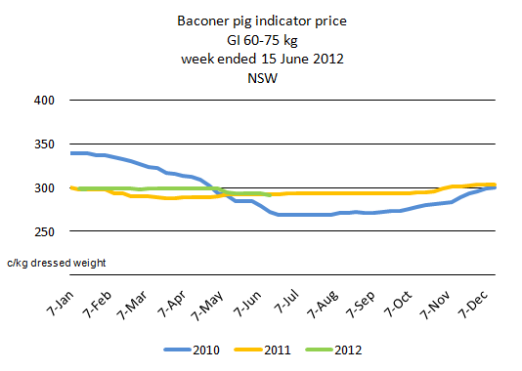

Data attribution

Climate
Bureau of Meteorology
- Weekly rainfall totals: www.bom.gov.au/jsp/awap/rain/index.jsp
- Monthly and last 3-months rainfall percentiles: www.bom.gov.au/jsp/awap/
- Temperature anomalies: www.bom.gov.au/jsp/awap/
- Rainfall forecast: www.bom.gov.au/jsp/watl/rainfall/pme.jsp
- Seasonal outlook: www.bom.gov.au/climate/ahead
- Drought statement: www.bom.gov.au/climate/drought/drought.shtml
- ENSO Wrap-Up: www.bom.gov.au/climate/enso/
- Soil moisture (BoM, CSIRO and the former Bureau of Rural Sciences): www.eoc.csiro.au/awap/

Water
New South Wales
- New South Wales Water Information: http://waterinfo.nsw.gov.au/
- New South Wales Office of Water, Department of Environment, Climate Change and Water: www.water.nsw.gov.au/Home/default.aspx
- Available water determinations register: www.wix.nsw.gov.au/wma/DeterminationSearch.jsp?selectedRegister=Determination
- Snowy Hydro: www.snowyhydro.com.au/lakeLevels.asp?pageID=47&parentID=61&grandParentID=4
Queensland
- Sunwater: www.sunwater.com.au
- seqwater: http://seqwater.com.au
South Australia
- SA Water: www.sawater.com.au/SAWater/Environment/TheRiverMurray/River+Murray+Levels.htm
- South Australian Department of Water: www.waterforgood.sa.gov.au/
Victoria
- Goulburn–Murray Water: www.g-mwater.com.au
Water trading
- Waterexchange: www.waterexchange.com.au

Commodities
Fruit and vegetables
- Datafresh: www.datafresh.com.au
Mutton, lambs, wheat, barley and grain sorghum
- The Land: hardcopy or online at http://theland.farmonline.com.au/markets.aspx
Cattle, mutton, lambs and pigs
- Meat and Livestock Australia: www.mla.com.au/Prices-and-markets
Canola
- Weekly Times: hardcopy

