7 June 2012
The full report is available from www.daff.gov.au/abares

Summary of key issues
- Recent heavy rainfall in south eastern Australia has led to flooding of some dairy and vegetable farmlands in south eastern Victoria. The extent of any damage is still being assessed.
- The recent rainfall in south eastern Australia has provided timely moisture for the establishment of recently sown winter crops.
- In the coming week up to 25 mm of rain is forecast for cropping areas of Western Australia, an area that has missed much of the recent rainfall.
- Autumn rainfall was generally below average across central and western Australia. This has exacerbated existing upper and lower soil moisture deficiencies across Western Australia’s cropping zone. Upper layer soil moisture deficiencies remain across south eastern Australia’s cropping areas despite recent rainfall.
- Water storage levels in the Murray–Darling Basin remained at 90 per cent of total capacity. This is around 60 percentage points higher than the same time in 2010.
- Wholesale prices for vegetables were generally higher in the week ending 2 June 2012 compared with the previous week, but fruit prices were lower on average.
- The world cotton indicator price (the Cotlook ‘A’ index) averaged US80.3 cents a pound in the week ending 6 June 2012, the lowest since the week ending 10 February 2010.
- The world indicator price of wheat (US no. 2 hard red winter, free on board Gulf ports) averaged US$279 a tonne in the week ending 29 May 2012, compared with US$294 a tonne in the previous week.
- The Queensland young cattle indicator price (330–400 kg live weight C3) rose 11 cents in the week ending 1 June 2012 to 372 cents a kilogram. Young cattle prices also rose in New South Wales, Victoria and Western Australia.
- Saleyard prices of lamb declined in most states in the week ending 1 June 2012. The indicator price for lamb (18-22 kg fat score 2-4) fell 4 per cent in Victoria and South Australia, but only 1 per cent in New South Wales. The indicator price rose by 3 per cent in Western Australian.

Climate

Notable events
- For the week ending 6 June, there was widespread rainfall across eastern Australia. Heavy falls in south eastern Victoria has reportedly led to flooding of dairy and vegetable farms.
- The highest measured rainfall total for the week was 284 millimetres (mm) at Haines Junction, approximately 80 km south west of Geelong, Victoria.
- In the coming week up to 25 mm of rain is forecast for cropping areas of Western Australia. The rain should provide much needed moisture for the germination of recently sown winter crops.
- May 2012 rainfall was below average across most parts of Australia. Only Tasmania and parts of southern and north eastern Australia received above average rainfall.
- Autumn 2012 rainfall was generally above average across northern and eastern Australia.
- Parts of southern and central Western Australia experienced severe rainfall deficiencies over autumn 2012. This is consistent with a long-term pattern of rainfall deficiencies in this area and has led to severe lower and upper soil moisture deficiencies. Upper soil moisture deficiencies also remain across south eastern cropping zones despite above average May rainfall.
- Climate models indicate that there will be further warming in the Tropical Pacific Ocean over the next six months, with conditions likely to approach or exceed El Niño thresholds during spring 2012 or summer 2012–13. At present, no climate models forecast a return to La Niña conditions (Bureau of Meteorology ‘ENSO Wrap-Up’ 5 June 2012).

Rainfall this week
For the week ending 6 June 2012, widespread falls of around 25 to 50 mm were recorded across eastern Australia, with particularly heavy rainfall in south east Victoria. Little or no rainfall was recorded over most of central and Western Australia, except in very south western coastal Western Australia where rainfalls over 100 mm were recorded. For further information, go to www.bom.gov.au/climate/current/weeklyrain.shtml.

Rainfall for the week ending 6 June 2012
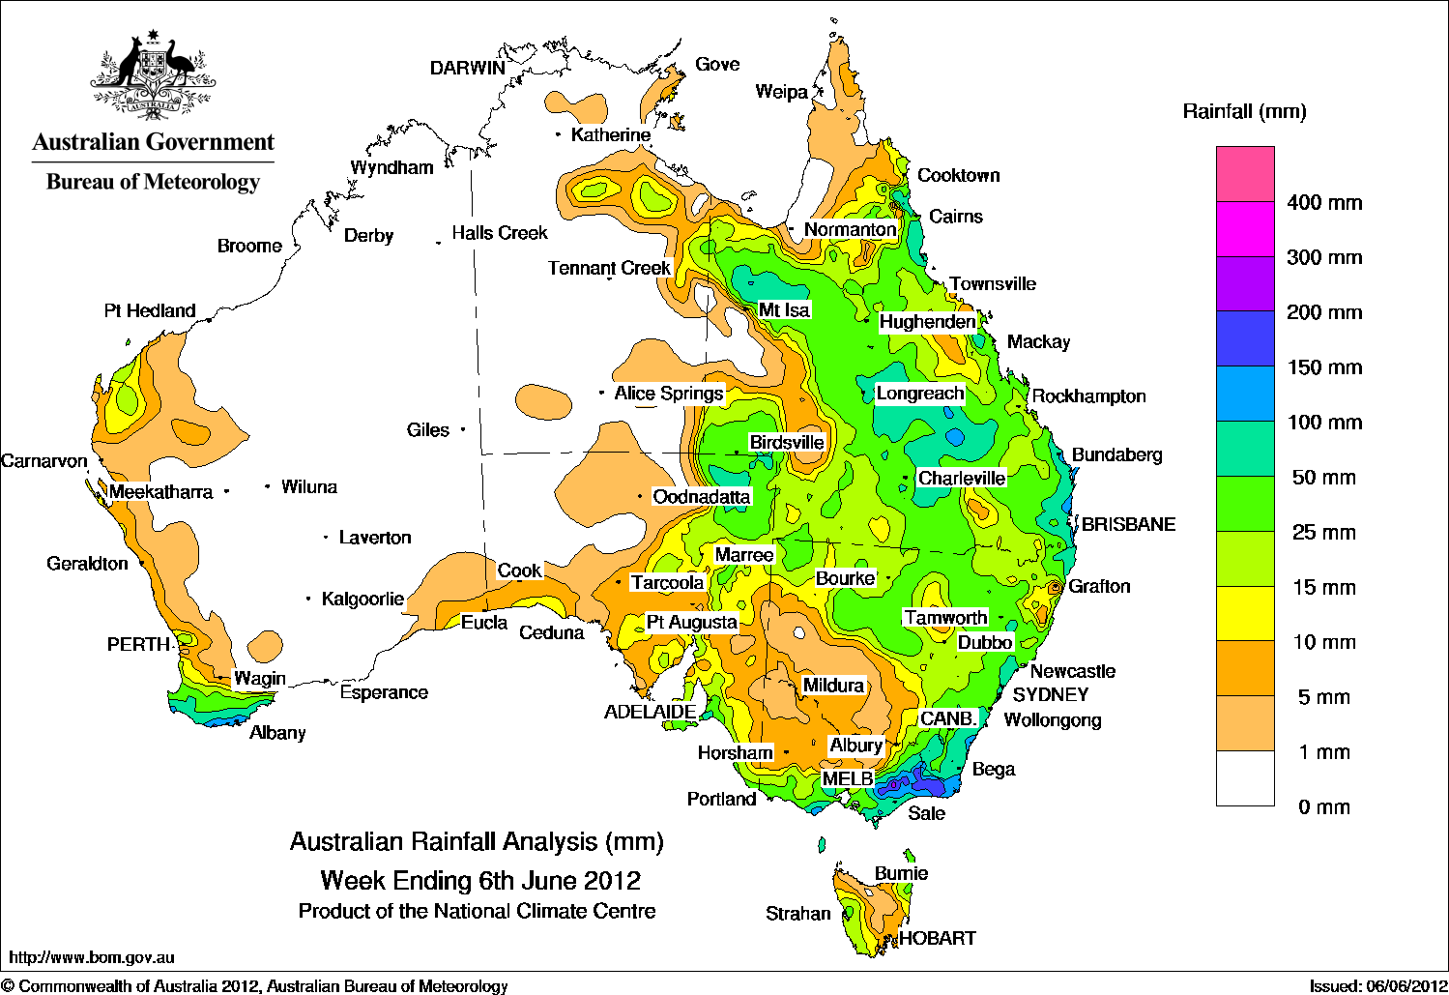

Temperature anomalies this week
Spatial temperature analyses are based on historical weekly temperature data provided by the Bureau of Meteorology. These temperature anomaly maps show the departure of the maximum and minimum from the long-term average. Temperature anomalies are calculated using high resolution gridded datasets from 1911 onwards. For further information on temperature anomalies, go to www.bom.gov.au/jsp/awap/.

Maximum temperature anomalies for the week ending 5 June 2012
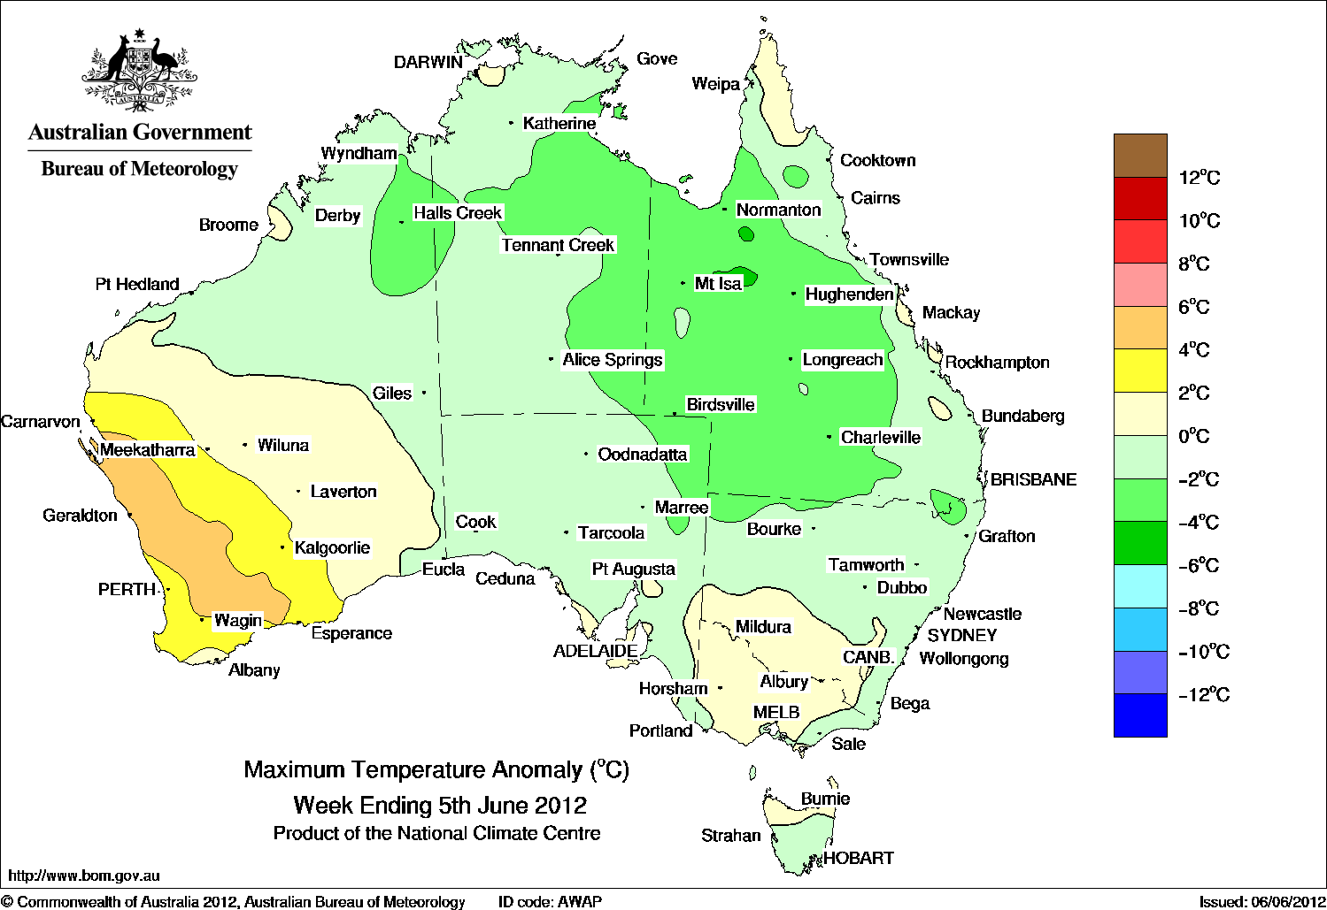

Minimum temperature anomalies for the week ending 5 June 2012
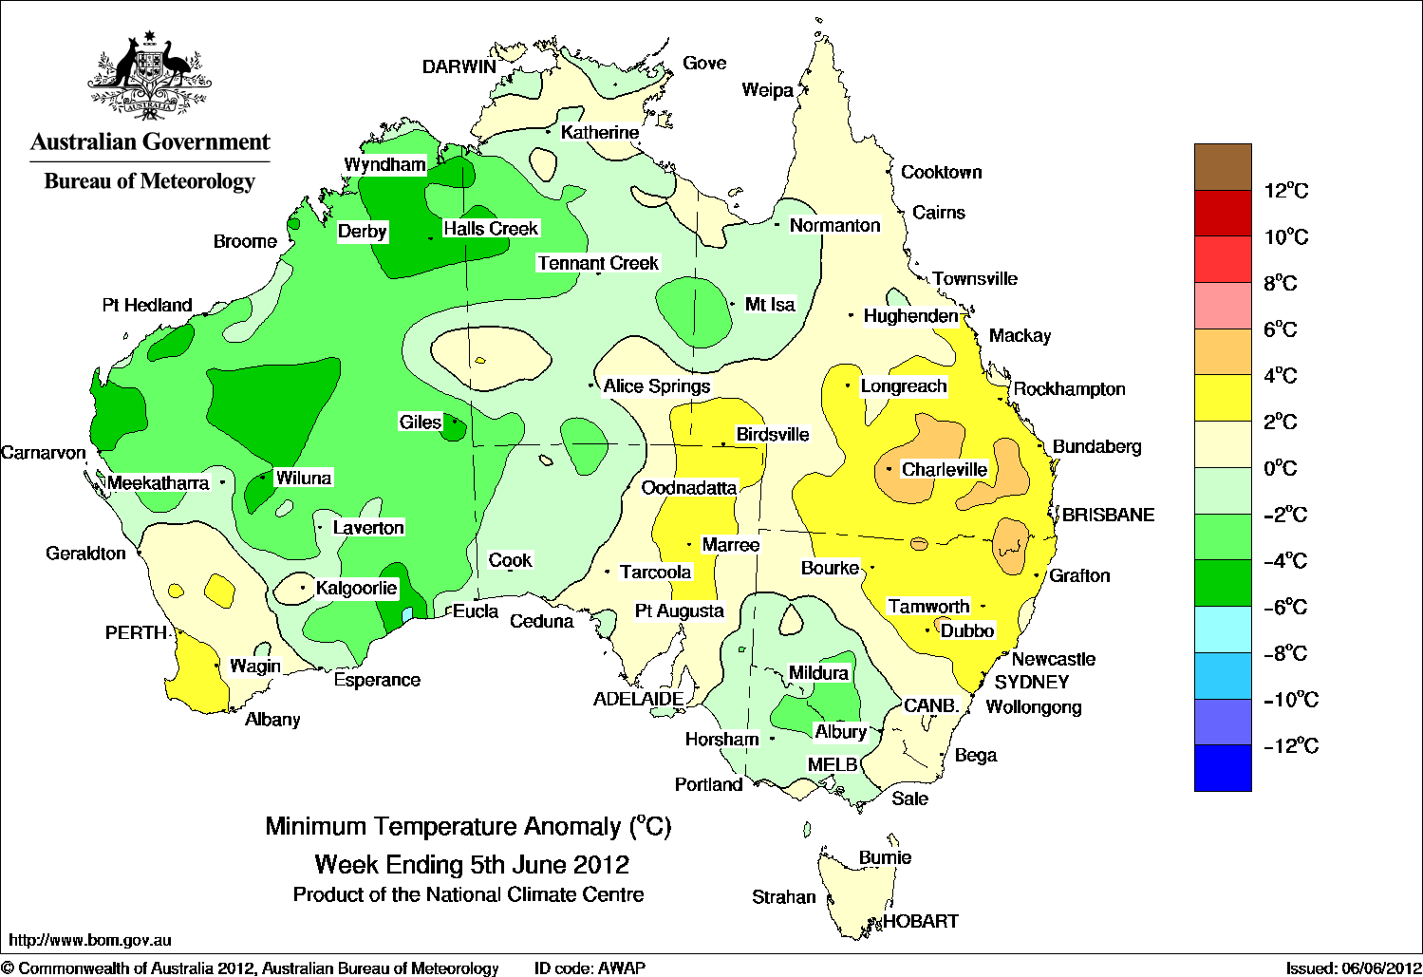

May 2012 rainfall

Rainfall percentiles for May 2012
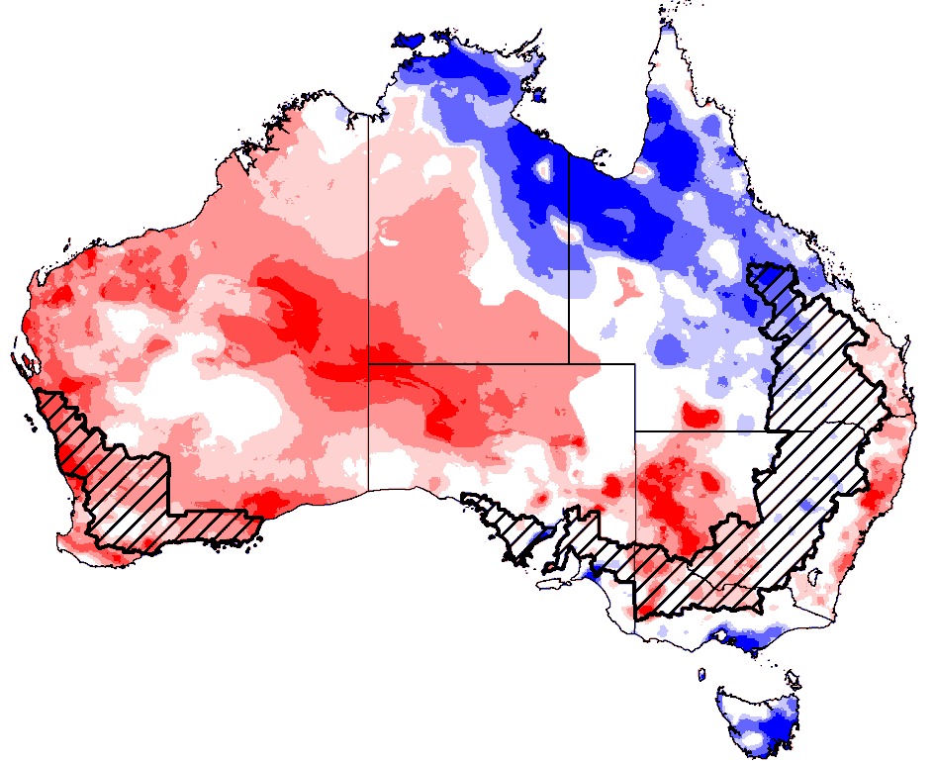 | 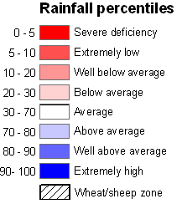

Autumn 2012 rainfall
Rainfall percentiles for autumn 2012
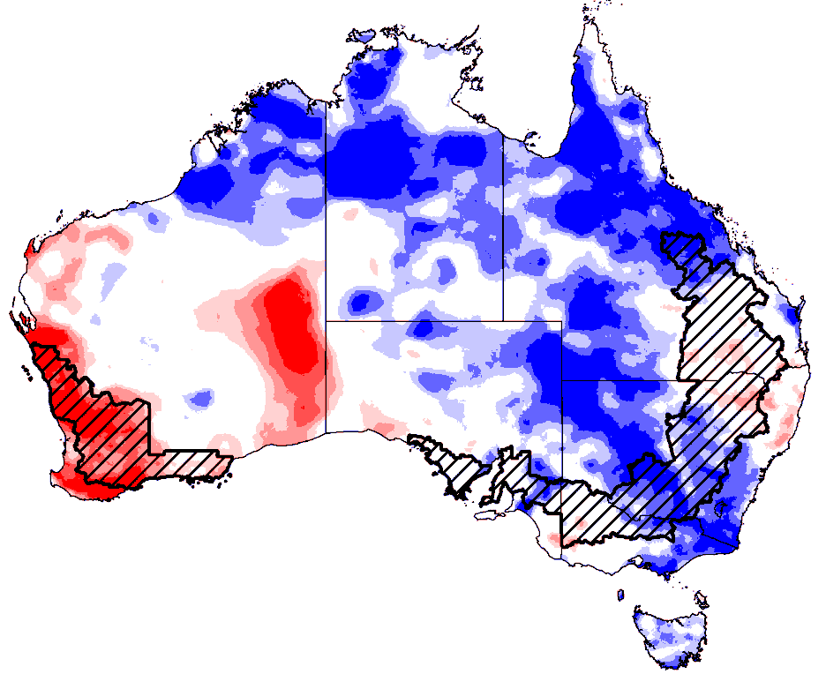

May 2012 relative soil moisture
The maps show the relative levels of modelled upper (0 to ~0.2 metres) soil moisture and lower (~0.2 to ~1.5 metres) soil moisture at the end of May 2012. These maps show soil moisture estimates relative to the long-term average with respect to the reference period 1961 to 1990.

Upper layer soil moisture
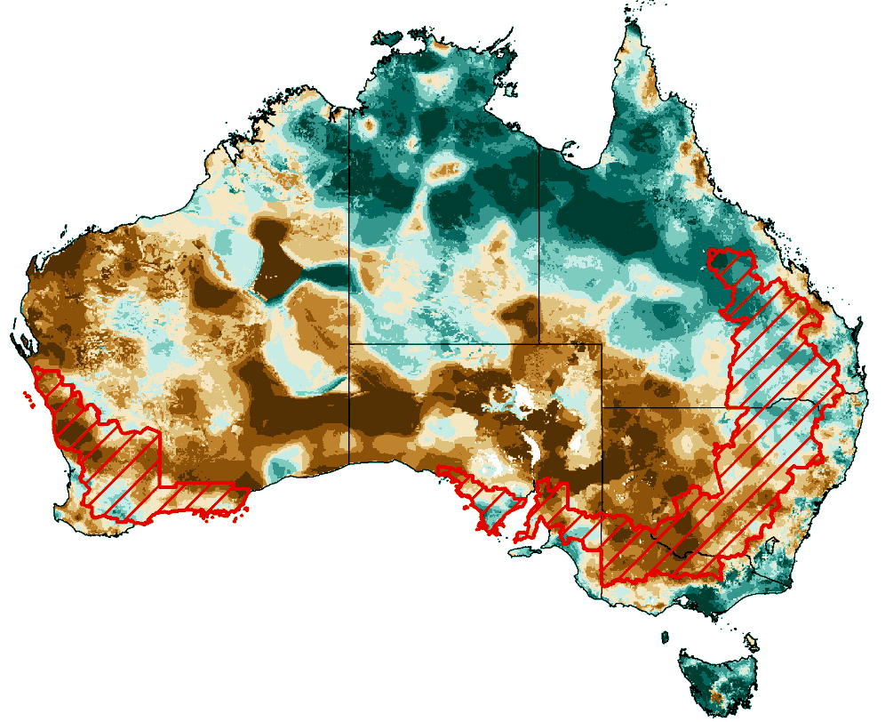 | 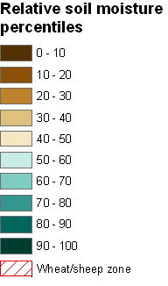
The bulk of plant roots occur in the top 0.3 metres of the soil profile and soil moisture in the upper layer of the soil profile (0.2 metres) is the most appropriate indication of the availability of water, particularly for germinating plants. The lower layer soil moisture is a larger, deeper store that is slower to respond to rainfall and tends to reflect accumulated events over seasonal and longer time scales.

Lower layer soil moisture
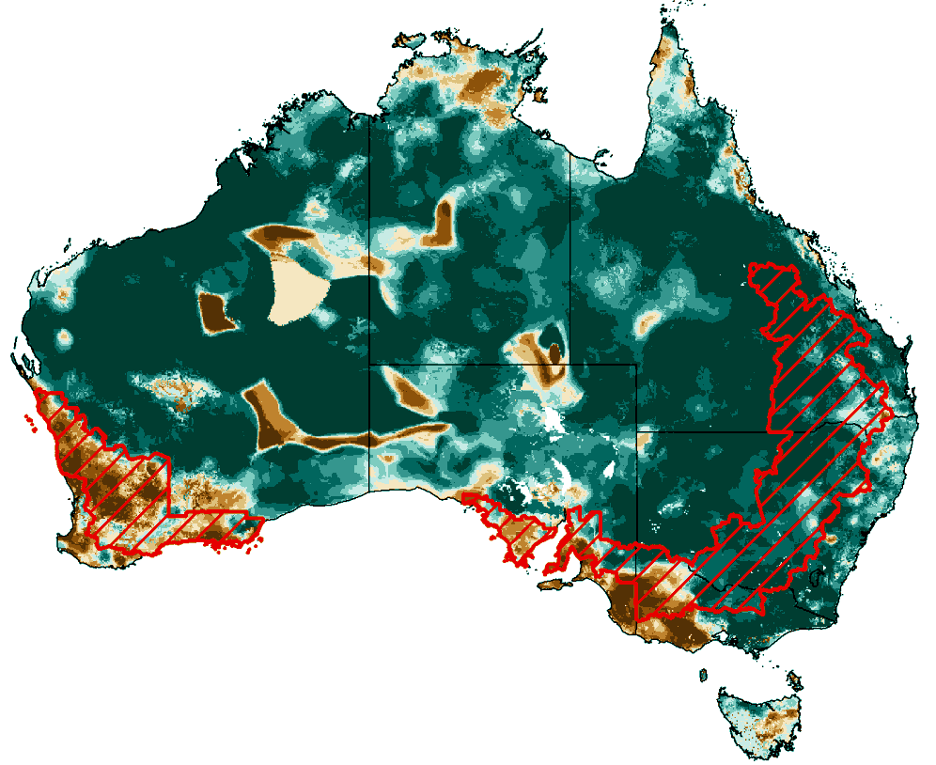

Rainfall outlook
The rainfall forecast below is produced from computer models. As it contains no input from weather forecasters, it is important to also check local forecasts and warnings by the Bureau of Meteorology.

Total forecast rainfall for the period 7 to 14 June 2012
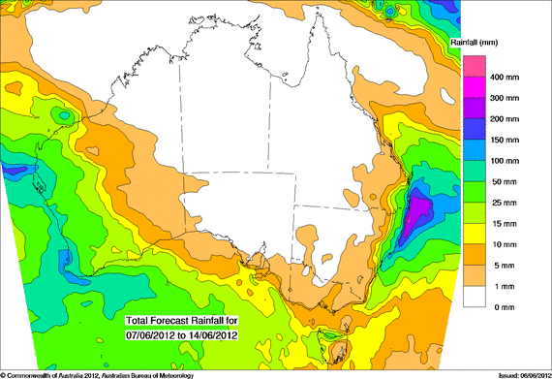

Water

Water availability
- Water storage levels in the Murray–Darling Basin (MDB) increased this week by 177 gigalitres (GL) and remained at approximately 90 per cent of total capacity. This is 7 percentage points or 1527 GL more than this time last year, and 60 percentage points more than the same time in 2010.

Water storages

Changes in regional water storage for May 2012 and the previous 12 months are summarised in the table and graphs below (current at 7 May 2012).
Region | Total capacity  (GL) | Current volume  (GL) | Current volume  (%) | Monthly change  (GL) | Monthly change  (%) | Annual change  (GL)
Murray-Darling Basin (MDB) | 22557 | 20366 | 90 | +237 | +1 | +1527
Snowy Scheme | 5744 | 3587 | 62 | -58 | -1 | +1368
Murray-Darling Basin Authority (MDBA) | 9352 | 8084 | 84 | +245 | +3 | +799
Queensland MDB | 186 | 165 | 89 | -3 | -2 | -16
Central Queensland | 3154 | 3138 | 100 | +1 |  | -9
South-east Queensland | 3517 | 3440 | 98 | -15 | 0 | -23
New South Wales MDB | 13884 | 13004 | 94 | +174 | +1 | +1006
Coastal New South Wales | 1074 | 1067 | 99 | -1 | 0 | +171
Victoria MDB | 8488 | 7197 | 85 | +65 | +1 | +912
Water storages in Queensland, New South Wales and Victoria
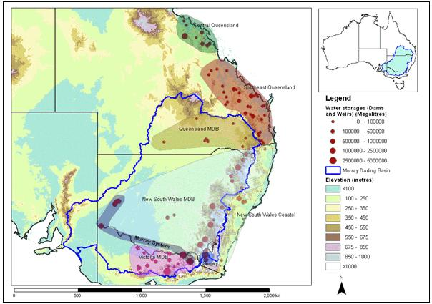
The blue line indicates the extent of the Murray–Darling Basin and the shaded areas denote the coverage of the individual reporting regions.

Water storages in the Murray–Darling Basin (NSW, Victoria and Queensland)
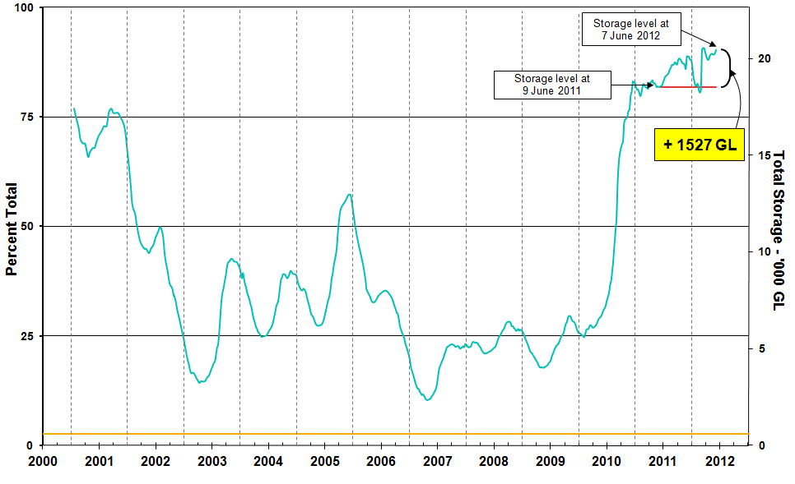
Information on irrigation water available in the Murray–Darling Basin from 1 January 2001 to 7 June 2012 is shown above. The top horizontal (red) line indicates the storage level at the similar time last year. The bottom horizontal (orange) line indicates the amount of ‘dead’ or unusable storage.

Water storages in the Murray–Darling Basin by state (NSW, Victoria and Queensland)

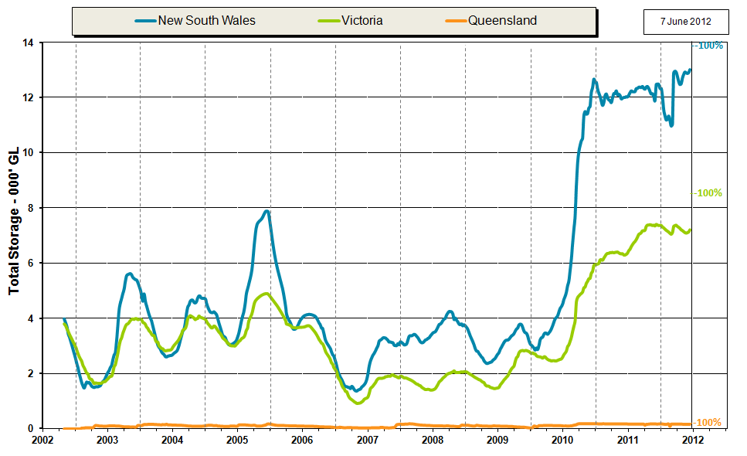

Commodities

Production and commodities
- The wholesale prices of fruit were lower in the week ending 2 June 2012 for pineapple (smoothleaf), rockmelon, watermelon (seedless), banana (cavendish), and kiwifruit (Hayward). Wholesale prices for avocado (hass), orange (navel) and apples (royal gala) were largely unchanged.
- The wholesale prices of tomatoes (field gourmet), broccoli and iceberg lettuce were higher in the week ending 2 June 2012 but lower for beans (round).
- The world cotton indicator price (the Cotlook ‘A’ index) averaged US80.3 cents a pound in the week ending 6 June 2012, the lowest since the week ending 10 February 2010 when the price was around US77 cents a pound.
- The world sugar indicator price (Intercontinental Exchange, nearby futures, no. 11 contract) averaged US19.3 cents a pound in the week ending 6 June 2012, which was largely unchanged from the previous week.
- The world canola indicator price (Rapeseed, Europe, free on board Hamburg) averaged US$593 a tonne in the week ending 5 June 2012, compared with US$599 a tonne in the previous week and 15 per cent lower than the same time last year when the price was US$699 a tonne.
- The Australian canola indicator price (Portland, Victoria) averaged of $518 a tonne in the week ending 4 June 2012, which was unchanged from the previous week and 8 per cent lower than the same time last year when the price was $562 a tonne.
- The world coarse grains indicator price (US no. 2 yellow corn, free on board Gulf ports) averaged US$253 a tonne for the week ending 6 June 2012, largely unchanged from the previous week.
- The world indicator price of wheat (US no. 2 hard red winter, free on board Gulf ports) averaged US$279 a tonne in the week ending 29 May 2012, compared with US$294 a tonne in the previous week.
- The Queensland young cattle indicator price (330–400 kg live weight C3) rose 11 cents in the week ending 1 June 2012 to 372 cents a kilogram. Young cattle prices also rose in New South Wales, Victoria and Western Australia.
- Saleyard prices of lamb declined in most states in the week ending 1 June 2012. The indicator price for lamb (18-22 kg fat score 2-4) fell 4 per cent to 424 cents per kilogram in Victoria and 427 cents per kilogram in South Australia. In New South Wales the indicator price declined by 1 per cent to 409 cents per kilogram but rose in Western Australian by 3 per cent to 414 cents per kilogram.
- The volume of beef and veal exports were around 87 000 tonnes in May 2012, two thousand tonnes higher than for the same month in 2011. Shipments to the United States were around 4 500 tonnes higher, which offset a fall in exports to the Republic of Korea.
- Australian milk production was 8 per cent higher in April 2012 than April 2011. Production rose in all states except Western Australia where there was a 6 per cent fall. Over the first ten months of 2011-12, Australian milk production was 4.3 per cent higher than the same months in 2010-11, which reflects producers continuing to increase production in response to ongoing favourable seasonal conditions and abundant supplies of irrigation water since the middle of 2010-11.
- The Indian Meteorology Department declared the onset of the south west monsoon over Kerala on 5 June 2012. Rainfall from the monsoon is important for India’s Kharif crops, such as rice, sorghum, maize, sugar and cotton. Although the monsoon has commenced and this is a notable event, this is not a guarantee it will deliver adequate rainfall over the season.

Recent movements in fruit and vegetable prices
Weekly wholesale prices for selected fruit, Melbourne market
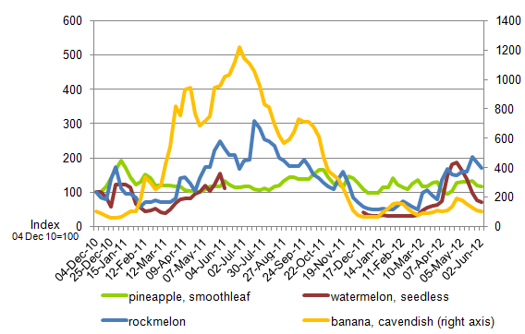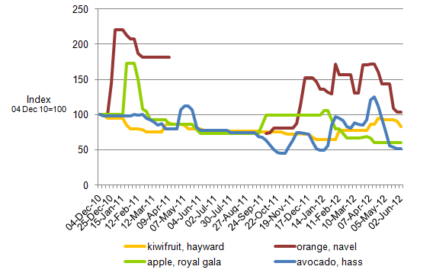
Weekly wholesale prices for selected vegetables, Melbourne market
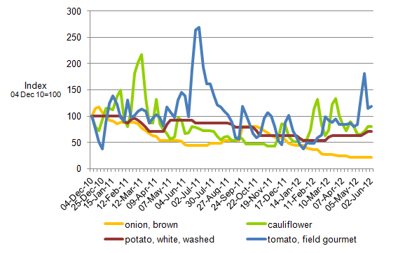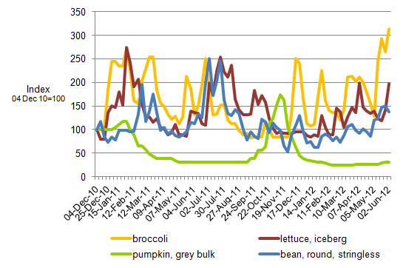

Selected world indicator prices
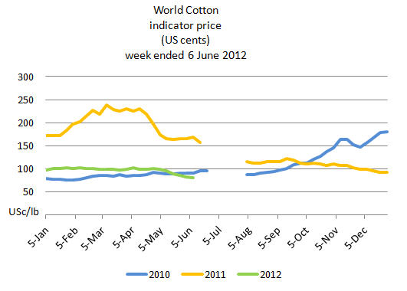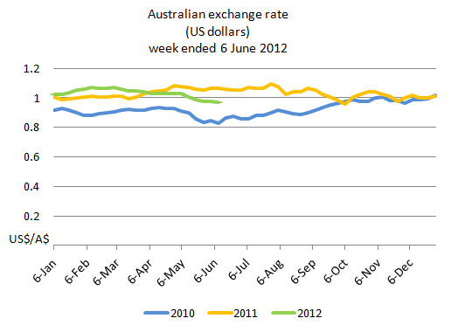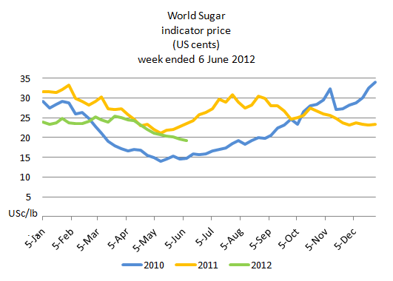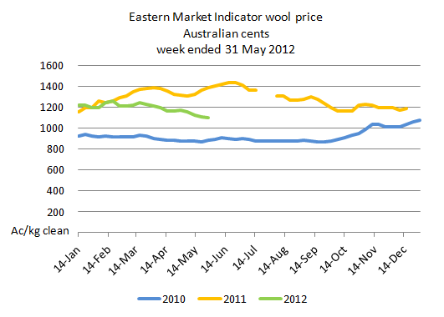

Crop indicator prices
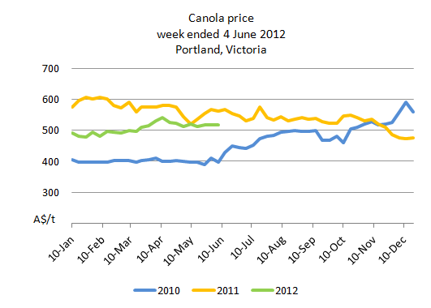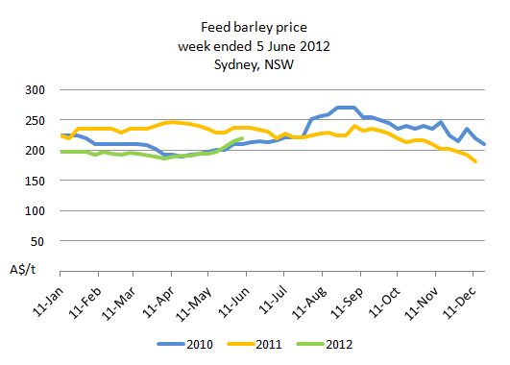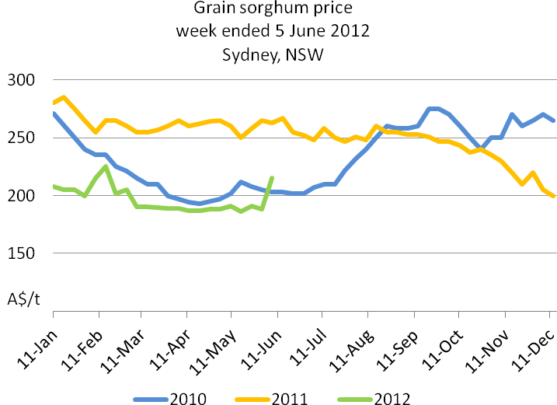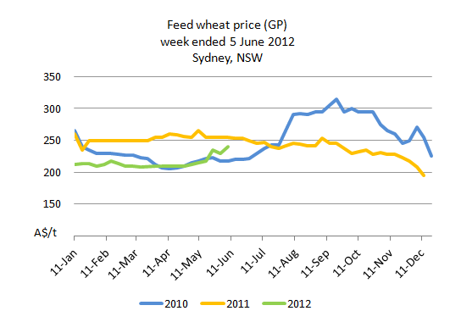

Livestock indicator prices
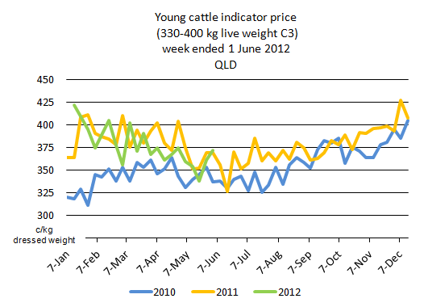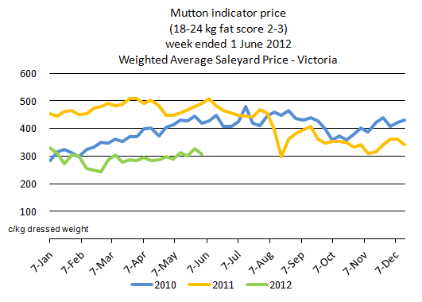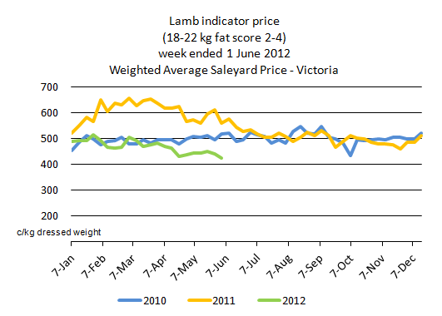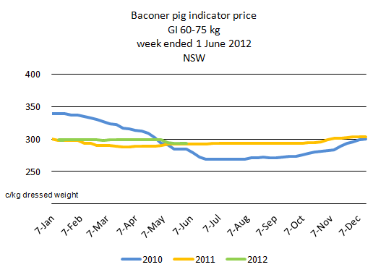

Data attribution

Climate
Bureau of Meteorology
- Weekly rainfall totals: www.bom.gov.au/jsp/awap/rain/index.jsp
- Monthly and last 3-months rainfall percentiles: www.bom.gov.au/jsp/awap/
- Temperature anomalies: www.bom.gov.au/jsp/awap/
- Rainfall forecast: www.bom.gov.au/jsp/watl/rainfall/pme.jsp
- Seasonal outlook: www.bom.gov.au/climate/ahead
- Drought statement: www.bom.gov.au/climate/drought/drought.shtml
- ENSO Wrap-Up: www.bom.gov.au/climate/enso/
- Soil moisture (BoM, CSIRO and the former Bureau of Rural Sciences): www.eoc.csiro.au/awap/

Water
New South Wales
- New South Wales Water Information: http://waterinfo.nsw.gov.au/
- New South Wales Office of Water, Department of Environment, Climate Change and Water: www.water.nsw.gov.au/Home/default.aspx
- Available water determinations register: www.wix.nsw.gov.au/wma/DeterminationSearch.jsp?selectedRegister=Determination
- Snowy Hydro: www.snowyhydro.com.au/lakeLevels.asp?pageID=47&parentID=61&grandParentID=4
Queensland
- Sunwater: www.sunwater.com.au
- seqwater: http://seqwater.com.au
South Australia
- SA Water: www.sawater.com.au/SAWater/Environment/TheRiverMurray/River+Murray+Levels.htm
- South Australian Department of Water: www.waterforgood.sa.gov.au/
Victoria
- Goulburn–Murray Water: www.g-mwater.com.au
Water trading
- Waterexchange: www.waterexchange.com.au

Commodities
Fruit and vegetables
- Datafresh: www.datafresh.com.au
Mutton, lambs, wheat, barley and grain sorghum
- The Land: hardcopy or online at http://theland.farmonline.com.au/markets.aspx
Cattle, mutton, lambs and pigs
- Meat and Livestock Australia: www.mla.com.au/Prices-and-markets
Canola
- Weekly Times: hardcopy

