
31 May 2012
The full report is available from www.daff.gov.au/abares

Summary of key issues
- Rainfall across south-eastern Australia in the past week has provided timely moisture for germination of recently sown crops. No rainfall was received in Western Australian cropping regions.
- Heavy rain in eastern Queensland has delayed the start of the sugar cane harvest, although the crop is expected to carry through to the end of harvest in good condition.
- Widespread rainfall is forecast across eastern Australia over the coming week. No significant rainfall is forecast in western and southern Australia.
- Water storage levels in the Murray–Darling Basin increased this week by 56 gigalitres (GL) to approximately 90 per cent of total capacity.
- The wholesale prices of vegetables were generally higher in the week ending 26 May 2012 compared with the previous week but the wholesale prices of fruit were generally lower.
- The wholesale prices of fruit were generally lower in the week ending 26 May 2012, with significant decreases in banana (cavendish), watermelon (seedless) and rockmelon prices.
- The wholesale prices of potato (white, washed), cauliflower, iceberg lettuce, pumpkin (grey bulk) and beans (round) were higher in the week ending 26 May 2012.
- The world cotton indicator price (the Cotlook ‘A’ index) averaged US82.8 cents a pound in the week ending 30 May 2012, the lowest since the week ending 17 February 2010.
- The world coarse grains indicator price (US no. 2 yellow corn, free on board Gulf ports) averaged US$254 a tonne for the week ending 30 May 2012, compared with US$278 a tonne in the previous week.
- The Queensland young cattle indicator price (330–400 kg live weight C3) rose 6.8 per cent to 361 cents a kilogram in the week ending 25 May 2012. Young cattle prices also rose in South Australia, but fell in New South Wales, Victoria and Tasmania.
- Saleyard prices of lamb increased in most states in the week ending 25 May 2012. Lamb rose by 3 per cent in New South Wales and South Australia, to 412 cents and 446 cents per kilogram respectively. In Western Australia the indicator price rose by 1 per cent to 400 cents per kilogram. Victoria was the only state to record a decline.

Climate

Notable events
- For the week ending 30 May 2012, widespread falls of around 25 millimetres (mm) were recorded across most of eastern Australia. Little or no rainfall was recorded over most of central and Western Australia. The highest measured rainfall total for the week was 342 mm at Mosman, near Port Douglas, in north Queensland.
- Rainfall across most of south-eastern Australia over the past week has provided timely moisture for germination of recently sown winter crops. With large areas of crops already sown the rainfall has provided a promising start to the season.
- No rainfall was recorded in cropping areas of Western Australia this week. With soil moisture deficiencies remaining and no significant rain forecast in the coming week, winter crops in this area will be heavily reliant on rainfall over the coming weeks to allow germination and establishment.
- Heavy rain on the Queensland coast over the past week has resulted in a delay to the start of the sugar cane harvest. Despite the delay, the rainfall is expected to carry the crop through to the end of harvest in good condition.
- An inland trough is expected to bring widespread falls of around 25mm to eastern Australia over the coming week. Further rainfall will assist with the establishment of winter crops in this area.

Rainfall this week
For the week ending 30 May 2012, widespread falls of around 25mm were recorded across most of eastern Australia, little or no rainfall was recorded over most of central and Western Australia. For further information, go to www.bom.gov.au/climate/current/weeklyrain.shtml.

Rainfall for the week ending 30 May 2012
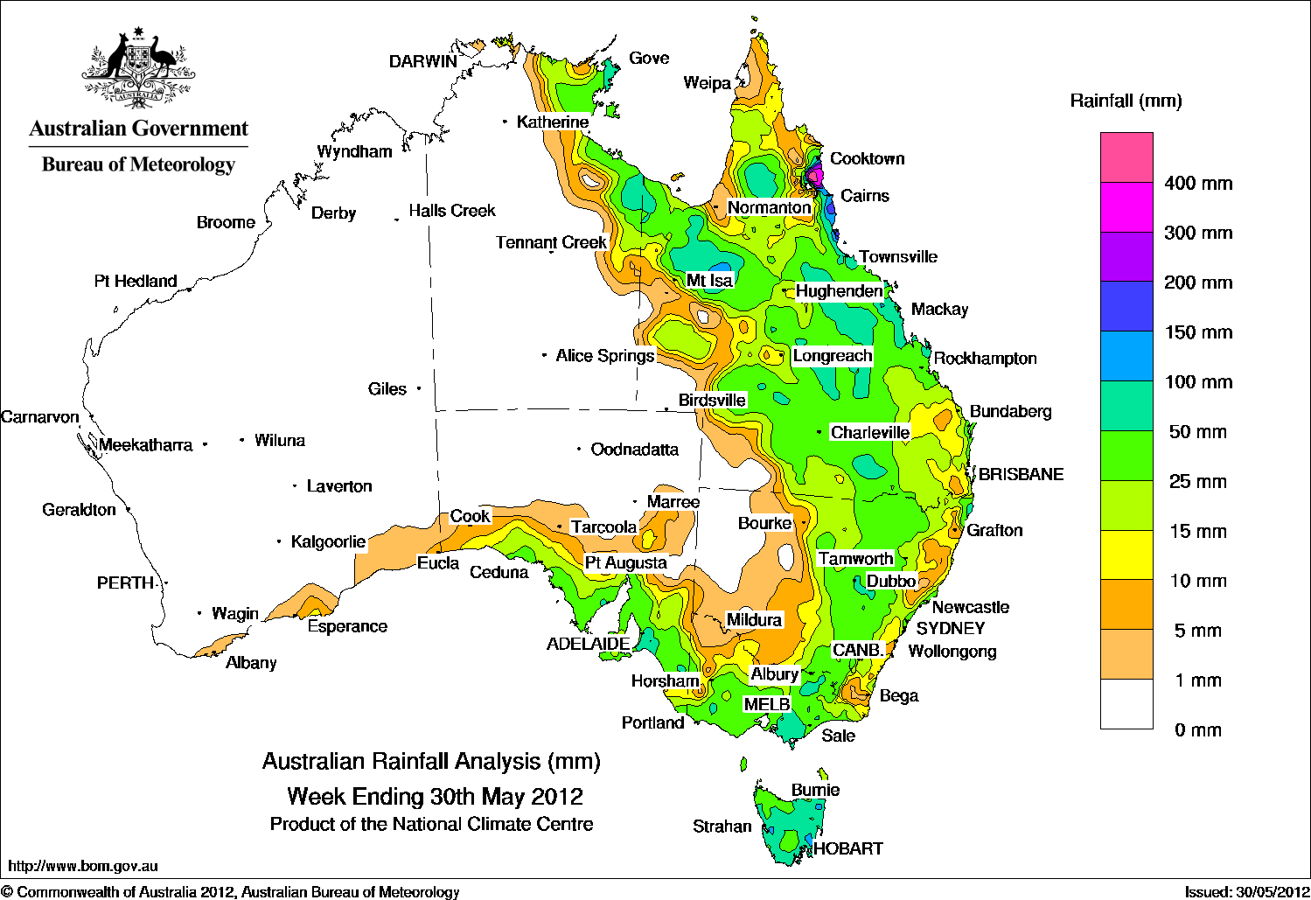

Temperature anomalies this week
Spatial temperature analyses are based on historical weekly temperature data provided by the Bureau of Meteorology. These temperature anomaly maps show the departure of the maximum and minimum from the long-term average. Temperature anomalies are calculated using high resolution gridded datasets from 1911 onwards. For further information on temperature anomalies, go to www.bom.gov.au/jsp/awap/.

Maximum temperature anomalies for the week ending 29 May 2012
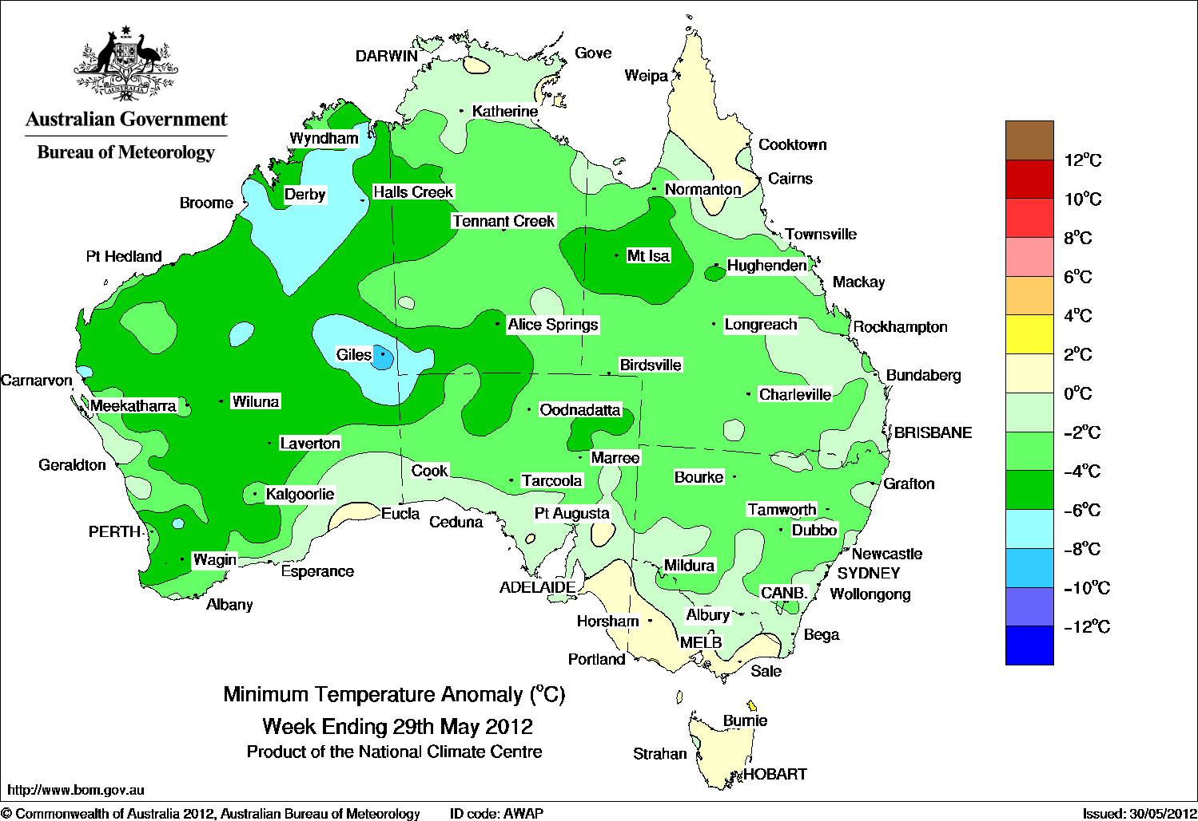

Minimum temperature anomalies for the week ending 29 May 2012
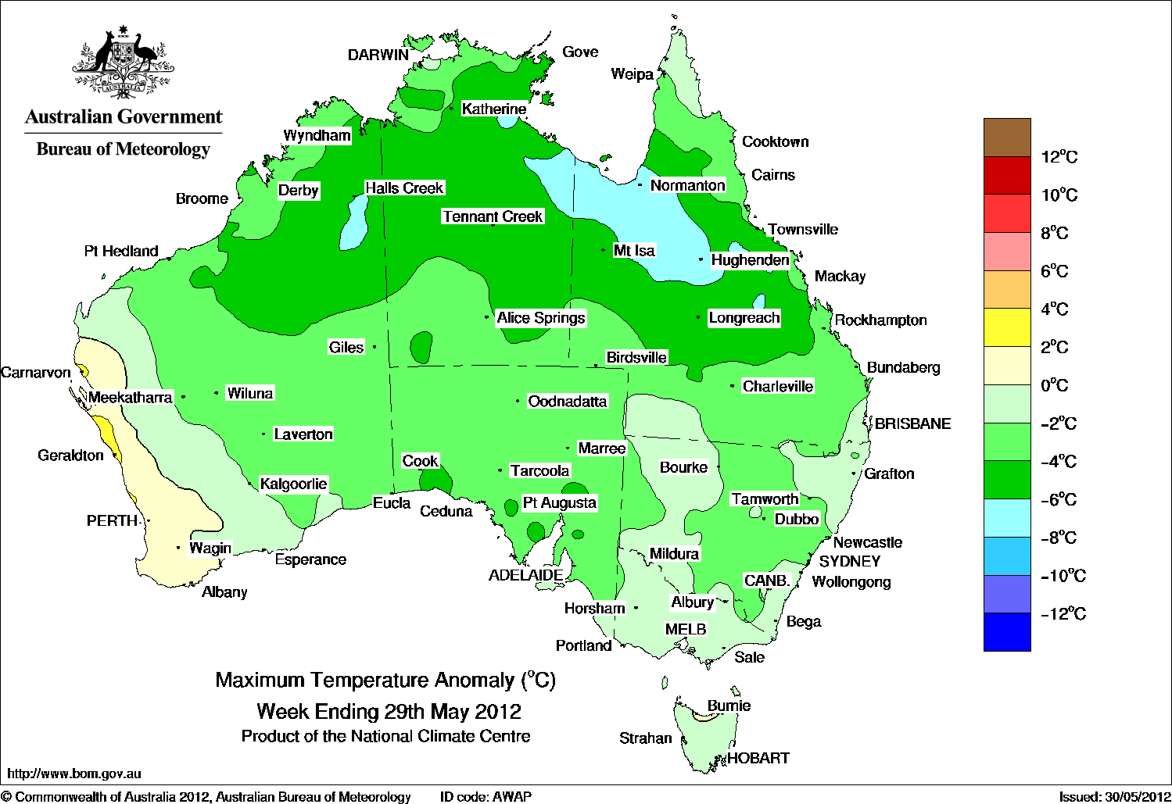

Rainfall outlook
The rainfall forecast below is produced from computer models. As it contains no input from weather forecasters, it is important to also check local forecasts and warnings by the Bureau of Meteorology.

Total forecast rainfall for the period 31 May to 7 June 2012

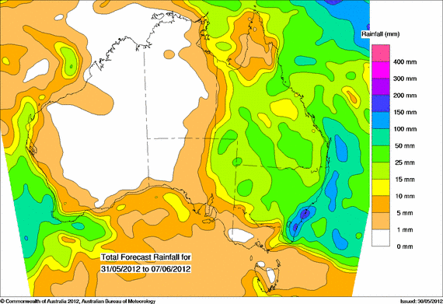

Water

Water availability
- Water storage levels in the Murray–Darling Basin (MDB) increased this week by 56 gigalitres (GL) to approximately 90 per cent of total capacity. This is 8 percentage points or 1727 GL more than this time last year.

Water storages in the Murray–Darling Basin (NSW, Victoria and Queensland)
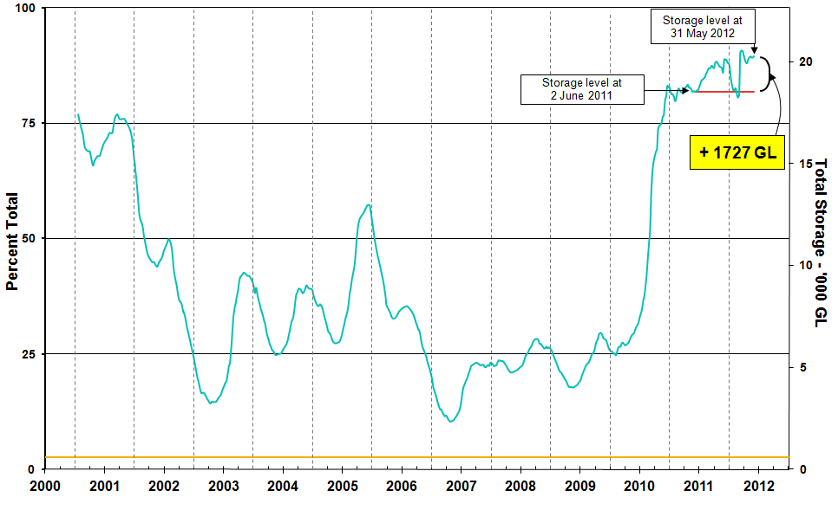
Information on irrigation water available in the Murray–Darling Basin from 1 January 2001 to 31 May 2012 is shown above. The top horizontal (red) line indicates the storage level at the similar time last year. The bottom horizontal (orange) line indicates the amount of ‘dead’ or unusable storage.

Commodities

Production and commodities
- The wholesale prices of fruit were generally lower in the week ending 26 May 2012, with significant decreases in banana (cavendish), watermelon (seedless) and rockmelon prices. Avocado (hass), pineapple (smoothleaf) and kiwifruit (hayward) prices had more modest decreases.
- The wholesale prices of potato (white, washed), cauliflower, iceberg lettuce, pumpkin (grey bulk) and beans (round) were higher in the week ending 26 May 2012. The wholesale prices of tomato (field gourmet) and broccoli were lower.
- The world cotton indicator price (the Cotlook ‘A’ index) averaged US82.8 cents a pound in the week ending 30 May 2012, the lowest since the week ending 17 February 2010, when the price was around US80 cents a pound.
- The world sugar indicator price (Intercontinental Exchange, nearby futures, no. 11 contract) remained relatively unchanged in the week ending 30 May 2012 at an average of US19.6 cents a pound.
- The Eastern Market Indicator price for wool fell 1.6 per cent in the week ending 24 May 2012 to 1104 cents a kilogram clean. The number of bales offered was 10 per cent lower than the previous week and was the third smallest offering this season.
- The world canola indicator price (Rapeseed, Europe, free on board Hamburg) averaged US$599 a tonne in the week ending 29 May 2012, compared with US$607 a tonne in the previous week.
- The Australian canola indicator price (Portland, Victoria) averaged $518 a tonne in the week ending 28 May 2012, compared with $516 a tonne in the previous week.
- The world coarse grains indicator price (US no. 2 yellow corn, free on board Gulf ports) averaged US$254 a tonne for the week ending 30 May 2012, compared with US$278 a tonne in the previous week.
- The world wheat indicator price (US no. 2 hard red winter, free on board Gulf ports) averaged US$294 a tonne in the week ending 29 May 2012, compared with US$293 a tonne in the previous week.
- The Queensland young cattle indicator price (330–400 kg live weight C3) rose 6.8 per cent to 361 cents a kilogram in the week ending 25 May 2012. Young cattle prices also rose in South Australia, but fell in New South Wales, Victoria and Tasmania.
- Saleyard prices of lamb increased in most states in the week ending 25 May 2012. Lamb rose by 3 per cent in New South Wales and South Australia, to 412 cents and 446 cents per kilogram respectively. In Western Australia the indicator price rose by 1 per cent to 400 cents per kilogram. Victoria was the only state to record a decline, where the indicator price (18-22 kg fat score 2-4) fell 2 per cent to 442 cents a kilogram.

Recent movements in fruit and vegetable prices
Weekly wholesale prices for selected fruit, Melbourne market
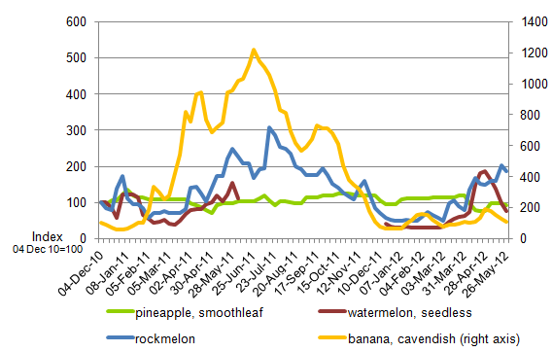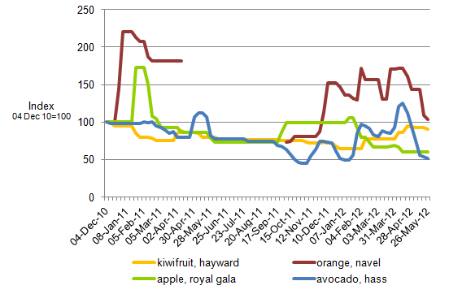
Weekly wholesale prices for selected vegetables, Melbourne market

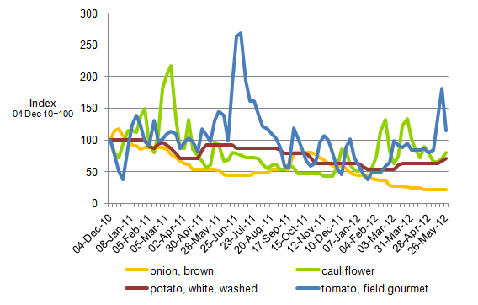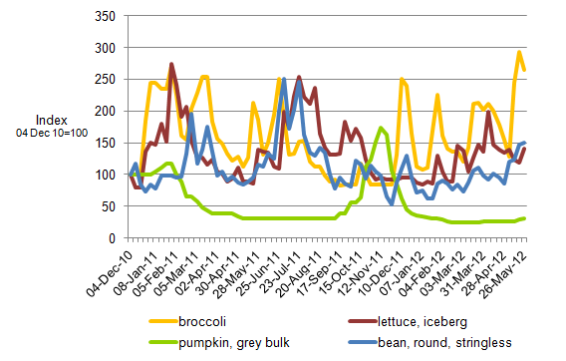

Selected world indicator prices
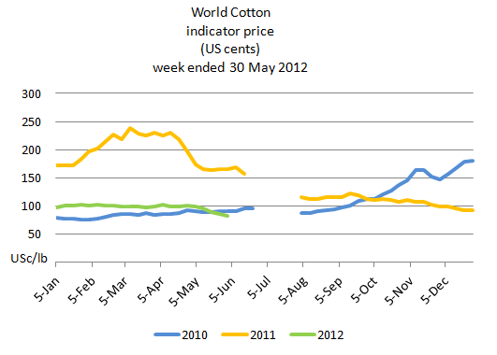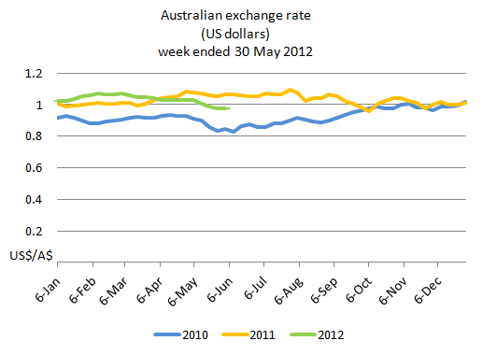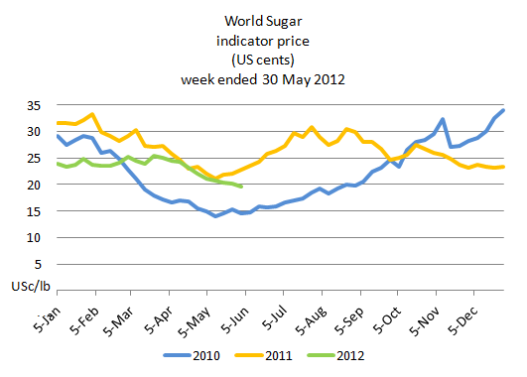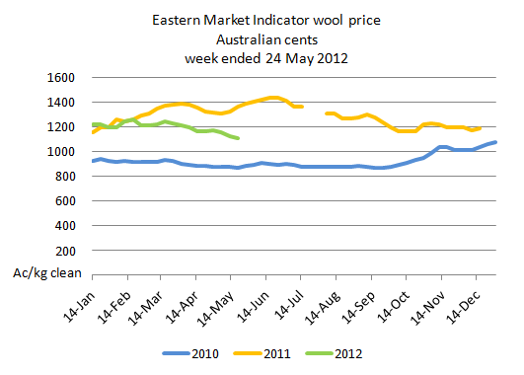

Crop indicator prices
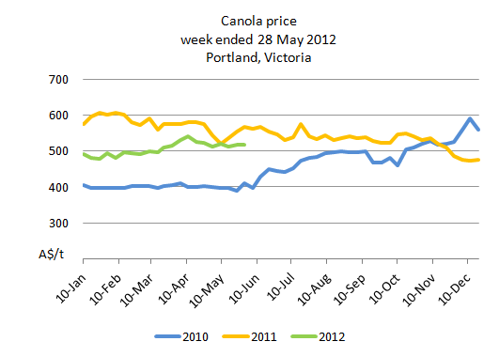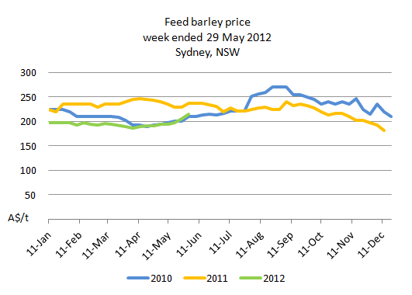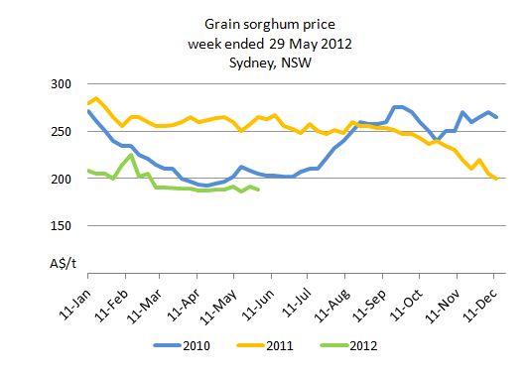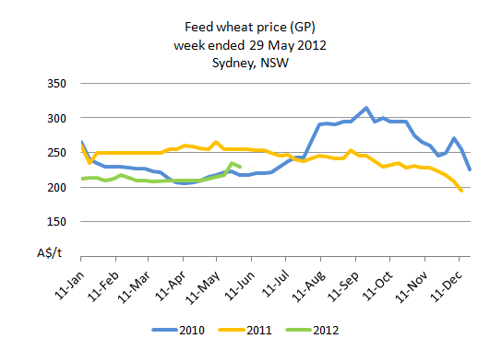

Livestock indicator prices
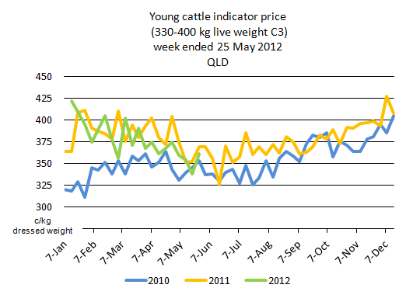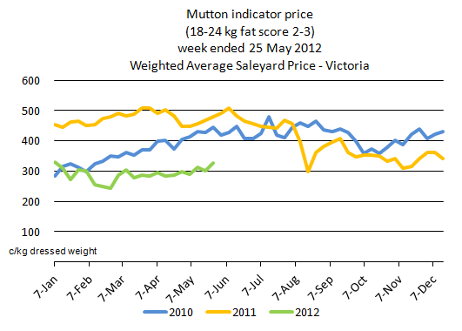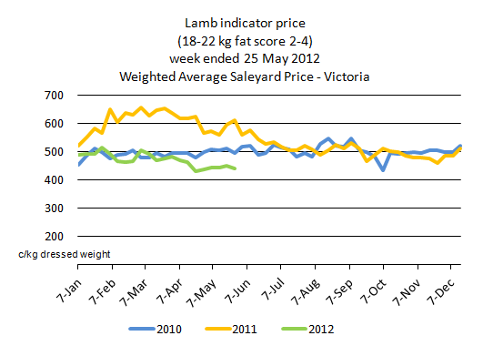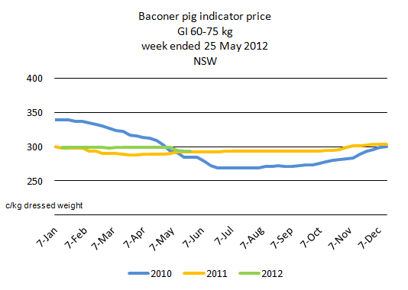

Data attribution

Climate
Bureau of Meteorology
- Weekly rainfall totals: www.bom.gov.au/jsp/awap/rain/index.jsp
- Monthly and last 3-months rainfall percentiles: www.bom.gov.au/jsp/awap/
- Temperature anomalies: www.bom.gov.au/jsp/awap/
- Rainfall forecast: www.bom.gov.au/jsp/watl/rainfall/pme.jsp
- Seasonal outlook: www.bom.gov.au/climate/ahead
- Drought statement: www.bom.gov.au/climate/drought/drought.shtml
- ENSO Wrap-Up: www.bom.gov.au/climate/enso/
- Soil moisture (BoM, CSIRO and the former Bureau of Rural Sciences): www.eoc.csiro.au/awap/

Water
New South Wales
- New South Wales Water Information: http://waterinfo.nsw.gov.au/
- New South Wales Office of Water, Department of Environment, Climate Change and Water: www.water.nsw.gov.au/Home/default.aspx
- Available water determinations register: www.wix.nsw.gov.au/wma/DeterminationSearch.jsp?selectedRegister=Determination
- Snowy Hydro: www.snowyhydro.com.au/lakeLevels.asp?pageID=47&parentID=61&grandParentID=4
Queensland
- Sunwater: www.sunwater.com.au
- seqwater: http://seqwater.com.au
South Australia
- SA Water: www.sawater.com.au/SAWater/Environment/TheRiverMurray/River+Murray+Levels.htm
- South Australian Department of Water: www.waterforgood.sa.gov.au/
Victoria
- Goulburn–Murray Water: www.g-mwater.com.au
Water trading
- Waterexchange: www.waterexchange.com.au

Commodities
Fruit and vegetables
- Datafresh: www.datafresh.com.au
Mutton, lambs, wheat, barley and grain sorghum
- The Land: hardcopy or online at http://theland.farmonline.com.au/markets.aspx
Cattle, mutton, lambs and pigs
- Meat and Livestock Australia: www.mla.com.au/Prices-and-markets
Canola
- Weekly Times: hardcopy

