Weekly Australian Climate, Water and Agricultural Update

24 November 2011
The full report is available from www.daff.gov.au/abares

Summary of key issues
- Recent rainfall across New South Wales has delayed the winter grain harvest. Rainfall forecast over the next week could cause further delays and downgrades to grain quality in some regions.
- The recent rainfall will improve soil moisture and assist pasture growth across southern Australia.
- Wetter conditions are favoured over summer in eastern and western Australia, while drier conditions are favoured for parts of central Queensland and south-east Australia (Bureau of Meteorology Seasonal Outlook, 22 November 2011).
- Water storage levels in the Murray–Darling Basin decreased this week by 194 gigalitres to approximately 86 per cent of total capacity.
- General security allocations in the New South Wales Murrumbidgee Valley system increased this week from 69 to 72 per cent of entitlement.
- Avocado, peach and rockmelon wholesale prices were higher in the week ending 19 November 2011. Prices of bananas continued to decline, while vegetable prices were generally lower or steady.
- The world wheat indicator price (US hard red winter, free on board Gulf ports) averaged US$288 a tonne in the week ending 22 November 2011, compared with US$302 a tonne in the previous week.
- The world sugar indicator price averaged US23.7 cents a pound in the week ending 23 November 2011, US1.2 cents a pound lower than the previous week.
- The Australian canola indicator price (Portland, Victoria) averaged $509 a tonne for the week ending 21 November 2011, compared with $521 a tonne in the previous week.
- The Eastern Market Indicator price for wool fell by 2.4 per cent in the week ending 17 November 2011 to 1190 cents a kilogram clean.
- Saleyard cattle prices in the week ending 18 November 2011 were generally higher, despite a 29 per cent rise in saleyard throughput at National Livestock Reporting Service centres.
- Saleyard sheep prices fell in most states (except Victoria) in the week ending 18 November 2011, despite lower saleyard throughput. The largest decline was in South Australia, where prices fell by 12 per cent to 267 cents a kilogram.
1. Climate

Notable events
- For the week ending 23 November 2011, rainfall was mostly recorded in northern, central and south-east Australia. The highest measured total for the week was 216 millimetres at Daly Waters in the Katherine region of the Northern Territory.
- Recent rainfall across New South Wales has caused delays to the winter grain harvest, particularly in northern cropping regions. Rainfall forecast over the next week may result in further delays to the harvest and could downgrade grain quality in some areas.
- The recent rainfall will improve soil moisture and assist pasture growth across southern Australia.
- The La Niña conditions have changed little over the past fortnight, with most atmospheric and oceanic indicators remaining at, or just exceeding, La Niña thresholds. This event is likely to peak near the end of the year and persist into early 2012. The current event is considerably weaker than the very strong 2010-11 event (Bureau of Meteorology ENSO ‘Wrap-up’, 23 November 2011).
- Wetter conditions are favoured over eastern and western Australia for the December 2011 to February 2012 (summer) period. Drier conditions are favoured for parts of central Queensland and south-east Australia (Bureau of Meteorology National Seasonal Rainfall Outlook, 22 November 2011).
- Warmer daytime and night time temperatures are favoured over parts of northern and southern Australia for the December 2011 to February 2012 (summer) period, while cooler daytime temperatures are favoured for north-east New South Wales and southern Queensland (Bureau of Meteorology National Seasonal Temperature Outlook, 22 November 2011).

Rainfall this week
For the week ending 23 November 2011, rainfall was received mostly recorded in northern, central and parts of south-east Australia. For further information, go to www.bom.gov.au/climate/current/weeklyrain.shtml.

Rainfall for the week ending 23 November 2011
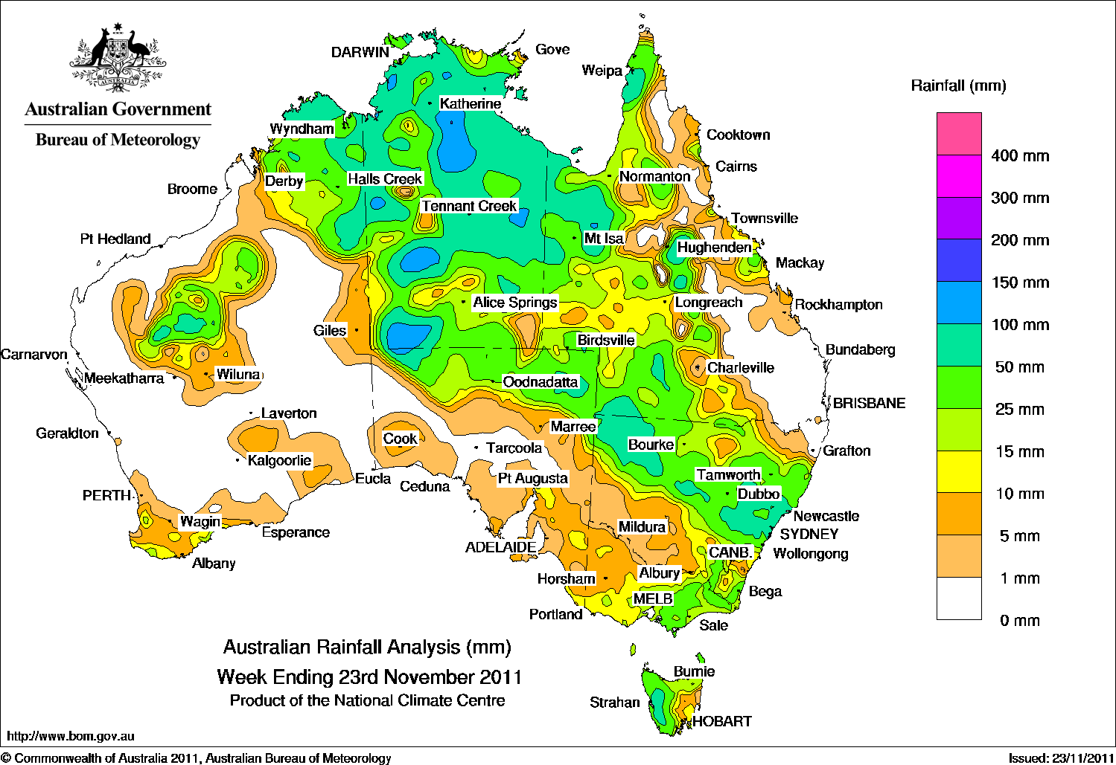

Temperature anomalies this week
Spatial temperature analyses are based on historical weekly temperature data provided by the Bureau of Meteorology. These temperature anomaly maps show the departure of the maximum and minimum from the long-term average. Temperature anomalies are calculated using high resolution gridded datasets from 1911 onwards. For further information on temperature anomalies, go to www.bom.gov.au/jsp/awap/.

Maximum temperature anomalies for the week ending 22 November 2011
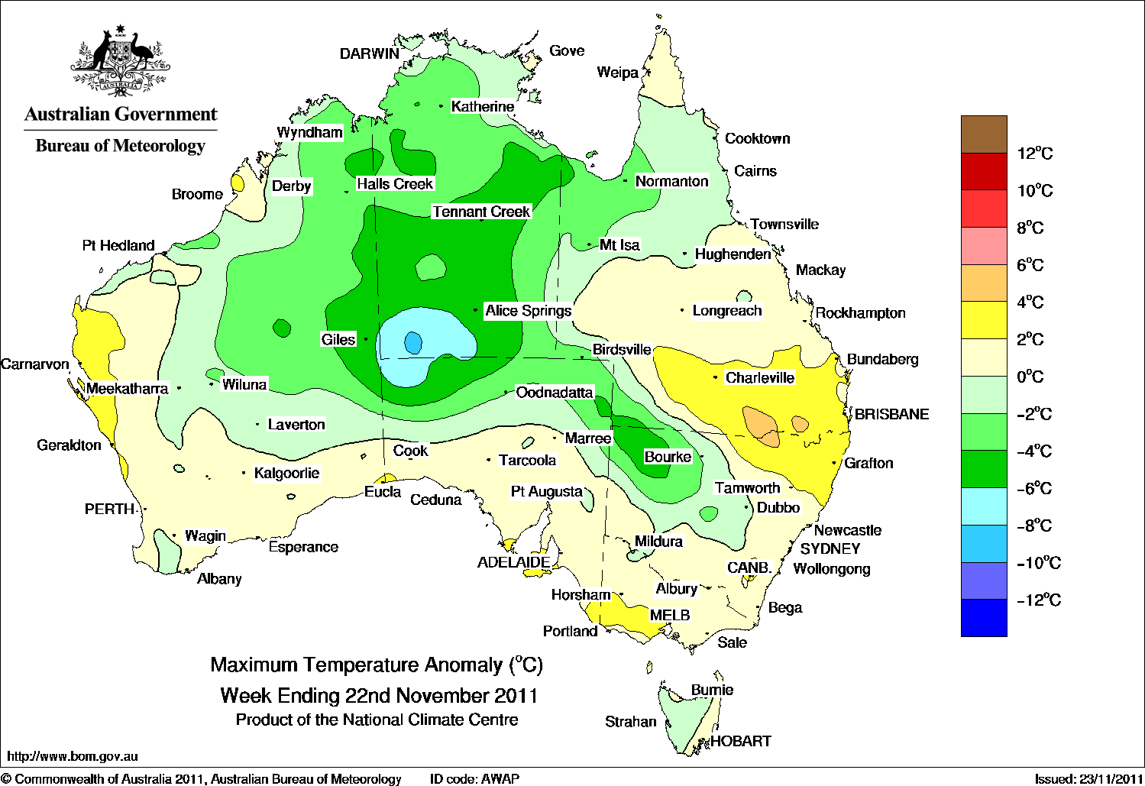

Minimum temperature anomalies for the week ending 22 November 2011
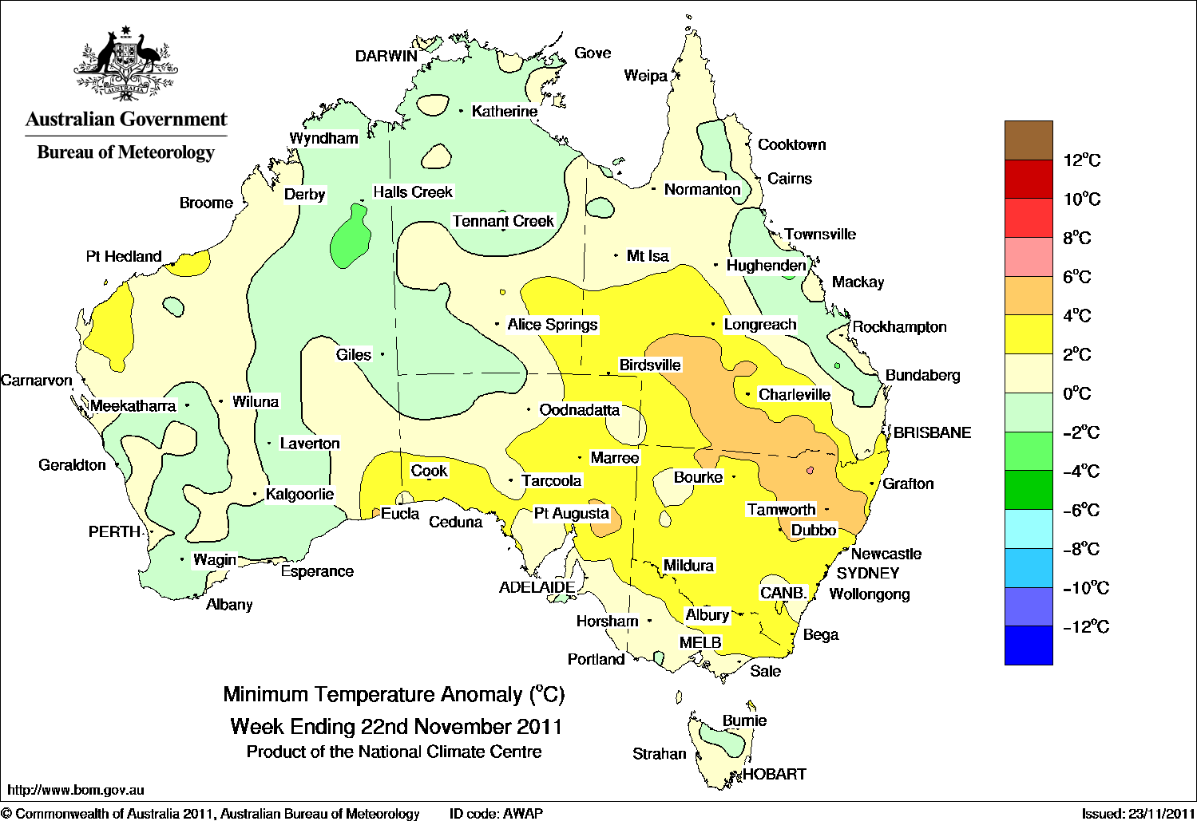

Rainfall outlook
The rainfall forecast below is produced from computer models. As it contains no input from weather forecasters, it is important to also check local forecasts and warnings by the Bureau of Meteorology.

Total forecast rainfall for the period 24 November to 1 December 2011

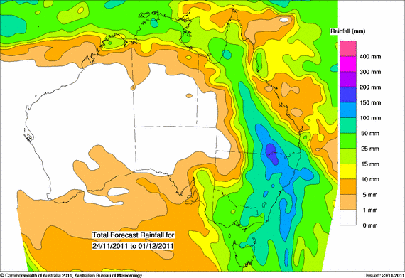

Seasonal outlook

Chance of exceeding the median rainfall – December 2011 to February 2012
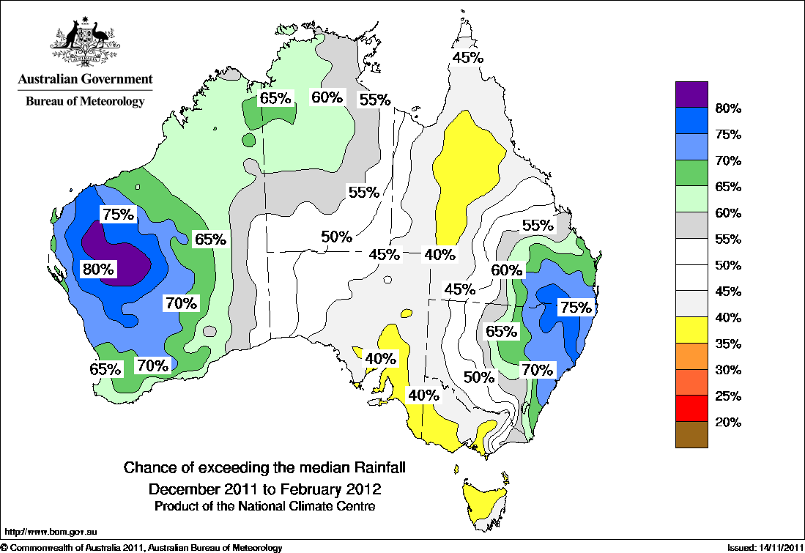

Chance of exceeding the median maximum temperature – December 2011 to February 2012
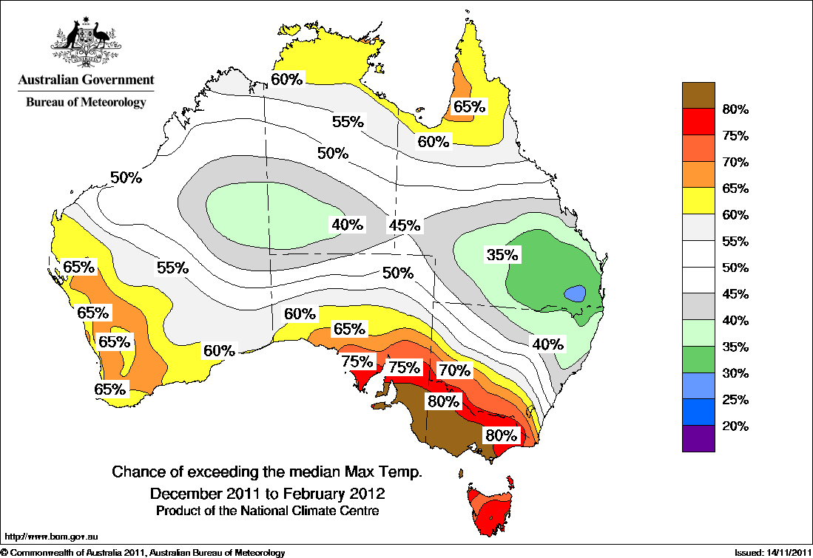

Chance of exceeding the median minimum temperature – December 2011 to February 2012

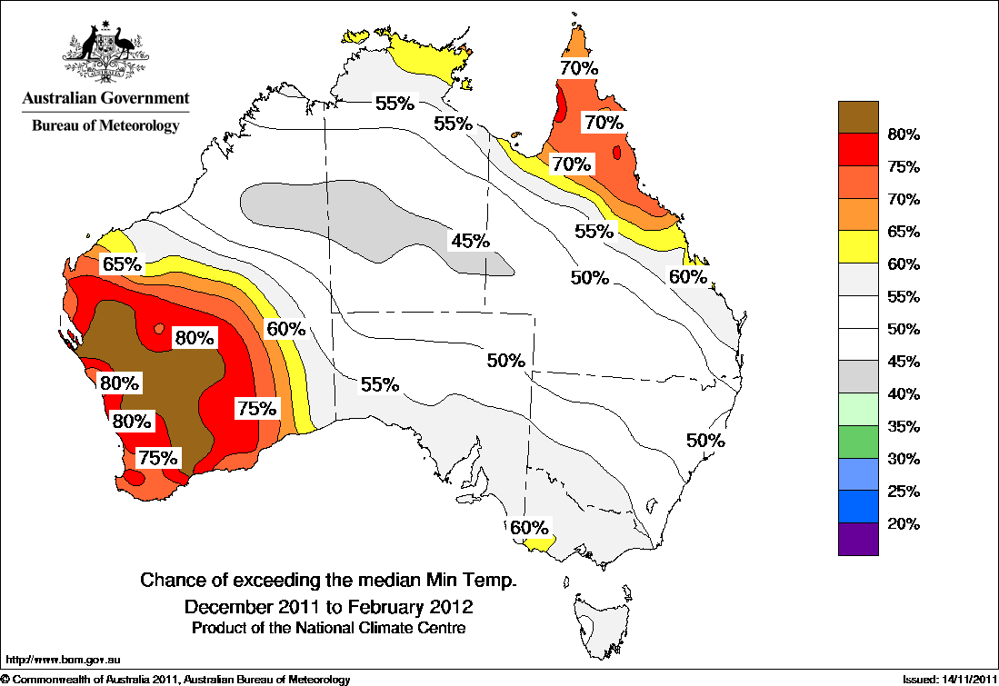

Water

Water availability
- Water storage levels in the Murray–Darling Basin decreased this week by 194 gigalitres (GL) to approximately 86 per cent of total capacity. This is 9 percentage points or 2090 GL more than this time last year.
- General security allocations in the New South Wales Murrumbidgee Valley system increased this week from 69 to 72 per cent of entitlement.

Water storages

Water storages in the Murray–Darling Basin (New South Wales, Victoria and Queensland)
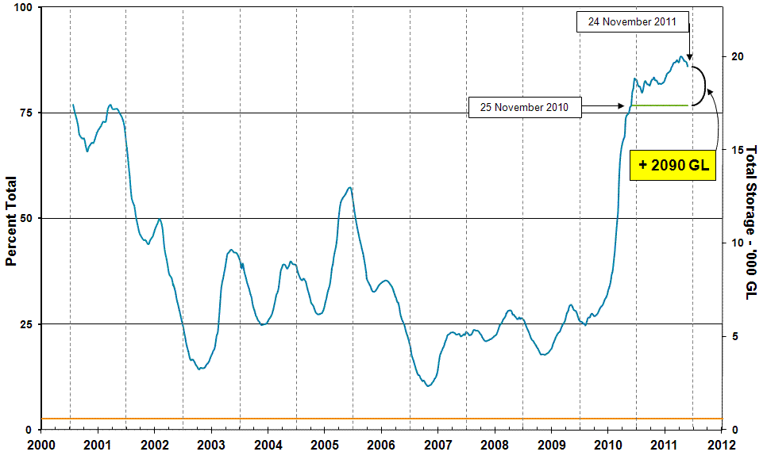
Information on irrigation water available in the Murray–Darling Basin from 1 January 2001 to 24 November 2011 is shown above. The green line indicates the storage level at the same time last year. The orange line indicates the amount of ‘dead’ or unusable storage.

Commodities

Production and commodities
- Avocado, peach and rockmelon wholesale prices were higher in the week ending 19 November 2011, but banana prices declined to their lowest level since early February 2011.
- Peach prices are currently 37 per cent lower than at the same time in 2010, under the influence of a forecast larger 2011–12 stone fruit harvest.
- Vegetable wholesale prices were generally steady or lower in the week ending 19 November 2011, with a particularly significant decline for beans. Conditions have been favourable for potato production, resulting in a year on year decline of 38 per cent in wholesale potato prices.
- The world wheat indicator price (US hard red winter, free on board Gulf ports) averaged US$288 a tonne in the week ending 22 November 2011, compared with US$302 a tonne in the previous week.
- The world coarse grains indicator price (US no. 2 yellow corn, free on board Gulf ports) averaged US$264 a tonne in the week ending 23 November 2011, compared with US$280 a tonne in the previous week.
- The world sugar indicator price (Intercontinental Exchange, nearby futures, no. 11 contract) fell by a further 4.7 per cent to average US23.7 cents a pound in the week ending 23 November 2011. Bearish factors affecting sugar prices include approval by the Indian government to export one million tonnes of white sugar in 2011–12.
- The Australian canola indicator price (Portland, Victoria) averaged $509 a tonne for the week ending 21 November 2011, compared with $521 a tonne in the previous week.
- The Eastern Market Indicator price for wool fell by 2.4 per cent in the week ending 17 November 2011 to 1190 cents a kilogram clean. The number of bales offered at auction was around 8 per cent higher than the previous week. The pass-in rate across all auction centres was 16 per cent.
- Saleyard cattle prices in the week ending 18 November 2011 were generally higher, despite a 29 per cent rise in saleyard throughput at National Livestock Reporting Service centres. Young cattle prices rose in all states except South Australia where they were unchanged. Heavy steer prices remained steady in Queensland and South Australia, but rose in New South Wales and Victoria, while medium cow prices rose in all states.
- Saleyard lamb prices were mixed in the week ending 18 November 2011, with prices averaging higher in New South Wales and Western Australia but falling in South Australia and Victoria. Lamb yardings in reported saleyards in the eastern states increased by 14 per cent, but fell by 12 per cent in Western Australia.
- Saleyard sheep prices generally fell in the week ending 18 November 2011, despite lower saleyard sheep throughput. The largest decline was in South Australia, where prices fell by 12 per cent to 267 cents a kilogram. Saleyard sheep prices in Victoria, the only state where prices rose, were 2 per cent higher at 316 cents a kilogram.

Recent movements in fruit and vegetable prices
Weekly wholesale prices for selected fruit, Melbourne market
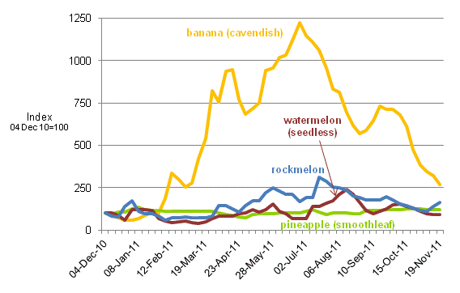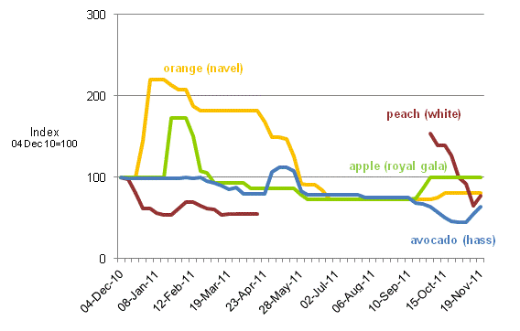

Weekly wholesale prices for selected vegetables, Melbourne market
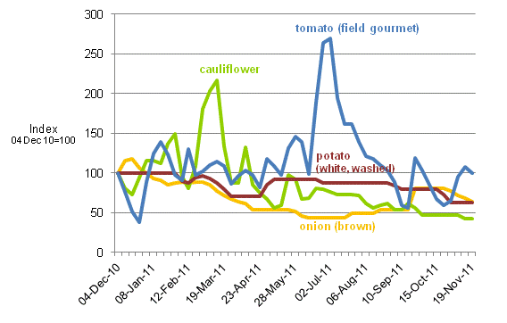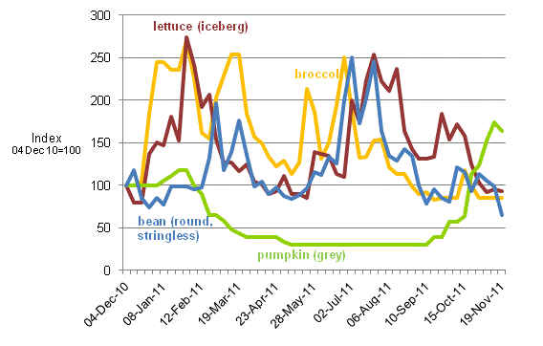

Selected world indicator prices
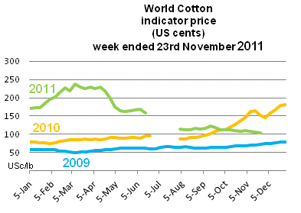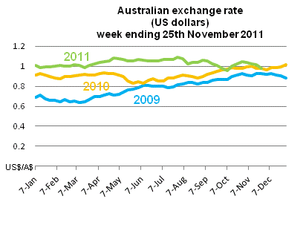
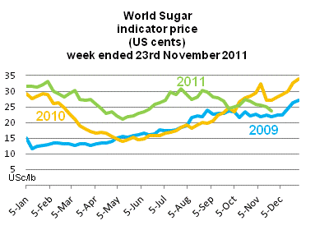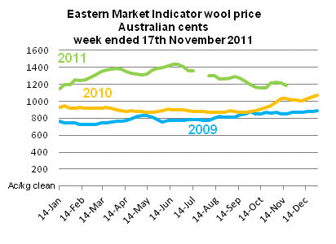

Crop indicator prices
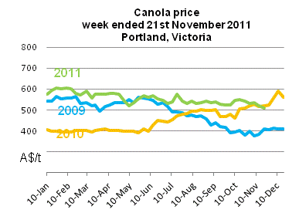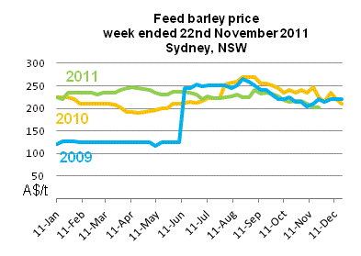
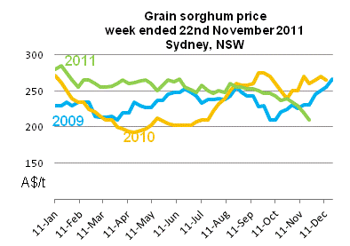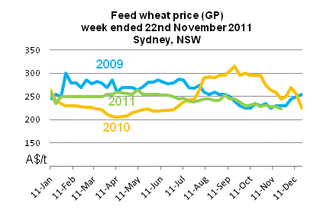

Livestock indicator prices
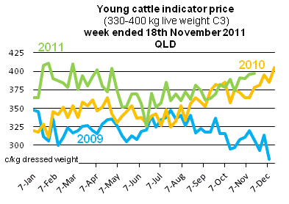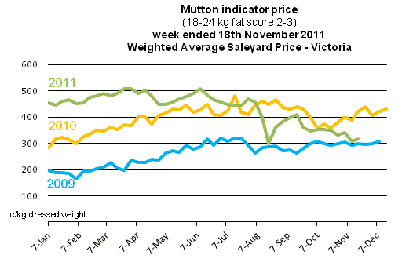
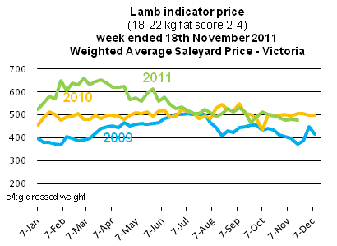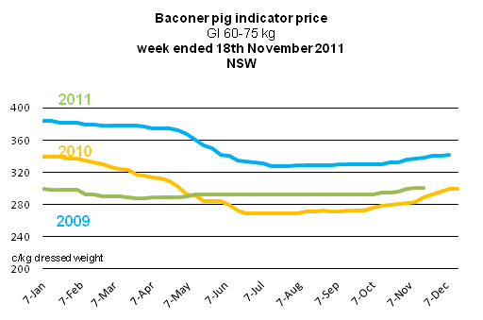

Data attribution

Climate
Bureau of Meteorology
- Weekly rainfall totals: www.bom.gov.au/jsp/awap/rain/index.jsp
- Monthly and last 3-months rainfall percentiles: www.bom.gov.au/jsp/awap/
- Temperature anomalies: www.bom.gov.au/jsp/awap/
- Rainfall forecast: www.bom.gov.au/jsp/watl/rainfall/pme.jsp
- Seasonal outlook: www.bom.gov.au/climate/ahead
- Drought statement: www.bom.gov.au/climate/drought/drought.shtml
- ENSO Wrap-Up: www.bom.gov.au/climate/enso/
- Soil moisture (BoM, CSIRO and the former Bureau of Rural Sciences): www.eoc.csiro.au/awap/

Water
New South Wales
- New South Wales Water Information: http://waterinfo.nsw.gov.au/
- New South Wales Office of Water, Department of Environment, Climate Change and Water: www.water.nsw.gov.au/Home/default.aspx
- Available water determinations register: www.wix.nsw.gov.au/wma/DeterminationSearch.jsp?selectedRegister=Determination
- Snowy Hydro: www.snowyhydro.com.au/lakeLevels.asp?pageID=47&parentID=61&grandParentID=4
Queensland
- Sunwater: www.sunwater.com.au
- seqwater: http://seqwater.com.au
South Australia
- SA Water: www.sawater.com.au/SAWater/Environment/TheRiverMurray/River+Murray+Levels.htm
- South Australian Department of Water: www.waterforgood.sa.gov.au/
Victoria
- Goulburn–Murray Water: www.g-mwater.com.au
Water trading
- Waterexchange: www.waterexchange.com.au

Commodities
Fruit and vegetables
- Datafresh: www.datafresh.com.au
Mutton, lambs, wheat, barley and grain sorghum
- The Land: hardcopy or online at http://theland.farmonline.com.au/markets.aspx
Cattle, mutton, lambs and pigs
- Meat and Livestock Australia: www.mla.com.au/Prices-and-markets
Canola
- Weekly Times: hardcopy

