Weekly Australian Climate, Water and Agricultural Update

27 October 2011
The full report is available from www.abares.gov.au

Summary of key issues
- Rainfall received this week over parts of southern Australia will assist grain fill in crops in the lead up to harvest.
- Lightning associated with stormy weather has reportedly started a number of large fires throughout western Queensland. The grassfires burning last week were contained but have caused pasture damage in some areas.
- Large numbers of cotton bollworms have been found in canola crops in the north-west cropping region of New South Wales.
- The tropical Pacific Ocean is now in the early stages of a late-forming La Niña event. Indications are that this event will be considerably weaker than the strong 2010–11 event (Bureau of Meteorology ENSO ‘Wrap-up’, 26 October 2011).
- Wetter than average conditions are favoured over much of Australia for the November 2011 to January 2012 period. Warmer temperatures are favoured over parts of south-east Australia (Bureau of Meteorology National Seasonal Rainfall and Temperature Outlooks, 25 October 2011).
- The world coarse grains indicator price (US no. 2 yellow corn, free on board Gulf ports) averaged US$281 a tonne in the week ending 26 October 2011, compared with US$280 a tonne in the previous week.
- The world wheat indicator price (US hard red winter, free on board Gulf ports) averaged US$307 a tonne in the week ending 25 October 2011, compared with US$298 a tonne in the previous week.
- The world cotton indicator price (the Cotlook ‘A’ index) averaged US108.1 cents a pound in the week ending 26 October 2011, the lowest price in 13 months.
- Saleyard lamb prices eased in most states in the week ending 21 October 2011.
- Saleyard cattle prices in the week ending 21 October 2011 were generally lower, with the Queensland young cattle indicator price falling by 16 cents to 373 cents a kilogram.
- Most fruit and vegetable prices were lower or steady in the week ending 22 October 2011, with only pumpkin prices increasing. Banana prices were 23 per cent lower.
- The world sugar indicator price fell 2.8 per cent in the week ending 26 October 2011, to US26.7 cents a pound.

Climate

Notable events
- For the week ending 26 October 2011, rainfall was recorded in all states and territories with the highest falls received in northern and south-west Australia. The highest measured total for the week was 461 millimetres at Babinda in far north Queensland.
- Rainfall received this week over southern Australia will assist grain fill in crops in the lead up to harvest. The rain may have caused some harvest delays in Western Australia’s northern wheat belt.
- Lightning associated with thunderstorms in western Queensland has started a number of large grassfires. Fires burning in Queensland’s central-west and far south-west last week have been contained, but have caused significant damage to pastures in some areas. There are few reports of any stock losses. Natural Disaster Relief and Recovery Arrangements for the Queensland Bushfires (August to October 2011) have been made available for 26 Local Government Areas.
- Large numbers of cotton bollworms have been found in canola crops in the north-west cropping region of New South Wales. The bollworms can damage crops including cotton, maize, chickpeas, lucerne and lupins. The extent of any damage is unknown, but control measures are underway.
- The tropical Pacific Ocean is now in the early stages of a late-forming La Niña event. Models suggest a further strengthening of the event is likely through until mid-summer 2011–12. Current observations and outlooks indicate that this La Niña will be considerably weaker than the strong 2010–11 event (Bureau of Meteorology ENSO ‘Wrap-up’, 26 October 2011).
- Wetter conditions are favoured across large parts of northern, eastern and south-west Australia over the November 2010 to January 2012 period. A warm Indian Ocean is the main contributor to this outlook (Bureau of Meteorology National Seasonal Rainfall Outlook, 25 October 2011).
- Warmer days and nights are favoured across south-east Australia for the November 2011 to January 2012 period. Cooler days are favoured for parts of south-east Queensland and north-east New South Wales (Bureau of Meteorology National Seasonal Temperature Outlook, 25 October 2011).

Rainfall this week
For the week ending 26 October 2011, rainfall was received in all states and territories. For further information, go to http://www.bom.gov.au/climate/current/weeklyrain.shtml.

Rainfall for the week ending 26 October 2011
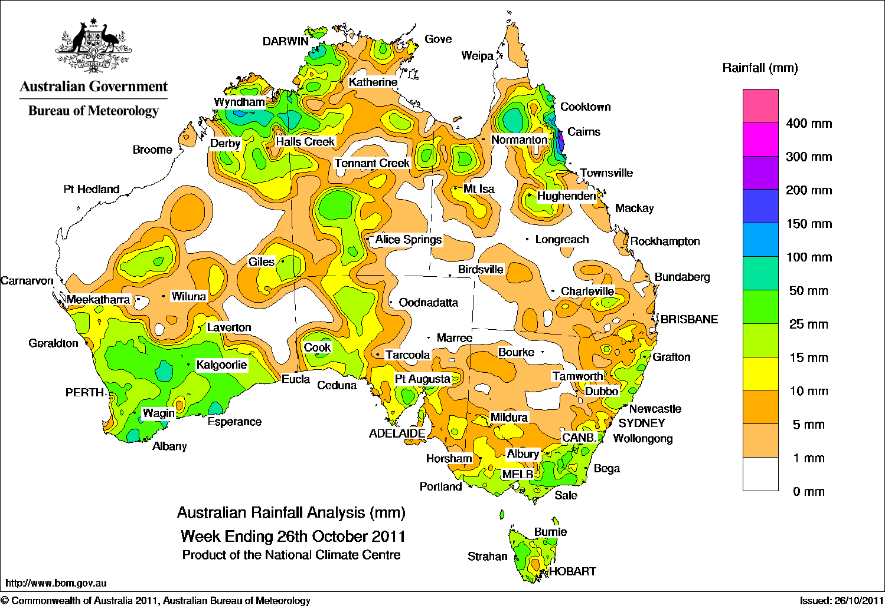

Temperature anomalies this week
Spatial temperature analyses are based on historical weekly temperature data provided by the Bureau of Meteorology. These temperature anomaly maps show the departure of the maximum and minimum from the long-term average. Temperature anomalies are calculated using high resolution gridded datasets from 1911 onwards. For further information on temperature anomalies, go to www.bom.gov.au/jsp/awap/.

Maximum temperature anomalies for the week ending 25 October 2011
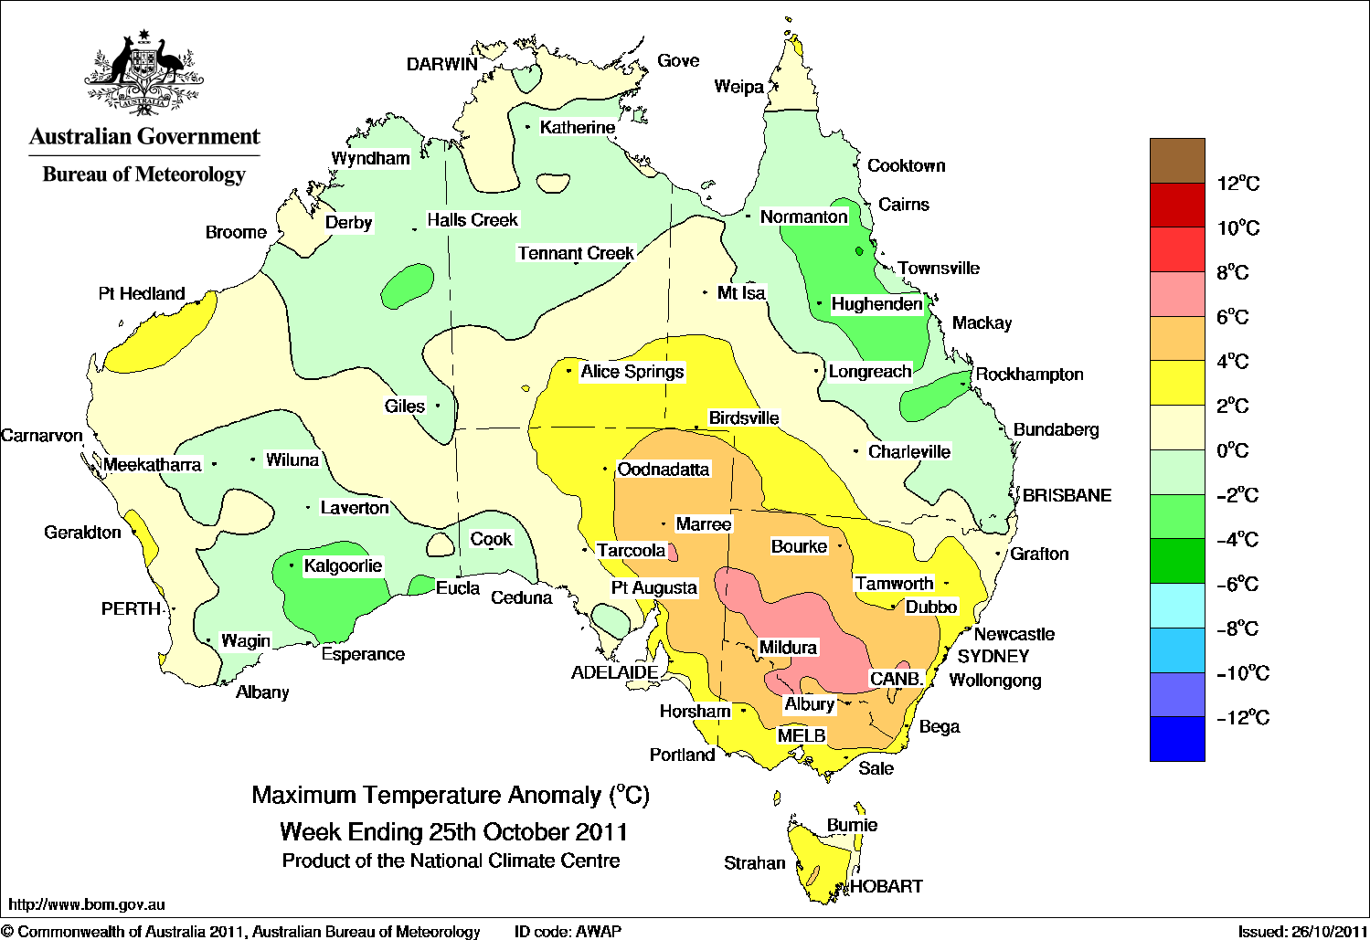

Minimum temperature anomalies for the week ending 25 October 2011
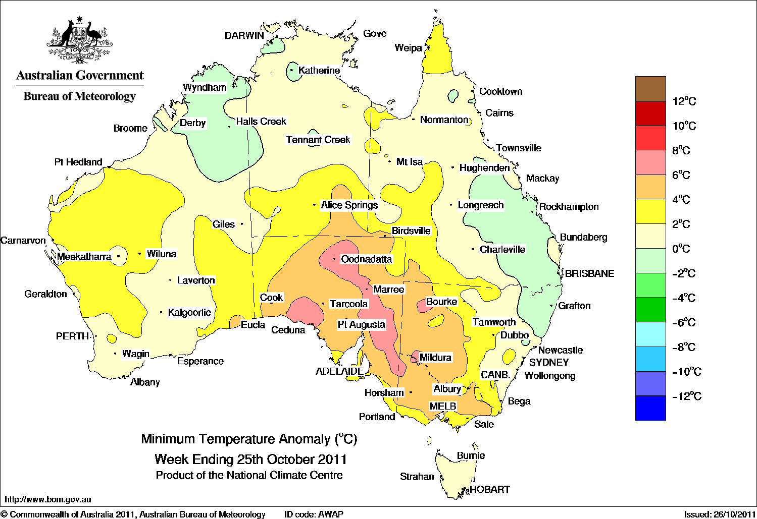

Forecast rainfall
The rainfall forecast below is produced from computer models. As it contains no input from weather forecasters, it is important to also check local forecasts and warnings by the Bureau of Meteorology. For further information on the forecast rainfall, go to http://www.bom.gov.au/jsp/watl/rainfall/pme.jsp.

Total forecast rainfall for the period 27 October to 3 November 2011

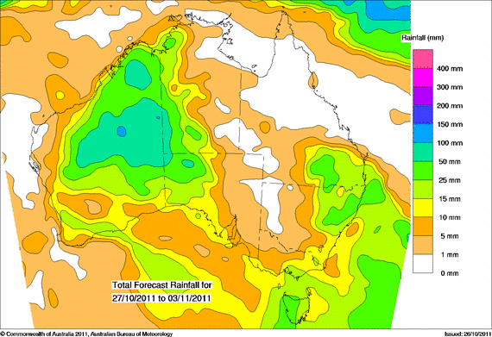

  - Seasonal outlook

Chance of exceeding the median rainfall – November 2011 to January 2012
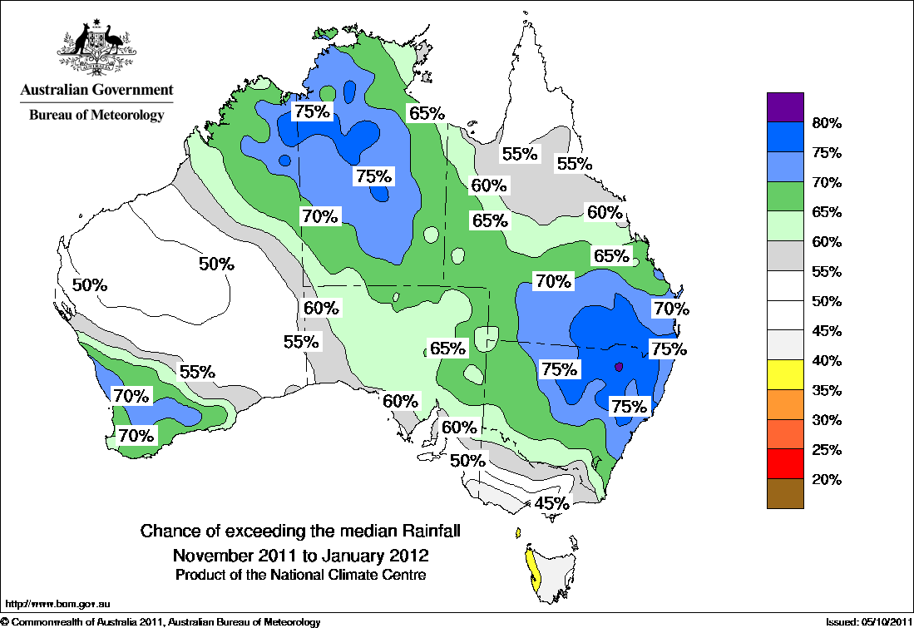

Chance of exceeding the median maximum temperature – November 2011 to January 2012

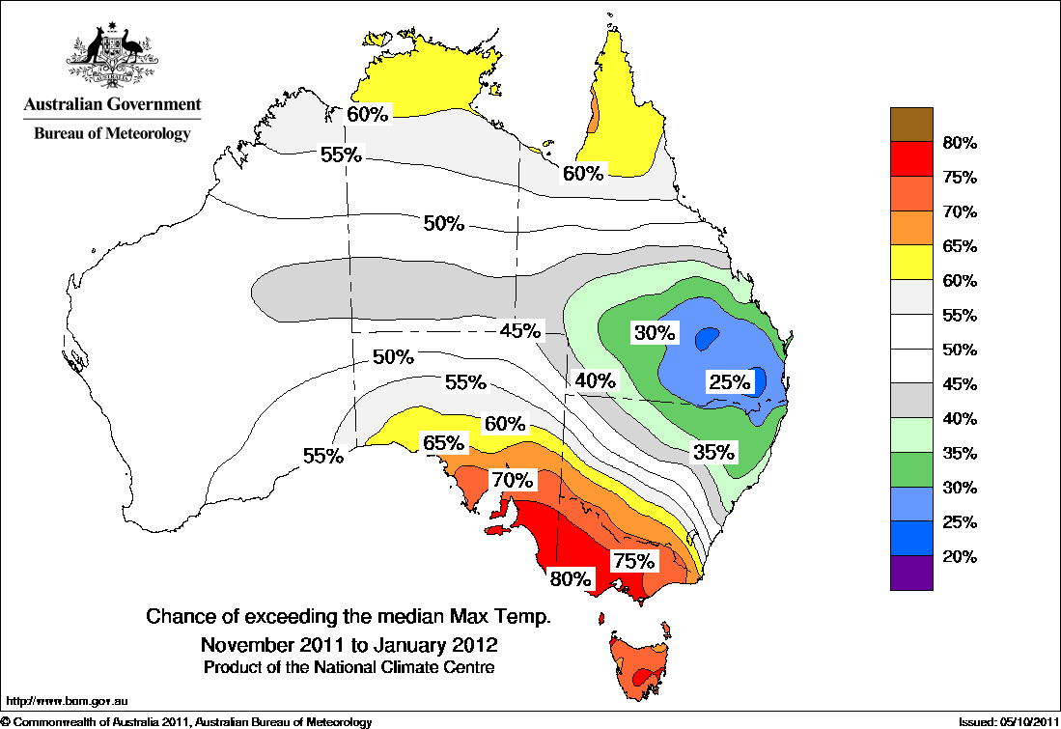

Chance of exceeding the median minimum temperature – November 2011 to January 2012
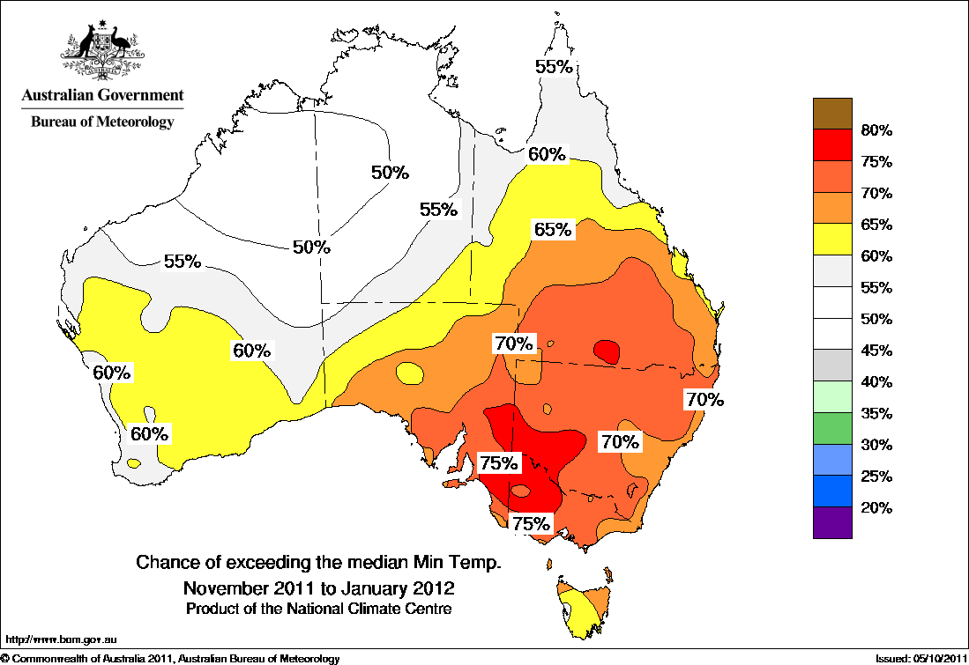

Water

Water availability
- Water storage levels in the Murray–Darling Basin decreased this week by 92 gigalitres (GL) but remained at approximately 88 per cent of total capacity. This is 13 percentage points or 2979 GL more than this time last year.

Water storages in the Murray–Darling Basin (New South Wales, Victoria and Queensland)
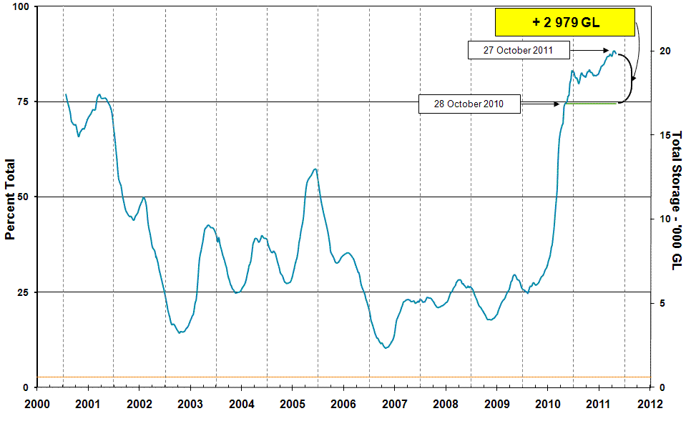
Information on irrigation water available in the Murray–Darling Basin from 1 January 2001 to 27 October 2011 is shown above. The green line indicates the storage level at the same time last year. The orange line indicates the amount of ‘dead’ or unusable storage.

Commodities

Production and commodities
- The world coarse grains indicator price (US no. 2 yellow corn, free on board Gulf ports) averaged US$281 a tonne in the week ending 26 October 2011, compared with US$280 a tonne in the previous week.
- The world cotton indicator price (the Cotlook ‘A’ index) averaged US108.1 cents a pound in the week ending 26 October 2011, the lowest price in 13 months. The last time the world cotton indicator price fell below US110 cents a pound was in the week ending 22 September 2010, when it was US108.6 cents a pound.
- The world wheat indicator price (US hard red winter, free on board Gulf ports) averaged US$307 a tonne in the week ending 25 October 2011, compared with US$298 a tonne in the previous week.
- The President of Ukraine signed a law abolishing export taxes on wheat and corn. An export tax remains on barley until 1 January 2012.
- Saleyard lamb prices eased in most states in the week ending 21 October 2011. This was most noticeable in Victoria and South Australia, where an increase in lambs yarded resulted in prices in both states declining to 498 cents a kilogram. Despite lamb yardings remaining seasonally low, saleyard lamb prices in Western Australia decreased by 6 per cent to 431 cents a kilogram, reflecting lower quality lambs at the Katanning saleyards. In New South Wales, prices decreased by 2 per cent to 393 cents a kilogram. Lamb prices in Tasmania remained relatively steady, averaging 511 cents a kilogram.
- Saleyard sheep prices in the week ending 21 October 2011 were mixed. In Western Australia, sheep prices increased by 6 per cent to 362 cents a kilogram. Sheep prices in South Australia increased by 1 per cent to 334 cents a kilogram. In Victoria, the offering of lower quality sheep resulted in saleyard prices holding relatively steady at 351 cents a kilogram. Sheep throughput in New South Wales declined, however were higher compared with the same week in the previous season. As a result, prices in New South Wales declined by 5 per cent to 519 cents a kilogram.
- The Eastern Market Indicator price for wool fell by 2 cents in the week ending 20 October 2011, to 1158 cents a kilogram clean, despite the number of bales offered at auction increasing by 11 per cent compared with the previous week.
- Saleyard cattle prices for the week ending 21 October 2011 were generally lower. The Queensland young cattle indicator price fell by 16 cents to 373 cents a kilogram. Young cattle prices also fell in all other states except South Australia. Heavy steer prices fell in all states, while medium cow prices fell in Queensland and Tasmania, but rose in all other states.
- The world sugar indicator price (Intercontinental Exchange, nearby futures, no. 11 contract) fell 2.8 per cent to US26.7 cents a pound in the week ending 26 October 2011, after a two week period of increases related to deteriorating harvest conditions in Brazil and floods in Thailand.
- Wholesale prices of avocadoes, bananas and melons were lower in the week ending 22 October 2011. Banana prices (cavendish variety) declined by 23 per cent but were still more than five times higher than at the same time in 2010. Mango prices (kensington pride variety) were 7 per cent lower than at the same time in 2010, reflecting improved mango supplies in 2011.
- Most vegetable wholesale prices were lower in the week ending 22 October 2011, with pumpkins amongst the few vegetables whose prices rose.

Recent movements in fruit and vegetable prices
Weekly wholesale prices for selected fruit, Melbourne market
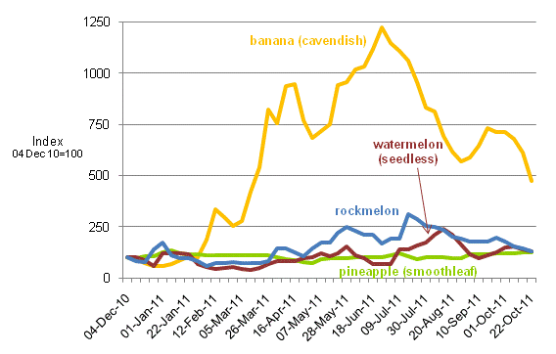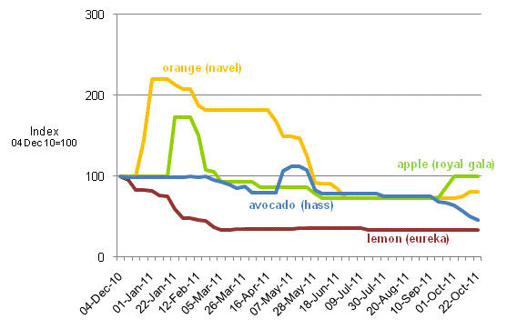

Weekly wholesale prices for selected vegetables, Melbourne market
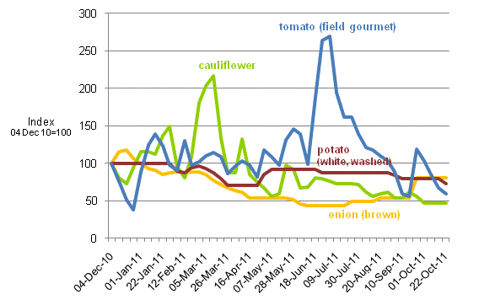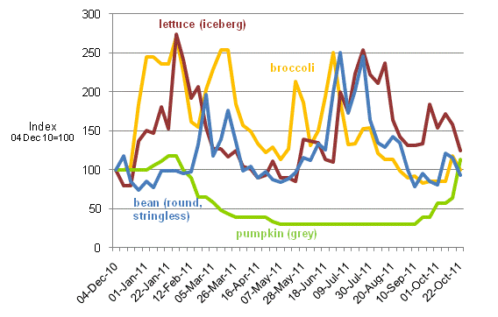

Selected world indicator prices
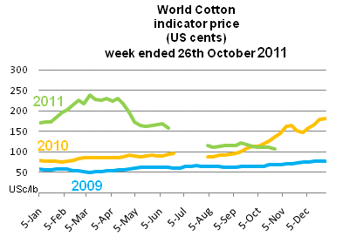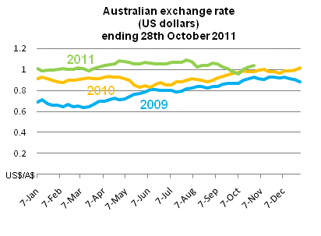
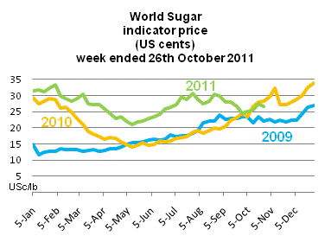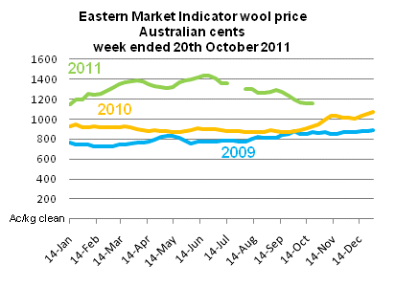

Crop indicator prices
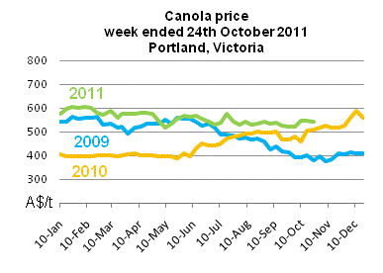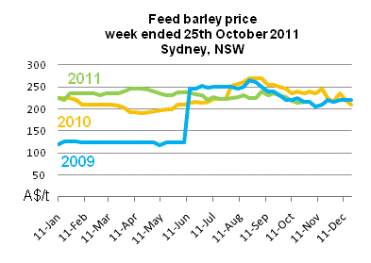
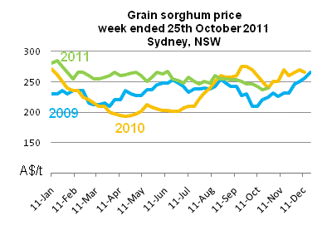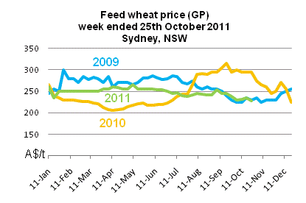

Livestock indicator prices
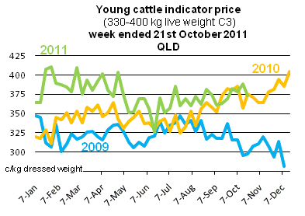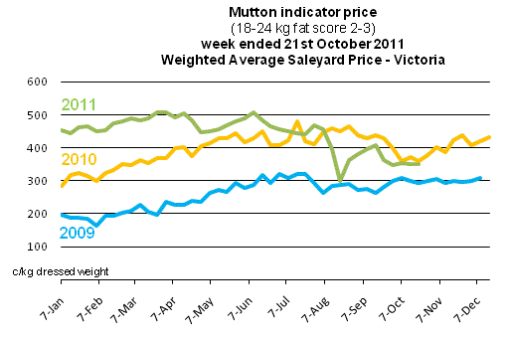
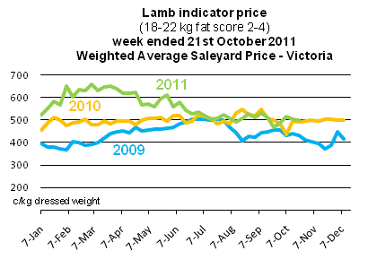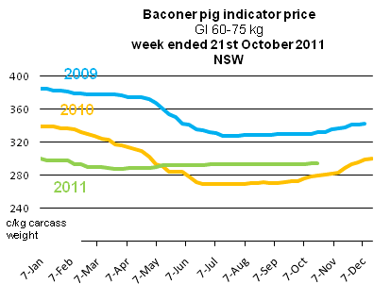

Data attribution

Climate
Bureau of Meteorology
- Weekly rainfall totals: www.bom.gov.au/jsp/awap/rain/index.jsp
- Monthly and last 3-months rainfall percentiles: http://www.bom.gov.au/jsp/awap/
- Temperature anomalies: http://www.bom.gov.au/jsp/awap/
- Rainfall forecast: www.bom.gov.au/jsp/watl/rainfall/pme.jsp
- Seasonal outlook: www.bom.gov.au/climate/ahead
- Drought statement: www.bom.gov.au/climate/drought/drought.shtml
- ENSO Wrap-Up: www.bom.gov.au/climate/enso/
- Soil moisture (BoM, CSIRO and the former Bureau of Rural Sciences): www.eoc.csiro.au/awap/

Water
Murray–Darling Basin
- Murray–Darling Basin Authority: www.mdba.gov.au/water/waterinstorage
New South Wales
- New South Wales Water Information: http://waterinfo.nsw.gov.au/
- New South Wales Office of Water, Department of Environment, Climate Change and Water: www.water.nsw.gov.au/Home/default.aspx
- Available water determinations register: www.wix.nsw.gov.au/wma/DeterminationSearch.jsp?selectedRegister=Determination
- Snowy Hydro: www.snowyhydro.com.au/lakeLevels.asp?pageID=47&parentID=61&grandParentID=4
Queensland
- Sunwater: www.sunwater.com.au
- seqwater: http://seqwater.com.au
South Australia
- SA Water: www.sawater.com.au/SAWater/Environment/TheRiverMurray/River+Murray+Levels.htm
- South Australian Department of Water: www.waterforgood.sa.gov.au/
Victoria
- Goulburn–Murray Water: www.g-mwater.com.au
Water trading
- Waterexchange: www.waterexchange.com.au

Commodities
Fruit and vegetables
- Datafresh: www.datafresh.com.au
Mutton, lambs, wheat, barley and grain sorghum
- The Land: hardcopy or online at http://theland.farmonline.com.au/markets.aspx
Cattle, mutton, lambs and pigs
- Meat and Livestock Australia: www.mla.com.au/Prices-and-markets
Canola
- Weekly Times: hardcopy

