Weekly Australian Climate, Water and Agricultural Update

1 September 2011
The full report is available from www.abares.gov.au

Summary of key issues
- Rainfall in eastern parts of Australia this week will assist growth rates particularly for winter crops in southern Queensland and northern New South Wales.
- Crop producers are being advised to manage mice populations as warmer spring conditions will bring increased food sources for the rodents.
- General security irrigation allocations have increased for the Murray and the Murrumbidgee Valley areas of New South Wales to 15 and 57 per cent respectively. An increase to high reliability irrigation water shares in the Murray, Broken, Goulburn and Loddon systems in Victoria were also announced today.
- Water storage levels in the Murray–Darling Basin increased this week by 24 gigalitres and remained at approximately 87 per cent of total capacity.
- The recent weaker trend with vegetable prices continued in the week ending 27 August 2011, as warmer weather brings increased supplies. Fruit prices were largely unchanged, apart from declines for bananas and watermelons.
- The world wheat indicator price (US hard red winter, free on board Gulf ports) averaged US$355 a tonne for the week ending 30 August 2011 compared with US$339 a tonne last week.
- The world coarse grains indicator price (US no. 2 yellow corn free on board Gulf ports) averaged US$327 a tonne for the week ending 31 August 2011 compared with US$307 a tonne in the previous week.
- Saleyard cattle prices for the week ending 26 August 2011 were generally higher, including the Queensland young cattle indicator price which rose by 5 per cent to 381 cents per kilogram (dressed weight). Medium cow and feeder steer prices increased in all states, except South Australia.
- Saleyard lamb prices for the week ending August 26 2011 averaged higher in all states except New South Wales, where prices were steady. Lamb throughput at reported saleyards in the eastern states were mixed, with yardings increasing by 19 per cent in New South Wales, but decreasing by 31 per cent and 2 per cent in Victoria and South Australia, respectively.

Climate

Notable events
- For the week ending 31 August 2011, rainfall was mostly recorded across eastern parts of Australia. Medium to heavy rainfall was received in north-east New South Wales, south-east and central Queensland, and western Tasmania. The highest measured total for the week was 192 millimetres at Byfield on the central-east coast of Queensland.
- The rainfall received this week will assist growth rates in winter cropping areas of northern New South Wales and southern Queensland. The rainfall will also assist growth of pastures, and allow an improvement in condition of grazing livestock in these areas.
- Leaf rust and powdery mildew has been detected in some crops in south east Queensland.
- Mice are reportedly damaging crops in the Victorian Mallee area. Crop producers in many parts of the country have been advised that mice populations will need to be managed with the coming warmer spring conditions and subsequent increase in food sources available to mice.
- Current neutral El Niño Southern Oscillation conditions are forecast to continue through spring with a possibility of a weak La Niña event forming in late 2011 (Bureau of Meteorology, 31 August 2011).

Rainfall this week
For the week ending 31 August 2011, rainfall was mostly received in eastern parts of Australia with much of the continent receiving little or no rainfall. For further information, go to www.bom.gov.au/climate/current/weeklyrain.shtml.

Rainfall for the week ending 31 August 2011
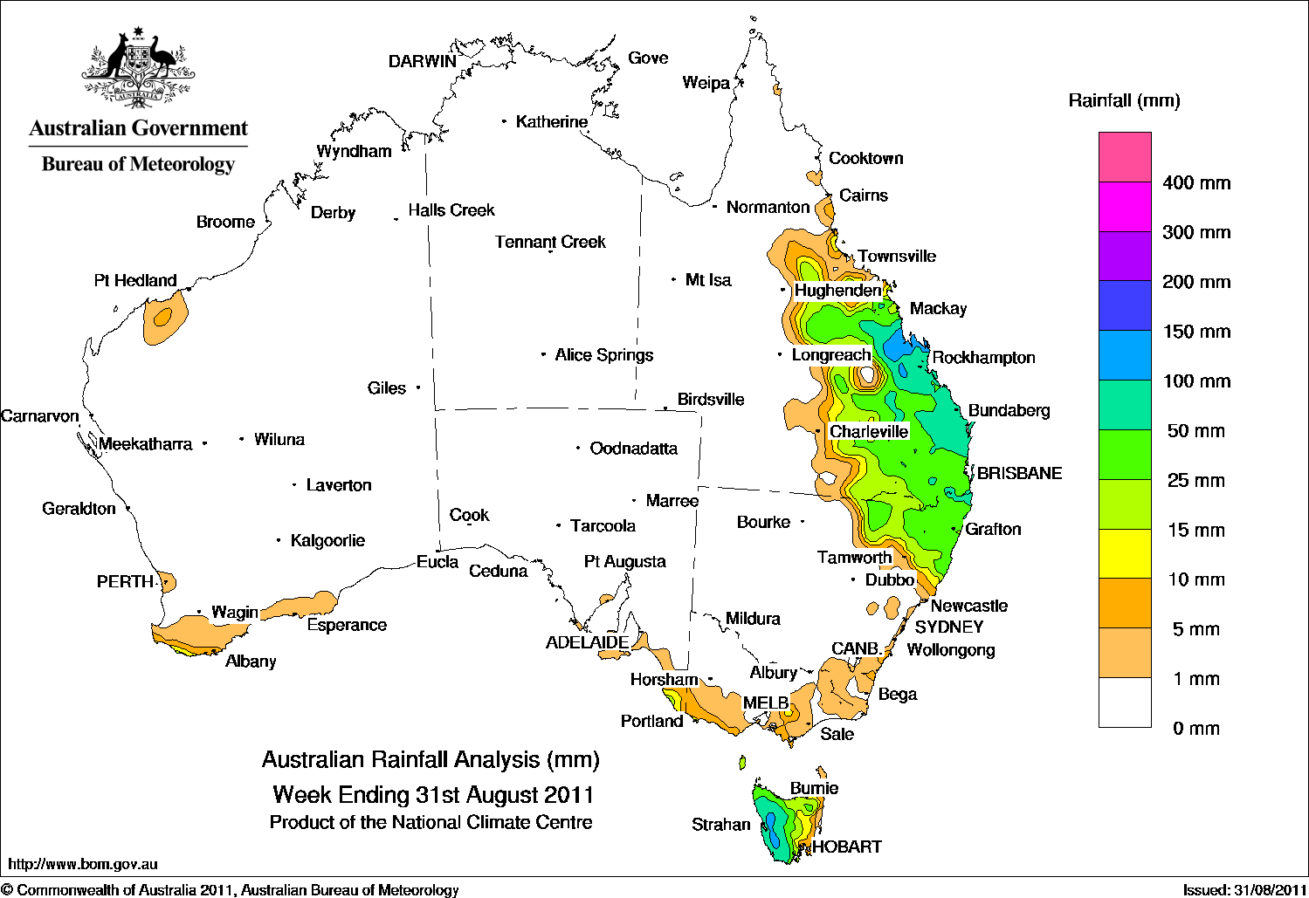

Temperature anomalies this week
Spatial temperature analyses are based on historical weekly temperature data provided by the Bureau of Meteorology. These temperature anomaly maps show the departure of the maximum and minimum from the long-term average. Temperature anomalies are calculated using high resolution gridded datasets from 1911 onwards. For further information on temperature anomalies, go to www.bom.gov.au/jsp/awap/.

Maximum temperature anomalies for the week ending 30 August 2011
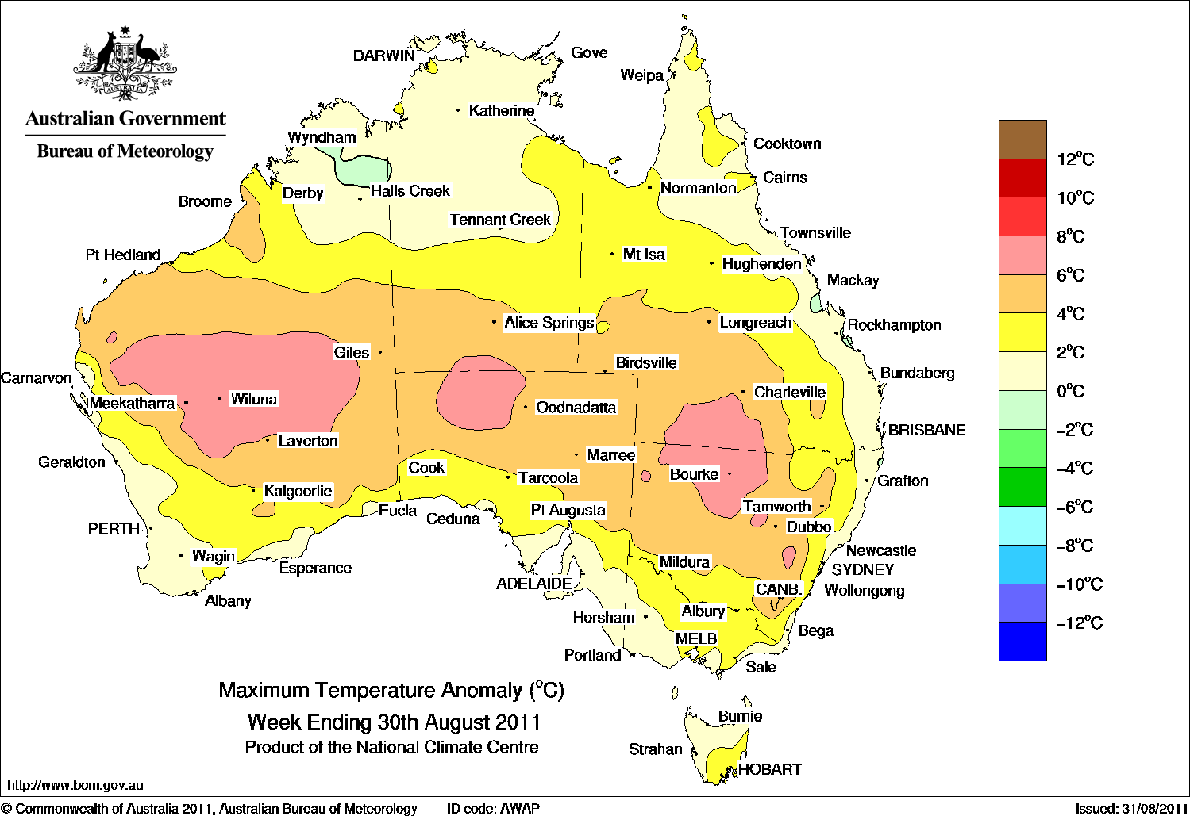

Minimum temperature anomalies for the week ending 30 August 2011
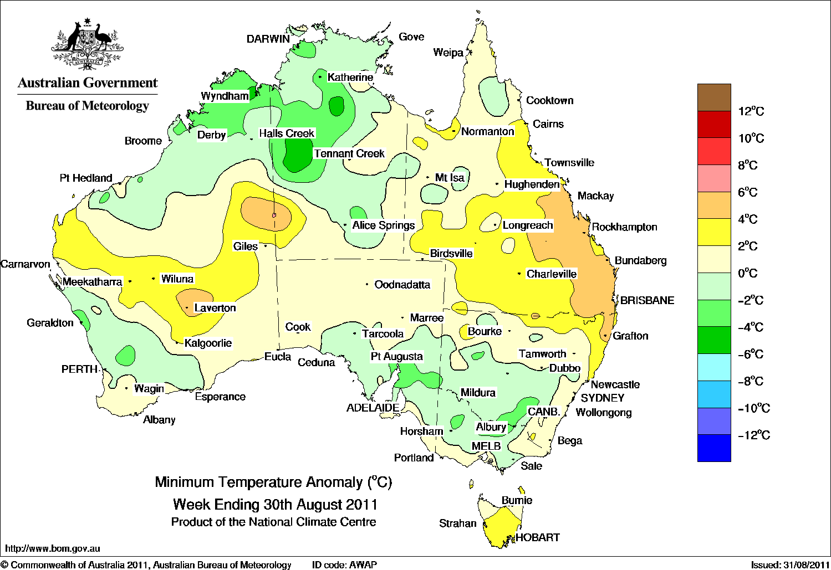

Rainfall outlook
The rainfall forecast below is produced from computer models. As it contains no input from weather forecasters, it is important to also check local forecasts and warnings by the Bureau of Meteorology.

Total forecast rainfall for the period 01–08 September 2011

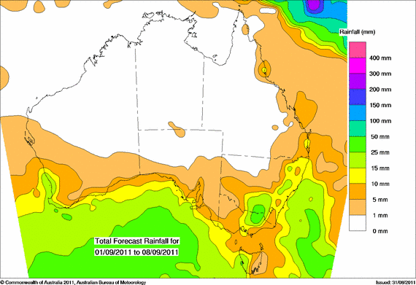

Water

Water availability and trading
- Water storage levels in the Murray–Darling Basin (MDB) increased this week by 24 gigalitres (GL) to approximately 87 per cent of total capacity. This is 35 percentage points or 7 846 GL more than this time last year.
- Increases to high reliability irrigation allocations in the Murray, Broken, Goulburn and Loddon systems in Victoria were announced today. The increases announced were 11 percent, 2 per cent, 9 per cent and 9 per cent, respectively. This brings the total of high reliability water shares for the systems to 61 per cent, 36 per cent, 87 per cent and 87 per cent, respectively.
- Increases to general security irrigation allocations were announced today for the NSW Murray and the Murrumbidgee Valley of 5 per cent and 4 per cent, respectively. The total allocation for the two irrigation areas is now at 15 and 57 per cent of entitlement, respectively.

Water storages
Changes in regional water storage for August 2011 and the previous 12 months are summarised in the table and graphs below (current at 1 September 2011).
Region | Total capacity  (GL) | Current volume  (GL) | Current volume  (%) | Monthly change  (GL) | Monthly change  (%) | Annual change  (GL)
Murray-Darling Basin (MDB) | 22557 | 19601 | 87 | +440 | +2 | +7846
Snowy Scheme | 5744 | 2607 | 45 | +240 | +4 | +1134
Murray-Darling Basin Authority (MDBA) | 9352 | 7818 | 81 | +167 | +2 | +2879
Queensland MDB | 186 | 175 | 94 | 0 | 0 | +31
Central Queensland | 3154 | 3081 | 98 | -34 | -1 | +146
South-east Queensland | 3517 | 3445 | 98 | -26 | -1 | +732
New South Wales MDB | 13884 | 12367 | 89 | +155 | +1 | +4663
Coastal New South Wales | 1074 | 1043 | 97 | +4 | 0 | +228
Victoria MDB | 8488 | 7059 | 83 | +285 | +3 | +3152
Water storages in Queensland, New South Wales and Victoria
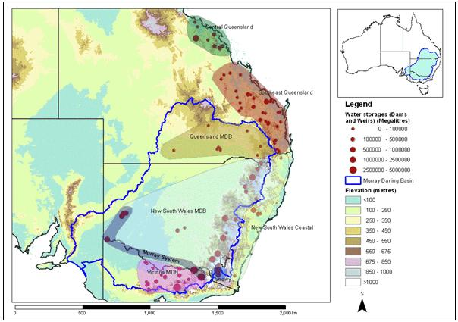
The blue line indicates the extent of the Murray–Darling Basin and the shaded areas denote the coverage of the individual reporting regions.

Water storages in the Murray–Darling Basin (NSW, Victoria and Queensland)
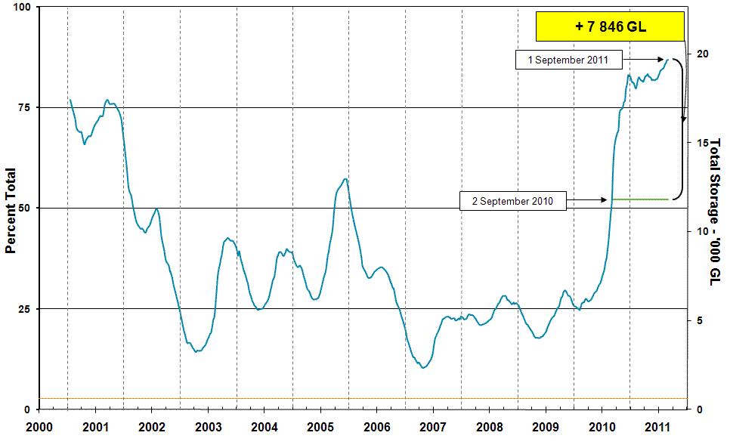
Information on irrigation water available in the Murray–Darling Basin from 1 January 2001 to 1 September 2011 is shown above. The green line indicates the storage level at the same time last year. The orange line indicates the amount of ‘dead’ or unusable storage.

Water storages in the Murray–Darling Basin by state (NSW, Victoria and Queensland)
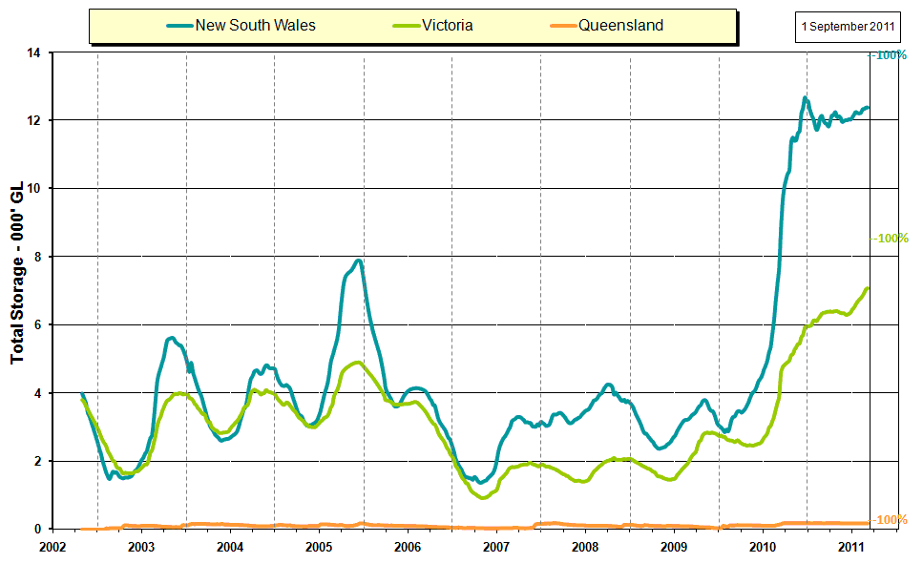

Commodities

Production and commodities
- There was little movement of fruit wholesale prices in the week ending 27 August 2011, apart from declines for watermelons and bananas. Retail prices for bananas in Melbourne appear to be declining more slowly than wholesale prices (figure A).
- Apart from a small price increase for cauliflower, vegetable wholesale prices were steady or lower in the week ending 27 August 2011, as warmer weather brings forth increased supplies.
- The world wheat indicator price (US hard red winter, free on board Gulf ports) averaged US$355 a tonne for the week ending 30 August 2011 compared with US$339 a tonne last week.
- The world coarse grains indicator price (US no. 2 yellow corn free on board Gulf ports) averaged US$327 a tonne for the week ending 31 August 2011 compared with US$307 a tonne in the previous week.
- Saleyard cattle prices for the week ending 26 August 2011 were generally higher, including the Queensland young cattle indicator price which rose by 5 per cent to 381 cents per kilogram. Medium cow and feeder steer prices increased in all states, except South Australia.
- Saleyard lamb prices for the week ending August 26 2011 averaged higher in all states except New South Wales, where prices were steady. Lamb throughput at reported saleyards in the eastern states were mixed, with yardings increasing by 19 per cent in New South Wales, but decreasing by 31 per cent and 2 per cent in Victoria and South Australia, respectively.
- The EMI indicator price for wool was largely unchanged at 1264 cents a kilogram (clean) for the week ending 24 August 2011.
Figure A: Retail and wholesale prices for cavendish bananas, Melbourne

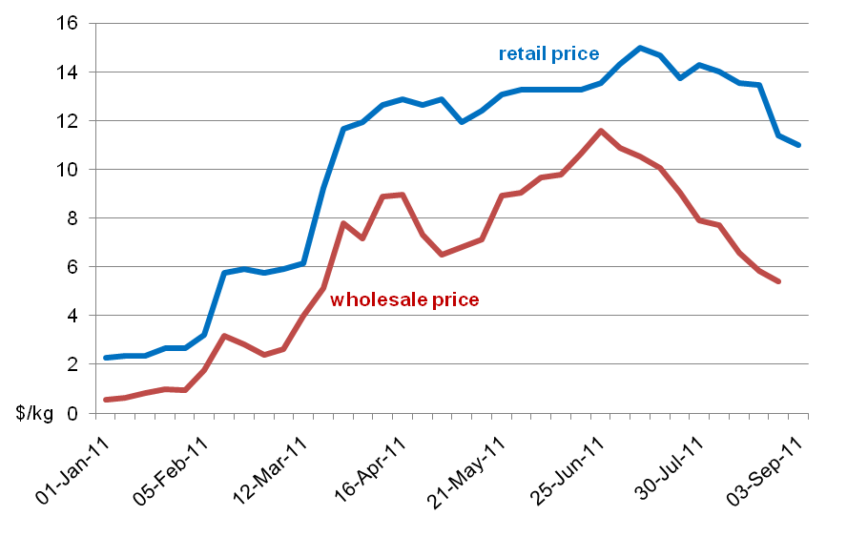
Selected world indicator prices
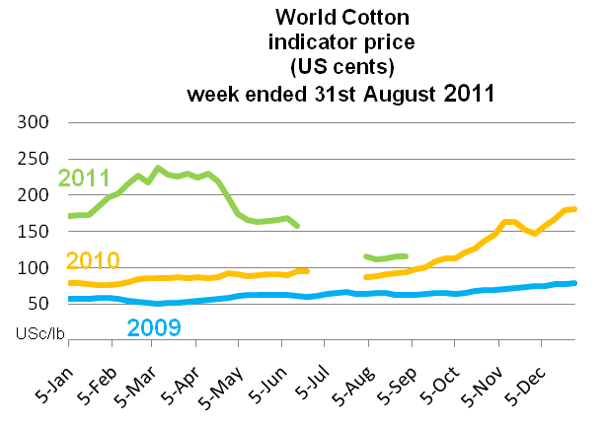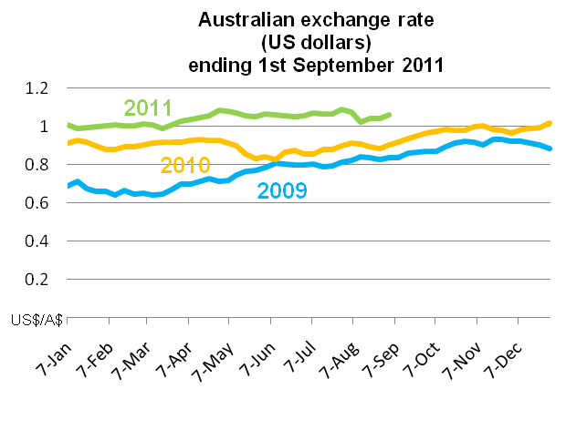
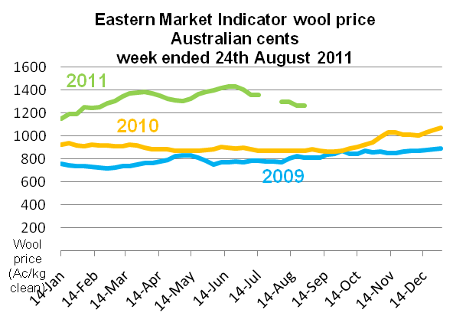

Recent movements in fruit and vegetable prices
Weekly wholesale prices for selected fruit, Melbourne market
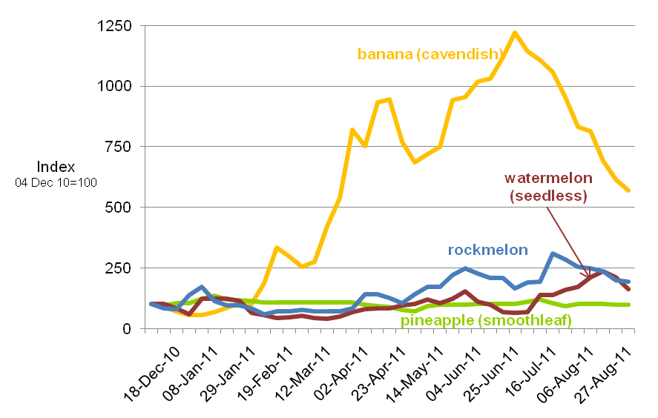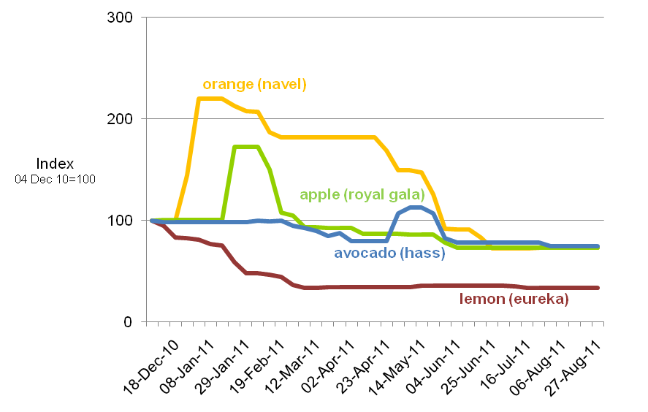

Weekly wholesale prices for selected vegetables, Melbourne market
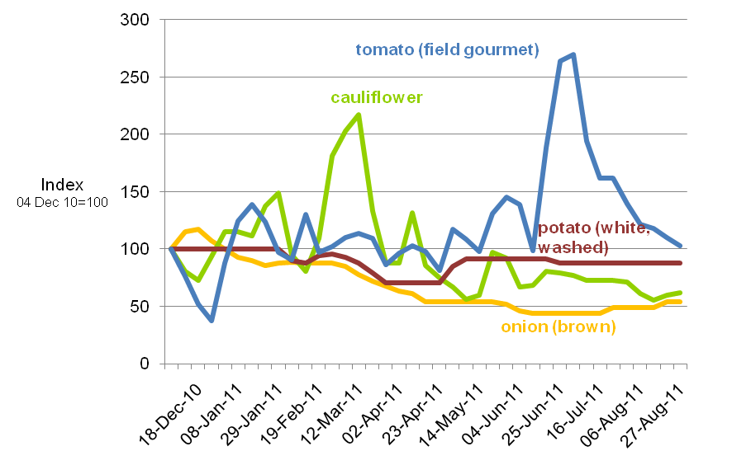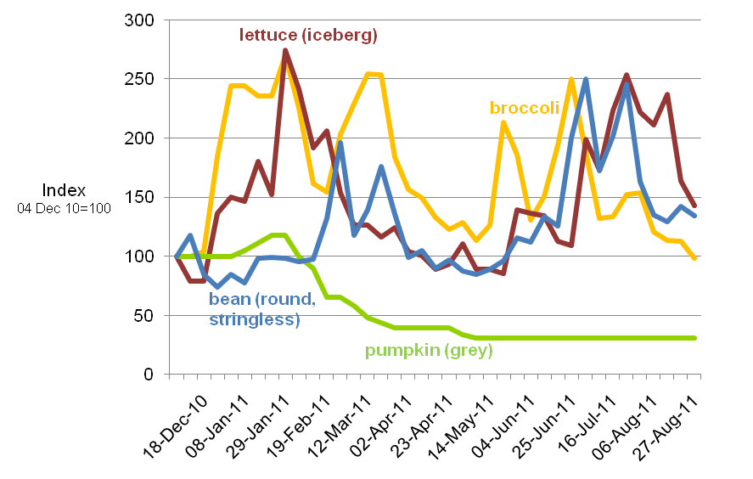

Crop indicator prices
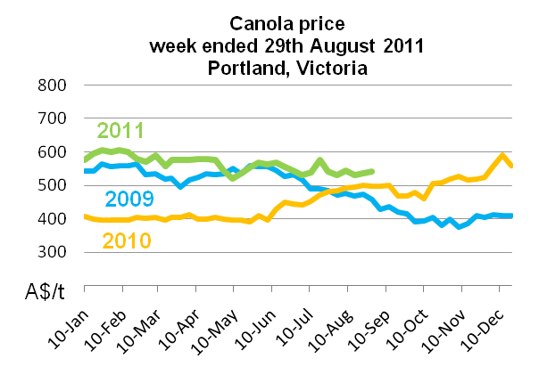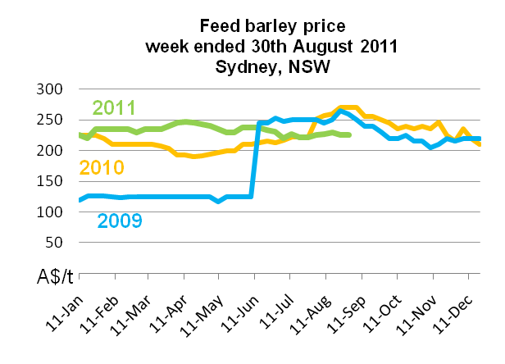
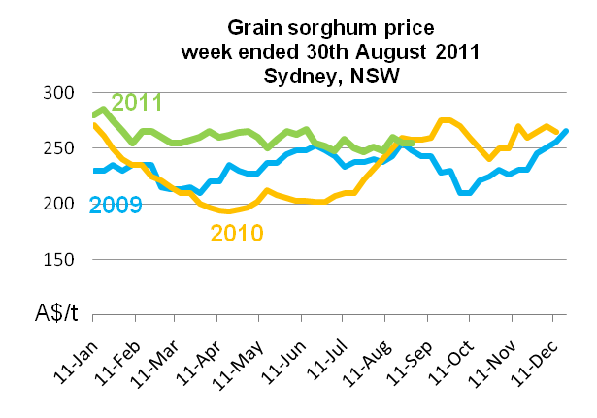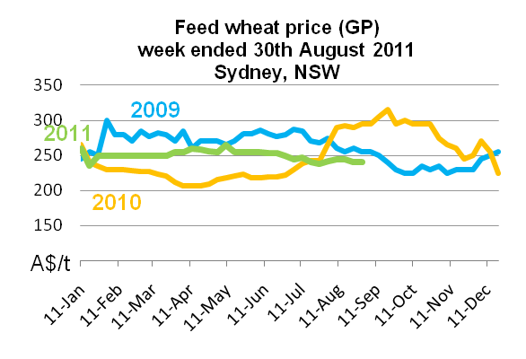

Livestock indicator prices
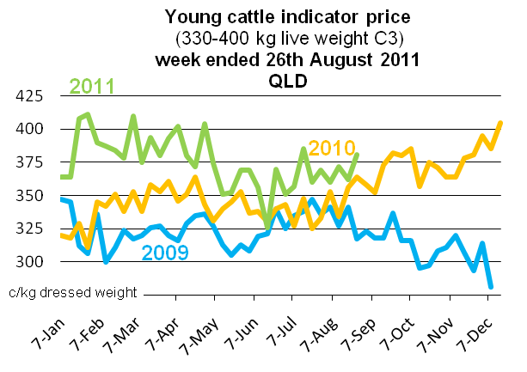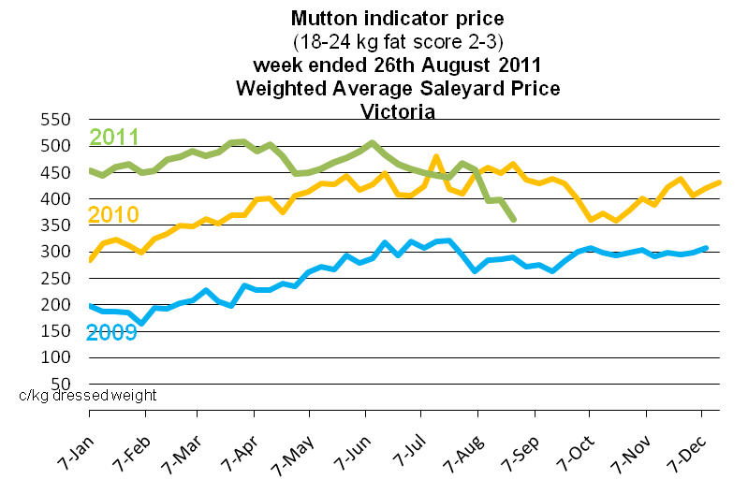
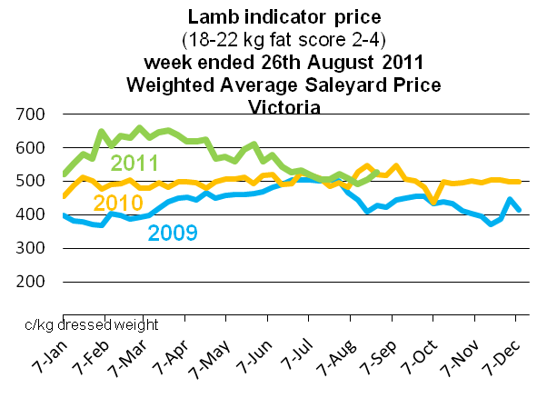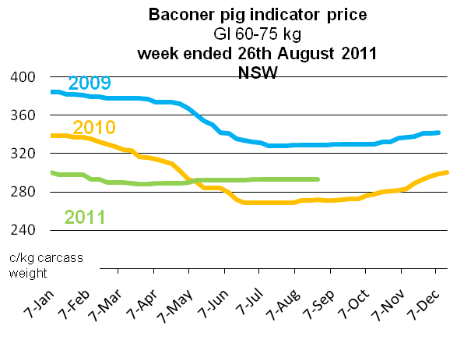

Data attribution

Climate
Bureau of Meteorology
- Weekly rainfall totals: www.bom.gov.au/jsp/awap/rain/index.jsp
- Monthly and last 3-months rainfall percentiles: http://www.bom.gov.au/jsp/awap/
- Temperature anomalies: http://www.bom.gov.au/jsp/awap/
- Rainfall forecast: www.bom.gov.au/jsp/watl/rainfall/pme.jsp
- Seasonal outlook: www.bom.gov.au/climate/ahead
- Drought statement: www.bom.gov.au/climate/drought/drought.shtml
- ENSO Wrap-Up: www.bom.gov.au/climate/enso/
- Soil moisture (BoM, CSIRO and the former Bureau of Rural Sciences): www.eoc.csiro.au/awap/

Water
Murray–Darling Basin
- Murray–Darling Basin Authority: www.mdba.gov.au/water/waterinstorage
New South Wales
- New South Wales Water Information: http://waterinfo.nsw.gov.au/
- New South Wales Office of Water, Department of Environment, Climate Change and Water: www.water.nsw.gov.au/Home/default.aspx
- Available water determinations register: www.wix.nsw.gov.au/wma/DeterminationSearch.jsp?selectedRegister=Determination
- Snowy Hydro: www.snowyhydro.com.au/lakeLevels.asp?pageID=47&parentID=61&grandParentID=4
Queensland
- Sunwater: www.sunwater.com.au
- seqwater: http://seqwater.com.au
South Australia
- SA Water: www.sawater.com.au/SAWater/Environment/TheRiverMurray/River+Murray+Levels.htm
- South Australian Department of Water: www.waterforgood.sa.gov.au/
Victoria
- Goulburn–Murray Water: www.g-mwater.com.au
Water trading
- Waterexchange: www.waterexchange.com.au

Commodities
Fruit and vegetables
- Datafresh: www.datafresh.com.au
Mutton, lambs, wheat, barley and grain sorghum
- The Land: hardcopy or online at http://theland.farmonline.com.au/markets.aspx
Cattle, mutton, lambs and pigs
- Meat and Livestock Australia: www.mla.com.au/Prices-and-markets
Canola
- Weekly Times: hardcopy

