Australian fisheries and

aquaculture outlook 2020
David Mobsby, Amara H Steven and Robert Curtotti
Research by the Australian Bureau of Agricultural and Resource Economics and Sciences
March 2020
© Commonwealth of Australia 2020
Ownership of intellectual property rights
Unless otherwise noted, copyright (and any other intellectual property rights, if any) in this publication is owned by the Commonwealth of Australia (referred to as the Commonwealth).
Creative Commons licence
All material in this publication is licensed under a Creative Commons Attribution 4.0 International Licence except content supplied by third parties, logos and the Commonwealth Coat of Arms.
Inquiries about the licence and any use of this document should be emailed to copyright@awe.gov.au.
Cataloguing data
This publication (and any material sourced from it) should be attributed as: Mobsby, D, Steven, AH & Curtotti, R 2020, Australian fisheries and aquaculture outlook 2020, ABARES, Canberra, March, DOI:. CC BY 4.0. https://doi.org/10.25814/5e4377eb3eea2
ISBN 978-1-74323-464-8
ISSN 2652-5151
Australian Bureau of Agricultural and Resource Economics and Sciences (ABARES)
GPO Box 858 Canberra ACT 2601
Telephone 1800 900 090
Web awe.gov.au
The Australian Government acting through the Department of Agriculture, Water and the Environment, represented by the Australian Bureau of Agricultural and Resource Economics and Sciences, has exercised due care and skill in preparing and compiling the information and data in this publication. Notwithstanding, the Department of Agriculture, Water and the Environment, ABARES, its employees and advisers disclaim all liability, including liability for negligence and for any loss, damage, injury, expense or cost incurred by any person as a result of accessing, using or relying on any of the information or data in this publication to the maximum extent permitted by law.

Australian fisheries and aquaculture timeline
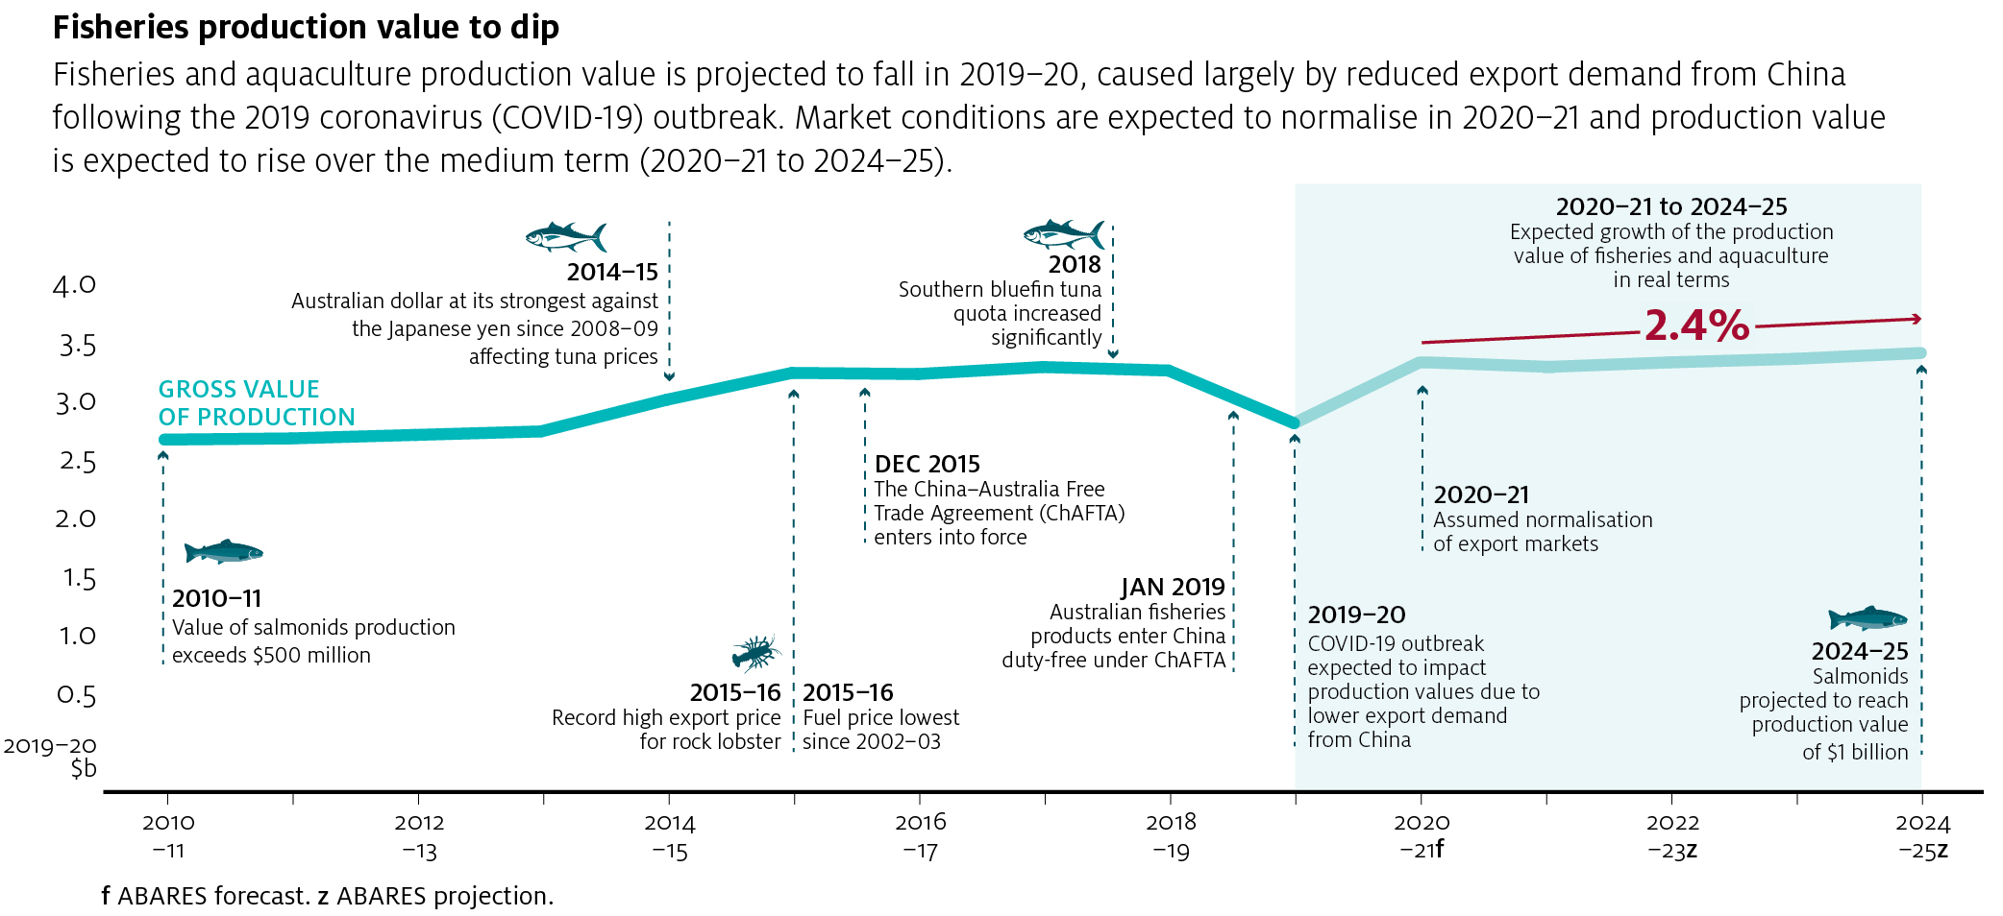

Outlook for Australian fisheries and aquaculture

Fisheries production value to fall in 2019–20
Fisheries and aquaculture production value is forecast to decline by 12% in 2019–20 to $2.81 billion. A fall in rock lobster production value is expected to account for the majority this fall, driven largely by the effects of reduced export demand from China following the outbreak of the 2019 coronavirus (COVID-19). The outbreak is assumed to impact markets for the second half of the 2019–20 financial year followed by a resumption of typical market conditions by the end of the financial year.
Production value is expected to rise by 21% in 2020–21 to $3.40 billion following the assumed normalisation of export markets. In addition, some of the forgone production volume (especially from quota-managed fisheries, including rock lobster and abalone) in 2019–20 is expected to be carried over to the next financial year through some producers choosing to delay catching their seasonal quota until the second half of 2020, increasing production value in 2020–21. This is likely to subdue price recovery over the short term.
The magnitude of the impact of the COVID-19 outbreak is uncertain and depends on the extent of the outbreak, its duration and the effectiveness of control measures. Because of this, the effects of the outbreak could last beyond the 2019–20 financial year. For more information on COVID-19 see Potential impact of COVID-19 outbreak on fisheries exports.

Production value to rise over the medium term
Between 2020–21 and 2024–25 Australian fisheries and aquaculture production value is projected to rise by 2.4% to $3.41 billion in real terms (2019–20 dollars). This is largely the result of expected growth in production value of salmonids, prawns and abalone. Aquaculture’s share of total production value (from expanding sectors, including finfish, abalone and prawns) is expected to continue to rise.
Australian fisheries production value, 1999–2000 to 2024–25
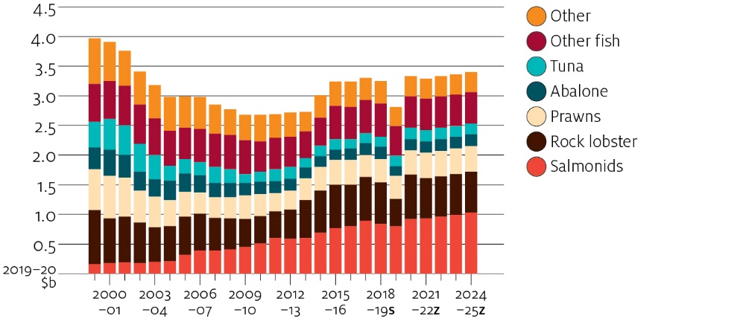
f ABARES forecast. z ABARES projection.
Source: ABARES

Aquaculture’s share of production value to rise
The aquaculture sector steadily increased its overall contribution to Australian fisheries and aquaculture GVP between 2000–01 and 2017–18. This mirrors a global trend of an increasing share of fisheries production from the aquaculture sector (FAO 2018). For Australia, the growing share of aquaculture production value has largely been the result of the rapid rise of the salmonid industry as well as a period of declining wild-caught production value during the 2000s. Over the medium term aquaculture’s share of production value is projected to continue to rise and account for nearly half of Australia’s fisheries and aquaculture production value by 2024–25. Continued growth in salmonid aquaculture production is the key driver behind the growth in aquaculture’s share of production value, but increased prawn and abalone aquaculture production are also important.
Fisheries production value by sector, 1999–2000 to 2024–25
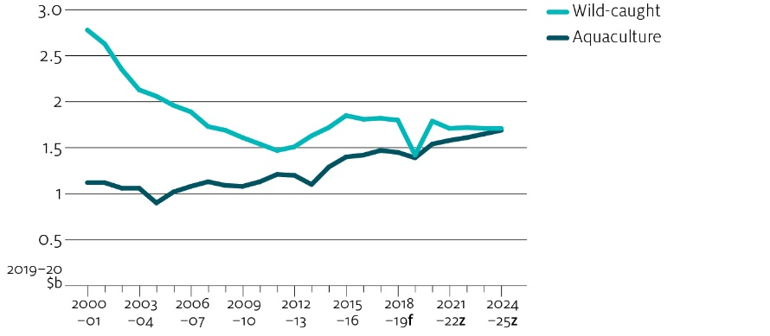
s ABARES estimate. z ABARES projection
Source: ABARES

Fisheries exports to decline in the short term
Australia's trade in fisheries products is driven by several factors, including the proximity of Australia to a fast-growing seafood market in Asia and Australia's reputation as a reliable and high-quality supplier of high unit value fisheries products.
Australia's fisheries and aquaculture industry is also highly exposed to trade, so trends in world markets and Australia's exchange rate influence the price received for most of Australia's major produced species. Export value is forecast to fall by 8% in 2019–20 reflecting the effects of COVID-19. Exports are forecast to rise by 23% in 2020–21 following the assumed normalisation in export markets. The value of Australia's fishery exports is projected to rise by 2.6% in real terms between 2021–22 and 2024–25 to $1.66 billion. Growing incomes and populations are the key drivers behind the growth in export value. Over the outlook period, movements in world prices will be a major determinant of export unit values.
Australian fisheries export value, 1999–2000 to 2024–25
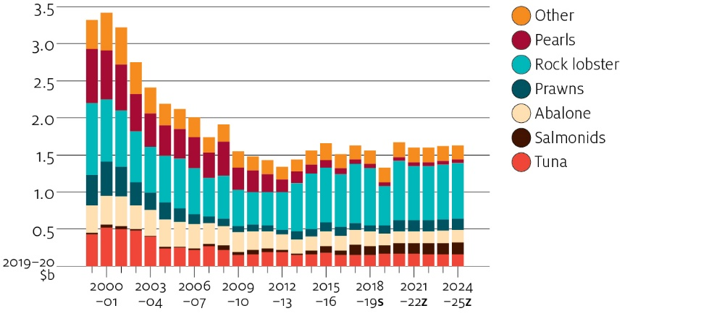
s ABARES estimate. z ABARES projection
Source: ABARES

Outlook for key species

Rock lobster demand impacted in short term
The COVID-19 outbreak is anticipated to reduce export demand and beach price for rock lobster in the short term. Rock lobster is typically exported as a high unit value live product. In 2018–19 China was the destination for approximately 94% of Australia's $752 million of rock lobster exports. The outbreak of COVID-19 is expected to have a significant impact on the rock lobster industry in the short term as a result of reduced demand and limited opportunities for alternative markets.
Over the medium term the value of rock lobster production is projected to rise. Australia's major rock lobster fisheries are output controlled through total allowable catches and production volumes are assumed to increase only moderately. Growth in the value of Australian rock lobster production value is projected to be driven largely by higher export unit values.
Global lobster supply is expected to be constrained by limitations on the volume of wild-catch and relatively small global aquaculture production. This will tend to result in price increases in response to higher global demand because supply may not be able to proportionately respond to increased demand.
Rock lobster production value, 2000–01 to 2024–25
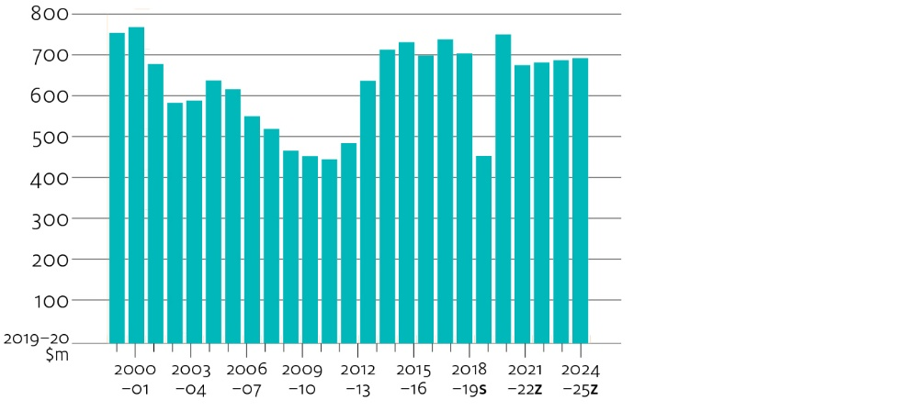
f ABARES forecast. z ABARES projection.
Source: ABARES
Assuming normalisation of market conditions in the medium term, import demand from Asia, particularly from a growing middle class in China, is anticipated to increase over the medium term. However, competition from Canadian exporters is expected to limit upside price potential. Over the projection period, the value of lobster exports from Canada is projected to remain high and will continue to compete with Australian rock lobster exports to China (Fisheries and Oceans Canada 2018).

Salmonids
Global aquaculture salmonid production (including salmons, trouts and smelts) increased significantly between 1990 and 2017. Global aquaculture salmonid production exceeded wild-catch production in 1996 and contributed 78% of global salmonid supply by 2017. Norway and Chile are the largest producers of salmonids (predominantly of Atlantic salmon), together contributing 48% of global salmonid aquaculture production in 2017. Global salmonid production increased by 5% in 2017 to 4.5 million tonnes, of which 3.5 million tonnes was from aquaculture (FAO 2020).
Despite strong growth, the aquaculture sector has periodically been affected by disease outbreaks and algal blooms. These outbreaks have often increased production costs, reduced production and contributed to price volatility in the sector. These factors contribute some uncertainty to the outlook. Over the outlook period, environmental constraints are anticipated to slow the global production growth rate of Atlantic salmon. Producers may look for opportunities to increase production through expansion and research and development (Mowi 2019).
Global salmonid production by sector, 1990 to 2017
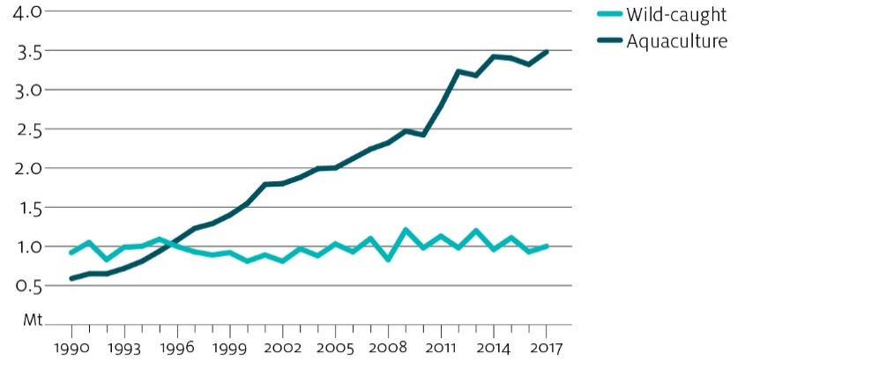
Source: FAO 2020
The COVID-19 outbreak is expected to result in a reduction of exports to China, leaving global producers in search of new export market opportunities for the remainder of 2019–20. This reduction in demand is expected to reduce global prices in 2019–20. Global prices are assumed to recover to their pre-outbreak levels by 2020–21, then steadily increase over the remainder of the outlook period in line with growing global demand for salmonid products in emerging markets.
Trends that impact markets, such as consumer demand for sustainability and traceability of fish products, are likely to continue driving policy and innovation in the salmonid aquaculture sector (FAO 2019). Increasing production of other salmonid species, such as trout and coho salmon, and the emergence of new export destinations are also expected to provide opportunities.
Australia is a relatively small producer and exporter of farmed Atlantic salmon. Tasmania is Australia's primary producer, contributing around 98% of Australia's salmonid production in 2017–18. Rapid growth of the Tasmanian industry since the early 1990s has been underpinned by successful marketing campaigns promoting domestic consumption of salmonid products. Production is expected to remain at around 60 thousand tonnes between 2018–19 and 2020–21, and then projected to increase by 3% per year for the remainder of the outlook period to reach 69 thousand tonnes by 2024–25. Production increases over the period will be supported by expansions into new lease areas and further research and development (Breen 2019).
Australian imports of salmonids amounted to 14,468 tonnes in 2018–19, contributing around 25% of domestic salmonid consumption. Imports of salmonids over the outlook period are projected to grow steadily to fill the gap between domestic production and consumption. Export levels are expected to be maintained over the outlook period.

Abalone
World abalone production more than quadrupled between 2007 and 2017, increasing from 41,375 tonnes in 2007 to 174,633 tonnes in 2017 (FAO 2020). Despite this strong growth, global wild-caught abalone production fell from 9,542 tonnes to 6,341 tonnes in the same period, driven partly by declining global wild-catch stocks and restrictive quotas (Cook 2016; FAO 2020). The increase in aquaculture abalone has mainly been from China.
World abalone production, 1990 to 2017
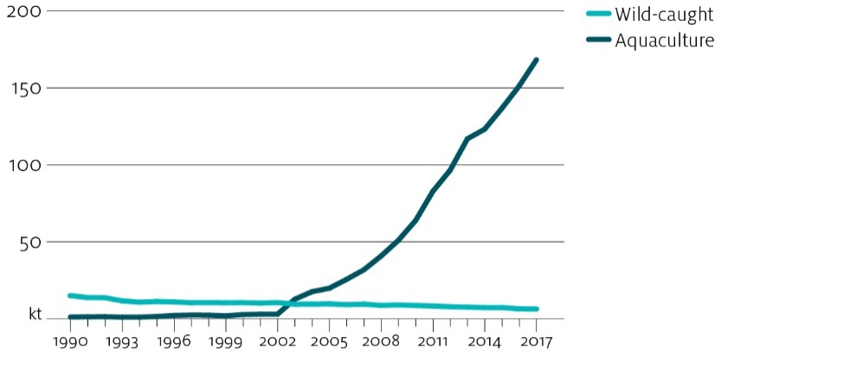
Source: FAO 2020
Australia produces predominantly wild-caught abalone, but aquaculture is projected to provide most of the projected growth over the medium term. Wild-caught volumes are expected to remain constrained by conservatively set total allowable catch. The value of Australian abalone production is projected to rise by 5% to $200 million (in 2019–20 dollars) over the period 2020–21 to 2024–25. The share of aquaculture abalone production has increased steadily over the period 2000–01 to 2017–18, from negligible levels to reach 22% by the end of the period.
Australian abalone unit export prices have increased over recent years and in 2018–19 were the highest on average in real terms since 2006–07. This reflects growing demand in China and a reduction in tariffs to that market. Tariffs on Australian abalone exports entering China have decreased annually since the China–Australia Free Trade Agreement came into force in late 2015. Since 2019 Australian abalone exports have entered China duty-free. Australia produces species of abalone that are not produced in China and wild-caught product achieves a premium in China, especially if delivered as live product.
The outbreak of COVID-19 in China is expected to have negative effects on prices for the remainder of the 2019–20 financial year. The virus has led to the cancellation of orders for abalone in early 2020. When markets will resume normal operation is unclear. Increased export competition is expected as trade is diverted from China to alternative markets. Prices are assumed to recover over the remainder of the outlook period.
Australian abalone production, 2000–01 to 2024–25
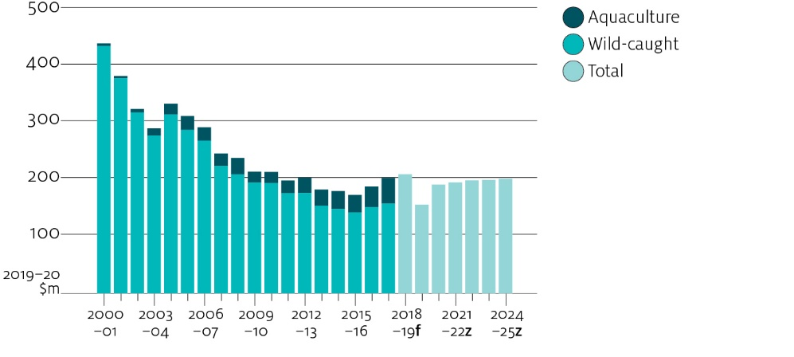
f ABARES forecast. z ABARES projection.
Source: ABARES

Tuna
The Australian tuna industry is highly export oriented. Australian exporters compete in the premium export tuna market (bluefin tuna, bigeye tuna and yellowfin tuna). Southern bluefin tuna is the major tuna species produced in Australia and accounts for most tuna production value, largely because of ranching of wild-caught southern bluefin tuna in South Australia.
Japan is the major destination for Australian tuna exports, reflecting its status as the world's largest consumer of sashimi grade tuna. Premium tuna consumption (for products such as sushi and sashimi) in Japan has declined, reflecting several factors such as changes in consumer preferences. Japan's share of global bluefin tuna import value has also fallen as the trade has diversified to other markets (FAO 2016, 2019). However, although Japanese imports of bluefin tuna have declined over the past decade, Japan remains by far the largest importer of bluefin tuna. As such Japan remains the primary market for global whole bluefin tuna and has a major influence on world prices. Since 2012 global import prices have generally declined as the supply of bluefin tuna has increased (FAO 2020).

World bluefin tuna production, 1990 to 2017
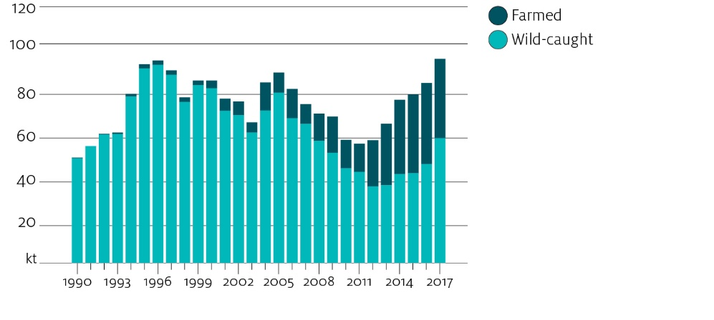
Source: FAO
Over the projection period, global supply of bluefin tuna is anticipated to increase as stocks recover and the aquaculture industry expands (Campling, Antony & McCoy 2017). In addition to anticipated increases in global supply, declining demand from Japan and shifts away from the traditional wholesale model (as a result of consumer demand shifting towards lower cost frozen fillets of sashimi tuna) are expected to place downwards pressure on high-grade tuna prices (Campling, Antony & McCoy 2017). Together with the assumption that the Japanese yen will slightly depreciate against the Australian dollar, export prices are projected to fall in real terms over the medium term. Relatively low export prices to the farm gate for aquaculture producers could result in the share of long line catch of southern bluefin tuna remaining relatively high over the projection period.
Alternative markets for high value tuna, such as the Republic of Korea and the United States, have experienced some growth. Continued growth in these markets could absorb some of the impact from declining demand from Japan and increased global production. Unlike for rock lobster, abalone and salmon, China has not been a significant market for high-grade tuna.

Prawns
Australia is a relatively minor producer of prawns, but supplies and exports several high unit value species. Australia also imports a significant quantity of prawns to meet domestic consumption. These imports are generally of a lower unit value than domestic prawns.
The outbreak of COVID-19 in China in early 2020 is expected to negatively affect international demand for prawns and result in global prices falling in 2019–20. This is expected to impact local producers. Over the remainder of the outlook period, the value of prawn production in Australia is projected to rise, largely reflecting an increase in aquaculture prawn production. Most Australian prawn production is wild-caught, but the share of aquaculture-produced prawns is increasing. A planned large-scale prawn farm in northern Queensland is expected to add between 2,000 and 2,500 tonnes to aquaculture output over the outlook period. Another project in the Northern Territory could significantly increase aquaculture prawn production beyond projections if the farm becomes operational over the outlook period.
Australian prawn production, 2004–05 to 2024–25
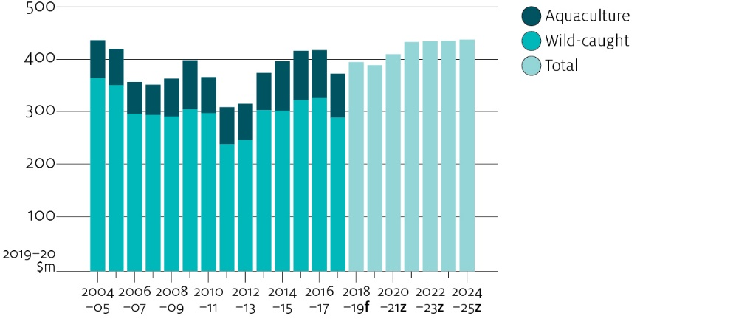
f ABARES forecast. z ABARES projection.
Source: ABARES

Potential impact of COVID-19 outbreak on Australian fisheries exports
The outbreak of COVID-19 is expected to reduce demand for Australian fisheries product exports to China. China is the major export destination for Australian seafood products and accounted for 58% of Australia's total fisheries product export value in 2018–19. In that year Australia’s fisheries product exports to China peaked around the Lunar New Year period. The outbreak of COVID-19 during this period in 2019–20 is expected to have significant short-term impacts on fisheries exports.
Australian fisheries product exports to China are concentrated in three product groups. In 2018–19 rock lobster, abalone and salmonids accounted for 97% of all fisheries product exports to China.
Major fisheries product exports to China, 2018–19
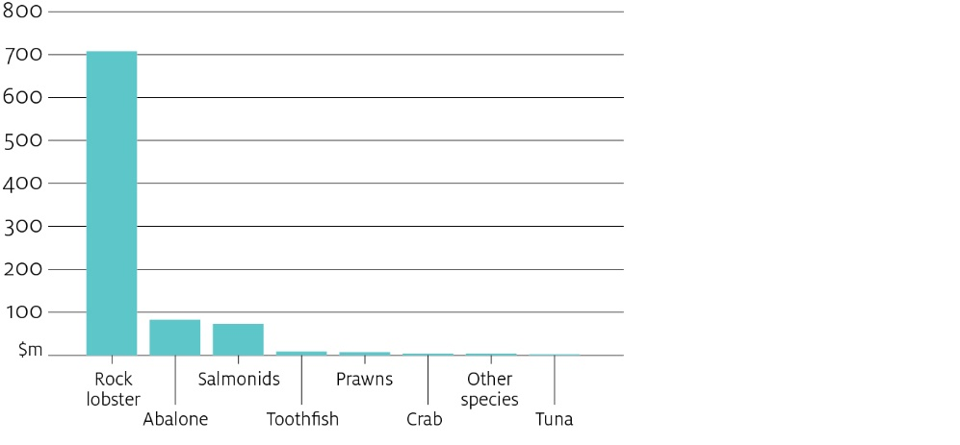
Source: ABARES
For a number of reasons, the COVID-19 outbreak could be more disruptive to seafood trade than the 2003 SARS outbreak. The 2003 SARS outbreak largely occurred during the second half of the 2002–03 financial year. Compared with 2018–19, the Australian export market for fisheries products was overall less concentrated and overall value of exports less dependent on a single commodity. In 2001–02 China accounted for just 3% of export value compared with 58% in 2018–19.
The value of Australian fisheries product exports declined by 12% in 2002–03. However, the effect of the 2003 SARS outbreak on the value of Australian fisheries product exports is uncertain because the Australian dollar appreciated strongly against the US dollar (12%) and the Japanese yen (6%) that year. An appreciation of the Australian dollar tends to reduce export prices in Australian dollar terms.
The impact of COVID-19 on Australian seafood exports depends on the extent and duration of the outbreak as well as the effectiveness of control measures. Export prices are expected to fall in response to reduced demand and limited alternative markets for some commodities. In addition to the effect of direct exports to China, alternative markets for fisheries products are expected to be exposed to more competition as a result of redirected trade, further placing downward pressure on the price of these commodities.
Rock lobster, tuna, abalone, prawns and salmonids accounted for 85% of total fisheries export value in 2018–19. The impact on these commodities depends on a number of factors, including dependence on export markets, the major export destinations and the level of market concentration. For example, rock lobster is highly export dependent, highly concentrated and China is the major market. In 2018–19 China was the destination for approximately 94% of the $752 million of rock lobster exported that year. For this reason, the price impacts of the COVID-19 outbreak are expected to be most significant for this commodity.
Prawns and salmonids have relatively lower export dependence and have lower market concentration compared with rock lobster. China was the major export destination for salmonids accounting for 62% of exports in 2018–19. China accounted for 8% of Australian prawn export value in 2018–19. Despite salmonids relatively high share of exports to China, overall low export dependence means this product is expected to be less impacted by the COVID-19 outbreak than rock lobster.
Export market concentration of major fisheries products, 2018-19
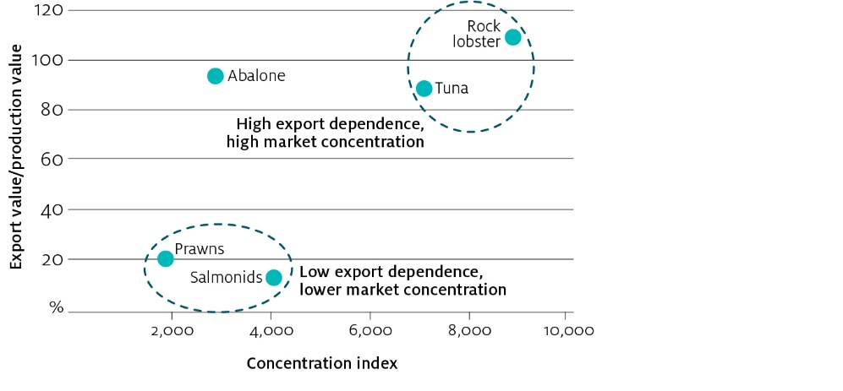
Source: ABARES
Note: In 2018–19 China was the largest export market for rock lobster, abalone and salmonids. Export value greater than 100% could be the result of timing of exports and value added activities (such as processing and transport costs) that increase the value of product from the beach to port. Market concentration index is measured by the Herfindahl-Hirschman Index.

References
Breen, F 2019, Tasmanian salmon farm takes to open, wild water in 'fortress pens' built for millions at Storm Bay, Australian Broadcasting Corporation, 5 September 2019.
Campling, L, Antony, L & McCoy, M 2017, The Tuna Longline Industry in the Western and Central Pacific Ocean and its Market Dynamics, Pacific Islands Forum Fisheries Agency, Honiara.
Cook, P 2016, 'Recent Trends in Worldwide Abalone Production', Journal of Shellfish Research, vol. 35, no. 3.
FAO 2016, Globefish highlights, no. 4, Food and Agriculture Organization of the United Nations, January to June, Rome.
—— 2018, The State of World Fisheries and Aquaculture 2018 - Meeting the sustainable development goals, Rome.
——2019, Globefish highlights, no. 4, Food and Agriculture Organization of the United Nations, January to June, Rome.
—— 2020, Statistics—introduction, Fisheries and Aquaculture Department, Food and Agriculture Organization of the United Nations, Rome, accessed 30 January 2020.
Fisheries and Oceans Canada 2018, Outlook to 2027 for Canadian fish and seafood, Economic Analysis and Statistics Directorate, Fisheries and Oceans Canada, Ottowa, Canada.
Mowi 2019, Salmon farming industry handbook 2019, Mowi.

