# Future scenarios for the southern Murray-Darling Basin

Report to the Independent Assessment of Social and Economic Conditions in the Basin

Mihir Gupta, Neal Hughes, Linden Whittle and Tim Westwood

Research by the Australian Bureau of Agricultural and Resource Economics and Sciences

Research report 20.2

February 2020



© Commonwealth of Australia 2020

**Ownership of intellectual property rights**

Unless otherwise noted, copyright (and any other intellectual property rights, if any) in this publication is owned by the Commonwealth of Australia (referred to as the Commonwealth).

**Creative Commons licence**

All material in this publication is licensed under a [Creative Commons Attribution 4.0 International Licence](https://creativecommons.org/licenses/by/4.0/legalcode) except content supplied by third parties, logos and the Commonwealth Coat of Arms.

Inquiries about the licence and any use of this document should be emailed to [copyright@awe.gov.au](mailto:copyright@awe.gov.au).



**Cataloguing data**

This publication (and any material sourced from it) should be attributed as: Gupta, M, Hughes, N, Whittle, L, & Westwood, T 2020, *Future scenarios for the southern Murray-Darling Basin*, *Report to the Independent Assessment of Social and Economic Conditions in the Basin*, ABARES research report, Canberra, February, CC BY 4.0. <https://doi.org/10.25814/5e5c8daaa823a>

ISBN 978-1-74323-460-0

ISSN 1447-8358

Australian Bureau of Agricultural and Resource Economics and Sciences (ABARES)

GPO Box 858 Canberra ACT 2601

Telephone 1800 900 090

Web [awe.gov.au](http://agriculture.gov.au/)

The Australian Government acting through the Department of Agriculture, Water and the Environment, represented by the Australian Bureau of Agricultural and Resource Economics and Sciences, has exercised due care and skill in preparing and compiling the information and data in this publication. Notwithstanding, the Department of Agriculture, Water and the Environment, ABARES, its employees and advisers disclaim all liability, including liability for negligence and for any loss, damage, injury, expense or cost incurred by any person as a result of accessing, using or relying on any of the information or data in this publication to the maximum extent permitted by law.

**Acknowledgements**

The authors would like to thank Thomas Jackson, David Galeano and Steve Hatfield-Dodds from ABARES, for their invaluable advice and feedback.

Contents

Summary v

The scenarios v

Key findings v

Background 7

The sMDB water market 7

The Water Trade Model 7

Scenarios 10

Results 12

Appendix A: The model 20

Appendix B: Additional tables 22

Appendix C: Future water recovery 26

Supply effect of future water recovery 26

References 28

**Tables**

Table 1 Scenario assumptions 10

Table 2 Average annual GVIAP, by scenario and irrigation activity, sMDB 19

Table B1 Average water allocation price ($/ML) by trading zone 22

Table B2 Average net trade (GL) by trading zone 22

Table B3 Number of years (out of 14 years) trade limits were binding in each trading zone 23

Table B4 Irrigation water use by catchment 23

Table B5 Percentage chance of allocation price ranges in southern basin, by scenario 23

Table B6 Water use (GL) by activity, ‘dry’, ‘wet’ and ‘average’ years, current market 24

Table B7 Water use (GL) by activity, ‘dry’, ‘wet’ and ‘average’ years, future market 24

Table B8 Water use (GL) by activity, ‘dry’, ‘wet’ and ‘average’ years, future market (dry) 25

Table B9 Percentage change in units of production, future market scenarios compared with the current market 25

Table C1 Water entitlement types 26

Table C2 Future water recovery through on-farm programs, by entitlement type (ML) 27

**Figures**

Figure S1 Weighted water allocation price by scenario, southern Murray-Darling Basin vi

Figure 1 Scope and coverage for the Water Trade Model 8

Figure 2 Water Trade Model inputs and outputs 8

Figure 3 Surface water supply distribution by scenario, southern Murray-Darling Basin 12

Figure 4 Total water demand across the sMDB, by scenario 13

Figure 5 Weighted water allocation price by scenario, southern Murray-Darling Basin 14

Figure 6 Average water use by scenario, southern Murray-Darling Basin 15

Figure 7 Dairy water use in wet, average, and dry years, by scenario 16

Figure 8 Percentage change in dairy water use, for different seasonal conditions 16

Figure 9 Average net trade by scenario and trading zone 17

Figure 10 Price gaps between the Barmah Below and Murrumbidgee trading zones 18

**Boxes**

Box 1 Variation in water use is particularly pronounced in traditional irrigation sectors 15

## Summary

This report presents recent economic modelling undertaken by ABARES to support the [Independent Assessment of Social and Economic Conditions in the Basin](https://www.basin-socio-economic.com.au/). In particular, this report presents a series of forward looking scenarios for the southern Murray-Darling Basin water market, examining potential future water prices, trade flows and irrigation sector outcomes, taking into account recent and expected trends for water supply and demand. These results are generated using the ABARES Water Trade Model: a data-driven economic model of the southern Murray-Darling Basin water market.

### The scenarios

Three scenarios are considered:

|  |  |
| --- | --- |
| Current market | Current irrigation development (horticultural plantings), current water recovery under the Basin Plan, current trade rules and commodity prices. |
| Future market | Full maturity of recently established almond plantings, and future water recovery to meet Basin Plan requirements (3,200 GL target) via on-farm infrastructure upgrades. |
| Future market (dry) | As above, but with an 11 per cent reduction in water supply and a 3 per cent reduction in rainfall. |

For each scenario, a range of water supply conditions are simulated (based on the historical climate sequence 2005-06 to 2018-19) to provide a picture of potential water market and irrigation outcomes across representative ‘dry’, ‘average’ and ‘wet’ years.

There are two key caveats to these scenarios. Firstly, the climate sequence used (2006 to 2019) is particularly dry in the context of the longer historical record and may differ from average future climate conditions. Secondly, these scenarios are based on current farms using current capital and technology, and do not allow for long-term adaptation (innovation / technological change) or structural adjustment (changes in capital investment).

### Key findings

* *Higher water prices*: a significant increase in average water allocation market prices is estimated across the southern Murray Darling Basin. Compared to the current market scenario, allocation prices are estimated to be 28 per cent higher in the future market scenario and 50 per cent higher in the future market (dry) scenario. In the future market scenario prices are estimated to remain above $200 per ML in 8 out of 10 years. While water prices in 2018–19 (around $445 per ML) would be considered high relative to historically observed prices, the same price would be considered an average price in the future, occurring much more frequently. Larger price increases are modelled in dry years under both the future market (up to $116/ML higher) and future market (dry) (up to $192/ML higher) scenarios.
* *Inter-regional trade limits having a larger effect*: growth in water demand in the lower Murray due to maturing Almonds trees (particularly in NSW and SA Murray), leads to greater pressure for inter-regional water trade, more frequently binding trade limits and large differences in prices between regions. Particularly in dry years, trade limits lead to significantly higher prices in the Murray below Barmah region (between $955/ML and $1075/ML) compared to the Murrumbidgee (between $665/ML and $712/ML).
* *Just enough water to maintain horticultural plantings in dry years*: While water supply (including both surface water and other sources such as groundwater) is sufficient to meet estimated demand from horticultural plantings (fruits, nuts and grapevines) in all scenarios, in practice there remains some risk of supply shortfalls within each water year, particularly if future conditions are drier than modelled or trade constraints are tightened. Horticultural plantings are estimated to use around 1276 GL on average each year in the ‘future scenarios’.
* *Reductions in water use in some traditional irrigation sectors and regions*: water use in the dairy and rice sectors is modelled to decrease on average by 14 per cent and 15 per cent respectively in the future market scenario (relative to the current market scenario). In dry years, more significant decreases are predicted for these sectors in order to meet horticultural water demand, with dairy and rice decreasing by up to 55 per cent and 32 per cent respectively. Average water use declines by around 18% in the Goulburn-Broken region and around 7% in the Murrumbidgee in the future market scenario.
* *Decrease in GVIAP for traditional irrigation sectors*: gross value of irrigated agricultural production (GVIAP) is modelled to decrease for the dairy and rice sectors on average by 9 per cent and 13 per cent respectively in the future market scenario (relative to the current market scenario). In contrast, existing almond plantings, assumed to be fully mature in the future, drive a substantial increase in production and gross value (around 23 per cent for both) for the almond sector. The decrease in other sectors is partially offset by an increase in farm productivity, through on-farm infrastructure upgrades. The dairy sector is also able to reduce the effect of high water prices by substituting water for fodder. Overall, the total GVIAP across all sectors is modelled to increase on average by 0.8 per cent in the future market scenario and decrease by 4.1 per cent in the future market (dry) scenario.

Figure S1 Weighted water allocation price by scenario, southern Murray-Darling Basin

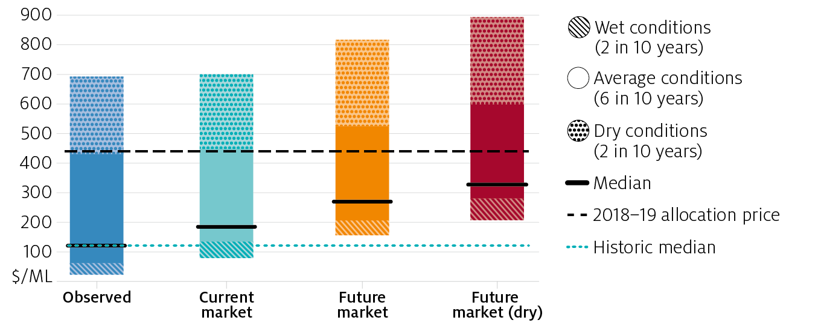

## Background

### The sMDB water market

The Water Act was passed in 2007 and the Murray-Darling Basin Plan was introduced in 2012, with the aim of addressing long-term environmental problems from over extraction. Since 2007, more than 2,100 GL of water rights have been recovered for environmental use (DA 2019), nearly 20 per cent of water supply.

Water markets have been a key institutional response, ensuring water flows to its highest value use, and helping the irrigation sector adapt to reductions in supply. However, in recent years, water markets in the southern basin have been under significant pressure. A combination of lower water supply (brought about by environmental water recovery and lower inflows due to climate change) and higher irrigation demand (particularly from horticulture) have seen water prices increase dramatically, with some water rights increasing in value by around 200 per cent between 2013 and 2019.

With an additional 501.6 GL of environmental water recovery still to be completed under the Basin Plan, the government established an independent panel to examine potential futures for the Murray Darling Basin (MDB), with a particular focus on the socio-economic effects of the Basin Plan on river communities. ABARES was contracted by the panel to contribute to this analysis using the Water Trade Model, with its ability to separate the effects of climate, policy and economic shocks on the southern Murray-Darling Basin water market.

Simulations are presented in this report for long-term future water allocation prices and irrigation activity under plausible future scenarios, while controlling for external factors such as commodity prices, trade limits and climate.

### The Water Trade Model

ABARES has developed an economic model of water trade and irrigation activity in the southern Murray-Darling Basin (sMDB). The model has been extensively documented in past reports (see Hughes et. al. 2016, Gupta et. al. 2018, Gupta and Hughes 2018). Recent updates to the model, will be documented in a separate forthcoming report.

The model is estimated using historical data from 2005–06 to 2018–19 (14 years). The irrigation activities considered in the model and the catchment regions are shown in Figure 1. A unique comprehensive dataset was developed for the model, detailing water availability (entitlements, allocations and carryover), market outcomes (prices and trade flows), irrigation activity (area irrigated and water use), climate (rainfall) and commodity prices. The model also defines ‘other water’ to take into account differences between irrigation water use (based on farm reported values) and allocation water supply (based on regulated surface water entitlements).

The inputs and outputs for the water trade model are listed in Figure 2, and can be modified to design various scenarios. For more detail see Appendix A.

Figure 1 Scope and coverage for the Water Trade Model



Figure 2 Water Trade Model inputs and outputs

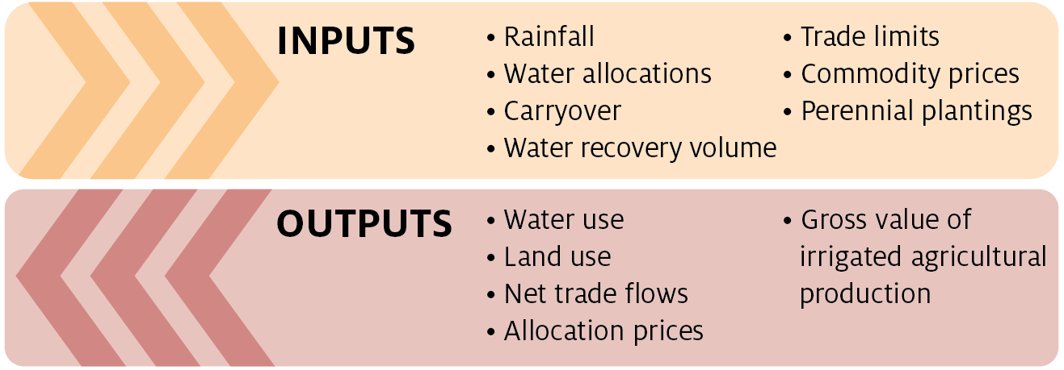

#### Limitations of this analysis

There are some caveats to the results presented in this report, listed below, that reflect the short-term nature of the ABARES Water Trade Model and the scenarios considered in this analysis. Nevertheless, the results provide an indication of potential future trends in sMDB water markets, and a deeper understanding of the drivers of water demand and supply in the region.

* The analysis is based on current farms using current capital and technology, and do not allow for long-term adaptation or structural adjustment.
* The historical climate conditions assumed for the Current market and Future market scenarios are drier that the average for the longer historical record, and may differ from typical future climate conditions.
* The analysis does not provide a prediction of future prices or irrigation activity. Results are presented for representative ‘dry’, ‘average’ and ‘wet’ seasonal conditions, and are not forecasts for specific future periods.
* Trade rules are assumed reflect market conditions in 2018–19, and do not account for possible changes to the Goulburn Inter-Valley Trade limit or other trade rules.
* Commodity prices are also fixed to observed values in 2018-19. Prices higher or lower than assumed will alter the demand for water from farms producing that commodity, and hence their overall water use and production.
* The analysis does not include consideration of potential benefits from environmental water recovery to the irrigation sector (for example, potentially improved water quality or delivery), or to the broader community. Measuring these benefits would require data and methods beyond the scope of this project.
* The analysis assumes that environmental water recovery is fully complete in each of the future scenarios. ABARES has not considered the feasibility of recovering the remaining environmental water by any particular date.

## Scenarios

The ABARES Water Trade Model was used to estimate water allocation prices, water trade and irrigation activity under three different scenarios (Table 1). The current market scenario holds all water market drivers (including water recovery, almond water use and commodity prices) fixed at currently observed levels (i.e. 2018–19), in order to provide an accurate comparison point for ‘future scenario’ results. The ‘future scenarios’ (future market and future market (dry)) are designed to provide insight for plausible futures for the southern Murray-Darling Basin, and have been developed in consultation with the panel, the Murray-Darling Basin Authority (MDBA) and Marsden Jacob Associates (MJA).

In the future market scenario, water recovered under the Basin Plan is completed in full and a further 501.6 GL of water rights (in LTAAY terms) is recovered across the basin. This future water recovery is assumed to occur via on-farm infrastructure upgrades. The scenario also takes into account an increase in farm productivity and water demand due to the effects of these upgrades.

In addition, all existing almond trees are assumed to be fully mature, thereby increasing the demand for water from the almond industry. This predominantly affects the lower Murray regions (particularly the SA Murray and NSW Murray below Barmah), where new plantings have occurred in recent years.

In the future market (dry) scenario, these assumptions are all repeated, and climate change is assumed to further reduce rainfall and water supply. Previous work undertaken by CSIRO (2008) was used to inform the assumptions in this scenario.

Table 1 Scenario assumptions

|  |  |  |  |  |  |  |  |  |
| --- | --- | --- | --- | --- | --- | --- | --- | --- |
|  | **Name** | **Rainfall** | **Allocation volume** | **Water recovery (a)** | **Recovery mechanism** | **Trade limits** | **Commodity prices** | **Water demand** |
| R | Current market (c) | No change | No change | Current | Current | Current | Current | Current |
|  | **SCENARIOS** | |  |  |  |  |  |  |
| 1 | Future market | No change | No change | Future recovery | 100% through on-farm programs | Current | Current | Modelled increase (b, d) |
| 2 | Future market (dry) | 3% decrease | 11% decrease | Future recovery | 100% through on-farm programs | Current | Current | Modelled increase (b, d) |

Note: (a) Water recovery target for the Murray-Darling Basin as a whole. (b) Water demand refers to irrigator’s willingness to pay for water. (c) Current market scenario is a reference case that assumes current water demand and supply conditions, and results differ from observed historical trends in prices and irrigation activity. (d) Water demand increases due to maturing of current almond plantings, and the effect of increased productivity and water use efficiency for farms participating in on-farm water recovery programs.

The ABARES Water Trade Model is short-term and static in nature, and does not allow for future structural change (for example: changes in horticultural plantings, or reductions in the size of the dairy herd). Future changes in productivity or technological advancements are also not taken into account. Therefore, the results presented in this report are not forecasts of future water prices in specific years.

However, the model can be used to assess scenarios and examine the effects of specific changes – such as those designed for the ‘future scenarios’. In this report, the model uses a historical climate sequence to provide a picture of how the market might perform under a range of water supply conditions, including dry, wet and average years. As such the results are best interpreted as a *distribution*, where each ‘year’ could be considered an individual scenario.

## Results

#### Water supply for irrigation use will decrease

One of the major changes considered in the ‘future scenarios’ is a decrease in irrigation water supply across the southern basin. In both scenarios, an additional 501.6 GL of water rights are assumed to be recovered across the MDB. Moreover in the future market (dry) scenario, climate change is assumed to further decrease rainfall and water supply (informed by previous assessments of future water availability undertaken by CSIRO 2008).

The resulting distributions of future water supply in the southern basin can be seen in Figure 3. Water availability for irrigation is expected to be lower in the future, decreasing on average by around 300 GL in the future market scenario, and 700 GL in the future market (dry) scenario, compared to the current market scenario. In the future market (dry) scenario, water supply across the southern basin is expected to be lower than 3800 GL in 8 out of 10 years. While the effects are spread across all catchments in the connected southern basin, the biggest decreases in water supply (before trade) occur in the SA Murray and the Vic. Murray.

Figure 3 Surface water supply distribution by scenario, southern Murray-Darling Basin

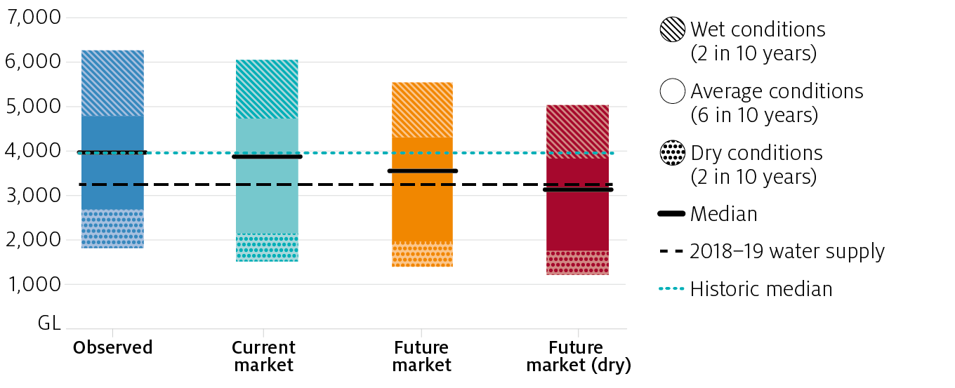  
Note: Water supply levels shown in this chart only include major surface water entitlement rights and exclude ‘other water’ sources such as groundwater.

#### Demand for water will increase

Anticipated changes in water demand are the other major driver of water allocation prices and inter-regional trade in the southern basin in the ‘future scenarios’. In both scenarios, the area planted with almond trees is not assumed to increase; however, all existing almond trees are assumed to be fully mature (bearing), thereby increasing the demand for water from the almond-growing industry. It is important to note that the proportion of bearing to non-bearing trees varies substantially by catchment. For example, in the Vic. Murray, almost all existing almond trees are bearing (around 95 per cent), while in the SA Murray, only around half of the existing trees are bearing. This has a considerable effect on *where* the demand for water increases in the future.

Additionally, the future scenarios take into account an increase in farm productivity and water demand due to the effects of on-farm infrastructure upgrades.

Taking these likely changes in water demand into account, Figure 4 presents the total water demand across the southern basin for prices between $1/ML and $1000/ML for each scenario. As shown, the demand for water increases in the ‘future scenarios’ compared to the current market scenario. The total demand for water is marginally higher in the future market (dry) scenario compared to the future market scenario due to marginally lower on-farm rainfall (a 3 per cent decrease is assumed).

Figure 4 Total water demand across the sMDB, by scenario

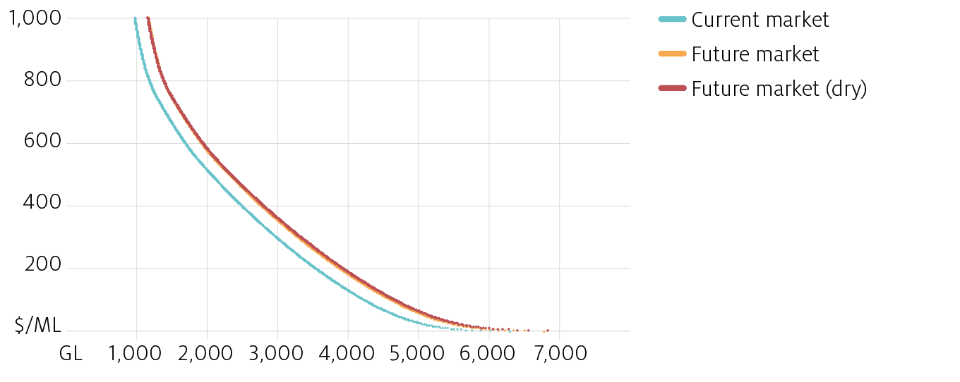  
Note: Rainfall is fixed at average over seasonal conditions, and the time trend and commodity prices are set to 2018–19 values.

#### Prices will likely be higher

Figure 5 shows the distribution for modelled water allocation prices in the southern Murray-Darling Basin. Compared to the current market scenario, there is a significant increase in water prices in each of the future scenarios. In the future market scenario, on average, around two-thirds of the increase in prices is attributed to the additional recovery of water through on-farm programs, while a third is attributed to greater water demand from the almonds sector.

While the average annual price in 2018–19 (around $445/ML) would be considered high in the current market scenario, occurring in just 3 out of 10 years, the same price would be considered an average price in the future market (dry) scenario, occurring much more frequently. Importantly, the range for water prices in both ‘future scenarios’ is also considerably higher; prices above $200/ML were modelled in 8 out of 10 years in the future market scenario, and in all years in the future market (dry) scenario (see Table B1 and B5). This will likely place some pressure on irrigation industries such as dairy and rice, which have historically used much less water than other sectors, during years with high water prices.

The economic impact of higher water prices on irrigators will vary substantially between individuals. Farmers who have made the decision to own much of the water they use will most likely be better off if water prices increase – both in terms of income and wealth – while farmers who rely heavily on purchasing water allocations will likely be worse off. Detailed analysis of water ownership and use is beyond the scope of this analysis.

It is worth noting that results are presented here as average annual prices across the southern basin. Prices typically vary across catchments when trade constraints are binding and can also vary substantially within each water year.

Figure 5 Weighted water allocation price by scenario, southern Murray-Darling Basin



#### Allocation prices are sensitive to changes in rainfall and supply

In the future market (dry) scenario, seasonal conditions are assumed to be drier than historically observed. A 3 per cent decrease in rainfall is assumed, leading to greater demand for irrigation water, as well as an 11 per cent decrease in surface water supply. These assumptions are consistent with assessments of future water availability undertaken by CSIRO (2008).

Allocation prices are quite sensitive to changes in rainfall and water supply, increasing by 17 per cent on average in the future market (dry) scenario, compared to the future market scenario. Most of this increase (around 90%) is due to a reduction in the availability of surface water.

It is possible that the drought conditions experienced in 2019–20 (or in other years in the future) could be wetter or drier than those observed historically or assumed in the future market (dry) scenario, and therefore prices could be lower or higher than the ranges presented in this report.

#### Water use in traditional irrigation sectors will decrease

The average annual future water use across the southern basin is presented by activity in Figure 6. Total water use is expected to decrease by around 3 per cent in the future market scenario and 12 per cent in the future market (dry) scenario compared to the current market scenario. The changes in average water use across the southern basin are smaller than the changes in water supply described in Figure 3, as there are also other sources for water supply (such as groundwater and on-farm storages) which are accounted for in the model.

Water markets in the southern basin have evolved to facilitate the flow of water towards its highest value use. Despite the decrease in total water use (and water supply), there is a significant increase in water use for almonds (around 41 per cent compared to the current market scenario), as water is redirected from other irrigation activities such as rice (which decreases on average by 15 and 31 per cent in the future market and future market (dry) scenarios respectively) and dairy (decreases on average by 14 and 24 per cent in the future market and future market (dry) scenarios respectively). In dry years, more significant decreases are predicted for these sectors, with dairy and rice water use decreasing by up to 55 per cent and 32 per cent respectively. Table B4 shows the modelled change in water use by catchment.

Figure 6 Average water use by scenario, southern Murray-Darling Basin

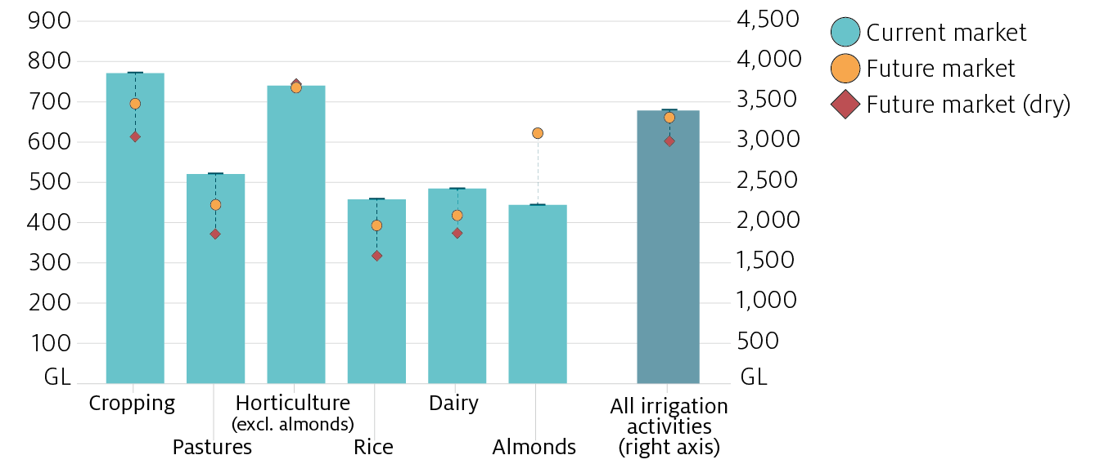

Recently there has been significant concern that during a drought, there would be insufficient water to meet the demand from horticultural plantings (fruits, nuts and grapevines), thereby significantly driving up prices. While the results from the Water Trade Model suggest that water supply (including both surface water and other sources such as groundwater) is sufficient to meet annual horticultural demand (based on observed almond plantings in 2018-19) in all scenarios, in practice there remains some risk of supply shortfalls within each water year, particularly if future conditions are drier than modelled or trade constraints are tightened.

Note these results are based on estimates of existing almond plantations and do not consider additional almond plantings in the future. Furthermore, the Water Trade Model relies on annual data and does not provide insights for day to day water trading and irrigation activity.

Box 1 Variation in water use is particularly pronounced in traditional irrigation sectors

|  |
| --- |
| On average, water use in the dairy industry is lower by around 69 GL in the future market scenario and 116 GL in the future market (dry) scenario, compared to the current market scenario (average annual water use of 486 GL). However, dairy water use (and water use in other traditional sectors such as rice) varies considerably depending on seasonal conditions and water prices. Figures 7 and 8 show the distribution of water use in the dairy sector in each scenario, and how it varies across representative ‘wet’ or ‘dry’ years (each occurring in 2 out of 10 years in the future) and ‘average’ years (occurring in 6 out of 10 years in the future).  **Traditional irrigation sectors are more sensitive to high prices**  During the past decade, irrigated pastures (predominantly used for dairy production in the sMDB) has become an increasingly opportunistic activity, relying on relatively low water prices for profitable returns. A recent survey of dairy farmers in the Goulburn-Murray Irrigation district suggested most (56%) would not consider purchasing water at prices above $200/ML (Dairy Australia 2017). In part, this also reflects the capacity for dairy farmers to use purchased fodder in place of irrigated pastures when water prices are high.  **High water prices are more likely in the future**  In the future market scenarios, higher water prices are generally more likely, and a greater increase in prices is modelled in dry years compared to the current market scenario. This leads to an overall decrease in water use in the dairy sector, which is particularly pronounced in dry years (as shown in Figure 7 for all modelled scenarios).  However, there is considerable variation in water use in this sector, even in dry years. Dairy water use was modelled to decrease by 38 per cent on average in dry years (Figure 8) in the future market scenario (up to a maximum of 55 per cent in the driest year), compared to the current market scenario. Overall, dairy water use decreases by an average of 14 per cent and 24 per cent in the future market and future market (dry) scenarios respectively, compared to the current market scenario (Figure 8).  The results suggest that the irrigated dairy sector in the southern basin is likely to face continued adjustment pressure in the future. It is important to recognise however, that this analysis does not incorporate responses from farmers that would offset higher water prices (for example, technological change), structural changes in the industry, or future dairy prices.  Figure 7 Dairy water use in wet, average, and dry years, by scenario  C:\Users\gupta mihir\AppData\Local\Microsoft\Windows\INetCache\Content.Word\9-01.png  Figure 8 Percentage change in dairy water use, for different seasonal conditions  C:\Users\gupta mihir\AppData\Local\Microsoft\Windows\INetCache\Content.Word\10-01.png |

#### Inter-regional trade limits will have a larger effect

In the ‘future scenarios’, there is a greater reliance on inter-regional trade, which in turn highlights the importance of water markets in facilitating the movement of water to its highest value use, and the role of trade limits in the future. Figure 9 shows the modelled average net trade, as well as the range, for each trading zone (catchments are grouped into trading zones, see note below Figure 9). A general increase in water trading activity is expected across the southern basin in the future.

As discussed previously, most of the increase in future water demand occurs in the almond industry which is primarily located in the Barmah Below trading zone (which includes catchments below the Barmah choke, such as the SA Murray and the Vic. Murray Below). Consequently there is a considerable increase in the volume of water imported into this region, which is primarily sourced from the Murrumbidgee and Northern Victoria.

Figure 9 Average net trade by scenario and trading zone

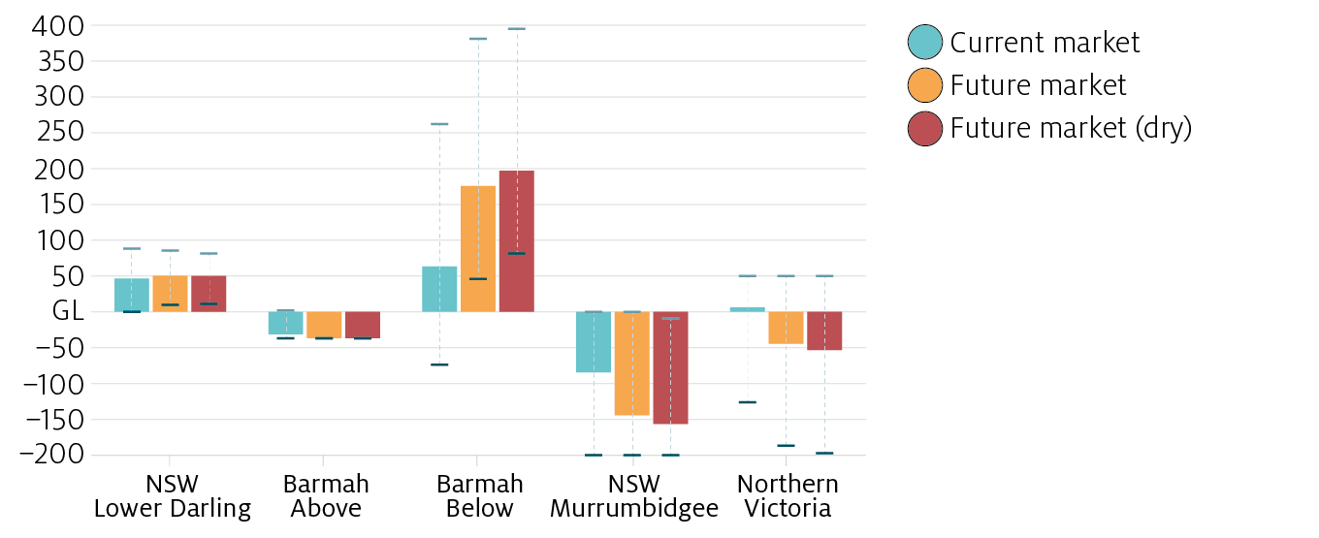  
Note: **Barmah Above** trading zone includes the NSW Murray Above and Vic. Murray Above; **Barmah Below** trading zone includes the NSW Murray Below, Vic. Murray Below and the SA Murray; **Northern Victoria** trading zone includes Vic. Goulburn-Broken and Vic. Loddon-Campaspe.

A number of hydrological constraints affect the volume of water that can be traded across the southern basin, and inter-regional trade is regulated by state governments using inter-valley trade limits. While these limits can apply at various times during the water year, an annual limit is approximated using historical data in the Water Trade Model. The model suggests these trade limits are binding more often in the future (Table B3), leading to larger price gaps between catchments above and below the Barmah choke. In particular, the Murrumbidgee reaches the modelled export trade constraint in 8 out of 14 years in the ‘future scenarios’ (Table B3).

As shown in Figure 10, this leads to different distributions for water allocation prices in the Murrumbidgee compared to the Barmah Below in the future. While the price in average years is relatively similar in both trading zones, particularly in dry years, the Murrumbidgee price is typically much lower, reflecting the mix of irrigation activities in the region and a binding trade constraint limiting the volume of water that can be exported (See Table B1 for average water prices by catchment; see Table B3 for number of years where trade limits are binding).

Figure 10 Price gaps between the Barmah Below and Murrumbidgee trading zones

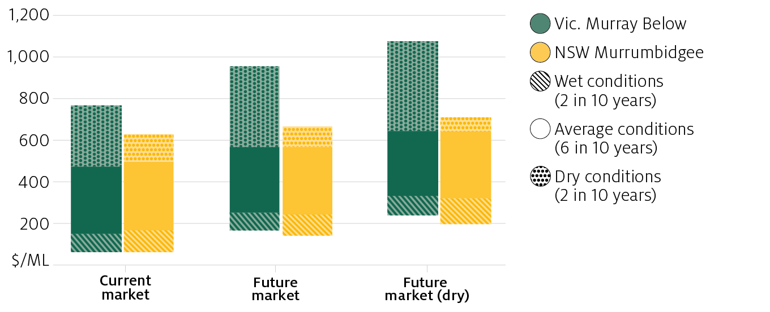

It is important to note that the water market is going through some changes in 2019–20 that have not been considered in the model. In particular, the Goulburn-Murray Inter-valley trade limit is being revised to essentially reduce the volume of water that can be exported from the Goulburn to the Murray.

#### GVIAP for traditional irrigation sectors will decrease

Table 2 shows the average annual gross value of irrigated agricultural production (GVIAP) across the southern basin by activity. Total GVIAP across all activities *increases* by 0.8 per cent on average each year in the future market scenario compared to the current market scenario. While this increase is primarily driven by significantly higher almond production, ABARES research also shows that recovering water through on-farm programs leads to greater productivity for participating farms in this scenario. While the average annual GVIAP for most irrigation sectors (except horticulture) is estimated to decline, this decrease would be greater if water was recovered solely through buybacks.

In the future market (dry) scenario, total GVIAP *decreases* by 4.1 per cent compared to the current market scenario. The positive effect of on-farm programs on farm productivity and greater almond production is more than offset by a decrease in production in other sectors due to lower rainfall and higher water prices.

In both future market scenarios, production (Table B9) for most irrigation activities (except horticulture) decreases, following the changes in irrigated area and water use (Table B4). The average decrease in dairy production is smaller than the average decrease in dairy water use, as farmers are able to substitute water for fodder and maintain a relatively higher level of production. However, for many farms, increased reliance on fodder for dairy production would likely lead to higher input costs and reduced profitability. While this could lead to structural changes in the dairy industry in the longer-term, it is important to note the model does not account for such changes.

Table 2 Average annual GVIAP, by scenario and irrigation activity, sMDB

|  |  |  |  |
| --- | --- | --- | --- |
| **Irrigation activity** | **Current market**  **($m)** | **Future market**  **($m)** | **Future market (dry)**  **($m)** |
| Cropping | 441.7 | 413.6 | 366.2 |
|  |  | (-6.4%) | (-17.1%) |
| Pastures | 457.7 | 420.0 | 364.1 |
|  |  | (-8.2%) | (-20.5%) |
| Horticulture | 2,435.7 | 2,472.2 | 2,428.5 |
|  |  | (1.5%) | (-0.3%) |
| Rice | 191.4 | 165.5 | 133.4 |
|  |  | (-13.5%) | (-30.3%) |
| Dairy | 726.8 | 664.3 | 608.7 |
|  |  | (-8.6%) | (-16.2%) |
| Almonds | 658.0 | 813.0 | 807.9 |
|  |  | (23.5%) | (22.8%) |
| **All irrigation activities** | **4,911.3** | **4,948.7** | **4,708.8** |
|  |  | (0.8%) | (-4.1%) |

## Appendix A: The model

ABARES Water Trade Model is a data-driven economic model of the southern Murray-Darling Basin water market. The model is based on a comprehensive database containing information on water supply (allocations, entitlements, and carryover), water demand (irrigation area, water use) and water market (prices and trade flows) on a catchment scale over the period 2005–06 to 2018–19. This data is used to estimate a statistical model linking demand for irrigation water (by catchment and activity) with water market prices, commodity prices and rainfall.

This statistical model is combined with a standard economic (partial equilibrium) framework, allowing for water to trade across activities and regions subject to limits on inter-regional water trading. As demonstrated by Gupta et al. (2018) the model is able to accurately recreate historical variations in water market prices and trade-flows, and irrigation water use. This combination of data and economic theory make the Water Trade Model a useful policy analysis tool that can be used to simulate the effects of specific climate or policy shocks, while also producing results consistent with historically observed data.

However, like any economic model the Water Trade Model is a significant approximation of reality, and it is important to note some of the limitations of the model that are relevant for interpreting the results discussed in this paper.

#### Annual time scale

The model operates on an annual (financial year) timescale, and the modelled water allocation prices presented in the report are all annual averages. In practice, water allocation prices can vary substantially within a water year. As such, monthly or daily water prices could be significantly higher or lower than the annual averages predicted by the model.

#### Trade constraints

A number of hydrological constraints affect the volume of water that can be traded across the southern basin, and inter-regional trade is regulated by state governments using inter-valley trade limits. The model has been designed to take into account key trade limits including the Murrumbidgee IVT, the Goulburn-Murray IVT and the Barmah Choke limit. In reality these trade limits are complex and can apply at various times during the water year. However, the model uses an annual timescale and uses an annual total trade limit that is approximated using historical data and advice from a number of stakeholders. While the resulting modelled inter-regional trade flows are approximate, they generally match the historical data with a reasonable degree of accuracy (Gupta et al. 2018).

#### Commodity prices

Since the scenarios presented in this report are forward-looking simulations, commodity prices are fixed to 2018–19 values (for all irrigation activities except hay). Long-term forecasts of commodity prices are not taken into account. Hay prices are allowed to vary in line with the assumed climate sequence (hay prices typically increase in dry years and decrease in wet years).

#### Water recovery

Future water recovery is assumed to occur entirely through on-farm infrastructure upgrades. Further, these upgrades are assumed to have some positive effects on irrigation water demand and productivity (based on ABARES research). Future research could examine alternative recovery mechanisms (such as buybacks) that will have different effects on water markets.

#### Structural change

The water trade model is a ‘short-run’ model that takes irrigation development and capital investment as fixed. This means that the model does not consider potential future changes in horticultural plantings (beyond the maturation of recent plantings), or structural changes in other irrigation sectors (such as the size of the dairy cattle herd). Future changes in productivity or technological advancements are also not taken into account. In practice, such changes have the potential to moderate water price increases. Future research could examine the interaction between industry structural adjustment and water market outcomes in more detail.

#### Climate change

In the ‘current market’ and ‘future market’ scenarios, a historical climate sequence is used (2005–06 to 2018–19), which is particularly dry in the context of the longer historical record and may differ from average future climate conditions. The future market (dry) scenario uses the same sequence, however rainfall and allocations are assumed to be 3 per cent and 11 per cent lower across the southern basin. Future research could incorporate climate change projections to provide a more accurate estimate of potential future water supply.

#### Carryover

In this study, the model takes carryover volumes as fixed (as part of the historical climate sequence). In practice, changes in water supply and demand could induce changes in carryover behaviour which would have implications for water prices. For example, increased carryover volumes would tend to smooth water prices between dry and wet years. Future research could relax this assumption, simulating carryover behaviour as well as inter-regional trade.

## Appendix B: Additional tables

Scenario results for the water allocation price (Table B1), net trade (Table B2 and Table B3) and irrigation water use (Table B4) are summarised in the tables below. The percentage chance of modelled allocation prices being within a certain range is shown in Table B5, for each scenario. Tables B6, B7 and B8 show the average water use in ‘dry’, ‘wet’, and ‘average’ years, by irrigation activity. Table B9 shows the percentage change in production by irrigation activity.

Table B1 Average water allocation price ($/ML) by trading zone

|  |  |  |  |  |  |
| --- | --- | --- | --- | --- | --- |
| **Scenario** | **Murrumbidgee** | **Lower Darling** | **Barmah Above** | **Barmah Below** | **Northern Victoria** |
| **Current market** |  |  |  |  |  |
| Average | 306 | 305 | 212 | 308 | 356 |
| Minimum | 63 | 63 | 32 | 63 | 150 |
| Maximum | 630 | 769 | 536 | 769 | 825 |
| **Future market** |  |  |  |  |  |
| Average | 372 | 426 | 241 | 426 | 455 |
| Minimum | 139 | 169 | 54 | 169 | 250 |
| Maximum | 665 | 955 | 547 | 955 | 955 |
| **Future market (dry)** |  |  |  |  |  |
| Average | 434 | 510 | 274 | 510 | 533 |
| Minimum | 201 | 241 | 93 | 241 | 322 |
| Maximum | 712 | 1075 | 560 | 1075 | 1075 |

Note: Catchments within the same trading zone are able to freely trade with each other and have the same water price. **Barmah Above** trading zone includes the NSW Murray Above and Vic. Murray Above; **Barmah Below** trading zone includes the NSW Murray Below, Vic. Murray Below and the SA Murray; **Northern Victoria** trading zone includes Vic. Goulburn-Broken and Vic. Loddon-Campaspe.

Table B2 Average net trade (GL) by trading zone

|  |  |  |  |  |  |
| --- | --- | --- | --- | --- | --- |
| **Scenario** | **Murrumbidgee** | **Lower Darling** | **Barmah Above** | **Barmah Below** | **Northern Victoria** |
| **Current market** |  |  |  |  |  |
| Average | -84.7 | 46.5 | -31.5 | 63.4 | 6.3 |
| Minimum | -200.0 | 0.0 | -37.0 | -73.9 | -126.4 |
| Maximum | 0.0 | 88.3 | 1.8 | 262.2 | 50.0 |
| **Future market** |  |  |  |  |  |
| Average | -144.3 | 50.5 | -37.0 | 175.6 | -44.8 |
| Minimum | -200.0 | 9.7 | -37.0 | 46.0 | -187.0 |
| Maximum | 0.0 | 85.5 | -37.0 | 381.3 | 50.0 |
| **Future market (dry)** |  |  |  |  |  |
| Average | -156.7 | 50.2 | -37.0 | 197.0 | -53.6 |
| Minimum | -200.0 | 11.0 | -37.0 | 81.6 | -197.6 |
| Maximum | -9.1 | 81.5 | -37.0 | 395.3 | 50.0 |

Table B3 Number of years (out of 14 years) trade limits were binding in each trading zone

|  |  |  |  |
| --- | --- | --- | --- |
| **Region** | **Current market** | **Future market** | **Future market (dry)** |
| Murrumbidgee |  |  |  |
| Export | 2 | 8 | 8 |
| Import | 5 | 2 | 0 |
| Lower Darling |  |  |  |
| Export | 1 | 0 | 0 |
| Import | 0 | 0 | 0 |
| Barmah Above |  |  |  |
| Export | 12 | 14 | 14 |
| Import | 0 | 0 | 0 |
| Barmah Below |  |  |  |
| Export | 0 | 0 | 0 |
| Import | 0 | 0 | 0 |
| Northern Victoria |  |  |  |
| Export | 0 | 0 | 0 |
| Import | 6 | 4 | 4 |

Table B4 Irrigation water use by catchment

|  |  |  |  |
| --- | --- | --- | --- |
| **Region** | **Current market average annual (GL)** | **Future market % change** | **Future market (dry) % change** |
| NSW Lower Darling | 93.6 | -2.3% | -6.2% |
| NSW Murray Above | 434.5 | -5.0% | -14.8% |
| NSW Murray Below | 109.8 | 46.2% | 34.5% |
| NSW Murrumbidgee | 1049.7 | -6.6% | -16.8% |
| SA Murray | 297.5 | 17.2% | 15.4% |
| Vic. Goulburn-Broken | 514.2 | -17.8% | -30.4% |
| Vic. Loddon-Campaspe | 52.6 | -17.0% | -30.2% |
| Vic. Murray Above | 156.9 | -1.2% | -5.5% |
| Vic. Murray Below | 707.3 | -2.6% | -7.0% |

Table B5 Percentage chance of allocation price ranges in southern basin, by scenario

|  |  |  |  |  |
| --- | --- | --- | --- | --- |
| **Scenario** | **Low prices ($0 – $199/ML)** | **Moderate prices ($200 – $399/ML)** | **High prices ($400 – $599/ML)** | **Very high prices ($600/ML & above)** |
| Observed | 64% | 7% | 21% | 7% |
| Current market | 50% | 14% | 21% | 14% |
| Future market | 14% | 50% | 14% | 21% |
| Future market (dry) | 0% | 64% | 14% | 21% |

Table B6 Water use (GL) by activity, ‘dry’, ‘wet’ and ‘average’ years, current market

|  |  |  |  |
| --- | --- | --- | --- |
| **Irrigation activity** | **Wet years**  **(2 in 10 years)** | **Average years**  **(6 in 10 years)** | **Dry years**  **(2 in 10 years)** |
| Cotton | 521 | 407 | 266 |
| Rice | 808 | 461 | 101 |
| Dairy | 746 | 498 | 193 |
| Almonds | 442 | 442 | 442 |
| Fruit | 314 | 302 | 271 |
| Grapevines | 413 | 367 | 301 |
| Vegetables | 79 | 78 | 74 |
| Pastures – grazing | 393 | 258 | 88 |
| Pastures – hay | 372 | 277 | 158 |
| Other broadacre | 72 | 41 | 2 |
| Other cereals | 483 | 336 | 118 |
| Other crops | 14 | 9 | 1 |
| **All irrigation activities** | **4,385** | **3,503** | **2,215** |

Table B7 Water use (GL) by activity, ‘dry’, ‘wet’ and ‘average’ years, future market

|  |  |  |  |
| --- | --- | --- | --- |
| **Irrigation activity** | **Wet years**  **(2 in 10 years)** | **Average years**  **(6 in 10 years)** | **Dry years**  **(2 in 10 years)** |
| Cotton | 491 | 385 | 244 |
| Rice | 664 | 401 | 81 |
| Dairy | 665 | 435 | 119 |
| Almonds | 622 | 622 | 622 |
| Fruit | 320 | 307 | 276 |
| Grapevines | 407 | 359 | 293 |
| Vegetables | 81 | 80 | 76 |
| Pastures – grazing | 354 | 227 | 66 |
| Pastures – hay | 330 | 222 | 116 |
| Other broadacre | 58 | 30 | 1 |
| Other cereals | 435 | 296 | 94 |
| Other crops | 11 | 7 | 1 |
| **All irrigation activities** | **4,182** | **3,400** | **2,170** |

Table B8 Water use (GL) by activity, ‘dry’, ‘wet’ and ‘average’ years, future market (dry)

|  |  |  |  |
| --- | --- | --- | --- |
| **Irrigation activity** | **Wet years**  **(2 in 10 years)** | **Average years**  **(6 in 10 years)** | **Dry years**  **(2 in 10 years)** |
| Cotton | 452 | 352 | 215 |
| Rice | 543 | 329 | 59 |
| Dairy | 603 | 382 | 101 |
| Almonds | 622 | 622 | 622 |
| Fruit | 320 | 308 | 277 |
| Grapevines | 399 | 351 | 281 |
| Vegetables | 81 | 80 | 76 |
| Pastures – grazing | 316 | 195 | 59 |
| Pastures – hay | 292 | 175 | 76 |
| Other broadacre | 45 | 22 | 1 |
| Other cereals | 383 | 251 | 78 |
| Other crops | 9 | 5 | 1 |
| **All irrigation activities** | **3,821** | **3,096** | **2,027** |

Table B9 Percentage change in units of production, future market scenarios compared with the current market

|  |  |  |
| --- | --- | --- |
| **Irrigation activity** | **Future market  compared to Current market**  **(% change)** | **Future market (dry)  compared to Current market**  **(% change)** |
| Cotton | -2.8% | -10.4% |
| Rice | -13.5% | -30.3% |
| Dairy | -8.6% | -16.2% |
| Almonds | 23.5% | 22.8% |
| Fruit | 2.1% | 1.4% |
| Grapevines | -0.4% | -4.7% |
| Vegetables | 3.8% | 4.0% |
| Pastures – grazing | -6.7% | -18.0% |
| Pastures – hay | -15.4% | -32.2% |
| Other broadacre | -18.5% | -37.8% |
| Other cereals | -9.1% | -22.4% |

## Appendix C: Future water recovery

In this analysis, all future water recovery is assumed to only occur through on-farm programs. Water is recovered through three broad entitlement types, summarised in Table C1. Further detail for the model dataset and methodology will be made available in a forthcoming technical report.

Table C1 Water entitlement types

| **Entitlement class** | **Description** |
| --- | --- |
| *high* | Vic. High reliability, NSW High security, SA class 3 |
| *low* | Vic. Low reliability, NSW General security |
| *supplementary* | NSW Supplementary |

### Supply effect of future water recovery

On the supply side, we assume that future water recovery volumes are distributed across regions and entitlement types in proportion to existing recovery. Total MDB future water recovery of $\overline{B}=$ 501.6 GL (in LTAAY units) is assumed (including 51.6 GL of recovery remaining to satisfy the 2,750GL target and an additional 450 GL to reach 3,200 GL).

In the equations below, ${\overset{̃}{B}}_{hik}$ is the total volume of additional water recovery by entitlement type (in nominal units), region and method, ${\overset{̃}{E}}_{hi}$ is the volume of water entitlements (by type and region) left remaining after recovery to date (and therefore available for future recovery) and $f_{hi}$ are the LTAAY conversion factors. $b_{k}∈[0,1]$ is a parameter reflecting the future split between *on-farm* and *buyback* recovery (for this study we assume $b_{on-farm}=1,b_{buyback}=0$).

$${\overset{̃}{B}}_{hik}=b_{k}.\sum_{k}{B_{hiTk}}.\frac{\overline{B}}{\sum_{i}{\sum_{h}{\sum_{k}{B_{hiTk}}}}.f_{hi}}$$

$${\overset{̃}{E}}_{ih}=E_{hiT}-\sum_{k}{B_{hiTk}}$$

$${\overset{̃}{B}}_{hi}≤{\overset{̃}{E}}_{ih}$$

Here $B_{hiTk}$ is the volume of entitlement recovered to-date (by region *i*, entitlement type *h* and recovery method *k,* and where *T* is the last time period, 2018-19).

Using these equations, ABARES estimated a hypothetical distribution of additional on-farm water recovery across the MDB, which is summarised in Table C2 in LTAAY terms. Detailed water supply data is not available for Queensland catchments within the MDB. ABARES assumed 41.7 GL of the future water recovery target of 501.6 GL is recovered in Queensland (based on the proportion of historical water recovered in the region), leaving 459.9 GL to be recovered across the rest of the basin. Future research could seek to update these estimates.

Table C2 Future water recovery through on-farm programs, by entitlement type (ML)

|  |  |  |  |
| --- | --- | --- | --- |
| **Irrigation activity** | **High** | **Low** | **Supplementary** |
| **Northern Murray-Darling Basin** |  |  |  |
| NSW Border Rivers | 0 | 366 | 388 |
| NSW Gwydir | 1,547 | 13,179 | 3,842 |
| NSW Lachlan | 335 | 13,334 | 0 |
| NSW Macquarie-Castlereagh | 0 | 12,903 | 430 |
| NSW Namoi | 0 | 3,983 | 0 |
| **Southern Murray-Darling Basin** |  |  |  |
| NSW Lower Darling | 874 | 7,777 | 0 |
| NSW Murray Above | 0 | 73,905 | 32 |
| NSW Murray Below | 5,820 | 18,194 | 26 |
| NSW Murrumbidgee | 4,613 | 57,631 | 5,699 |
| SA Murray | 52,200 | 0 | 0 |
| VIC Goulburn-Broken | 81,296 | 1,859 | 0 |
| VIC Loddon-Campaspe | 3,673 | 96 | 0 |
| VIC Murray Above | 26,504 | 948 | 0 |
| VIC Murray Below | 67,528 | 911 | 0 |

## References

CSIRO 2008, [Water availability in the Murray-Darling Basin](https://publications.csiro.au/rpr/download?pid=legacy:530&dsid=DS1), A report to the Australian Government from the CSIRO Murray-Darling Basin Sustainable Yields Project, CSIRO, Canberra.

DA 2019, [Progress of water recovery](http://www.agriculture.gov.au/water/mdb/progress-recovery/progress-of-water-recovery), Department of Agriculture, Canberra.

Dairy Australia 2017, [Regional irrigated land and water use mapping in the Goulburn-Murray Irrigation District](https://www.gbcma.vic.gov.au/downloads/CatchmentEconomy/RILWUM_DairyEvaluationFinal2017_LowRes.pdf), Dairy Australia and Murray Dairy.

Gupta, M & Hughes, N 2018, [Future scenarios for the southern Murray-Darling Basin water market](https://www.agriculture.gov.au/abares/research-topics/water/future-scenarios-smdb), Australian Bureau of Agricultural and Resource Economics and Sciences, Canberra.

Gupta, M, Hughes, N, & Wakerman-Powell, K 2018, [A model of water trade and irrigation activity in the southern Murray-Darling Basin](https://www.agriculture.gov.au/sites/default/files/abares/documents/research-topics/water/a-model-of-water-trade-irrigation.pdf), Australian Bureau of Agricultural and Resource Economics and Sciences, Canberra.

Hughes, N, Gupta, M & Rathakumar, K 2016, [Lessons from the water market: the southern Murray-Darling Basin water allocation market 2000–01 to 2015–16](https://www.mdba.gov.au/sites/default/files/pubs/ABARES-lessons-water-market-report-14-15_0.pdf), Australian Bureau of Agricultural Resource Economics and Sciences, Canberra.